THE UNITED REPUBLIC OF TANZANIA
THE PRESIDENT’S OFFICE
REGIONAL ADMINISTRATION AND LOCAL GOVERNMENT

NAMANGA FORM THREE PRE-MIDTERM EXAMINATION

031 PHYSICS
MARKING SCHEME AUGUST 2024

SECTION A
1.
C | D | D | B | E | B | E | C | E | D
01 marks@ = 10marks
2.
H | E | B | C | F | D
01 marks@ = 06 marks
SECTION B
- (a) This is because you cannot clearly see anything that is closer than 25cm to your eye. A lens with a short focal length makes a powerful magnifying glass. With a short focal length, your eye gets closer to the object that is to be magnified. 04 marks
- Solution
Given: f_{O} = 2 cm, f_{E} = 6 cm, u_{o} = 2.4 cm, L = 17 cm
(i) Consider the figure below:
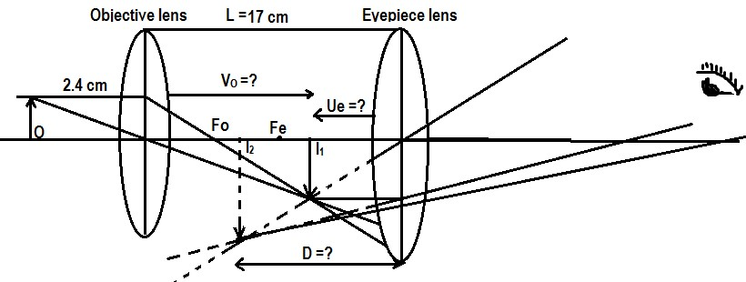
Diagram 01 marks
Refraction from the objective lens:

From:

V_{O} = 12 cm, but V_{O} + U_{E} = L → U_{e} = L – V_{O} = 17 cm – 12 cm = 5 cm ………… 01 marks

Also consider the refraction from the eyepiece lens
From:
D = -30 cm, (According to real – is – positive the final image is virtual)
∴ The distance of the final image from the eyepiece is 30 cm ……. 01 marks

(ii) Linear magnification (total magnification)
From: 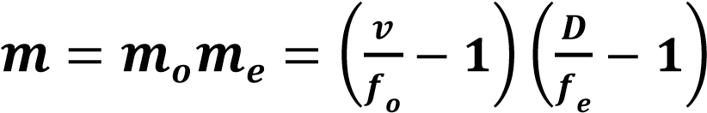 ……………………………………. 01 marks
∴ 𝒍𝒊𝒏𝒆𝒂𝒓 𝒎𝒂𝒈𝒏𝒊𝒇𝒊𝒄𝒂𝒕𝒊𝒐𝒏 𝒊𝒔 𝟐𝟎 ………………………………………….. 01marks

- (a) By observing smoke particles in random motion (Brownian motion) in a smoke cell, we can conclude that air particles are in random motion since they collide with the smoke particles, resulting in the random motion of the smoke particles. 05 marks
- Momentum is conserved. The lump of plasticine increases the mass of the trolley, but has no momentum in the direction of the trolley. The momentum mv, remains constant, and since mass has increased the velocity reduces. 04 marks

- Solution:
Given Cross section area of stem, A = 0.5${cm}^{2}$
Height of stem, h = 18 cm
The volume of stem, V1 = Ah = 9 ${cm}^{3}$
Total volume, Vt = (9 + V2) ${cm}^{3}$
Minimum density, ρmn = 0.8 g/ ${cm}^{3}$
Maximum density, ρmx = 1.0 g/${cm}^{3}$
The volume of bulb, V2 =?
(a) The volume of bulb, V2 = ?
From:
$V_{bulb}= \frac{Ahρ_{min}}{ρ_{max}-ρ_{min}}$ ………………………………………………. 02 marks
$V_{bulb}=\frac{9×0.8}{1.0-0.8}=36{cm}^{3}$ ……………………………………… 02 marks
(b) What height, h2 of hydrometer when shifted to measure 0.9 g/${cm}^{3}$
From:
$V_{bulb}= \frac{Ahρ_{min}}{ρ_{max}-ρ_{min}}$ ……………………………………………….. 01 marks
$\frac{0.9×0.5×h}{1.0-0.9}=36{cm}^{3}$ ……………………………………………….. 02 marks
𝒉=𝟑𝟔×𝟎.𝟏𝟎.𝟓×𝟎.𝟗=8 𝑐𝑚 02 marks

- (a) Water has low density as compared to mercury. The liquid column would be too tall since atmospheric pressure pushes water to a height of about 10m. 04 marks
- Is a simple piston pump that is used to inject fluid into or withdraw fluid from the body ……………………………………………………………01 marks

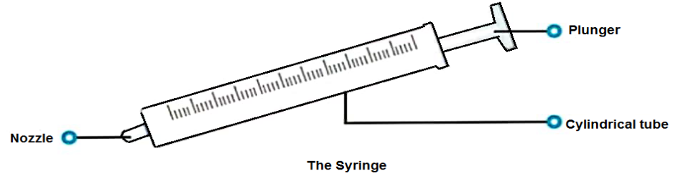
Working principle
It consists of a plunger that fits in a tube. The plunger is pulled and pushed
while inside a cylindrical tube or barrel. This action enables the syringe to take
in or expel fluid through the opening (nozzle) at the end of the tube 04 marks
- (a) Because of the scattering of the sun’s light when it enters the earth’s atmosphere. The blue light is scattered more than other colours due to the difference in their wavelength. While on the moon, the sky appears black because the moon has no atmosphere to scatter sunlight. 04 marks
- Data given
Least count = 0.01mm
Sleeve scale = 1.6cm =16mm
Thimble scale = 0.48mm
Zero error = -0.003cm = -0.03mm …………………………………………… 01 marks
From
Diameter of the rod = sleeve scale +thimble scale ……………………………… 01 marks
Diameter of the rod = 16mm + 0.48mm = 16.48mm ………………………… 01 marks
But
Correct diameter = 16.48mm + 0.03mm = 16.51mm ……………………… 01 marks
Therefore, correct diameter of the rod = 16.51mm ……………………… 01 marks

- (a) Testing for negative charge, the electroscope must be positively charged. Hence the leaf collapses if the negatively charged material is brought near the cap of the electroscope. Testing for positive charge, the electroscope must be negatively charged. Hence the leaf collapses if the positively charged material is brought near the cap of the electroscope 05 marks
- As you walk across a carpet your feet rub electrons off the carpet, leaving you with slightly negative static charge. When you reach for a doorknob you get a shock as electrons jump from you to the knob, which conducts electricity. OR
While walking on a carpet, you are sort of insulated hence high electrons accumulation. On the other hand, the door has excess of the opposite charges. This results in a mild electric shock. 04 marks
SECTION C
- (a) Ice being less dense than water, floats on the water. This insulates water below against heat loss to the cold air above. Water at 4°C being dense remains at the bottom of the lake. This enables fish and other aquatic life to survive in the water below the ice. 04 marks
- Iron contracts in the morning due to low temperature. This makes the nut to hold tightly onto the wheels. The reverse happens on a hot day. 05 marks
- Because water has a larger index of refraction than air does, the critical angle for the diamond-water interface is no longer 24.4° but increases to 33.3°. Therefore, this particular ray is no longer totally internally reflected. Only some of the right ray will be reflected back into the diamond, while the reminder escapes into the water. Consequently, less light exits from the top of the diamond, causing it to lose much of its sparkle 04 marks
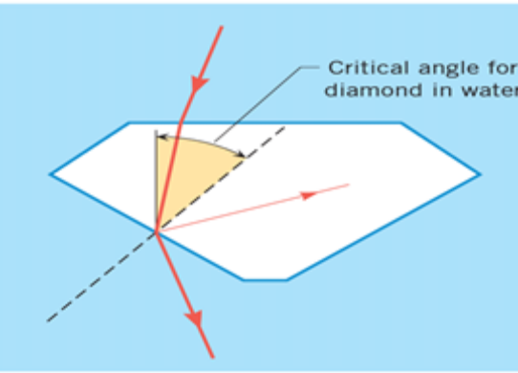
Diagram 02 marks
- (a) disadvantages of friction
- It causes wear and tear
- It produces heat in various machine parts causing efficiency to decrease
- Due to friction noise is produced in machine
- Causes loss of energy in form of heat and sound
- Causes motion of a body to slow down
- Heat produced by friction can cause appliance to burn
- It causes wounding, when skin wearing
Any five points @ 01 marks = total 05 marks

  - Polishing lowers the ability of material atoms to come closer (i.e. to bond each together) and thus reduce friction
- Polished surface is much frictionless than smooth surface. This is because for the smooth surfaces, atoms of both the materials come very closer to each other and the number of bonds between them increases and thus friction increases 05 marks
- Soln:
Given: m = 4 kg, $∅$ = 40⁰
Consider the fig below
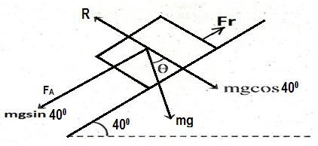
Diagram 01 marks
From:
𝑨𝒕 𝒄𝒐𝒏𝒔𝒕𝒂𝒏𝒕 𝒔𝒑𝒆𝒆𝒅 (𝒂 = 𝟎), 𝝁 = 𝒕𝒂𝒏𝜽 02 marks
∴ 𝝁 = 𝒕𝒂𝒏𝜽 = 𝒕𝒂𝒏𝟒𝟎 = 𝟎. 𝟖𝟒 02 marks

- (a) The following are the rules used to locate image in the curved mirror.
- A ray of light travelling to the mirror parallel to the principal axis, a ray is reflected through the principal focus
- A ray of light travelling to the mirror through the centre of curvature is reflected along its own path
- A ray of light travelling to the mirror through the principal focus is reflected parallel to the principal axis 01.5marks@ =04.5 marks
- Light rays before striking the air bubbles have to travel through water. These light rays which strike the air bubbles at an angle greater than critical angle for water air surface are totally reflected and it is because of these reflected rays that the air bubbles appear silvery. 04.5 marks
- Data given
u = 20 cm, f = 12 cm, v = v
From:
Therefore, v = 30 cm, A positive value of v means a real image is formed. Hence a real image is formed 30 cm away from the mirror on the same side as the object 06 marks

