THE UNITED REPUBLIC OF TANZANIA
PRESIDENT’S OFFICE
REGIONAL ADMINISTRATION AND LOCAL GOVERNMENT
NAMANGA SECONDARY SCHOOL
FORM THREE TERMINAL EXAMINATION
PHYSICS
MARKING SCHEME 2024

SECTION A
- @1mark (total 10marks)
I | Ii | Iii | iv | V | vi | Vii | viii | ix | x
C | D | A | B | A | B | B | A | B | D

- @ 1mark (total 6marks)
LISTA | I | ii | Iii | Iv | v | vi
LIST B | E | C | D | A | B | A

SECTION B
- $(a)$ (i) Do not drop the thermometer or subject it to heavy shock
(ii) Do not bend the thermometer or bite the bulb
(iii) Do not use a damaged or broken thermometer as it cause injury
(iv) Keep the thermometer away from unsupervised children
(v) Sterilize thermometer after to avoid contamination
Any three @ 03Marks
$(b)$ Because of the force of gravity, the man leg will be pulled towards the Earth.
And thus the man gets tired since his opposing the force of gravity of the
Earth (03 Marks)
$(c)$ It is because molecular motion is faster in gases than in liquid ……(03Marks)

- $(a)$ Since the body will just submerge beneath water, then average density of a body
will be equal to that of water i.e. $1g/{cm}^{3}$ …… (1 Mark)
Thus,
Total mass$=$total volume …….. (1 Mark)
$M_{s}+M_{c}=V_{s}+V_{c}$
$M_{s}+M_{c}=\frac{M_{s}}{ρ_{s}}+V_{c}$ …… (1 Mark)
$M_{s}+48=\frac{M_{s}}{8}+400$ …… (1 Mark)
$M_{s}+48=0.125M_{s}+400$
$M_{s}-0.125M_{s}=400-48$
${0.875M}_{s}=352$ …… (1 Mark)
$M_{s}=\frac{352}{0.875}$
$∴$The mass of steel$, M_{s}=402. 29 g$ …… (1 Mark)
(b) – magnets ……………………………………………….. 02 marks
Magnets keep the door of the freeze tight all the time maintaining the low
temperature medium in the freezer ……………………………….. 02 marks
- (a) Static electricity-related incidents at retail gasoline outlets are extremely unusual, but the potential for them to happen appears to be the highest during cool or cold and dry climate conditions. In rare circumstances, these static related incidents have resulted in a brief flash fire occurring at the fill point.
- Consumers can take steps to minimize these and other potential fueling hazards by following safe refueling procedures such that;
- Turn off your vehicle engine. Put your vehicle in park and/or set the emergency brake. Disable or turn off any auxiliary sources of ignition such as a camper or trailer heater, cooking units, or pilot lights.
- Do not smoke, light matches or lighters while refueling at the pump or when using gasoline anywhere else.
- Use only the refueling latch provided on the gasoline dispenser nozzle. Never jam the refueling latch on the nozzle open.
- Do not re-enter your vehicle during refueling. If you cannot avoid re-entering your vehicle, discharge any static build-up BEFORE reaching for the nozzle by touching something metal with a bare hand -- such as the vehicle door -- away from the nozzle.)
- In the unlikely event a static-caused fire occurs when refueling, leave the nozzle in the fill pipe and back away from the vehicle. Notify the station attendant immediately. 04 marks
    - Data given
Main scale reading =0.5mm
Least count (LC) of micrometer screw gauge = 0.01mm
Circular scale reading (CSR) = 27divisions
Then
The reading = MSC + $CSR×LC$ …………………………………… 01 marks
The reading = 0.5mm + $27×0.01mm$ …………………………….. 0.5 marks
The reading = 0.5mm + 0.27mm …………………………… 0.5 marks
The reading = 0.77mm …………………………………… 01 marks
Also
The correct reading
Reading = 0.77mm + 0.05mm = 0.82mm ……………………… 01 marks
Therefore, the correct diameter of the wire is 0.82mm. ……….. 01 marks

- $(a)$
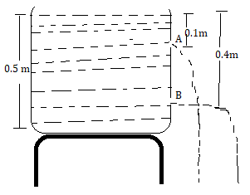 diagram 01 marks
Since pressure depend on the depth, the hole B will spurt the water furthest compare to the hole A. this because the hole B has more pressure compare to the hole A … 02 marks

- Data given
Sides(s) = 2cm
Depth (h) = 10cm
Density of water = 1027kg/$m^{3}$
Acceleration due to gravity (g) = 10N/kg
Pressure difference ($∆P)= ?$
From
$∆P=P_{B}- P_{T}$
$but P= ρgh$
$∆P= ρg (h_{b}-h_{t})$ ……………………………………… 01 marks
Hence
$h_{b} =10cm=0.1m$
$h_{t}=10cm-2cm=8cm=0.08m$
$∆P= 1027×10 \left(0.1-0.08\right)=10270 ×0.02=205.4N/m^{2}$ 01 marks
Therefore, the pressure difference between the top and the bottom is $205.4N/m^{2}$ ………………………………………………… 01 marks

- From
Upthrust (U) = $ρVg$ ………………………………………01 marks
But V = $S^{3}$ = 2$×2×2=8{cm}^{3}$ ……………………………… 0.5 marks
Upthrust = $1.027×8×0.01=0.082N$ …………………. 0.5 marks
Therefore, weight of water displaced by the cube = 0.082N …… 01 marks
- $(a)$ From,
$Average velocity=\frac{total distance }{total time}$ ……….......(2 marks)

$=\frac{-20+12.7}{2+1.6}$ ……….......(2 marks)
$=-2.03 m/s$
$∴Average velocity is 2.03 m/s$ downwards ………....... (2 marks)

$\left(b\right)$ Given:
Two pair of resistor (R=4Ω each)
Suppose the two pairs are parallel to each other;
Total resistance for each pair (R_{T1}) = 4Ω +4Ω … ….. (1mark)
R_{T1} = 8Ω
Also for the second pair (R_{T2}) = 8Ω … ……..(1mark)
But for parallel resistors $R_{T}= \frac{R_{T1}×R_{T2}}{R_{T1}+R_{T2}}$
${ R}_{T}= \frac{8Ω ×8Ω }{8Ω+8Ω }$ ….(1mark)
${ R}_{T}=\frac{64Ω}{16Ω}$
${ R}_{T}=4Ω$
$∴$Since the total resistance is 4 ohm, then the two pairs are in parallel.
Then the diagram below shows the two pair of resistors in parallel. ..(3marks)
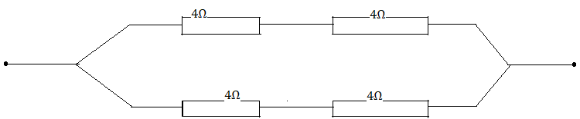
- $(a)$ Given
Length of the rod (l) = 0.997m
New length = 1m
Initial temperature( $∅_{0})=20℃$
Linear expansivity = $2.6×{10}^{-5}K^{-1}$)
Final temperature =?
From;
$∆l=αl_{0}∆θ$ ……………………………………………………… 01 marks
$∆θ=\frac{∆l}{αl_{0}}$
$∆θ= \frac{1-0.997}{2.6×{10}^{-5}K^{-1}) ×0.997 }$ …………………………… 01 marks
$∆θ=\frac{0.003}{2.5766×{10}^{-5}}$ = 116.43K ……………………………………… 01 marks
But;
$θ_{i}=116.43+293=409.43K or 136.43℃$
Therefore; final temperature will be $409.43K or 136.43℃$ ….. 02 marks
$(b)$ Consider the figure below
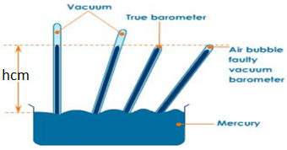

Procedures
- Take a 1m tube full of mercury and insert it upside down into a container containing mercury as seen above (0.5mark)
- Indicate the level of mercury reached when the tube is upright (hcm). (0.5mark)
- Tilt the tube until its top end is in the level of mercury (hcm) when the tube is upright (0.5mark)
Observation
- If the tube is completely filled with mercury, then the empty space is vacuum.
(0.5mark)
- If the empty space could still exist on top of the tube, then the empty space is not vacuum and hence the simple barometer could be regarded as being not accurate because could give wrong values of atmospheric pressure of a place. (1marks)

SECTION A
- (a) Frictional force is directly proportional to the perpendicular force (normal force) between two surfaces in contact. This can be verified as follows
- Materials needed
- Known weights, wooden block, horizontal table, spring balance, string
- Procedures
- Tie the wooden block to the spring balance
- Move the block and measure the dynamic friction
- Place the weight on the block, move it and measure the dynamic friction
- Add some extra weights to the block, move the block and measure the dynamic friction
- Conclusion
- The harder the two surfaces are pressed together the greater the friction
- Thus, mathematically
$$F_{r}∝R$$

$$F_{r}=kR$$
$$but$$
$$k=μ$$
$$thus$$
$$\left[F_{r}=μR \right]$$
- Where $μ$ is a constant of proportionality called coefficient of friction which is the measure of roughness and smoothness of the two surfaces in contact
- Recall that $F_{r}=μR$
- It implies that $\left[μ=\frac{F_{r}}{R}\right]$
Thus, coefficient of friction, $μ$ is defined as the ratio of frictional force resisting the motion of two surfaces in contact to normal force pressing the two surfaces together (05 marks)

(b)
- Polishing is the method of reducing friction between two surfaces through reducing irregularities between them.
- This is done by means of depositing a fine layer of a suitable material on the surface of the body
- This material fill up the space between the projections on the surface and makes it smooth
- Thus, interlocking between the body and the surface decreases and the surface offers lesser friction to a body moving over it
- Polishing lowers, the ability of material atoms to come closer (i.e. to bond each together) and thus reduce friction
- Polished surface is much frictionless than smooth surface. This is because for the smooth surfaces, atoms of both the materials come very closer to each other and the number of bonds between them increases and thus friction increases (05 marks)

(c) Given
Mass of wood = 5kg
Angle subtended = 60$°$
Coefficient of friction = 0.32
Suppose the body slides down the plane
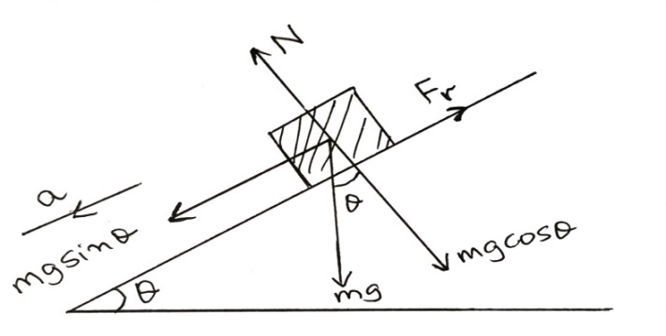
Diagram 01 mark
Perpendicular to the plane, no motion and then
$N=mg\cos{θ}$

Parallel to the plane, the body slide down the plane, then
$F_{net}=mg\sin{θ}-F_{r}$ ………………………………………………………... 01 mark
$ma=mg\sin{θ}-μ_{K}N$
$ma=mg\sin{θ}-μ_{K}mg\cos{θ}$
$ma=mg\left(\sin{θ}-μ_{K}\cos{θ}\right)$
$a=g\left(\sin{θ}-μ_{K}\cos{θ}\right)$ ………………………………………………………. 01 mark
$a=10 (sin60-0.32cos60$ ………………………....……………………… 01 mark
$a=10\left(0.8660-0.16\right)=10×0.706=7.1m/s^{2}$
Therefore, the acceleration down the plane =$7.1m/s^{2}$ …………….. 01 mark
- (a)
- when light passes from a liquid to the water, it is bent toward the normal, because the liquid and water has the same refractive index ……… 02 marks
- Since the glass crown is denser than water, the light bends away from the normal …………………………… 02 marks

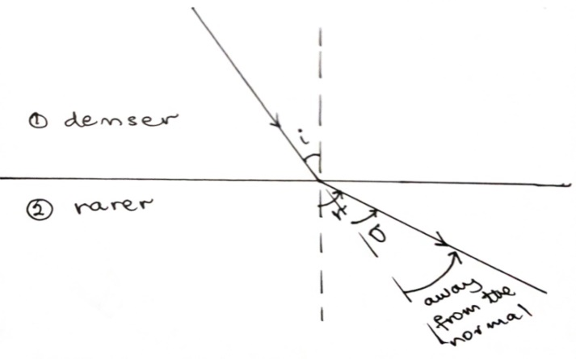
diagram 01 marks
(b) Given
Real depth = 24cm
Apparent depth = 6cm
Refractive index = ?
From
Refractive index = $\frac{real depth }{apparent depth}$ ………..………………………………… 01 marks
Refractive index = $\frac{24cm}{18cm}=1.333$ ………………………………………… 01 marks
Therefore; refractive index of water is 1.333 ……………………………… 02 marks
(c) Differentiate between the primary and secondary rainbow.
Primary rainbow | Secondary rainbow
- It has red colour on the outer edge and violet colour on the inner edge | It has red colour on the inner edge and violet colour on the outer edge
- Total internal reflection seen to occur once | Total internal reflection seen to occur twice
- Light enters the top of the drop | Light enters the bottom of the drop
- It is brighter | It is faint (dim)
- It is small in size | It is big in size
- It observed at an angle of $42°$ | It observed at an angle of $52°$
01 marks@ =TOTAL 06 marks
- (a) (i) Yes, three vectors having unequal magnitude can add up to give a zero vector. This can occur in the case of a triangle whose each vertex is formed from a head and tail of successive vectors. (03 marks)
- If you're pulling something with a handle at an angle, part of the force you are exerting is up or down on the handle. So, you would want to have the handle be as close as possible to the angle you're pulling it in (parallel with the ground) to have maximum force pulling the load. (03 marks)

- Given
Force, F = 60N
Angle to horizontal =38$°$
Vertical component = ?

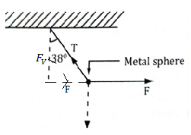
Diagram 01 mark
From;
$sinθ= \frac{F}{T}$
F = $Tsinθ$ ……………………………………………………………. 0.5 mark
$T= \frac{F}{sinθ}=\frac{60}{sin38}=97.46N$ ……………………………………………. 01 mark
But;
$cosθ=\frac{F_{v}}{T}$
$F_{V}=Tcosθ$ …………………………………………………………… 0.5mark
$F_{V}= 97.46\cos{38=76.80N}$
Therefore; the vertical component =76.80N ……………………………….. 01 mark

(c)
- Let the distance between the object and the mirror be $x$
- For a plane mirror, object distance is equal to the image distance. So the distance between object and image $S_{o}=2x$
- After time t, distance between the mirror and the object will be obtained from
$u=x-V_{m}t$
- Distance between object and image after time t is now given by
$S_{t}=2x-2V_{m}t$ …………………………………… 01 marks
- Thus, distance travelled by image in time t is
$d=S_{o}-S_{t}$
$d=2x-\left(2x-2V_{m}t\right)$
$d=2V_{m}t$ ………………………………………. 01 mark
- Dividing by $t$ on both sides we have
$\frac{d}{t}=\frac{2V_{m}t}{t}$
$\frac{d}{t}=2V_{m}=V_{i}$ …………………………………… 01mark
- So, speed of image $V_{i}=2V_{m}$ =$2×10m/s$ =20m/s
Therefore; speed by which image approach will be 20m/s ………………… 02 mark

