THE UNITED REPUBLIC OF TANZANIA
PRESIDENT’S OFFICE
REGIONAL ADMINISTRATION AND LOCAL GOVERNMENT
NAMANGA SECONDARY SCHOOL
FORM THREE TERMINAL EXAMINATION
PHYSICS
Time: 3:00 Hours MAY 2024

INSTRUCTIONS
- This paper consists of sections A, B and C with a total of ten (11) questions
- Answer all questions in the spaces provided
- All writing must be in blue or black ink except drawings, which must be in pencil.
- All communication devices, calculators and any unauthorized materials are not allowed in the examination room
- Write your examination number at the top corner of every page
- Where necessary the following constants may be used
- Acceleration due to gravity, g = 10 m/s²
- Density of water = 1g/cm³ or 1000 kg/m³
- Density of mercury = 13.6 g/cm³ or 13600 kg/m³
- Latent heat of fusion = 334000J/kg
- Latent heat of vaporization = 2265000J/kg
- Specific heat capacity of ice = 2100Jkgk
- Specific heat capacity of water and steam = 4200Jkgk

SECTION A (16 Marks)
Answer all questions in this section
- For each of the items (i) – (x), choose the correct answer from among the given alternatives and write its letter beside the item number in the answer booklet provided
(10 Marks)
- Which property is observed when the tea bag is dipped into the cup of water?
- Evaporation
- Transpiration
- Diffusion
- Osmosis

- A bus which is heavenly over loaded on its basement carrier is unlikely to overturn because;-
- It will run faster down hill
- Its base area is increased
- Its weight balances with the reactions
- Its center of gravity is lowered

- When charging bodies by friction, the particles which are transferred are:
- Electrons C Neutrons and protons
- Neutrons D Protons and electrons

- What criterion supports the argument that potential and kinetic energies are similar?
- Both produce heat C Both are forms of mechanical energy
- One is the substitute of the other D Both are forms of electrical energy

- Which of the following force can cause the mosquito larva to float on water?
- Surface tension C Adhesive forces
- Frictional forces D Cohesive forces

- The temperature of the body is 25$℃$. What would this temperature in the Fahrenheit scale?
- 59$℉$ B 77$℉$ C 57$℉$ D 7.7$℉$

- Figure below shows a measuring cylinders containing water before and after is immersed. What is the volume of the stone?
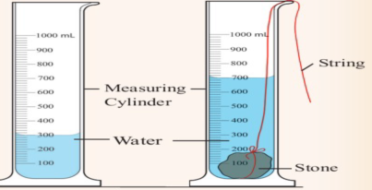
- 300cm³ B 400cm³ C 700cm³ D 500cm³

- When stretched beyond the elastic limit, a metal such as steel;-
- Undergoes plasticity C Becomes brittle
- Breaks immediately D Becomes elastic

- According to study of machine a bottle opener corresponds to:-
- First class lever
- Wheel barrow
- Fishing rod
- Third class lever

- A measuring cylinder is filled with oil. A girl says that the pressure at the bottom of the cylinder depends on?
- The height of oil C The area at the bottom
- The oil lubrication property D The oil density

- Match each item in LIST A with a response in LIST B by writing its letter below the number of the corresponding item in table provided (06 marks)
LIST A | LIST B
- Distance time graph represent a motion of a stone released from rest from a tall building  - Distance time graph represent a motion of a body moving with constant velocity  - Velocity time graph representing a motion of a car retarding uniformly after application of brake  - Velocity time graph for a body moving in a straight line with a uniform velocity  - Velocity time graph representing a motion of a body dropped freely vertically  - Constant velocity. | 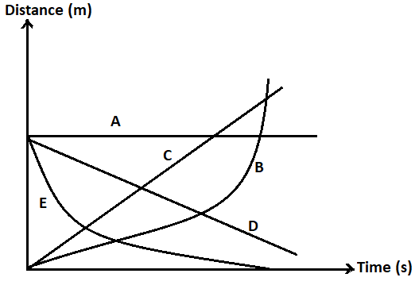

SECTION B (54 Marks)
- $(a)$ Clinical thermometer is the temperature measuring device used to measure temperature
of the body only. State two precautions in using clinical thermometer (03 Marks)
$\left(b\right)$A man standing with his one leg held on air got tired. Give reason (03 Marks)
$\left(c\right)$Give reason why the rate of diffusion is higher in gases than in liquid at the same temperature (03 Marks)

- $(a)$ Mass of sealed container of volume $400{cm}^{3}$ is $48 g$. What is the mass of steel of
density $8000kg/m^{3}$ that can be attached beneath the container, if the container is to
float when submerged in fresh water? (05 Marks)
$(b)$ Explain this statement On opening a freezer door, Bosco finds that it is slightly hard
to open. What makes the freezer door a bit hard to open? What is the importance of
this? (04 marks)

- (a) Explain why is it dangerous when petrol is pumped through pipe into your car
petrol tank and how can you minimize the danger? 04 marks
    - When a screw gauge with a least count 0.01mm is used to measure the diameter of a wire, the reading on the sleeve is found to be 0.5mm and the reading on the thimble is found to be 27 divisions. What is the correct diameter of the wire, if the zero error for the gauge is -0.005cm? 05 marks

- (a) A can holds water with a constant depth of 0.5m. Hole A is punched in the can
0.1m below the surface of the water and hole B is punched 0.4m from the surface.
From which hole will the water spurt the furthest? Explain your answer. 03 marks
      - A cube of sides 2cm is completely submerged in water so that the bottom of the cube is at a depth of 10cm. if density of water is 1027kg/$m^{3}$ and acceleration due to gravity iss 10N/kg:
- What is the difference between the pressure at the bottom of the cube and the pressure at the top? 03 marks
- What is weigh of water displaced by the cube? 03 marks

- $(a)$ A ball is dropped from a height of $20 m$ above the ground. It hits the ground in $2 s$ and
bounces back up to a height of $12.7 m$ in $1.6 s$. What is its average velocity? 04 marks
$(b)$ You are provided with two pairs of resistors having the same resistance of $4Ω .$ With the help of diagram arrange the resistors so that the effective resistance is $4Ω$. 05 marks

- $(a)$ A brass road of length of 0.997 m at 20⁰C is hung from a steel framework with a height of 1.00 m at 20⁰C as shown in the figure below
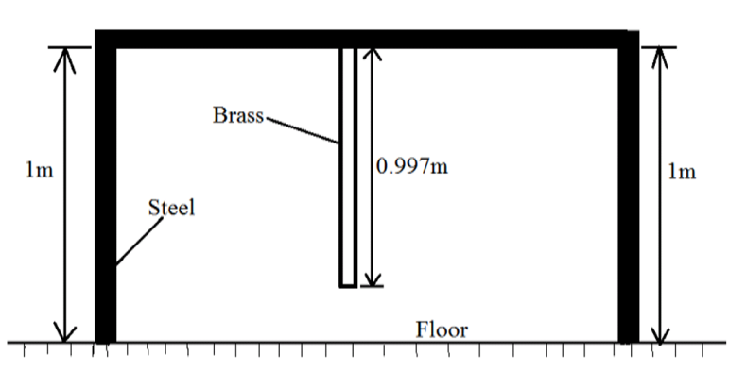
At what temperature would the brass rod just touch the floor?
(Given that linear expansivity of brass is $2.6×{10}^{-5}K^{-1}$) (05 marks)
$(b)$ Describe an experiment used to test an accurate simple barometer (04 Marks)

$$SECTION C (30 MARKS)$$
$$Answer any two question in this section$$
- (a) Frictional force between the two surfaces in contact is directly proportional to the
normal force. Descried experimental on how the frictional force depend normal
reaction. (05 marks)
(b) When two surfaces are polished, the coefficient of friction between them decreases.
But the coefficient of friction increases and becomes very large if the surfaces are
made highly smooth. Explain (05 marks)
(c) A block of wood of mass 5kg is placed on a rough plane inclined at 60⁰. Calculate its
acceleration down the plane if coefficient of friction between the block and the plane
is 0.32 (05 marks)

- (a) You notice that when a light ray enters a certain liquid from water, it is
bent toward the normal, but when it enters the same liquid from crown
glass, it bent way from the normal. What can you conclude about the
liquid’s index of refraction? (05 marks)
(b) Water is poured into a beaker to a depth of 24 cm. To an eye looking vertically down
through the water, the bottom of the beaker appears to be raised 6 cm from the bottom
of the beaker. Determine the refractive index of the water (06 marks)
(c) Differentiate between the primary and secondary rainbow. (4 marks)

- (a) (i) Can three or more vectors with unequal magnitudes be added together so their
sum is zero? Explain (03 marks)
- Suppose you are pulling a wagon with the handle at an angle, how will you make your task easier? (03 marks)
- A trolley was pulled by a force of $60N$ acting $30°$ to the horizontal. Find the vertical component of this force (04 marks)
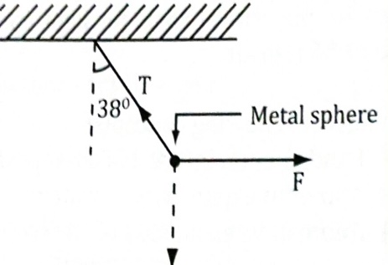
(c) A plane mirror is approaching you at a speed of 10 m/s you can see your image in it. At what speed will your image approach you? (05 marks)

