THE UNITED REPUBLIC OF TANZANIA
PRESIDENT’S OFFICE
REGIONAL ADMINISTRATION AND LOCAL GOVERNMENT
LONGIDO AND NAMANGA SECONDARY SCHOOLS


HISTORY
MARKING SCHEME 2024

SECTION A {16 Marks}
1. Answers {10% Marks}
i | ii | iii | iv | v | vi | vii | viii | ix | x
B | A | B | A | E | C | B | B | C | D

2. Answers {6% Marks}
i | ii | iii | iv | v | vi
F | A | I | G | E | C

SECTION B 54 {Marks}

3. Answers {1.5% X 6 = 9% Marks}
i | ii | iii | iv | v | vi
6 | 5 | 1 | 4 | 3 | 2

4. A SKETCH MAP OF EAST AFRICA {(2%X4 = 9%}
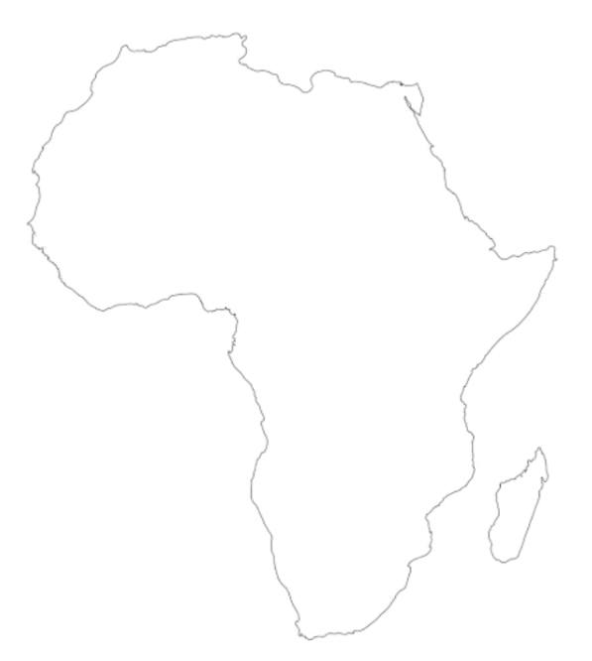
iv
iii
ii
i

5. {i} Four reasons to why Mkwawa of the Hehe decided to resist the German colonial
Rule. {1%X 4 = 4 Marks}
- German invasion.
- Protection of the throne.
- Protection of trade fortune.
- Failure of peace treaty.
{ii} Five reasons for the failure of the Hehe resistance. {1%X 5 = 5 Marks}
- Low technology.
- Betrayal.
- Collaboration of German with other native people.
- Mkwawa’s pride.
- Poor preparations.

6. {i}
. {1%X 4 = 4 Marks}
- Division of labor and specialization.
- Constant search for pasture and water for animals.
- Constant security against wild animals and hostile people.
- Need to enlarge the Maasai herds.

{ii} {1%X 5 = 5 Marks}
- Growth of trade.
- Growth of strong states.
- Population increase.
- Immigration of people.
- Increase of interaction of people.

7. {i} {1%X 4 = 4 Marks}
- Militarily defeated.
- Internal struggle for power.
- Drought.
- Diversion of trade routes.
{ii}
{1%X 5 = 5 Marks}
- Good Geographical location.
- Metal works.
- Agricultural activities.
- Strong standing armies.
- Population and migration of people.

8. {i}
{1%X 4 = 4 Marks}
- Companies and association.
- Missionaries.
- Traders.
- Explorers.
{ii} {1%X 5 = 5 Marks}
- Acted as language translators.
- Fake advice African kings.
- Introduction of colonial economy e.g. cash crop economy.
- Introduction of Christianity to calm the Africans.
- They introduced colonial education.

SECTION C 30 Marks.
9. {15 Marks}
- Introduction {1.5% Marks}
- Meaning of Iron technology.
- Examples of societies.
- Subject matter {2%X6=12% Marks}
The effects of Iron technology.
- Increase of production.
- Increase of population.
- Growth of trade.
- Growth of states.
- Rise of specialization and division of labor.
- Increase of migration of people.
- Conclusion {1.5% Marks}
Any relevant conclusion.

10. {15 Marks}
- Introduction {1.5% Marks}
- Meaning of Triangular trade.
- Subject matter {2%X6=12% Marks}
The consequences of Triangular trade.
- Decline of Trans-Saharan trade.
- Loss of man power.
- Rise of Forest states.
- Decline of Western Sudan states.
- Loss of originality.
- Stagnation of production.
- Conclusion {1.5% Marks}
Any relevant conclusion.

11. {15 Marks}
- Introduction {1.5% Marks}
- Meaning of the indirect rule.
- Subject matter {2%X6=12% Marks}
Reasons for Indirect rule.
- Control of African resistance.
- Increase of colonial production.
- Divide and rule the Africans.
- Inadequate number of colonial administrators.
- British had a big number of colonies.
- Increase of safety for colonialists.
- Conclusion {1.5% Marks}
Any relevant conclusion.

