THE UNITED REPUBLIC OF TANZANIA
THE PRESIDENT’S OFFICE
REGIONAL ADMINISTRATION AND LOCAL GOVERNMENT
LONGIDO DISTRICT
ANNUAL JOINT EXAMINATION

FORM THREE
HISTORY
MARKING SCHEME NOVEMBER 2024

SECTION A (16 Marks)
- Multiple choice.
C | C | D | D | C | C | E | C | A | C
1(10) = 10 Marks.
- Matching items.
H | G | C | B | F | A
1(6) = 6 Marks.
SECTION B (54 Marks)
- Short notes:
- ‘The colonial military institution consolidated colonialism’..
- They suppressed African resistance
- They collected tax and supervised colonial projects 1(3) = 3 Marks
- They defended colonial boundaries

- By burning salty reeds
- By trapping and evaporating salty sea water 1(3) = 3 Marks.
- By leaching method
- .
- The availability of trade items
- The role played by the Monsoon Winds 1(3) Marks.
- Accessibility of East African coast and its hinterland.
- Chronology.
3 | 2 | 6 | 1 | 4 | 5
1(6) = 6 Marks.

- MAP
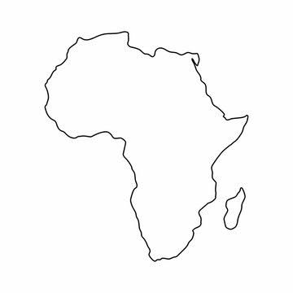
KEY
- GHANA
- UGANDA
- NIGERIA
- NAMIBIA
- TANGANYIKA
- D.R.C
vi
v
iv
iii
ii
i.

- colonial infrastructures transported migrant labourers from labour reserves to the areas of production
- colonial infrastructures transported colonial administrators to supervise colonial projects 3(3) = 9 Marks.
- colonial transport transported colonial troops to different areas of African resistance
- they also transported farm implements from the coast to the interior
- they also transported raw-materials from the interior to the coast
- they also transported manufactured goods from the coast to the interior

- They had feudal economy
- They had a central figure of authority 3(3) = 9Marks
- They had clearly defined boundaries
- They had standby armies

- The need to avoid African resistance
- The need to avoid conflict with French taxpayers 3(3) = 9 Marks
- The need to reduce administrative cost
- The need to ensure a smooth exploitative relation within her colonies.
- The need to accommodate African culture.
SECTION C (30 Marks)
- INTRODUCTION.
- Define Trans-Saharan trade
- State its periodization 2 Marks.
- State the participants
Main body
Effects of Trans-Saharan trade.
- Growth of towns and cities
- Growth and development of states
- Rise of educational institutions 2(6) = 12 Marks
- Spread of Islamic religion
- Introduction of new commodities from North Africa and Arabia into West Africa
- Rise of a class of rich merchants.
Conclusion. Any good conclusion (1 Mark)
- INTRODUCTION (2 Marks).
- Define Boer Trek
- State its periodization
- Provide its leaders
Main body. (effects of Boer Trek).
- Spread of segregationist policies in South Africa
- Africans’ migration
- Formation of Boer republics 2(6) = 12 marks
- Discovery of minerals
- Loss of property
- Enslavement of Africans.
Conclusion.
Any good conclusion is accepted (1 Mark).
- INTRODUCTION. (2 Marks)
- Define collaboration
- State the periodization of African resistance
- Mention few examples of African collaborators.
Main body.
- Effects of natural calamities
- Traditional rivalries
- The influence of agents of colonialism 2(6) = 12 Marks
- The ignorance of Europeans’ intention
- Futility of resistance
- The need to get political posts during colonialism
Conclusion.
Any good conclusion is accepted. (1 mark)

