PRESIDENT OFFICE
REGIONAL ADMINISTRATION AND LOCAL GOVERNMENT
LONGIDO DISTRICT JOINT EXAMINATION MARKING SCHEME
HISTORY-FORM THREE
1.
ITEM NO | i | ii | iii | iv | v | vi | vii | viii | ix | x
ANSWERS | C | D | A | C | D | B | A | B | D | E

(10 marks) 1@
2.
ITEM NO | i | ii | iii | iv | v | vi | vii | viii | ix | x
ANSWERS | E | H | Q | I | B | F | D | N | L | K

(10 marks) 1@
3 (a)TANZANIAN MAP SHOWING HISTORICAL SITES

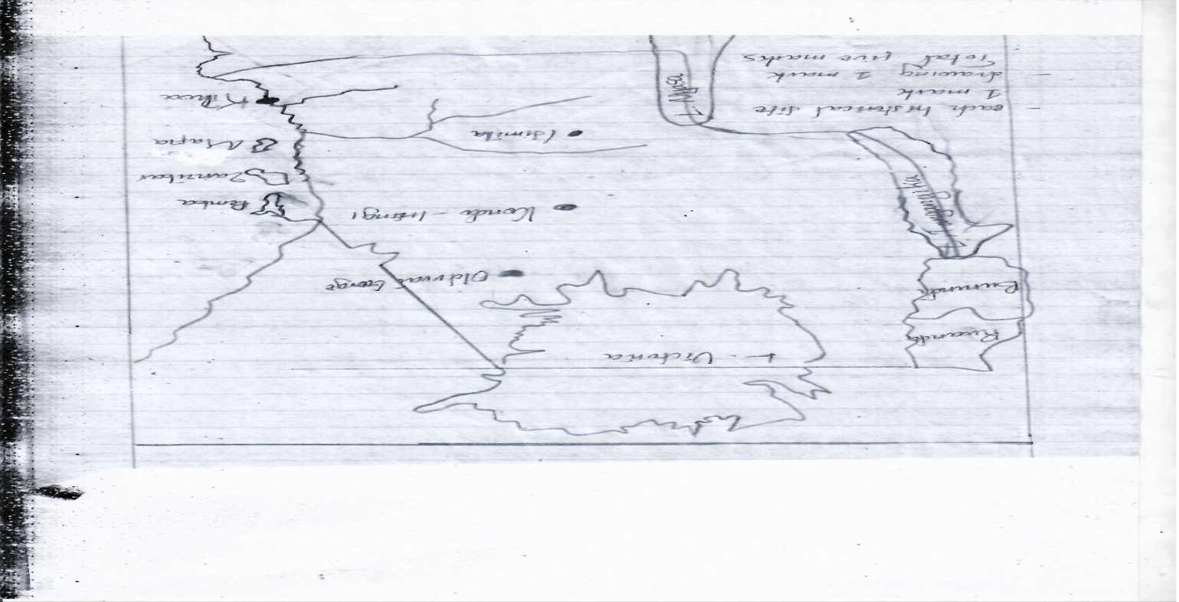3(b).Advantages of historical sites in Tanzania
- Storehouses of culture
- They historian in conducting historical research
- They help in passing traditions to new generation
- Gives people an idea of how life was during the past
- They help government to get foreign currency
(5 marks) @1

4(a)
1 | 2 | 3 | 4 | 5
iii | iv | ii | v | i
(5 marks) 1@

(b)Five methods used by the colonialists to impose their colonial control in Africa soon after the Berlin conference
- Treaty making technique
- Military conquest
- Collaboration Method
- Through the use of agents of colonialism Eg.Chartered Companies
- Divide and rule method.
(5 marks) @1
5 .The major changes in man’s way of life during the late Stone Age
Introduction
Late Stone Age lasted from 50000 BC to the second millennium around 1500 AD. It was associated with homo sapiens and homo sapiens sapiens. (1mark)
Major changes
- Man begun crops cultivation.
- Man stated to keep animals.
- Man stated to have permanent settlement
- Development of social and political organization
- Development of art and craft
- Development of specialization @3marrks(18 marks)

Conclusion :Any relevant ( 1mark)

6.The impacts of Dutch settlement at the Cape
Introduction
Students should give a short history of Dutch settlement at the Cape ( 1 mark)

Impacts of Dutch settlement at the Cape
- Introduction of new culture E.g. : The Dutch introduced their language at the Cape
- Introduction of social segregation
- Enslavement of Africans.
- Displacement of African Communities. @3 marks(Total 18 Marks)
- Increased warfare between the Dutch and Africans
- Expansion of European settlements at the Cape

Conclusion: Should be relevant to the topic (1 mark)

7. Effects of Ngoni Migration in East Africa
Introduction
Students should explain what was Ngoni Migration and support their explanations with vivid examples (1 Mark)

Effects of Ngoni Migration in East Africa
- Intermarriage occurred example between the Ngoni speaking people and the people of East Africa
- Death of people in East Africa due to fighting against the Ngoni @3 marks(18 Marks)
- Destruction of properties such as Crops and houses in East Africa
- Introduction of new fighting skills in East Africa example: the use of short stabbing spears
- Displacement of some African Communities
- Introduction of new culture in East Africa. example : the Ngoni introduced their language and other ways of life in East Africa

Conclusion: Any relevant (1 mark)
8 .Reasons for African resistance
Introduction
Resistance were the responses shown by Africans towards the imposition of colonial rule in Africa. Some Africans resisted passively and other actively.

Reasons for African resistance
- Land alienation
- Forced labour @3 Marks (Total 18Marks)
- Introduction of different forms of taxation to Africans by the Europeans
- Sexual harassment
- African local rulers wanted to regain their political freedom
- Africans were against European exploitation over their resources example: minerals

Conclusion: Any relevant (1 Mark)

9. Effect of Indirect rule on African Societies
Introduction
Indirect rule was the system of colonial administration where by African traditional rulers were used in administering their fellow Africans at the local level where by the top positions were held by the European Officials example: British used this system in most of her Colonies.

Effects of Indirect rule on African societies

- Tribalism developed in African societies
- Emergence of puppet class among the Africans
- Imbalance of development among the African states @ 3 Marks (Total 18 Marks)
- Social differences emerged among the Africans
- Africans were economically exploited Example: through forced labour ,taxation etc
- Africans Land was taken by the white settlers
Conclusion: Any relevant (1 Mark)

