

THE PRIME MINISTER’S OFFICE
REGIONAL ADMINISTRATION AND LOCAL GOVERNMENT
LONGIDO DISTRICT MID TERM JOINT EXAMINATION

FORM THREE
012 HISTORY
MARKING SCHEME AUGUST 2026

SECTION A (16 MARKS)
1. Multiple choice items = @ item = 1 mark, total = 10 marks
B | B | C | B | C | C | B | D | B | C

2. Matching item — 01 mark @ = 06 marks
B | A | D | C | E | F

SECTION B (54 MARKS)
3.
(a) Limitations of written records as a source of historical information: 03 marks
- They may be biased, reflecting the views/interests of the writer (e.g. colonial officials).
- Many pre-literate African societies had no written records, leaving gaps in information.
- Records can be destroyed by fire, insects, moisture or war.
- Some records were deliberately falsified or exaggerated by their authors.
- Access to archives/records can be restricted or expensive to obtain.

(b) Characteristics of primitive communalism: 03 marks
- Common/collective ownership of the means of production (land, tools).
- Absence of private property and social classes.
- No exploitation of one person by another; production was for immediate consumption.
- Simple tools (stone, wood) were used, with low levels of production.
- Division of labour was based mainly on age and sex.

(c) Reasons the Nyamwezi became prominent in long-distance trade: 03 marks
- Their central geographical location (Unyanyembe) linking the interior and the coast.
- They had strong, organised leadership (e.g. Chief Mirambo) able to protect caravans.
- They were skilled porters and had experience travelling long distances.
- They controlled key trade routes and could negotiate/enforce tolls with other societies.
- Availability of trade items (ivory) in their area and surrounding regions.
01½ marks @ = 09 marks

4. Chronological order — 01½ marks @ = 09 marks
Statement
Order | 3 | 5 | 1 | 6 | 2 | 4

- Map of Africa 09 marks
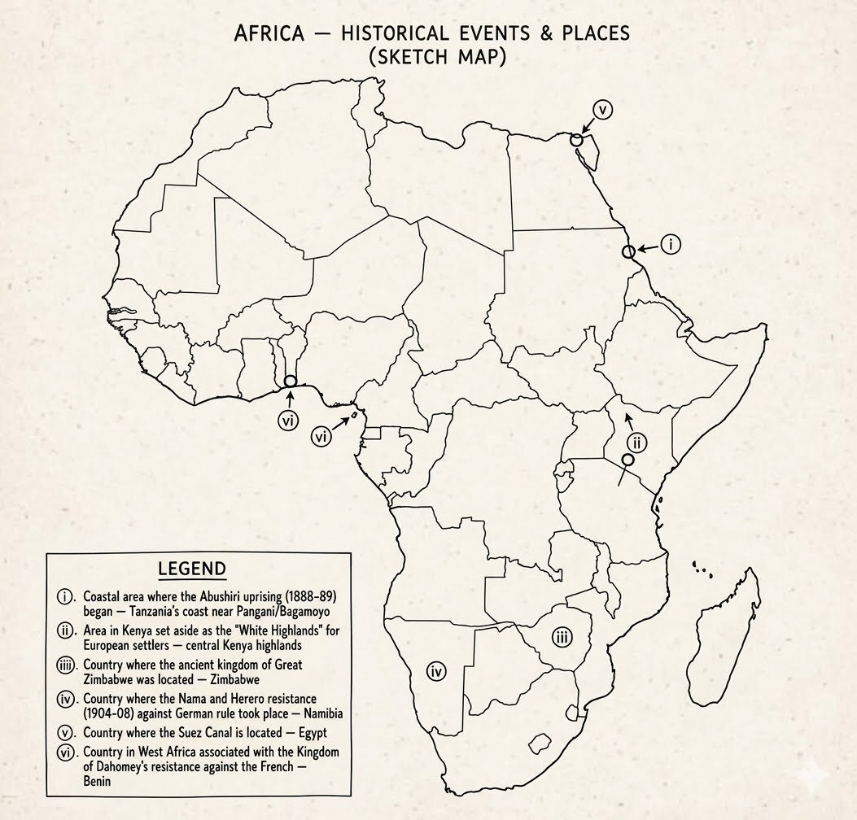

6. Differences — 01½ marks @ = 09 marks
(a) Legitimate trade vs Slave trade:
  - Legitimate trade: trade in agricultural and natural products (ivory, cloves, copal) that replaced the slave trade in the 19th century.
  - Slave trade: trade that involved the buying, selling and exporting of human beings as commodities/labour.
(b) Settler colonial economy vs Peasant colonial economy:
  - - Settler colonial economy: production organised on European-owned farms/plantations using African labour (e.g. Kenya, South Africa).
  - - Peasant colonial economy: production organised on small African-owned farms, with Africans growing cash crops themselves (e.g. Tanganyika).
(c) Formal colonialism vs Informal colonialism:
  - Formal colonialism: direct political control and administration of a territory by a foreign power.
  - Informal colonialism (imperialism): economic and political domination without formal/direct political administration.

7. Economic potentialities of South Africa that attracted British and Boer settlers (any six)
- Discovery of diamonds (Kimberley, 1867) and gold (Witwatersrand, 1886).
- Fertile agricultural land suitable for farming and livestock keeping.
- Strategic location on the Cape sea route to India and the East.
- Favourable climate for European settlement.
- Availability of cheap African labour for mines and farms.
01½ marks @ = 09 marks

8. Points to justify that abolition of the slave trade in East Africa took a long time (any six)
- Strong resistance/opposition from slave traders and dealers who profited from the trade.
- Continued demand for slave labour in plantations (e.g. clove plantations in Zanzibar).
- The vastness of the Indian Ocean coastline made patrol and enforcement difficult.
- Limited number of British naval patrol ships to intercept slave dhows.
- Some local rulers, including the Sultan of Zanzibar, were economically dependent on the trade and delayed enforcement.
- Gradual "Loophole" Treaties
01½ marks @ = 09 marks

SECTION C (30 MARKS)
A candidate should answer two questions from this section.
9. Effects of 19th century long-distance trade on East African societies (six points)
Introduction: meaning of long-distance trade
- Growth of powerful centralised states that controlled trade routes (e.g. Nyamwezi chiefdoms).
- Emergence and growth of trade centres/towns along caravan routes (e.g. Tabora, Ujiji).
- Increased social differentiation and rise of wealthy trading classes.
- Spread of new goods, ideas, languages (Kiswahili) and Islam into the interior.
- Intensification of the slave trade, since slaves were used as porters and sold.
- Increased warfare and insecurity as societies competed for control of trade routes.
- Attracted European explorers, missionaries and eventually colonial interest.
Conclusion: overall significance of long-distance trade

10. Historical limitations of written records (six points)
Introduction: meaning of written records
- They may be biased, reflecting the writer's own interests or point of view.
- Many African societies had no writing tradition, so records only cover limited periods/regions.
- Records can be lost or destroyed through fire, war, insects or poor storage.
- Some records contain deliberate falsification, exaggeration or propaganda.
- Language and translation problems can distort the original meaning.
- Access to archives may be restricted, expensive or require special permission.
- Interpreting old documents requires special skills (palaeography), which few historians have.
Conclusion: overall importance despite limitations

11. Factors that led to the Scramble and Partition of Africa (six points)
Introduction: meaning of the Scramble and Partition of Africa
- - The growth of industrial capitalism in Europe, creating a need for raw materials and markets.
- - Competition among European powers for prestige and political power.
- - The desire to secure strategic locations and trade routes (e.g. Suez Canal, Cape route).
- - Reports and publicity from European explorers and missionaries about Africa's resources.
- - The need to find outlets for Europe's surplus population through settlement.
- - The Berlin Conference (1884-85), which formalised rules for partition and reduced conflict among European powers.
- - Development of new technology (steamships, quinine, machine guns) that made conquest of the interior easier.
Conclusion: overall significance of the Scramble for Africa

