MKALAMA DISTRICT COUNCIL
FORM THREE HISTORY TERMINAL EXAMINATION , MAY– 2025 MARKING SCHEME

1.
i |  | ii |  | iii |  | iv | V |  | vi |  | vii | viii |  | ix |  | x
A |  | B |  | E |  | C | A |  | A |  | C | C |  | C |  | A
 |  | @1marks =10 Marks |  |  |  |  |  |  |  |  |  | 
LIST A |  |  | i |  | Ii |  |  | iii |  | iv |  |  | v |  | vi
LIST B |  |  | H |  | B |  |  | C |  | A |  |  | G |  | E
2.
@1marks =06 Marks

3. (i) The study of history promote patriotism because it teaches how the past and present generations offered their lives to build the nation and defend it from internal and external enemies.(3marks)

(ii) A student should identifies advantages of using oral tradition as a sources of getting historical information.
- Oral tradition entertain people.
- Makes people to appreciate their culture.
- It is useful for both literate and illiterate people.
- It express emotions and feelings of events.
- It is used as a complement of other sources of information.
- It helpful to provide first-hand information.
(3 marks).
iii. A student should be able to identify instrument and state the reason why decided to use that instrument
  - The instrument used to determine the fossil’s age was carbon- 14 dating. (Radiocarbon dating).
  - Reason for recommended such an instrument because carbon-14 is an effective for dating organic materials like bones, wood or shells that are up to about 50,000yeqrs old. @1.5 marks x 2= 3marks Total marks = 9.0 marks.

4.
I | Ii | Iii | iv | v | vi
6 | 1 | 4 | 2 | 3 | 5
@1.5 marks = 9.0 Marks.
5. A sketched map of Africa.

1 |
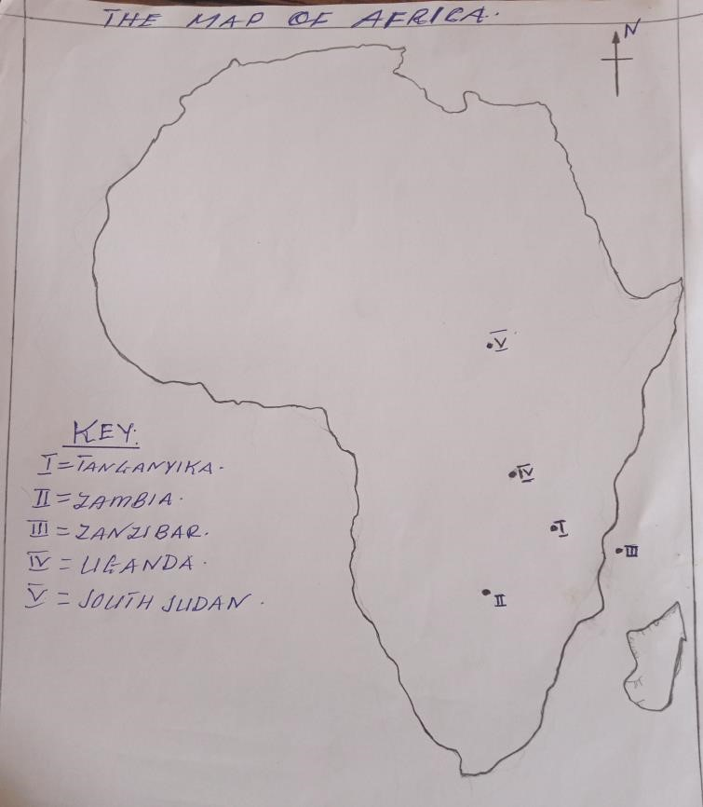 . Good map 1.5marks
Location @1.5marks x5 = 7.5 marks
. Total marks =9.0 marks

6. (a) A student should show the different between direct rule and indirect rule system.
  - Different from colonial masters such as direct rule used by Germany and indirect rule by British.
  - Different in using African assistances, indirect rule used local chiefs such as kings or headmen while direct rule used to appointees jumbes and Akida.
  - Different in creating puppet leader; British create puppet leader from African society but in direct rule used Germany officials
  - Difference in facing resistance from the Africans; indirect rule face minimal resistance while direct rule facing strong resistance.
@1 Marks x3 =3 Marks (ANY THREE POINTS)
- A student should give two advantages of indirect rule system to British.
  - It made the African chiefs more powerful than before.
  - It solved the problem of shortage of man power. iii. It reduced the operational cost. iv. It reduced African resistance.
v. It was suitable method of collecting taxes.
@1.5 marks x 2 = 3 Marks (any two advantages).
- A student should show the different between assimilation policy and association policy
- Assimilation policy involved making considerable efforts in develop social services in African colonies while association largely used to create government structure for easy exploitation.
- In assimilation policy, duties were performed by appointed federal officials who had no any traditional affiliation whereas in association policy the local rulers were restored although the chief were appointed by the French who performed many duties.
- The association policy was practised at a very minimum cost in the colonies while assimilation policy was practised at a very maximum cost to convert African into French.
- Assimilation policy the military laws required Africans to serve in the French army for a short period of time to become a citizen while in association introduced new military law that requires to serve in French army for a long period.
@1.5 marks = 3 Marks (any two point) Total marks = 9.0 marks.

- (a) A student should shows the benefits of migrant labourers to the capitalists during colonial economy in Africa.
  - It was easy to control
  - It was difficult to escape
  - They ensured constant supply of labour. iv. They helped to reduce African resistances
  - They provide markets for European manufactured goods.
  - They were very cheap to maintain.
@1marks x 6= 6 Marks
(b) A student should explain the reason why the colonialists built schools in cash-crop growing region.
➢ This aimed at training African on how to grow cash crops.
3@x1 Marks = 3marks
- A student should explain a reasons which led some Africans to collaborate with European during colonial invasion.
  - Wrong perception
  - Existence of missionaries.
  - Existence of enmity between two or more local African tribes, eg. Sangu and the Bena collaborated with Germany to fight against the Hehe.
  - Military motives, eg Menelik II in Ethiopia collaborated with Italy to acquire weapons.
  - Source of commerce and trade; Buganda
  - They were weak military
  - Natural calamities eg. Small pox, jiggers, drought, famine etc.
@1.5marks x6 = 9.0 Marks.

- Introduction : (1.5 marks)

Meaning of peasant agriculture and important information like location, participant and periodization.

Main body :( @ 2marks x 6 = 12 marks)
A student should shows the reasons why colonialists preferred and adopted peasant agriculture.

  - Hash or bad climatic condition.
  - Dense or high population. iii. It was cheap. iv. Presence of strong centralized states or political system.
  - Presence of pest and diseases.
  - Readiness of the people. vii. Shortage of labour. viii. Presence of mandatory territories.
ix. To ensure continuation of the production

Conclusion: (1.5 marks) Any relevant conclusion
Total marks = 15 marks.

- Introduction: (1.5 marks)
Meaning of long distance trade, participant, periodization and location.

Main body :( 2@marksx 6 = 12).

A student should shows the effects/consequences of long distance trade.
  - It led to the growth of town and cities eg.Walata, Gao,Timbuktu, Ujiji, Kilwa etc.
  - It led to the emergence of strong centralized states. Eg Mali, Ghana, Songhai. iii. Emergence of rich people such as Mirambo. iv. It led to the occurrence of intermarriages.
  - Emergence of strong leaders such as Mansa Kankan Musa, Mirambo.
  - Emergence of specialization and division of labour.
  - Introduction of Arabic culture like dressing style such as white caps ,gown
(kanzu),sandals etc viii. Introduction of Islam ix. Development and spread of Kiswahili into the interior. Some words borrowed from Arabic language like wakati, shukrani, shikamoo, kitabu etc.
  - Introduction of foreign goods and crops like firearms, beads, cotton clothes, bananas, cloves and coconut.
  - Growth of commercial centers such as lamu, Mombasa, Bagamoyo,Malindi
Kilwa etcc xii. Exploitation of east Africa resources like slavery, ivory, copper. xiii. Rise and expansion of states such as Bunyoro, Buganda and karagwe. xiv. Linkage between east Africa and the world economy.

Conclusion: (1.5 marks)
Any relevant conclusion
Total marks =15 marks

- A student should give out the reasons that led some areas in Africa to experience more intensive scramble than others.
Introduction – meaning of scramble for and periodization (1.5 Marks)

Main body: reasons for scramble for in most areas in Africa. 2.5@ = 12.5 Marks

i. Accessibility to the interior. ii. Presence of fertile land like high land in Malawi, kikuyu high land in Kenya, Niger basin, Congo basin and Nile basin.
iii. Presence of mineral e.g. gold, silver and diamond. iv. Dense population like Cameroon, Senegal, Gold coast, Ghana and Nigeria.
v. Geographical location mostly Congo and Niger basin.

Conclusion: (1 Marks)
Any relevant conclusion
Total marks = 15 marks

