
CATHOLIC DIOCESE OF IRINGA
ST. MARY’S ULETE SECONDARY SCHOOL
FORM ONE MONTHLY TEST
HISTORY
TIME: 2:30Hrs 15thFebruary 2023 P.m
Instructions
- This paper consists of sections A, B and C with a total of Ten (10) questions.
- Answer all questions in section A and B and two (2) questions from section C.
- All writings must be in blue or black ink
- All answers must be written in the spaces provided
- Write your official names on every page of your answer sheet (s)



SECTION A (40 Marks)
Answer all questions in this section
- For each of the items (i) –(x), choose the correct answer from among the given alternatives and write its letter in the space provided.
- The following are three ways in which narration of past event can be done:
- Riddles, proverbs and poems
- Songs, tales and music
- Myth epics and oral testimonies
- Jokes, religion and superstition

- The historical sites in East Africa are
- Morogoro, Maputo, Kapwirimbe and Gedi
- Isimila, olduvai George, Engaruka and Rusinga Island
- Nairobi, Engaruka, Jinja and Iringa
- Dar es salaam, Karagwe, Olorgesailie, and Lamu

- Which of the following is true about museums?
- They contains photographs, sculpture, remains of plants and animals
- They are very natural in nature
- They include earthquakes, rainfall wind and floods
- Wars, construction, vandalism and grazing

- Which tribe among the following is famous for sculpture production in Tanzania?
- Makonde
- Nyamwezi
- Hehe
- Mwera

- History can be defined as the study of ____________
- The life in traditional African societies
- Colonial rule in East Africa
- The environment
- Man’s activities against nature through different stages of development

- A source of historical information which contains remains which show man’s physical development activities and tools he used is called
- Museums
- Oral tradition
- Archives
- Historical sites

- The term “fossils” means
- Human creature which ate on vegetables
- Chimpanzee and gorilla
- Underground hardened remains which exist in rocks
- Hairy bodies of the earliest men

- Which of the following is the most used source of history in Tanzania?
- Archaeology
- Historical sites
- Written books
- Museums

- History teaches people to be patriotic and nationalists for their nation, which one among the following is good example of patriotism and nationalist?
- Kagera war of 1978 - 1979
- The first world war from 1914 - 1918
- The second world war 1939 - 1945
- The war between Russia and Ukraine

- The study of human societies, cultures and their development is called
- Archaeology
- Linguistics
- Anthropology
- Carbon 14

Answers
i | Ii | iii | iv | v | vi | vii | viii | ix | x

- Match the historical statements in List A with the explanations in List B by writing the letter of the correct response in space provided.

LIST A | LIST B
- Oral tradition  - National museum of Tanzania in Dar es salaam  - The great Mosque of Kilwa Kisiwani and Bagamoyo Roman Catholic Church built in 1872  - Special places where historical event took place  - The famous leader of Maji maji in southern Tanganyika  - The father of Tanzania nation  - Idd Amin  - Mkwawa  - Books, pamphlets, magazines and newspapers  - Kaole ruins in Bagamoyo | - Written records  - Museum  - Historical sites  - It is categorized into two namely cultural practices and narration of past events  - A good example of historical site which retain its original function up to now  - The leader of Hehe tribe  - Kinjekitile Bukero Ngwale  - Mwl .J.K. Nyerere  - Professor Alex Chami  - The Uganda leader  - Good examples of Historical sites found in Tanzania  - Is a very big museum which accommodates foreign and local tourists  - Isike Mirambo  - Kenneth Kaunda  - 1969  - Archaeology  - Anthropology

Answers
i | ii | iii | iv | v | vi | vii | viii | ix | x

SECTION B (70 Marks)
Answer all questions
- Write true if the statement is correct or False if the statement is not correct in the space provided.
- Written texts are more accurate than oral traditions _________________________
- History can only be obtained through oral traditions _________________________
- Historical site is the same as Museum in history _____________________________
- Protection of the past physical development from destruction is the limitation of historical sites ___________________________
- Rusinga island, Isimila and Nsongezi are historical sites found in Tanzania ______
- Dr. Louis and Mary Leakey used survey method to discover the skull of the first man __________________
- Female genital mutilation should be encouraged especially in this world of science and technology ________________
- Culture practice as the aspect of oral tradition include proverbs, poems, music, stories and superstitions ____________________
- Historical sites are places for preserving ancient objects such as utensils, working tools and settlement patterns ________________________
- In oral traditions, most narrations are centred on kings and queens living behind the ordinary people __________________
- Briefly explain the following terms

- History
_____________________________________________________________________________________________________________________________________________________________________________________________________________________________________________________________________________________________________________________________________________
- Museums
_______________________________________________________________________________________________________________________________________________________________________________________________________________________________________________________________________________________________________________________________________________
- Sources of history _______________________________________________________________________________________________________________________________________________________________________________________________________________________________________________________________________________________________________________________________________________
- Oral testimonies
_______________________________________________________________________________________________________________________________________________________________________________________________________________________________________________________________________________________________________________________________________________

- Epics
________________________________________________________________

____________________________________________________________________________________________________________________________________________________________________________________________________________________________________________________________________________

- Arrange the following sentences in chronological order by writing their roman numbers in the table provided.
- Other sites are Arabs buildings in Kilwa Kisiwani, Kaole stone town in Zanzibar
- These are places where man used to live or conduct his activities and so they may contain very ancient remains such as buildings, towers, rock paintings etc
- Historical sites preserve the past materials, promote tourism in the community and also provide employment to people who preserve ruins and items that are found in historical sites.
- Historical sites elsewhere in Africa include the pyramids of Giza in Egypt which were tombs of Egyptian Kings (Pharaoh)
- Historical sites are also known as antiquities. In Tanzania prominent historical sites include Olduvai George the home of the first man.
Answers
1st | 2nd | 3rd | 4th | 5th

- Complete each of the following statements with correct historical facts
- A building in which objects of artistic, cultural, historical or scientific interest are kept and shown to the public is called ___________________
- Ancient drawings and paintings are found in Amboni caves and ____________ in central Tanzania.
- Bagamoyo Roman Catholic was built by early visitors in ___________
- The two types of objects housed in museums are ___________________________ and _____________________________________
- Source history provided by elders to their off springs through the word of mouth is called ________________

- Study this sketch map and answer the questions which follow
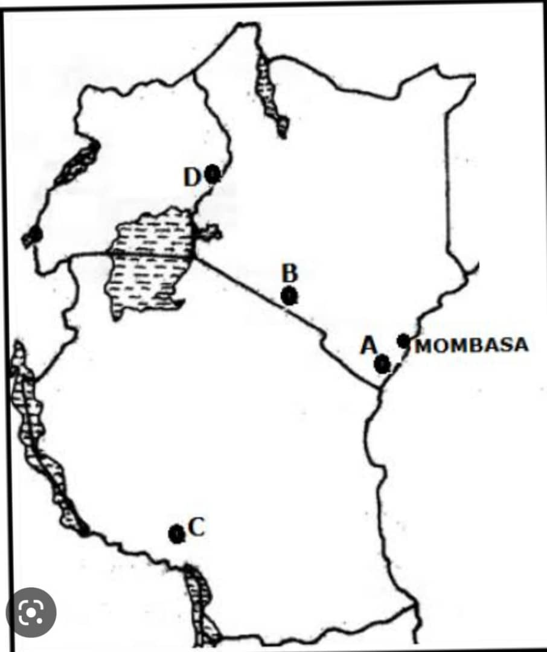

- What is the name of the historical site marked by letter A? ___________________
- The historical site marked by letter B is called ___________________________
- In which century was a skull of Zinjanthropus discovered at a place marked by letter D? _________________
- Which discovery made the historical site marked by letter C to be famous? ______________________
- The historical site marked by letter E is called ________________________

SECTION C (30 Marks)
Answer two (2) questions from this section
- Explain six limitations of using oral traditions as the source of historical information
- Explain the importance of studying history (give six points)
- Describe six ways in which a researcher can use to obtain historical information

Answers
_______________________________________________________________________________________________________________________________________________________________________________________________________________________________________________________________________________________________________________________________________________________________________________________________________________________________________________________________________________________________________________________________________________________________________________________________________________________________________________________________________________________________________________________________________________________________________________________________________________________________________________________________________________________________________________________________________________________________________________________________________________________________________________________________________________________________________________________________________________________________________________________________________________________________________________________________________________________________________________________________________________________________________________________________________________________________________________________________________________________________________________________________________________________________________________________________________________________________________________________________________________________________________________________________________________________________________________________________________________________________________________________________________________________________________________________________________________________________________________________________________________________________________________________________________________________________________________________________________________________________________________________________________________________________________________________________________________________________________________________________________________________________________________________________________________________________________________________________________________________________________________________________________________________________________________________________________________________________________________________________________________________________________________________________________________________________________________________________________________________________________________________________________________________________________________________________________________________________________________________________________________________________________________________________________________________________________________________________________________________________________________________________________________________________________________________________________________________________________________________________________________________________________________________________________________________________________________________________________________________________________________________________________________________________________________________________________________________________________________________________________________________________________________________________________________________________________________________________________________________________________________________________________________________________________________________________________________________________________________________________________________________________________________________________________________________________________________________________________________________________________________________________________________________________________________________________________________________________________________________________________________________________________________________________________________________________________________________________________________________________________________________________________________________________________________________________________________________________________________________________________________________________________________________________________________________________________________________________________________________________________________________________________________________________________________________________________________________________________________________________________________________________________________________________________________________________________________________________________________________________________________________________________________________________________________________________________________________________________________________________________________________________________________________________________________________________________________________________________________________________________________________________________________________________________________________________________________________________________________________________________________________________________________________________________________________________________________________________________________________________________________________________________________________________________________________________________________________________________________________________________________________________________________________________________________________________________________________________________________________________________________________________________________________________________________________________________________________________________________________________________________________________________________________________________________________________________________________________________________________________________________________________________________________________________________________________________________________________________________________________________________________________________________________________________________________________________________________________________________________________________________________________________________________________________________________________________________________________________________________________________________________________________________________________________________________________________________________________________________________________________________________________________________________________________________________________________________________________________________________________________________________________________________________________________________________________________________________________________________________________________________________________________________________________________________________________________________________________________________________________________________________________________________________________________________________________________________________________________________________________________________________________________________________________________________________________________________________________________________________________________________________________________________________________________________________________________________________

