THE UNITED REPUBLIC OF TANZANIA
THE PRESIDENT’S OFFICE
REGIONAL ADMINISTRATION AND LOCAL GOVERNMENT

NAMANGA FORM ONE PRE-MIDTERM EXAMINATION

012 HISTORY
Time: 2½ Hours August 2024

INSTRUCTIONS
- This paper consists of three Sections A, B and C with a total of eleven (10) questions.
- Answer all questions in section A and B and one (1) questions from section C.
- Section A carries 15 marks, section B carries 70 marks and section C carries 15 marks.
- Phones and any unauthorized materials are not allowed in the examination room.
- Write your Examination Number on every page of your answer booklet(s)

SECTION A {15 Marks}
Answer all questions in this section

1. For each of the items {i}-{x}, choose the correct answer from among the given alternatives and write its letter besides the item number in the space provided. {10 marks}

i. In archives, the official documents are stored for future uses. What are the merits of preserving the Historical sites?
A. They are used as film recording locations.
B. They can be used as a sanctuary.
C. They can be used as references of the past events.
D. They are the secondary sources of information.

ii. Creation of man according to Christian and Islamic Holy books was done by Supernatural being {GOD}. Which kind of life did Adam and Eve and their first generation live?
A. Feudal life. B. Primitive slavery.
C. Capitalistic life. D. Communal life.

iii. Which period in the history of human beings is marked by existence Homo Sapiens Sapiens to the evolution of technology?
A. Bronze Age. B. Early Stone Age.
C. Early Iron Age. D. Middle Stone Age.

iv. Today many Tanzania rural societies experience conflicts resulted from the shortage of land, a conflict between the pastoral societies and peasants. This challenge is inevitable because most of the pastoral societies are
A. Zero grazing farmers. B. sedentary pastoralists.
B. Trans-humans’ society. D. Nomadic pastoralists.

v. Acheulian stone tools were discovered first at St. Acheul in France.
A. They were less advanced than the Oldowan stone tools.
B. hard bigger rocks were broken to make those tools.
C. This process is called flacking and shaft.
D. Acheul stone tools are found in Kilwa.

vi. There is a connection between people’s past actions and their present life.
A. We are what we are today because of what will happen in future.
B. We are what we are today because of what is happening now.
C. We are what we are today because of what is written in the past.
D. We are what we are today because of what happened in the past.

vii. Oldowan tools were named after Olduvai Gorge in Tanzania where they were first discovered. They were also found in the shores of Lake Turkana in Kenya and Omo and Hadar valley in Ethiopia.
A. They were obtained from hard natural rocks.
B. They were made by breaking big hard rocks.
C. They were obtained from hard natural rocks.
D. They were obtained from hard natural rocks.

viii. Middle Stone Age societies developed the culture of obtaining food through hunting and gathering. The following culture did not develop in the Middle Stone Age.
A. Rock painting and personal decoration.
B. Religion activities.
C. Discovery and use of fire.
D. Underground mining.

ix. Which of the following facts represent the pre-colonial economic activities done in arid and semi-arid areas and areas with moderate rains.
{i} Pastoralism.
{ii} Shifting farming.
{iii} Permanent farming.
{iv} Mixed farming.
A. {i}, {ii} and {iv}. B. {ii}, {iii} and {iv}
C. {i}, {ii} and {iii}. D. {i}, {iii} and {iv}

x. Cloth making is an art of making clothes from cotton, bark of trees and skins of animals. In pre-colonial Africa, a number of communities specialized in cloth making.
A. The Gogo of Iringa made bark of trees clothes.
B. The Haya of Mwanza made clothes from animals skins
C. The Maasai were experts of making cotton clothes.
D. The Fipa of Rukwa valley produced cotton cloth.

2. Match the description in List A with correct responses in List B by writing the letter of the corresponding responses beside the item number in the answer in the spaces provided. {05 Marks}

LIST “A” | LIST “B”
- The Old Stone Age tools are also known as the.  - Islamic starting dates are known as.  - Study of the artifacts dug from.  - Gold mining by digging.  - Shifting cultivators. | A. B. Axum  B. Hijra.  F. Microliths tools  G. H. Historical site  I. Nok  J. Archaeology  K. Kwavi  L. Anthropology  M. Oduwan tools  N. Shaft

SECTION B {70 Marks}
Answer all questions in this section.

3. Briefly explain the following terms {
{i} Oral testimony
{ii} Mesolithic age
{iii} Paleolithic age
{iv} Neolithic age
{v} Creation of man

4. The following sentences are mixed up. Arrange them in a chronological order from the first to the last, by writing the Roman number of each statement in the space provided below.

- In this struggle man continually learns how to design fashioned better tools.
- In so doing he developed science and technology.
- History explains man’s struggle to master his environment.
- It shows the changing relationship between man and man in the course of material production.
- For example the people who lived in Engaruka long time ago controlled their environment by adopting irrigation and terracing.

ANSWERS

1^{ts} | 2nd | 3rd | 4th | 5th

5. Briefly answer each of the following questions

{i} Why did the people of Southern Uganda practice permanent farming in the time before colonialism.
{ii} Succession of power in inevitable for the survival of the state. Explain what is likely to happen if there will be weak succession of power…………………………………………..
{iii} What were the factors which determined transformation from stone age to iron age
{iv} What is DATING in History
{v} How did agriculture contribute to the rise and consolidation of trade in the pre-colonial Africa?…

6. Differentiate the following.

{i} Panning and Shaft methods of Gold mining
{ii} Historical sites and Museums
{iii} Oral tradition and Oral testimony
{iv} Stone Age and Iron Age
{v} Shifting farming and Mixed farming

7. Study the map bellow and answer the questions bellow.
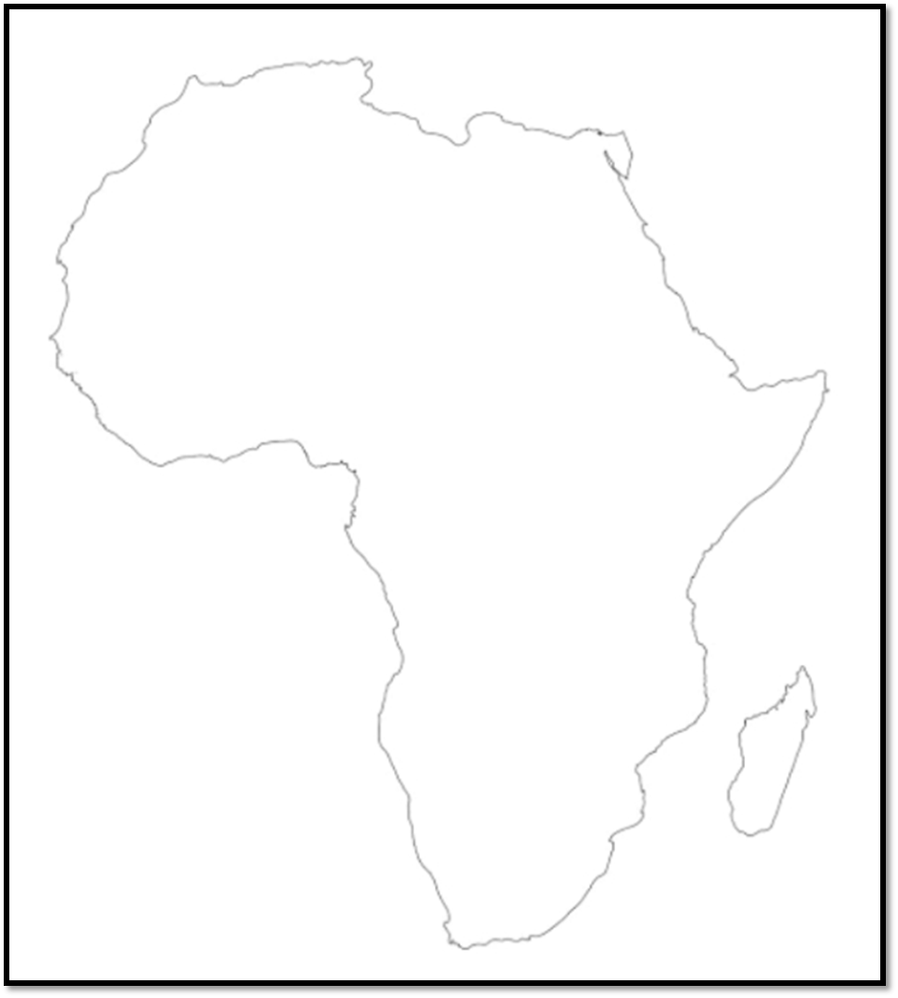
B
C
D
E
A
{i} Historical site A was a famous iron site in West Africa. What was the name of Historical site
{ii} Name the Iron site marked by letter B
{iii} What is the iron site marked by letter C{iv} Name a kind of Irrigation scheme practiced by the people of the area marked by letter D
{v} Mention a type of economic activity practiced in the area marked by letter E between Kenya and Somalia

8. Briefly explain five factors the rise of trade in pre-colonial Africa..

9. Briefly respond to the following questions.
{i} Show the relation between Fire and the discovery of Iron.
{ii} Present the reasons for the decline of batter trade.
{iii} In one paragraph, explain why shifting farming in pre-colonial Africa.
{iv} Briefly explain why the pastoralism came into existence.
{v} Show the differences between the theory of creation and theory of evolution.

SECTION C (15 Marks)
Answer one (1) essay questions from this section.

10. Explain any six changes that occurred in man’s life as a result of the discovery of iron technology.

