THE UNITED REPUBLIC OF TANZANIA
THE PRESIDENT’S OFFICE
REGIONAL ADMINISTRATION AND LOCAL GOVERNMENT
LONGIDO DISTRICT
ANNUAL JOINT EXAMINATION

FORM ONE
HISTORY
MARKING SCHEME NOVEMBER 2024

SECTION A (15 Marks)
- MULTIPLE CHOICES
D | C | C | A | A | D | D | B | B | D
1(10) = 10 MARKS.
- MATCHING ITEMS

F | G | J | D | H
1(5) = 5 MARKS

SECTION B (70 Marks)

- Hijra
Is the starting point of the Islamic calendar that is believed to be the year 622.C.E. The year 622C.E marked the pilgrimage of prophet Mohamed from Mecca to Medina.
- Archaeology
Is the study of past human activities and culture through their material remains.
- Neolithic revolution
A period in the late stone age when man started crop cultivation and animal keeping.
- Archives
The collection of private and public documents. Archives are places where documents and old written records are kept.
- Anthropology
Is the discipline that deals with the study of cultural practices and pattern of husman societies.

1st | 2nd | 3rd | 4th | 5th
III | IV | II | I | V

- Islam provided sharia,
- Islam led to the growth of educational institutions
- Islam promoted trade

- Because they provide more accurate data than the traditional methods.

- Due to surplus production
- Availability of transport animals
- Development of socio-political organization

- By burning salty reeds.

- By engaging in pastoralism because these areas received a minimum rainfall per year.

- Intercropping and Mixed farming
Intercropping refers to the cultivation of different crops on the same piece of land whereas mixed farming is a practice of cultivating and keeping animals.
- Centralized states refers to the states with a central figure of authority while decentralized states a states without a central figure of authority.
- Iron age and Stone Age
Iron age was a time when man made and used iron tools whereas Stone age was a period when man made and used stone tools. 2(5) = 10 Marks.
- Local and regional trade.
Local trade was a kind of trade that involved the exchange of goods between the people of the same locality whereas regional trade was the exchange of goods among the people of distinct regions.
- Nomadic pastoralism and Sedentary pastoralism
Nomadic pastoralism was a kind of pastoralism that involved the movement of pastoralists with their cattle from one place to another searching for water and pasture while sedentary pastoralism involved keeping animals in one areas while engaging in other economic activities.

- Sketch map of Tanzania
- Isimila
- Olduvai Gorge
- Kilwa
- Bagamoyo
- Kalambo falls
2(5) = 0 Marks
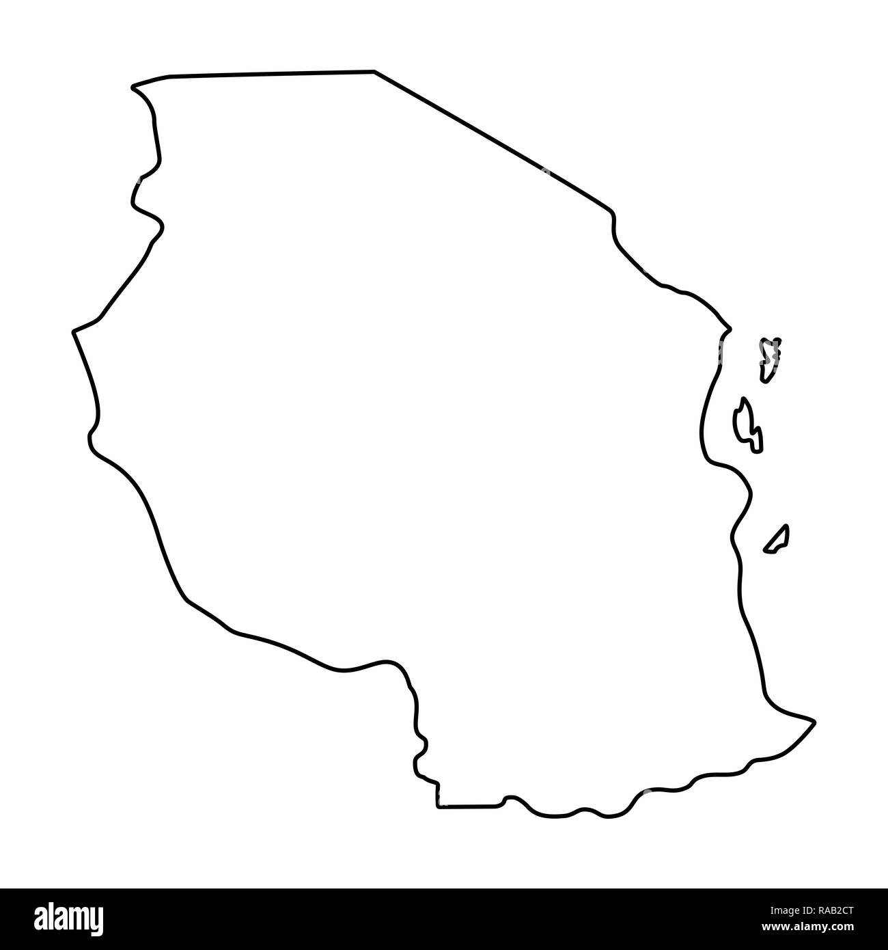

ii
iv
v
iii

- Political stability
- Availability of trade items
- Honest and trus among traders 2(5) = 10 Marks
- Availability of transport animals
- Islamic faith

- Understanding our origin
- Appreciating other people’s culture 2(5) = 10 Marks
- Promoting patriotism
- Encouraging the search for evidence
- Learning rom he past actions.

SECTION C (15 Marks)
- Introduction.
- Define state or political centralization
- State time when states were formed (2 marks)
- State a few examples of the pre-colonial states.
Main body
The factors for state formation.
- Trade
- Iron technology
- Migration 2(6) = 12 Marks
- Religion
- Strong army
- Strong leadership
Conclusion. (Any good conclusion). 1 mark.

