

THE PRESIDENT’S OFFICE
REGIONAL ADMINISTRATION AND LOCAL GOVERNMENT
LONGIDO DISTRICT

FORM ONE ANNUAL EXAMINATION
012 HISTORY
MARKING SCHEME 2025

SECTION A (15 MARKS)

D | C | C | A | A | D | D | B | B | D
1(10) = 10 MARKS.

E | C | I | D | H
1(5) = 5 MARKS

SECTION B (70 MARKS)

- Oral testimonies
These are narrations of the past provided by someone who witnessed the event or took part in it.
- Archaeology
Is the study of past human activities and culture through their material remains.
- Neolithic revolution
A period in the late stone age when man started crop cultivation and animal keeping.
- Archives
The collection of private and public documents. Archives are places where documents and old written records are kept.
- Anthropology
Is the discipline that deals with the study of cultural practices and pattern of husman societies.

1st | 2nd | 3rd | 4th | 5th
III | IV | II | I | V

- How did Islam play part in the rise and consolidation of pre-colonial centralized states?
- Islam provided sharia,
- Islam led to the growth of educational institutions
- Islam promoted trade
- Why are modern dating methods much preferred by archaeologists to traditional methods?
- Because they provide more accurate data than the traditional methods.

- Why did the pre-colonial people of Africa develop trade relations among themselves?
- Due to surplus production
- Availability of transport animals
- Development of socio-political organization

- Geography relates with history due to the fact that they both deal with the theories about the appearance of man on earth and the universe in which human beings live. On the other hand historical events normally occur in specific geographical environment and therefore geography helps history students to understand the subject better.

- The Golden stool was very important to the people of Asante because it was the symbol of wealth, Power and unity among them.

- Differentiating the following:
- Intercropping and Mixed farming
Intercropping refers to the cultivation of different crops on the same piece of land whereas mixed farming is a practice of cultivating and keeping animals.
- Oldowan tools were the tools made in the early stone age by Homo-habilis whereas Acheulian tools were made in the early stone age by Homo-erectus. Oldowan tools were named after Oldupai Gorge where they were firstly discovered where as Acheulian tools were named after St. Acheul, a valley in France where they were firstly discovered.
- Iron age and Stone Age
Iron age was a time when man made and used iron tools whereas Stone age was a period when man made and used stone tools. 2(5) = 10 Marks
- Nomadic pastoralism and Sedentary pastoralism
Nomadic pastoralism was a kind of pastoralism that involved the movement of pastoralists with their cattle from one place to another searching for water and pasture while sedentary pastoralism involved keeping animals in one areas while engaging in other economic activities.
- Centralized states refer to the states with a central figure of authority while decentralized states a state without a central figure of authority.

- A sketch map of Tanzania with following historical sites.
- Isimila
- Olduvai Gorge
- Kilwa
- Bagamoyo
- Kalambo falls
2(5) = 0 MMarks
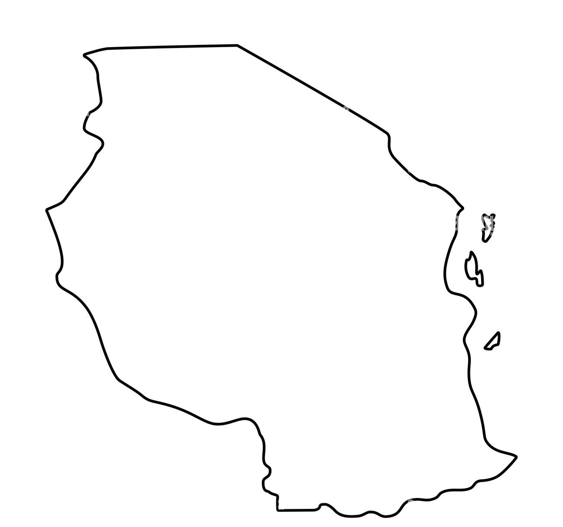
iii

iv
ii
v

- Factors for state formation
- Strong leadership
- trade
- strong armies 2(5) = 10 Marks
- iron technology
- Islamic faith

- Understanding our origin
- Appreciating other people’s culture 2(5) = 10 Marks
- Promoting patriotism
- Encouraging the search for evidence
- Learning rom he past actions.

SECTION C (15 MARKS)
- The rise of political centralization in pre-colonial time was due to both internal and external factors:
Introduction.
- Define agriculture
- State time when man started farming (2 marks)
- State a few types of pre-colonial agricultural practices
Main body
The impacts of agriculture in man’s life.
- Increased food production
- Rise of specialization
- trade 2(6) = 12 Marks
- Religion
- Permanent settlement
- Population increase
Conclusion. (any good conclusion). 1mark.

