NAMANGA SECONDARY SCHOOL
FORM ONE MID TERM EXAMINATION
HISTORY
TIME: 2:30 HRS AUGUST 2025

INSTRUCTIONS
- This paper consists of sections A, B and C with a total of TEN (10) questions.
- Answer all questions.
- All writing must be in blue or black ink.

SECTION A (15MARKS)

- For each of the items (i) – (x), choose the correct answer from among the given alternatives and write its letter in the box provided.

- The study of past human activities and events is known as;
- Archaeology.
- Geography
- History
- Sociology
- Which of the following is NOT a source of history?
- Oral traditions
- Written records
- Future predictions
- Archaeological findings
iii. The major significance of studying history is:
- Learning about future events
- Understanding the present through the past
- Ignoring past mistakes
- Memorizing dates only
iv. A place where historical records and documents are kept is called:
- A museum
- An archive C. A library

D. A laboratory
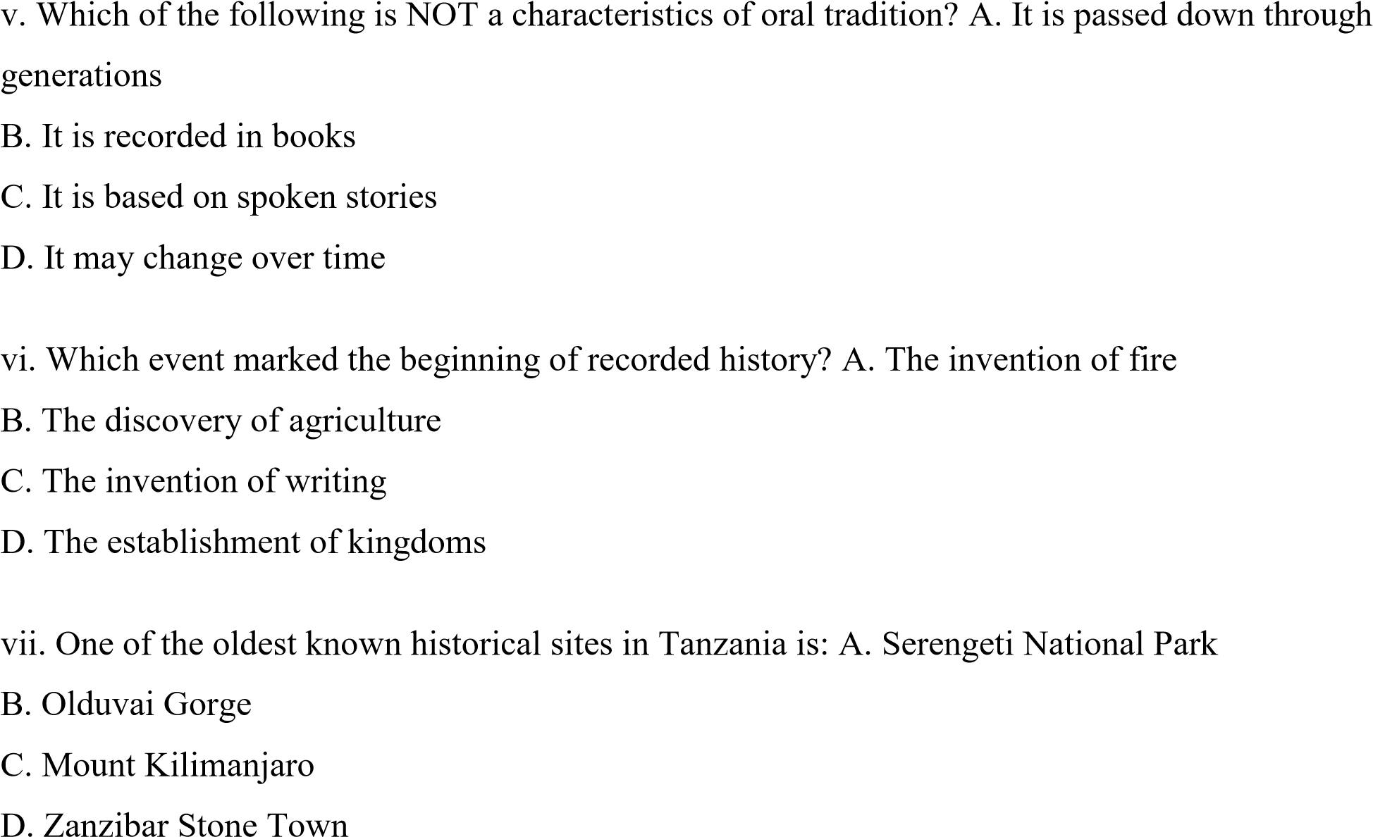
viii. Which of the following is an example of a historical monument?
A. A modern skyscraper
B. A historical palace
C. A football stadium
D. A shopping mall
ix. Which of the following is NOT an impact of historical events on modern society?
- Cultural preservation
- Political development
- Scientific discoveries D.
Predicting lottery numbers
x. The period before the invention of writing is known as:
A. Modern history B. Ancient history
- Prehistory
- Contemporary history

- Match the following historical terms with their correct definitions.
COLUMN A (Terms) | COLUMN B(Definitions)
- Archaeology | A. Stories and information passed by word of mouth.
- Oral traditions. | B.The study of human past through material remains.
- Historical monuments | C.Physical stuctures with historical significance
- Archives | D.A chronological sequence of historical events
- Timeline | E.Places where important historical documents are stored.

SECTION B: (70 MARKS)
Answer all questions
3. (a) Define history. (b) Mention and explain any four (4) sources of history.
4. (a) Why is studying history important? Provide four (4) reasons. (b) Explain any three (3) ways history is related to other disciplines.
5. (a) What are historical events? (b) Mention and explain any three (3) significant historical events in Tanzania.
6. (a) Define the term "historical monument." (b) Mention and explain any three (3) famous historical monuments in Africa.
7.The discovery of fire during the middle Stone Age had the same significance as a discover of computer in modern society. Explain
- Write short notes on the following
  - Acheulian tools
  - Oldowan tools
  - Bipedalism
  - Stone age
  - Carbon 14
- (a) mention three pre-colonial African mode of production
- All the three pre-colonial African mode of production had several features. Choose the mode of production that promotes justice patriotism and human rights. Give reasons for your choice.

SECTION C: (15 MARKS)
Answer the following essay question

- Write an essay on the significance of history in understanding modern society using the following guidelines: (a) Define history. (b) Explain the importance of studying history. (c) Conclusion.

FORM ONE MID TERM EXAMINATION
HISTORY MARKING SCHEME
- 10 marks 1@
i | ii | iii | iv | v | vi | vii | viii | ix | x
C | C | B | B | B | C | B | B | D | C

- 10 marks 2@
List A | i | ii | iii | iv | v
List B | B | A | C | E | D

- History is the study of events and processes that happened in the past and which might influence the future. 2marks
3(b). - Oral sources
- Museums
- Historical sites
- Archaeology 4points 8 marks 2@
- Archives
- Linguistics/ historical linguistics.
- Anthropology
- Ethnographic records.

4a) importance of history
- To understand our origin
- It promote tolerance
- It help to learn from past actions 4marks 1@
- It encourage search for evidence
- It help us to appreciate other people’s culture
- It promote patriotism
Any other related importances
4b) history and biology – evolution of human species is explained in both subjects.
- History and geography – they both explain origin of universe and human beings. While history talks about origin of human being, geography talks about universe where historical events occur.
- History and mathematics – mathematics is used for determining the chronology and sequence of historical events through graphs, charts timelines and mats is used to tell time in which events occurred.
- History and language – history studies the origin, development and changes of languages over time. History facilitates language to spread from one pace to another.
- History and music – history traces the origin development and influence of music throughout human existence, music serves as a vehicle for transmitting historical narratives.
- History and theatre arts – history offers historical perspectives and narratives while theatre arts bring emotional depth, sympathy and artistic explanations to historical events.
3points 6marks 2@
5. Historical events are the past occurrence that can be identified and studied through evidence and historical records.
Importance of historical events
- Help in teaching valuable lessons 10 marks 2@
- It foster critical thinking
- We understand societal patterns
Any relevant explanation
6. (a) Historical monuments are old buildings, structure or a place that is an important part of a country’s history.
OR
- are physical structures with historical significance.
6(b) famous historical monuments in Africa
- Pyramids of Giza( Egypt) 10marks 2@
- Churches of lallibela and Aksum (Ethiopia)
- Fort Jesus(Kenya)
- Stone town of Zanzibar(Tanzania)
- City ruins of great Zimbabwe(zimbabwe)
7. Significance of fire
- a source of light at night
- was used for warming the body
- was used for clearing bushes and forests 10marks 2@
- was used for chasing away wild animals
- was used for roasting meat.
Any other relevant explanation
8. - Acheulian tools – were more advanced tools used in early Stone Age which were discovered in St.Acheul in France.
- Oldowan tools – were simple and crude tools which were obtained from hard natural rocks and were discovered in olduvai gorge.
- Bipedalism – was the stage whereby man walked upright by using two limbs/legs.
- Stone Age – is the period in human history when stone was the main material for making tools and weapons.
- Carbon 14 – is the scientific method of determining dates of remains of animals and plants that died long time ago.
10 marks 2@

9.(a) three pre-colonial modes of productions
- Communalism.
- Feudalism.
-Slavery.
9(b). communalism because of
- No exploitation of man by man
- Collective ownership of major means of production 10 marks 2@
- No classes
- Subsistence production
- Absence of specialisation.
- Division of labour was simple and based on gender.
10. Importance of studying history
- To understand our origin
- It promote tolerance
- It help to learn from past actions 15 marks
- It encourage search for evidence
- It help us to appreciate other people’s culture
- It promote patriotism

