THE UNITED REPUBLIC OF TANZANIA
PRESIDENT’S OFFICE
REGIONAL ADMINISTRATION AND LOCAL GOVERNMENT
NAMANGA SECONDARY SCHOOL
FORM ONE TERMINAL EXAMINATION
HISTORY
TIME: 2:30 Hours 2024

Instructions
- This paper consists of three sections A, B and C with a total of ten {10} questions.
- Answer all questions in section A, B and C.
- Section A carries fifteen (15) marks and section B seventy {70} marks and C carry fifteen (15) marks each.
- All writing must be in blue or black ink.
- All answers must be written in the space provided.
- Cellular phones and any unauthorized materials are not allowed in the exam room.

FOR EXAMINER’S USE ONLY
Question numbers | Score | Examiner’s initials
1
2
3
4
5
6
7
8
9
10
TOTAL

SECTION A: (15 MARKS)
Answer all questions from this section.

- For each of the following items, choose the best answer from the given alternatives.

- The basic needs which man constantly struggle to obtain are:

- Water, food and clothes. C. Air, love and food.
- Relationship, love and peace. D. Food, shelter and clothes.

- He discovered the skull of the Zinjanthropus in Olduvai Gorge?

- Louis Leakey. C. David Livingstone.
- Vasco Da Gama. D. Charles Darwin.

- The collection of Public and private documents mostly in the public offices.

- Archives. C. Museum.
- Archaeology. D. Anthropology.

- The theory of evolution was proposed the following third year Theology University student in England.
- Bartholomew Diaz C. Nelson Mandela.

- Charles Darwin. D. Carl Peters.

- According to the Holy Bible, the first human being to exist in this world was:
- Ramapithecus. C. Adam.

- Australopithecus. D. Proconsul.

- In History, a difference of age between the parents and their children is referred as:
- Generation. C. Period.

- Age. D. Millennium.

(vii) The following are the earliest Iron sites of Africa:
- Nok and Ugweno. C. Axum and Engaruka.

- Meroe and Nok. D. Uvinza and Meroe.

(viii) A Historical site in which the Rock Painting art is displayed to show the civilization of the past is
- Kondoa Irangi. C. Olduvai Gorge.

- Bagamoyo. D. Olorgesaillie.

(ix) The Early Stone Age civilization remains are found in
- Olduvai and Orolgesaillie. C. Bagamoyo and Olduvai.

- Orolgesaillie and Kilwa. D. Kilwa and Bagamoyo.

(x) How can a blind student learn History properly in his/her condition?
A. Through visiting Archaeological site.

B. Through narratives of words of mouth.
C. Through color printed written materials.
D. Through visiting the Museums.

2. Match the items in LIST A with those in LIST B by writing the correct letter against the
Corresponding question number.
List A | List B
(i) Oval and pear shaped hand Axes associated with  Homo Erectus in the Paleolithic age.  (ii) The Middle Stone age sub Saharan stone tools.  (iii) The Earliest Stone age tools made by man in the Early  Stone Age.  (iv) Tiny Stone tools often of geometric shape made in the  Middle and Late Stone age.  (v) Long spear like tools used for fishing and other marine  Hunting. | A. Harpoon tools.  B. Iron tools.  C. Bony tools.  D. Microlith tools.  E. Oldowan tools.  F. Acheulean tools.  G. Sangoan tools  H. Bronze tools.
Answers for question Number 2
LIST A | i | ii | iii | iv | v
LIST B

SECTION B (70 Marks)
Answer all questions in this section.
3. Arrange the following sentences in a chronological order by writing roman numbers in the
Table provided.
{i} then people could make Microliths which made their job to be very simple.
{ii} The discovery of iron tools became a climax of ancient development of
Technology.
{iii} In the late stone age people could make better tools than previous.
{iv} The Microliths were sharper, tiny and better tools.
{v} When they discovered fire, they were able to manage their environment and
Food preparation.
Answers.
1st | 2nd | 3rd | 4th | 5th

4. Briefly write the meaning of the following terms
{i} Anthropology…………………………………………………………………………..
………………………………………………………………………………………………
……………………………………………………………………………………………....
………………………………………………………………………………………………
{ii} Archives .………………………………………………………………………………
………………………………………………………………………………………………
………………………………………………………………………………………………
{iii} A Generation…………………………………………………………………………..
………………………………………………………………………………………………
………………………………………………………………………………………………
………………………………………………………………………………………………
{iv} HIJRA ……………………………………………………………………………
………………………………………………………………………………………………
………………………………………………………………………………………………
{v} Australopithecus ……………………………………………………………………
………………………………………………………………………………………………
………………………………………………………………………………………………
5. (a). Mention any three advantages of using Archeology as a source of History.
{i} ………………………………………………………………………………………
………………………………………………………………………………………
{ii} ………………………………………………………………………………………
………………………………………………………………………………………
{iii} ………………………………………………………………………………………
………………………………………………………………………………………
(b). Mention any two limitations of Archeology as a source of History.
{i} ………………………………………………………………………………………
……………………………………………………………………………………….
{ii} ………………………………………………………………………………………
………………………………………………………………………………………

6. Complete the following statements with correct historical facts.
- The stories and tales provided by elders can be referred as………….……………
- ………………………is person dealing with metal works especially iron smelting?
- A person dealing with the study the physical remains of the past civilization and fossils as known as………………………
- ……………………….is a historical site having the remains of cave paintings in Central Tanzania.
- The areas around Lake Victoria, Edward, Albert, and Kivu are also referred as the……………………………
7. Study this sketch map and answer the question which follow
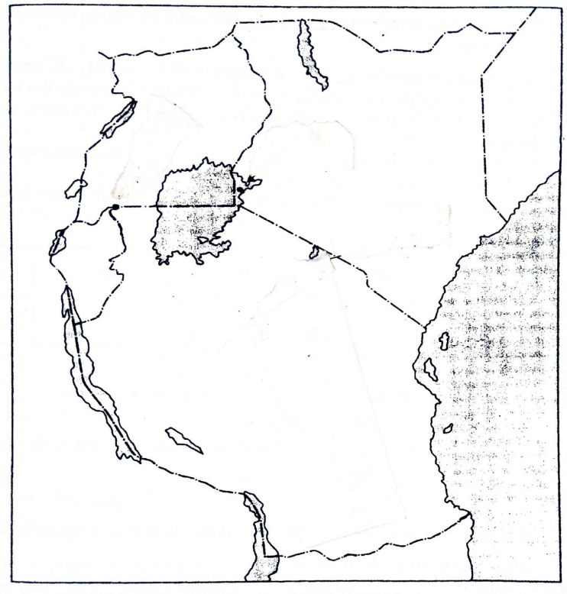
E
D
C
B
A
(i) What is the Historical site marked by the letter A ………………..………
(ii) Name the famous Historical site represented by the letter B ……..………
(iii) Mention the ancient trade center marked by the letter C …………………
(iv) Name the Stone Age site marked by letter D………………………..…….
- Name the famous slave trade center marked by letter E…………..………

8. Reveal any five effects of Iron technology in pre-colonial African societies.
{i} ………………………………………………………………………..……………..
…………………………………………………………………..…………………..
{ii} ……………………………..………………………………………………………..
……………………………..………………………………………………………..
{iii} …………………..…………………………………………………………………..
……………….……………………………………………………………………..
{iv} ………..……………………………………………………………………………..
……………………………………………………………………………………….
{v} ………………………………………………………………………………………
………………………………………………………………………………………

9. Show any five changes made by human communities in the late Stone Age.
{i} …………………………………………………..……………………………..……
…………………………………………………………………..…………………..
{ii} ……………………………..………………………………………………………..
……………………………..………………………………………………………..
{iii} …………………..…………………………………………………………………..
……………….……………………………………………………………………..
{iv} ………..……………………………………………………………………………..
……………………………………………………………………………………….
{v} ………………………………………………………………………………………
………………………………………………………………………………………
SECTION C (15 Marks)
Answer this question in essay form.
10. “History is a dead subject and it is fit not to be taught in Tanzanian secondary schools. Present any six reasons to oppose this statement.

