PUGU SECONDARY SCHOOL
HISTORY FORM ONE - JUNE 2023
LEAVE PACKAGE
- For each of the items (i)-(x) choose the correct answer among the given alternatives and write its
correct letter in the booklet provided.
- The team of ten (10) agricultural experts from Lyamungo coffee agricultural research centre visited the Form One students of Pugu Secondary School where they brainstormed students on the types of agriculture conducted by the Pre-colonial African societies. Then, students mentioned three types of agriculture. Therefore, visitors asked students what was the most common method of farming in Pre-colonial Africa? What was the correct answer the students supposed to give?
- Mixed farming B. Plantation agriculture C. Shifting cultivation D. Pastoralism farming E. Permanent crop cultivation

- The history teacher at Majohe Secondary school was in the class and provided the following
definition; “Is the source of historical information which deal with scientific study of past
plants and animal remains”. This definition is for which concept among the followings?

A. Archaeology B. Archieves C. Museums D. Oral traditions E. Historical sites

- Carbon -14 can determine the date of animals and plants which died beyond - ago
A. 50,000 years B. 5000 years C 500 years D. 50 years E. 60 years

- The History teacher at Kaizerege Secondary School was in the class; and provided the following definition; “Is the study of society’s cultural system, behaviour, beliefs and ideologies”. This definition is for which concept among the following?
- Archaeology B. Archives C. Anthropology D. Archaeologist E. Museums
- Mr. Msambiningwa is history teacher at Magogoni Secondary School; during his lesson, he told the students that “according to Charles Darwin, in his theory of evolution of man from primates to Homo-sapiens was associated with technological discovery like discovery of fire. Assume you are a student in that class, tell him at which age that discovery occurred?
- New Stone AgE B. Early Stone Age C. Late Stone Age D. Middle Stone Age E. Iron Age
- Mzee Laizer is a Maasai livestock keeper who moves from one place to another searching for water and pasture for his cattle. This movement of Mzee Laizer is known as:
- Pastoralism B. Nomadic pastoralism C. Sedentary pastoralism D. Permanent pastoralism E. animal keeping
- Identify the collective name used to describe the type of Pre-colonial trade that involved people from North Africa and West Africa around 1st century which greatly led to the formation of Ghana, Mali and Songhay empires in the Western Sudanic zone.
- Barter Trade
- Regional Trade
- Trans Saharan Trade
- Slave Trade
- Trans -Atlantic Slave Trade
- Mzee Ndelenyuma is an illiterate man with 120 years of age. He used to narrate past nationalist movements events in Africa to his grand children who are under 18 years old. What is the type of source of history?
- Oral Tradition B. Archives C. Museums D. Linguistics E. Achaeology.

- Salt making was the earliest industries in pre colonial Africa. Pre colonial Africa societies
obtained salt through various methods of extraction like leaching. This method was practiced at:

- Uvinza in Tanzania and Bilma in West Africa B. Taghaza, Idjil and Taouden West Africa C. Malawi by Manganja along Lake Nyasa D. Baganda and Ankole in Uganda

- Mr Grogan is retired Tanzania People’s defense Force. (TPDF). One day after taking dinner with his Grndchildren started to narrate about the Uganda,Tanzania War of 1978-1979. he said to them that Uanda - Tanzania war is unforgettable war in the history of Tanzania because J. K. Nyerere spent a lot of money to conduct that war. The method used by Mr. Grogan to narrates Tanzania Uganda war to his grandchildren is called….
- Archaeological site B. Oral Tradition C. Museums D. Linguistics E. anthropology
I | ii | iii | Iv | v | iv | iiv | iiiv | ix | x

- Part A and B have historical information. The statements in Part A match with eight of those in part B. Pick and match the eight pairs
PART A | PART B
- Fossils of early man were found in.........  - Man discovered fire during the.......  - Man originated from the family of....  - Modern man is also called.......  - Man discovered agriculture in the...  - Late stone Age care paintings can be found in.....  - Growth of population, increase in food production and specialization of labour were some effects of the.....  - The gradual development of plants and animals from a simple to a more complex form is called... | - Zinjathropus  - Homo sapiens  - Evolution  - Late stone Age  - Discovery of iron  - Middle Stone Age  - Kondoa Irangi  - Olduvai Gorge  - Homo habilis  - Primates

I | ii | iii | Iv | v | iv | iiv | iiiv | ix | x

- Years and important historical event that took place in Africa are shown in the table below. Write the year below the corresponding item number of event in the table provided.
EVENT | YEAR
- Discovery of Zinjanthropus at Olduvai Gorge.  - Death of Zwangendaba  - Emergence of Ntemiship system  - The Berlin Conference  - Discovery of Iron | 1845  1884  1959  1500  1859  1st Millennium 5th Millennium

EVENT | (i) | (ii) | (iii) | (iv) | (v)
YEAR

- Mention five advantages of using archaeology as a source of historical information
- ..................................................................................................
- ..................................................................................................
- ...................................................................................................
- ...................................................................................................
- ..................................................................................................
- Mention the difference between anthroplogy and ethnographic records (5)
- ..................................................................................................
- ..................................................................................................
- ...................................................................................................
- ...................................................................................................
- ..................................................................................................
- Briefly explain the following term
- Potssium argon ......................................................................................................
...............................................................................................................................
- Ardipithecus .........................................................................................................
..............................................................................................................................
- Iron forging .........................................................................................................
.............................................................................................................................
- Pastoralism ........................................................................................................
.............................................................................................................................
- Hand crafts industries ...........................................................................................
................................................................................................................................
- Describe the products or items made by the following handicrafts industries in Pre colonial Africa
- Basketry .................................................................................................................
- Capentry .................................................................................................................
- Pottery .....................................................................................................................
- Iron .........................................................................................................................
- Mention the uses of the following minerals in pre colonial Africa
- Gold.............................................................................................................................
- Copper ........................................................................................................................
- Salt .............................................................................................................................
- Silver ..........................................................................................................................
- Mention the methods used to obtain gold in pre colonial Africa
- .........................................................................................................
- .........................................................................................................
- During the Early Stone Age man made simple two types of stone tools which were mainly used for simple activities such as killing, skinning animals and breaking bones to obtain marrow. What were the names of stone tools discovered at St.Achuel in France(i)....................and Olduvai Gorge(ii).......................?

- Observe and study careful the picture bellow the answer the given questions
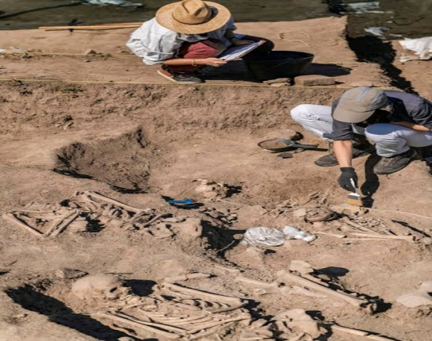
- What source of historical reconstruction is being applied in the picture above?
- What is the name given to the people who specialize in the activity depicted in the picture above
- What is the name given all ancient natural objects obtained through the activity above?
- What is the name given to all man made ancients objects /tools obtained through the activity above
- Why is above method of historical reconstruction regarded as the source of other sources of historical reconstruction?
- following map carefully then answer the following questions:
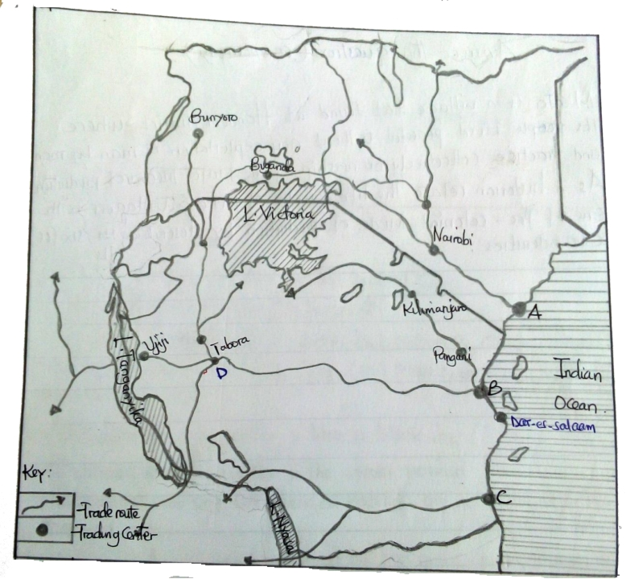
Questions:

- What are the names of the centres indicated by the letters A and B? and
- What is the name of the tribe that dominated the route that marked by letter C?

- What is the name of the famous local chief dominated the trade route started from centre B to D?

- The trade mapped above brought various impacts to the people of African societies. Mention any two impacts:a) and b) ________________________
  - What was the name of the trade in the map above?

SECTION C
- The form one students of Mshikamano secondary school will compete in a school debate with the motion which states that history subjet is more important than any other subject at secondary level. Being one of the proposer side, give six points to defend the motion.

- during the late Stone Age man had acquired some changes better than the previous era. In six points asses major changes of man’s way of life during the period.

- in Pre colonial Africa, Yao, Kerewe and Makua were the societies that practised crop cultivation,while Maasai, Karamajong and Pokot were the pastoral societies. As a historian, give five reasons how their activities changed the lives of human beings in Africa?

- in pre colonial Africa, the salt was well processed and extracted from various sources for the benefit of the Africans. Use five points to show why salt making industries were advantageous in the pre colonial Africa.

