WANGING'OMBE DISTRICT COUNCIL
JOINT MID_TERM EXAMINATION
HISTORY FORM ONE 2023
Instructions
- This paper consists of section A,B and C with total of ten (10) questions
- Answer all questions
SECTION A (15 Marks)
Answer all questions.
1. For each of the items (i)_(x), choose the correct answer from the given alternatives and write it's letter
- The collection of public document and they are kept is called
A. Museum B. Archives C. Archaeology D. Oral tradition
- The chronological order of events is usually shown in the following except... A. Time Chart B. Time Line C. Family Tree D. Carbon 14
- History is about...
A. Man's activities through various stages of his development.
B. How colonialist came to Africa
C. The actions of great men in society
D. The actions of heads of state and government
vi. The following is the major source of historical information for students in secondary
Schools
A. Archives B. Oral tradition C. Written records D. Museums
v. The famous archeologist in East Africa who discovered the skull for early man at Olduvai.
Gorge
A. Dr. Louis Leaky B. Archaeologist C. Artifacts D. Olorgesailie
vi. The scientific method of determining dates of the remains of plants and animals is called
A. Anno Domino (AD) B. Common Era (CE) C. Carbon 14 D. Age
vii. Millennium is the period of...................years.
A. 10 years B. 1000 years C. Many years D. One hundred years
viii. Which of the following sources of history can illiterate people not benefit?
a. museums b. historical sites. c. written sources d. linguistics
ix. The following are the examples of archaeological sites in Tanzania EXCEPT
A. Olduvai Gorge B. Isimila C. Kilwa D. Matogoro
x. One of the disadvantage of written sources of history is that;
A. Give right information always
B. Record details of important people only
C. One can easily get valuable and rare information
D. It is limited to few people in society

i | iii | iii | iv | v | vi | vii | viii | ix | x

2. Match the historical description in List A with the corresponding historical terms in List B by writing the letter of response below the item number in table provided.
List A | List B
i)Tanganyika independence  ii)Zanzibar Revolution  iii)Death of mwl Julius Kambarage Nyerere  iv)Death of Dr . John Pombe Magufuli.  V)Death of Abeid Amani Karume | - 1998  - 1972  - 1964  - 1999  - 2020  - 2021  - 1961
Answers
List A |  | Ii | Iii | iv | V
List B
SECTION B (70 Marks)
Answer all questions.
3. Briefly explain the following terms:
- A decade
----------------------------------------------------------------------------------------------------------------------------A century
- ----------------------------------------------------------------------------------------------------------------------------
A generation
----------------------------------------------------------------------------------------------------------------------------
- Age
--------------------------------------------------------------------------------------------------------------------------------------------------------------------------------------------------------------------------------------------------------
- Millennium
- --------------------------------------------------------------------------------------------------------------------------------------------------------------------------------------------------------------------------------------------------------
- (a) Explain how fire was discovered
--------------------------------------------------------------------------------------------------------------------------------------------------------------------------------------------------------------------------------------------------------
----------------------------------------------------------------------------------------------------------------------------
(b) Explain the contribution of fire to man during the middle stone age
--------------------------------------------------------------------------------------------------------------------------------------------------------------------------------------------------------------------------------------------------------

- Mention four methods used by historian to determine historical date.
--------------------------------------------------------------------------------------------------------------------------------------------------------------------------------------------------------------------------------------------------------
--------------------------------------------------------------------------------------------------------------------------------------------------------------------------------------------------------------------------------------------------------
6. Differentiate the following:
- Oral tradition and archaeology
--------------------------------------------------------------------------------------------------------------------------------------------------------------------------------------------------------------------------------------------------------
- Museums and Archives
--------------------------------------------------------------------------------------------------------------------------------------------------------------------------------------------------------------------------------------------------------
- Historical sites and Anthropology
--------------------------------------------------------------------------------------------------------------------------------------------------------------------------------------------------------------------------------------------------------
- Recalling events and carbon 14
--------------------------------------------------------------------------------------------------------------------------------------------------------------------------------------------------------------------------------------------------------
7. Study carefully the following map and name historical sites numbered 1 to 5.
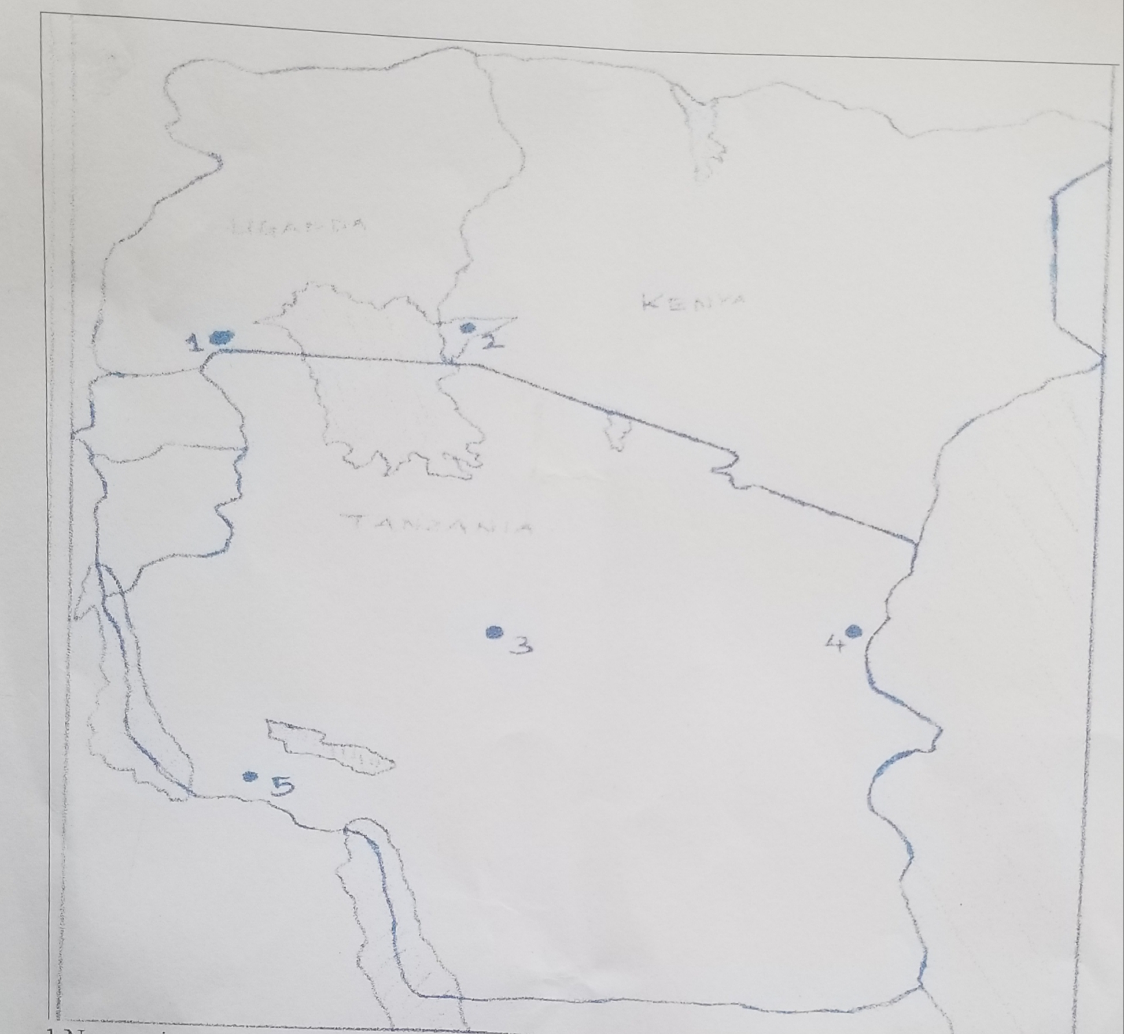

1...…...………………..............
2...…...................................
3....................…...................
4 .....,..................................
5 ...........................................
8. Briefly, explain four weakness of written records.
--------------------------------------------------------------------------------------------------------------------------------------------------------------------------------------------------------------------------------------------------------
--------------------------------------------------------------------------------------------------------------------------------------------------------------------------------------------------------------------------------------------------------
9. Briefly, explain four advantages of historical sites.
--------------------------------------------------------------------------------------------------------------------------------------------------------------------------------------------------------------------------------------------------------
--------------------------------------------------------------------------------------------------------------------------------------------------------------------------------------------------------------------------------------------------------
SECTION C (15 Marks)
10. Mudrick is the head of school at Pugu secondary school, received a letter from form one students who are not interested in History subject. As a form one student convince your fellow students to like that subject. (Five points)
--------------------------------------------------------------------------------------------------------------------------------------------------------------------------------------------------------------------------------------------------------
--------------------------------------------------------------------------------------------------------------------------------------------------------------------------------------------------------------------------------------------------------
--------------------------------------------------------------------------------------------------------------------------------------------------------------------------------------------------------------------------------------------------------
--------------------------------------------------------------------------------------------------------------------------------------------------------------------------------------------------------------------------------------------------------
--------------------------------------------------------------------------------------------------------------------------------------------------------------------------------------------------------------------------------------------------------
--------------------------------------------------------------------------------------------------------------------------------------------------------------------------------------------------------------------------------------------------------
--------------------------------------------------------------------------------------------------------------------------------------------------------------------------------------------------------------------------------------------------------
--------------------------------------------------------------------------------------------------------------------------------------------------------------------------------------------------------------------------------------------------------

