PRESIDENT’S OFFICE
REGIONAL ADMINISTRATION AND LOCAL GOVERNMENT
DODOMA CITY
CHINANGALI SECONDARY SCHOOL

FORM THREE MID-TERM EXAMINATION

GEOGRAPHY

TIME 3:00 Hours APRIL, 2025.
Instructions
1. This paper consists of sections A, B and C with a total of eleven (11) questions.
2. Answer all questions in sections A and B and two (2) questions from section C.
3. Section A carries sixteen (16) marks, Section B carries fifty four (54) marks and Section C carries thirty (30) marks.
4. Map extract of Sikonge (Sheet 137/2) is provided.
4. All writing must be in blue or black ink except drawing which must be in pencil.
5. Programmable calculators, communication devices and any other unauthorized materials are not allowed in the examination room.
6. Write your name on every page of your answer booklet(s) provided
SECTION A (16 Marks)
Answer all questions in this section.
1. For each of the items (i) – (x), choose the correct answer from among the given alternatives and write its letter in the answer booklet provided.
(i) Assume you are asked to help the form one student who failed to identify the type of Geography, which deals with the study of physical features. What type of Geography will you suggest among the following?
A. Human and economic geography B. Practical geography C. Mathematical geography
D. Physical geography E. Human geography.
(ii) When traveling in a fast moving vehicle, we notice trees and other objects on both sides of the road moving in opposite direction. This shows that the point of observation (the earth) is moving by rotation from:
A. West to East B. East to West C. East to South D. West to North E. West to South.
(iii) The layer of atmosphere characterized by 16 kilometer thick at the equator, temperature decrease with an increase in altitude and its boundary with the next layer is known as tropopause. The layer is called:
- Stratosphere B. Mesosphere C. Thermosphere D. Exosphere E. Troposphere.

(iv) Scorpion travelled to Mount Kilimanjaro and she became wondered to see the rainy in one side of the mountain while other side is mostly dry. Geographically, what is that type of rainfall?
A. Relief rainfall B. Convectional rainfall C. Frontal rainfall D. Seasonal rainfall
E. Sleet

(v) Find the temperature of Chalinze 500m above sea level if the temperature of the Mbulu 1500m above the sea level is 15C.
A. 24C B.25C C. 26C D.21C E.9C

(vi) People of bukoba district experienced shaking of crustal rocks which lead to the destruction of properties and death of people. Where this shaking does originated inside the earths crust? a) At the epicenter b) At the focus c) At the seismic waves d) At the fault e) At mantle.

(viii) The Government of Tanzania insists institutions to use source of energy in cocking that is friendly to the environment. Which of the following is the best source of energy? A. Fuel wood B. Solar C. Petroleum D. Nuclear E. Geothermal

(ix) Maasai and Barabaig of Tanzania are conducting pastoralism of seasonal movements with their herds in searching of pastures and water. What is that form of pastoralism?
A. Nomadic B. Semi-nomadic C. Transhumance D. Ranching E. Agro-forestry

(x) The tourism sector in Tanzania is growing rapidly as the number of tourists’ increases in each year. What among the following is not the factor for the development of tourism sector in Tanzania?
A. Peace and security B. Presence of sparsely sceneries.
C. Advertisements like ‘The royal Tour Film’ and Safari Channel D.Diplomatic strength E. Population increase.

2. Match the items in List A with the responses in List B by writing the letter of the corresponding response beside the item number.

SECTION A | SECTION B
(i) A funnel-shaped depression on top of a volcanic cone formed by violent volcanic eruption when the upper part of a volcanic plug is blown off.  (ii) A wall like feature formed when magma  cuts across a bedding plane.  (iii) A sheet of magma which lies along a  bedding plane.  (iv) A very large mass of magma which often  forms the root of a mountain.  (v) A dome-shaped feature formed when  magma push up the overlaying layers.  (vi) Widened crater formed when the upper part of a volcano is either blown away by violent eruptions | A. laccoliths  B. caldera  C. sills  D. Hot spring  E. lava  F. crater  G. dyke  H. batholiths

SECTION B (54 Marks)
Answer all questions in this section

3. Carefully study the map extract of Sikonge (sheet 137/2) provided answer questions that follow
- Calculate the total distance covered in kilometers if the car was travelling from Sikonge town (732787) to Iyombakuzoa church (755765) and turned back to Sikonge town.
- Calculate the bearing of grid reference 835846 to 782786.
- With evidence from the map, describe the social-economic activities carried out in the area.
- Calculate the area covered by seasonal swamps in km².
- Suggest the major types of settlement patterns dominated in mapped area.
- With evidence from the map describe the climatic condition of the area.

4. On 15th September, 2020 people of Kagera-north western Tanzania were struck by a sudden vibration of the earth’s crust measuring 5.9 magnitude on the Richter scale.
In light of this statement answer the following questions;

(a) What is the name of the geographical phenomenon that struck the people of Kagera?

(b) Identify the name of an instrument used to detect and measure the intensity of the phenomenon you have identified in (a) above.

(c) What is the name of the point in the earth’s crust where the phenomenon you have identified in (a) above originates?

(d) State any three (3) precautions you will have to take to protect yourself during the occurrence of the phenomenon identified in (a) above.

(e) Outline three (3) effects associated with the occurrence of the phenomenon identified in (a) above.

5. Weather and climate is the son from the same parents and they are dependent in its presence.
a) Identify four elements of weather.
b) List down about four climates of the world that you know.
c) Differentiate between weather and climate

6. Mr. Kasheko was watching the video program showing the ejection of molten materials within the Earth's crust or onto the earth's exterior. This process accompanied with the outbreak of ashes, gases and smokes. These molten materials sometimes cool and solidify within the Earth's crust to form both hypabyssal and plutonic rocks. And sometimes other materials reach the surface to form volcanoes.

(a) What was the genetic process observed by Mr.Kasheko from the video program?

(b) With examples explain the types of features produced by the process named in (a) above?

(c) Outline five (5) environmental impact resulted from the process named in (a) above.

7. With aid of diagram, explain concentric zones of the earth.

8. Study carefully the following photograph and then answer the questions that follow:
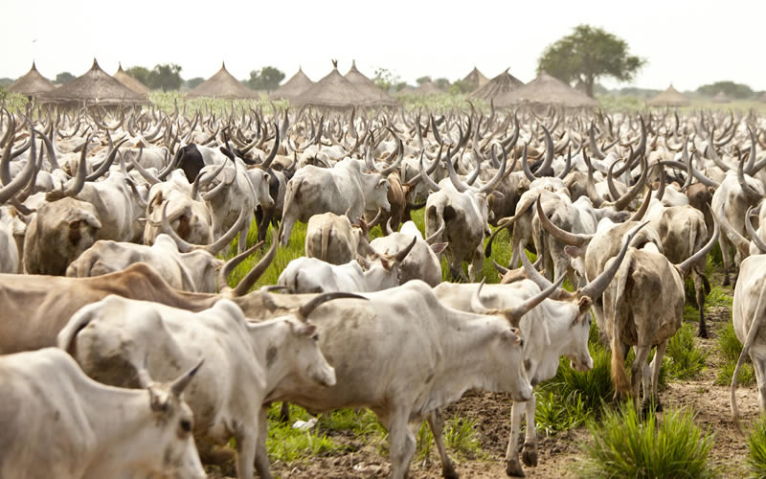

- What type of photograph is this? Give reasons for you answer.

- List down four products can be obtained from the animal seen on the photograph.

- What economic activities is taking place in the area?

- Name the economic and healthy importance of the product obtained from the animal seen on the photograph.

- State the possible factors which contributed to the development of the economic activity shown in the photograph.

- State the region in Tanzania where the photo might have been taken.

- Mwanaid’s mother wants to know some of the practical geography topics taught in Chinangali secondary school by them. His son Kisonga told her that only two of them he remember which are map reading and photography interpretation. Assume you are Kisonga, differentiate the topics by giving five points.

SECTION C (30 Marks)

Answer two (02) questions from this section.

9. Ash and Cinder cone, composite cone, crater and Caldera are among of the extrusive volcanic features. To what extent are volcanoes useful and disaster to man or human being? (Three points each).

10. Forests have significant contribution to social, economic and ecological development. They provide various products for human use such us timber, poles, wood, logs and honey. With examples explain six (6) points, what is likely to happen if the forest is cleared or destroyed?

11. There has been an on going debate in Tanzania following the Government’s move to enter into an agreement and lease of port of Dar es Salaam with an international company known as DP World of Dubai. As form three student who know about water management, prove with six points that harbours with good infrastructures are important to Tanzanians.

