PRESIDENT’S OFFICE
REGIONAL ADMINISTRATION AND LOCAL GOVERNMENT FORM THREE MID TERM EXAMINATION - 2023
GEOGRAPHY
Time 3:00 HRS

INSTRUCTIONS
- This paper consists of sections A, B, and C
- Answer all questions according to the instructions given
- Cellular phones and any unauthorized materials are not allowed in the examination room

SECTION A (25 Marks)

- For each of the following items (i) - (x) choose the correct answer and write its letter beside the number
  - Downward or upward movement of the earth’s crust are always given the name as …..
    - Internal earths movement ( )
    - External earths movements
    - Radial movements
    - Lateral movements
  - Is a bowl shaped depression at the mouth of a volcano or geyser
    - Hot springs
    - Lava ( )
    - Crater
    - Caldera
  - Endogenic geomorphic processes includes one among the following.
    - Faulting, earthquake, weathering, folding and mass wasting.
    - Folding, mass wasting, river action and faulting
    - Joints, volcanism, mass wasting and folding. ( )
    - Folding, earthquake, faulting and volcanism
  - Farmers at Mkombozi village invited Farm officer to give them knowledge on the kind of good soil for growing maize plant. One of the knowledge he provided was about rocks permeability. Assume you are the one invited, what would you tell the farmer about permeability of rock?
    - The ability of the rock to hold water.
    - The ability of the rock to allow water to pass through. ( )
    - The rate at which water enter the rock.
    - The ability of the rock to allow water to enter it.

  - The core comprises mainly of …………………………
    - Silica and magnesium
    - Silica and aluminum ( )
    - Nickel and iron
    - Iron and magnesium
  - In de jure census, among the following can be done
- People who stay in the house hold for the night are counted
- Is only done after five years
- Only permanent members of the house hold are counted ( )
- I only done after every ten years
vii Is a chart used for dating the history of the earth including its rocks?
- Carbon 14
- Periodic table ( )
- Geological time scale
- Measurement chart
- The earth’s sphere where life takes place is called …………………………
  - Hydrosphere ( )
  - Atmosphere
  - Biosphere
  - Barrysphere
- A geography teacher was teaching her student that, the earth is inclined in its orbit at which the intensity of sun rays reach different part of the earth varies and cause the earth to experience seasonal weather changes. By relating with the revolution of the earth, what result might occur on the earth?
  - Day and night ( )
  - Deflection of wind and ocean currents.
  - Season of the year.
  - High tides and low tides
- Tanzania broadcasting cooperation TBC is used to inform the prediction of atmospheric condition in a Region for 24 to 48 hrs.Suppose you are given chance to address majority about it,which title would you used
  - Weather elements
  - Weather station
  - Weather forecasting
  - Weather report ( )

- Match the following items LIST A and that of LIST B
LIST A | LIST B
- Batholiths  - Dykes  - Lacolith  - Lopoliths  - Phacolith | - up and down movement of the surface of water  - they form dome shaped structures  - are rising and falling in the level of water in the oceans  - large saucer – shaped structures  - movement of the surface water in the ocean  - extensive areas of the ocean floor  - a raised part of the ocean floor  - is a gentle sloping margin of a continent  - is a large body of water  - formed at the crest or anticline or in the trough of syncline  - when subjected to erosion, may form escarpments  - it formed when viscious magma reach the surface through a vent  - are wall like shaped structures  - it is made of granite

SECTION B (55 marks)

Answer all questions in this section.

- Study the map extract of Mpwapwa (sheet 163/4) and answer the following questions.

- At which part of the equator is Mpwapwa located (give one reason)
- Determine the size of the area covered by the forest found between Eastings 150 and 220 and South of Northings 900
- What type of vegetation is dominating in the area.
- Suggest four methods used to represent relief features in the mapped area
- Give the bearing of Veternary Research Institute grid reference (224995) to Mpwapwa Teachers Training college grid reference (203978)
- With evidence from the map suggest four social services found around grid reference 218983
- Study carefully the hypothetical data provided below show the production of crop in 000 tones Lon in Malindi

YEAR | MAIZE | BEANS | COFFEE
2020 | 200 | 100 | 150
2021 | 260 | 200 | 220
2022 | 275 | 180 | 200

- Present the given data by means of multiple graph
- If you observe the data of 2020 production was very low ,while in 2021 and 2022 production increased.what do you think could be the best measures taken to rescure crop from poor yield (give three point)
- Apart from the means used to present the given data what would be the other ways for presenting data above (three points)

5 . There was idea of disrtributing the Mkuranga into several district council.The final agree to invit the surveying team which will work to establish the boundaries of the council.
(i) What type of surveying will be applied by the surveying team to work
(ii) With reason suggest four tools that will be used by surveyor team
( iii) explain advantages of applying the type of survey in (i) above

6 Study the following photograph and answer the questions that follow.
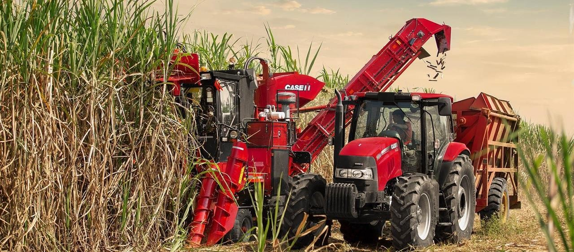
- Name the crop shown on the photograph. (2mark)
- What is the activity taking place on the photograph.(2mark)
- With one evidence, suggest the scale of production of the crop shown. (3marks)
- List down four conditions necessary for the growth of the crop shown on the photograph. (4 marks)
- Outline four factors that might affect the quality of the photograph given. (4marks)

SECTION C (30 Marks)
Answer two questions in this section
7 The ideally census must cover the whole country and all people residing in the country must be counted’’. Suppose you are given a task to educate your society about census. Why would you tell people that, it is very important for Tanzanian government to conduct census? (Explain five reasons).

8. Plantation is the most form of agriculture practiced in tropical region of Africa, Asia and South America. Justify six characteristics of plantations practiced in these areas.

9 Discuss six efforts that Tanzania must adopt to make tourism industry very potential for our national.

