THE UNITED REPUBLIC OF TANZANIA
MISANMISANMISANMISANMISANMISANMISANMISANMISANMISANMISANMISANMISANMISANMISANMISANMISANMISANMISAN MISANMISANMISANMISANMISANMISANMISANMISANMISANMISANMISANMISANMISANMISANMISANMISANMISANMISANMISAN MISANMISANMISANMISANMISANMISANMISANMISANMISANMISANMISANMISANMISANMISANMISANMISANMISANMISANMISAN MISANMISANMISANMISANMISANMISANMISANMISANMISANMISANMISANMISANMISANMISANMISANMISANMISANMISANMISAN MISANMISANMISANMISANMISANMISANMISANMISANMISANMISANMISANMISANMISANMISANMISANMISANMISANMISANMISAN MISANMISANMISANMISANMISANMISANMISANMISANMISANMISANMISANMISANMISANMISANMISANMISANMISANMISANMISAN MISANMISANMISANMISANMISANMISANMISANMISANMISANMISANMISANMISANMISANMISANMISANMISANMISANMISANMISAN MISANMISANMISANMISANMISANMISANMISANMISANMISANMISANMISANMISANMISANMISANMISANMISANMISANMISANMISAN MISANMISANMISANMISANMISANMISANMISANMISANMISANMISANMISANMISANMISANMISANMISANMISANMISANMISANMISAN MISANMISANMISANMISANMISANMISANMISANMISANMISANMISANMISANMISANMISANMISANMISANMISANMISANMISANMISAN MISANMISANMISANMISANMISANMISANMISANMISANMISANMISANMISANMISANMISANMISANMISANMISANMISANMISANMISAN MISANMISANMISANMISANMISANMISANMISANMISANMISANMISANMISANMISANMISANMISANMISANMISANMISANMISANMISAN MISANMISANMISANMISANMISANMISANMISANMISANMISANMISANMISANMISANMISANMISANMISANMISANMISANMISANMISAN MISANMISANMISANMISANMISANMISANMISANMISANMISANMISANMISANMISANMISANMISANMISANMISANMISANMISANMISAN MISANMISANMISANMISANMISANMISANMISANMISANMISANMISANMISANMISANMISANMISANMISANMISANMISANMISANMISAN MISANMISANMISANMISANMISANMISANMISANMISANMISANMISANMISANMISANMISANMISANMISANMISANMISANMISANMISAN MISANMISANMISANMISANMISANMISANMISANMISANMISANMISANMISANMISANMISANMISANMISANMISANMISANMISANMISAN MISANMISANMISANMISANMISANMISANMISANMISANMISANMISANMISANMISANMISANMISANMISANMISANMISANMISANMISAN
PRESIDENT’S OFFICE - REGIONAL ADMINISTRATION AND LOCAL GOVERNMENT
SIMIYU REGION
MISAN ACADEMIC DEVELOPMENT PROGRAM
FORM THREE JOINT ROUTE TO ANNUAL EXAMINATIONS, OCTOBER-2019
013 GEOGRAPHY – MARKING SCHEME
____________________________________________________________________________________________________
- (1 @ =10 marks)
(i) | (ii) | (iii) | (iv) | (v) | (vi) | (vii) | (viii) | (ix) | (x)
B | A | D | A | C | D | C | C | D | C

- (1 @ =5 marks)

(i) | (ii) | (iii) | (iv) | (v)
E | G | A | H | D

- (i) Chain survey – refers to a simple land survey whereby linear distances measured
and recorded by using a chain or tape. (2 mark)
(ii) Student should describe five equipments among the followings: (1 @ = 5 marks)
- A chain – for measuring distances.
- The tape – for measuring distances.
- Pegs – A piece of wood, metal or plastic used for marking station permanently.
- Ranging rods – Painted red and white to be seen easily for temporary marks of station.
- Cross staff – Used to measure right angles from the line of transverse.
- Arrows – For marking points on the ground and should be circular ends to make them more visible.
(iii) (a) Mistake in reading from a from the chain (1@ = 5 marks)
(b) Sagging of chain
(c) The use of too many chain lines or the use of too long chain lines
(d) Incorrect position of the arrows along the chain lines
(e) Unclear calling of measurement to the booker
(iv) Primary data – Are data which a researcher gather from the field through
questionnaires or interviews
While
Secondary data are those information a researcher get from other sources like
publication, magazine, books etc. ( 2 marks)
4. (a) Leveling is the process of determining the actual heights of point on the earths surface
where different in elevation of point are located. (2 marks)
(b) Student should identify the following among: (1 @ = 3 marks)
(i) Leveling staff
(ii) Theodolite
(iii) Tripod stand
(iv) Plumb bob
(v) Abney level
(c) (i) Used in production of contour lines (1 @ = 4 marks)
(ii) Used for determination of houses foundation
(iii) Used for construction of playground like football, tennis etc
(iv) used for determining the height the elevation of the land surface
5. This question also carries 12 marks as follows.
(i) (a) Grouped bar graph (1 @ = 3 marks)
(b) Compound line graph
(c) Simple bar graph
(ii) this table carries (1 marks)
Years | Average | Cotton | Result Used to Draw
2001 |  | 22000 | -5000
2002 | 216000 | 23000 | -4000
2003 | 8 | 28000 | 1000
2004 | 27000 | 28000 | 1000
2005 |  | 24000 | -3000
2006 |  | 32000 | 5000
2007 |  | 29000 | 2000
2008 |  | 30000 | 3000

DIVERGENCE BAR GRAPH SHOWING COTTON PRODUCTION IN MEATU DISTRICT 2001 – 2008. (In 000 tones) (0.5 mark)
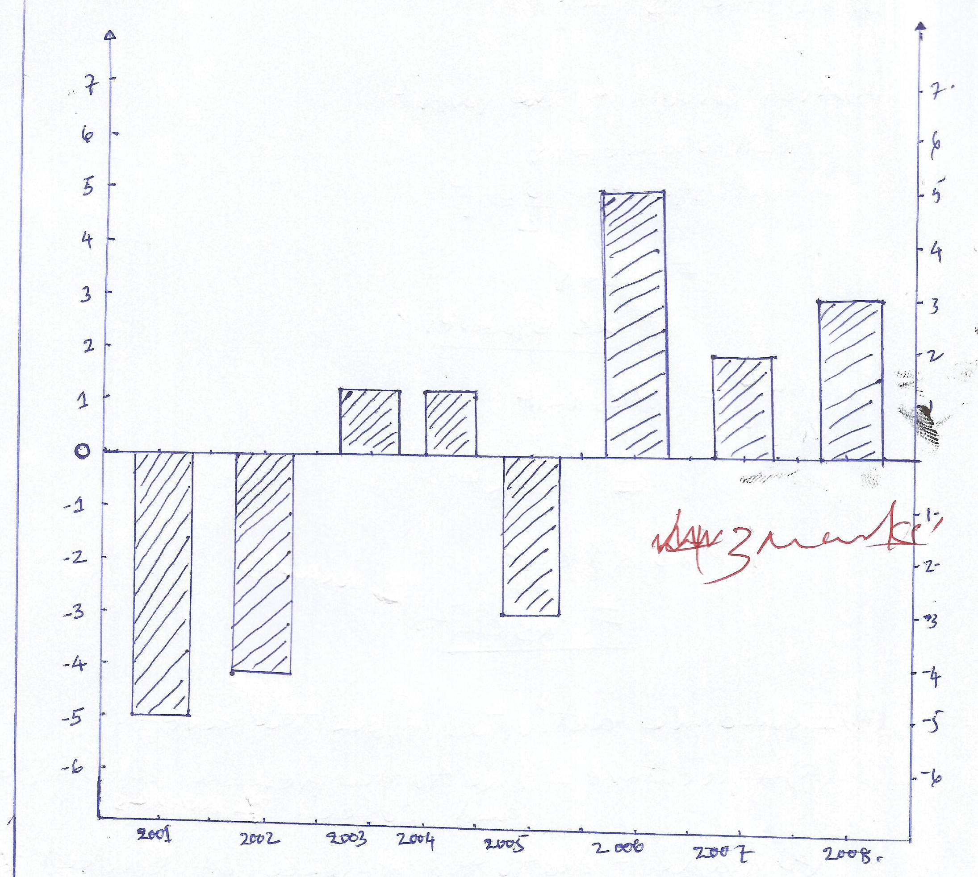
Scale:
Vertical scale: 1 cm = 1000 tones. (0.5 mark)
Horizontal scale: 1 cm = 1 year
(iii) Merits: (1 @ =2 marks)
- Simple to read and interpret
- Fluctuation come out clearly.
- Easy to compare the profit and loss.
- It gives visual impression.
Demerits (1 mark @ 2marks)
- It involves many calculations.
- Time consuming.
- Demand high knowledge.
- Not easy to construct.
6. (a) The relief of the mapped area is highlands , due to the presence of kivetek Hill, Elgeri
Hill, Lemugur Hill. (1 mark)
(b) (i) Road transport due to presence of road. (1 @ = 2marks)
(ii) Air transport due to presence of air stop
(c) One centimeter on the map represents a half kilometer on the ground.( 1 mark)
(d) the distance of road is 16km ( 3 marks)
(e) (i) Transport and communication (1@ =3 marks)
(ii) Education services eg, school, church etc
(iii) Health services due to presence of dispensary
7. (a) Ground/ Horizontal photograph. (1 mark)
(b) (i) shows side views of object.
(ii) Scale of photos decrease from fore to back.
(iii) It is taken horizontally. (3 marks)
(iv) It is taken on the level of the ground.
(c) (i) Hunting due to the forest and wild animals.
(ii) Forest harvesting like timbers. (2 marks)
(iii) Agriculture etc.
(d) The climatic condition of the area is equatorial due to the forest. (2 marks)
(e) Importance of the area.
- Home of wild animals
- Source of timber. (2 marks)
- Source of firewood, charcoal
- Tourism attraction.
8. Student should explain the following challenges ( at least five) (15 marks)
- High cost of investment.
- Poor methods of farming.
- Poor government support.
- Too much relying on rain.
- Lack of marketing.
- Limited quality farms.
- Inadequate disease control facilities etc.

9. Students should assess the contribution of mining sector in the country economy, and
should relying on that, up to how, Tanzania still not benefit much from mining sector since it contribute about (2.1 – 2.7%) per year due to the followings. (15 marks)
- Mining sector in Tanzania still small in terms of value.
- Mining sector earns low share of the export revenues for the country.
- Remove taxes for mining companies.
- Poor mining policies.
- Reluctant of mining companies of paying cooperate tax.
- Corruption to some Tanzania leaders, they are paid to betrayal their country. etc.
- The one who will provide a good conclusion must score

10. Textile industry is the type of industry that deals with making new industries from the
processed raw materials. (15 marks)
- textile industry in Tanzania can be promoted through the following ways:
- To improve transport and communication system on the area where textile industries located and on the market area
- Improvement in science and technology
- Government should formulate policies which support textile industries development in a country
- The local resources for textile industries should be explored for textile industrial use
- Controlling population growth so the capital can be invested in a textile industrial development rather than supporting the rapidly growing population

**************** All the Best *****************

