THE UNITED REPUPBLIC OF TANZANIA
PRESIDENT’S OFFICE
REGIONAL ADMISTRATION AND LOCAL GOVERNMENT
FORM THREE ARUSHA REGION ANNUAL EXAMINATION
013 GEOGRAPHY
TIME: 3 HOURS 2023
INSTRUCTIONS
- This paper consists of three sections A, B and C.
- Answer ALL questions in section A and B and only two questions from section C
- Map extract of KIGOMA (sheet 92/3) is provided.
- Credit will be given for the use of relevant sketch maps, examples and diagrams.
- Write your examination name to each page.

SECTION A
Answer all questions in this section
- For each of the items (i-x) choose the correct answer from the given alternatives and write it’s letter in the answer booklet (s) provided
- Hassan and Hussein discovered the renewed power of erosion of the river as the river was about the pour water in the ocean. What was the process discovered by Hassan and Hussein in relation to river characteristics.
- River regime
- River capture
- River meander
- River rejuvenation
- River profile
- The Tanzania meteorologists announced the temperature of Morogoro 100 m above the sea level is 29 C. what will be the temperature of Dodoma 800 m above level?
- 33. 2 C
- 20.8 c
- 32 C
- 24.8 C
- 4.2 C
- My uncle is living in Manzese street in Dar es salaam where settlements are very close to one another, what kind of settlement pattern is depicted in this area?
- Town settlement pattern
- Sparsely settlement pattern
- Nucleated settlement pattern
- Linear settlement pattern
- Kelvin is a form three student; he conducted simple research on rocks. In his research, he observed that some rocks expand when heated and contract when cold, hence they lose their outer particles. What is the geological process he observed?
- Weathering
- Block disintegration
- Exfoliation
- Frost action
- Pressure release

- Amina is a university student who conducted her research in the societies where the areas are occupied by water that resulted to the lack of land for Agriculture and settlements. Which method should be advised the societies to overcome the challenges?
- Land conservation
- Land reclamation
- Land policy method
- Plantation method
- Agro- forest method
- Philipo saw two streams/small rivers that are msiwasi river and lyandembela river joining into ruaha river. What is the geographical name of the smaller rivers?
- Tributaries
- Distributaries
- Watershed
- Yazoo stream
- Perennial rivers
- Mike and Joseph went to swimming at msimbazi river; while swimming Joseph reached a point at the center of the river where there was a round depression which was deeper than the rest of the parts of the river. What was this?
- Plunge pool
- River capture
- Pot hole
- Meander
- Knick point
- People of Bukoba district few years ago experienced shaking of crystal rocks which led to destruction of properties and death of people. Where the shaking does originated inside the earth’s crust?
- At the focus
- At the epicenter
- At the fault
- At the lake Victoria
- At the seismic
- Ms. Elizabeth is a small animal keeper at the village. She has two cows and she normally uses a rope to tie them to the post at one end of the rope and the other side being tied to a cow’s leg. Which process is this?
- Zero grazing
- Transhumance
- Tethering
- Nomadism
- Sedentary
- Mr. palm was passing through different streets going at his home and then he saw bending of fences and trees around that area. This happened due to which mechanism?
- Land slide
- Soil erosion
- Rock fall
- Soil creep
- Mud flow

- Match the descriptions of LIST A with the correct answer in LIST B by writing the letter of the correct response beside the item number in the answer booklet (s) provided.
LIST A | LIST B
- Finger -like masses of calcite hanging vertically from the roof of the cavern.  - A vertical hole, which is produced when the joints are enlarged by water percolating into the rock.  - Stumpy rock masses which grow from the floor of the cavern upward.  - A large depression formed when dolines join together.  - A very large depression, which is formed when several uvalas collapse.  - Large depression produced when several swallow holes join together | - Polje  - Clints  - Stalactites  - Stalagmites  - Grikes  - Uvala  - Swallow hole  - Doline  - Gorge

SECTION B
Answer all questions in this section
- Carefully study the map extract of KIGOMA (sheet 92/3) and then answer the following questions.
- Measure the distance of the road from grid reference 935593 to grid reference 970646 and write your answer in kilometer.
- Describe the relief of the area.
- With reason state four economic activities and two social activities taking place in the area.
- With two evidences suggest the type of climate where the map is taken.
- Calculate the area covered by Lake Tanganyika south of nothings 590 and write answer in kilometer square.

- Study the climatic data given below and then answer the question that follows.
Month | J | F | M | A | M | J | J | A | S | O | N | D
Temp (C) | 22 | 23 | 22 | 19 | 16 | 13 | 12 | 13 | 14 | 16 | 18 | 22
Rainfall (mm) | 8 | 8 | 17 | 43 | 124 | 167 | 162 | 142 | 83 | 53 | 200 | 15

- Draw the climograph to represent the data given.
- What are the temperature and rainfall characteristics of station K?
- With reasons suggest the possible climatic region from where the data have been taken.
- In which hemisphere the station was located.
- Which is the wettest month of this station?
- Suggest the possible occupation of the people to be found in this area.

- Assume you are a chain surveyor expert in one of the village and you have bee assigned a task of measuring a distance of a river from point A to point B
- Which seven steps will you follow to carry out such a task?
- How would you ensure the correctness of measurement as you carry out a task? Give two points

- Asha claims that the study of rock is wastage of time. Convince her that rock are very essential by describing six (6) importance of rock.

- Study the following photograph and answer the questions that follows;
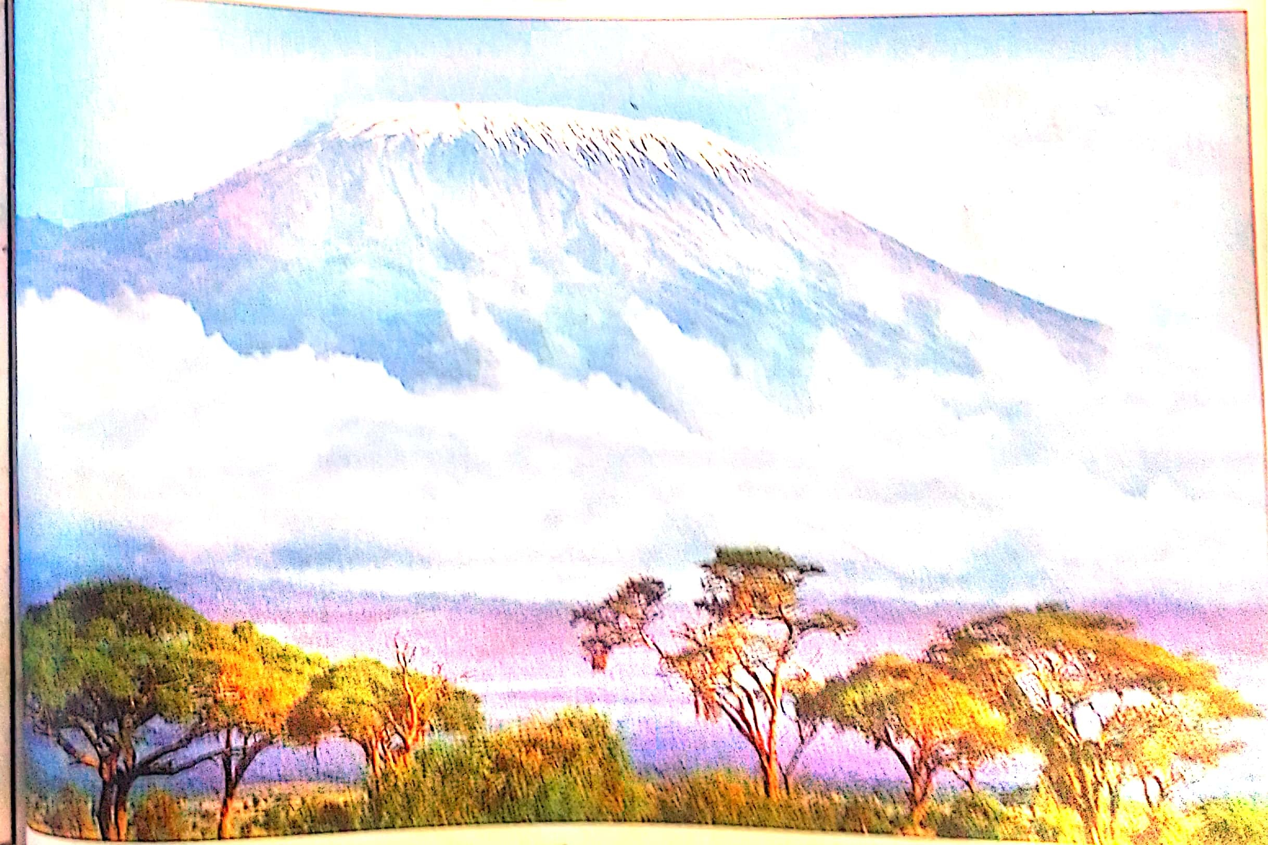

- Name the type of the photography by giving two evidences
- Describe any two (02) environmental problems which may affect the area above
- Identify any two (2) economic activities that might be conducted on the area shown on the photography by means of supportive evidences.
- Suggest one area where photograph might have been taken.
- Write one importance of the vegetation shown on the fore ground.

SECTION C
Answer any two (02) questions from this section
- Hydroelectric power contributes to the large percentage of electricity generated in Tanzania. The Tanzania electricity supply company (TANESCO) is the main producer of hydroelectric power in Tanzania. It produces electricity at several hydroelectric projects. Despite its achievement the company faced with several problems. Explain six (6) problems facing HEP production in Tanzania.

- Explain six (6) determinants which lead to the location of manufacturing industries in Tanzania.

- Form three students had a field study to the National Bureau of statistics. In the site, the statistician explained to them about different concepts of statistics and their benefits to users. Describe six (6) benefits of statistics that might have been explained by the statistician.

