PRESIDENT’S OFFICE
REGIONAL ADMINISTRATION AND LOCAL GOVERNMENT
FORM THREE LONGIDO DISTRICT EXAMINATION
GEOGRAPHY MARKING SCHEME
TIME: 2:30 HRS Thursday 6th August 2020

- Multiple choice questions

i | ii | iii | iv | v | vi | vii | viii | ix | x
B | B | A | A | C | C | A | A | C | C

- Matching items
i | ii | iii | iv | v | vi | vii | viii | ix | x
M | L | K | J | D | F | G | A | B | C

- Five (5) Factors for soil formation (10 marks)
- Define soils : Soil is the natural body of mineral, organic and nutrient constituents which result from the interaction of the country rock with the environmental factors of climate, topography, plant and animal life. (1.5 marks)
- Main body, give five factors (PCROT) 1.5 marks@
- Parent Material (Rock):This is the most important factor in soil formation since it determines the type of soil formed, soil colour, soil depth, the rate of soil formation, soil structure, soil texture, porosity and mineralogical composition or its fertility
- Climate: The important variables under climate include temperature, precipitation and wind. Temperature affects the rate of decomposition of organic matter, it contribute to soil profile development through weathering as well as the rate soil development. Precipitation also affects soil profile development. In some areas soil is eroded, leading to soil profile destruction while in areas deposition leads to positive soil development. Wind has both positive and negative impacts on soil profile development. It can erode the soil through deflation leading to soil degradation or it can deposit some materials at the edge of the desert to form the soil called loess.
- Relief (topography):The role of topography in soil formation is mostly indirect. It influences climate and vegetation. It controls the rate and nature of weathering, removal and deposition (redistribution) of the soil parent materials.
- Living Organisms (Biotic):These include the influence of plants, animals as well as human beings.
- Time: The time factor may be associated with the age of the country rock especially those on which soil have been directly formed.
- Conclusion. Any relevant one (1marks)

- Explain on six (6) factors affecting rainfall distribution on the earth’s surface.
This is the short essay question which have three parts i.e introduction, main body and conclusion.
- Introduction (2 marks)
In this part define rainfall and rainfall distribution/variation:
- Main body ( give six factors with 1 marks each factor)
- Vegetation cover
- Water bodies
- Ocean currents
- Prevailing winds
- Distance from the equator
- Distance from the sea
- Altitude or relief
- Nature and shape of the coast
- Human activities
- Conclusion (Any relevant conclusion: 2 marks)

- Study the map extract of Mkomazi (sheet 109/1) then answer the question that follows: (21 marks)

- Convert the given map scale into statement scale (2 marks)
Given scale 1:50,000
1km =100,000cm $\frac{1km ×50,000cm}{100,000cm}$ $\frac{5km}{10}$ $\frac{1km}{2}$
? km = 50,000cm
1cm $≈0.5 km$
Therefore one centimetre on the map represent a half kilometre on the ground
- Measure the distance of the railway from grid reference 960860 to grid reference 0205822 (4 marks)
Map distance obtained is 31.2cm
1km =100,000cm $\frac{1km ×50,000cm}{100,000cm}$ $\frac{5km}{10}$ $\frac{1km}{2}$
? km = 50,000cm
1cm $≈0.5 km$ $\frac{31.2cm ×0.5km}{1cm}$ 15.6km
31.2cm ?
Therefore the distance is 15.6km
- Measure the area of the seasonal swamp and give your answer in KM²
Data given:
Full square:0
Half square:68
Scale given 1:50,000
Total squares = full square = $\frac{half square}{2}$ 0 + $\frac{68}{2}$ 34 total squares
1 square box have 2cm each side
According to scale 1:50,000: 1cm = 0.5 km $\frac{2cm ×0.5 km}{1cm}$ 1km
2cm = ?
1km ×1km =1km² therefore area of 1 square =1km² 34 squares × 1km²
Area of seasonal swamp is 34 km²

- Name two ways used to show the height of the land in the mapped area (4 marks: evidences by showing position is needed to get a total of 2 marks @)
- Contour method which have been used to join places with the same height above the sea level. It is seen almost all parts of the map
- Hachuring method which have been used to show direction of slopes along the railway
- With evidences from the map, give three natural contents shown on the map. (1%@=3marks)
- Forest which is found on western part of the map at Kwamiali area
- Seasonal swamps which is found in many parts of the map like South Eastern part of the map.
- Scrubs in many parts like Southwestern part of the mapped area
- River such as Pangani river

- Give three economic activities taking place in the mapped area(1%@=3marks)
- Trade activities due to presence of road and railway which facilitate goods and people movement
- Lumbering activities due to presence of forest in western part of the map
- Agriculture activities, there is pastoralism on the area due to presence of scrubs in many parts of the map as well as river which support irrigation.
- 6tourism activities due to presence of forest in western part of the map
- Carefully study the following photograph and answer the questions that follow.
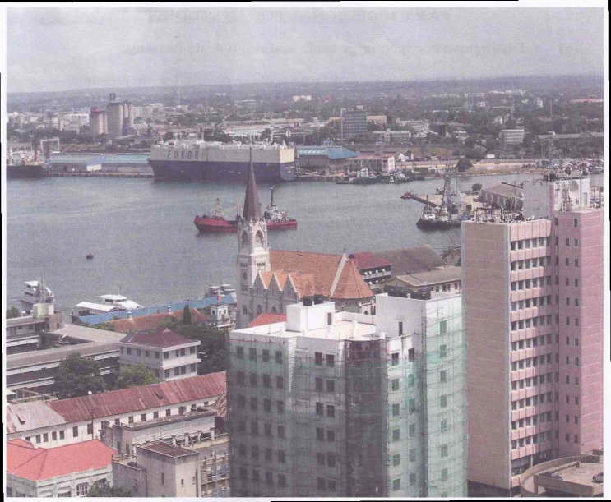
  - Suggest the type of the photograph by giving two reasons. (3 marks: to give type 1%, reason 1%@)
OBLIQUE PHOTOGRAPH because it shows both side and top view, it covered large area, it shows horizon and terrain, features appears in trapezoid shape especially top of buildings, etc.
  - Suggest any four economic activities that might be taking place in the area shown on the photograph. (4 marks 1%@ activity which have clear evidence)
- Fishing activities due to presence of water body that can be a lake in central part of the photograph
- There is trade activities due to presence of town area and water transport
- There is tourism activity due to presence of tall buildings that can be hotels for accommodating tourists as well as water body that can be a ocean
- Manufacturing industry due to presence of factory building in the back ground of the photograph.
  - Comment on the nature of the settlement pattern as it is portrayed on the area. (3marks)
- The nature of settlement pattern is nucleated because houses are seen to be in compacted form both in the fore and back ground of the photograph

- The government only can improve agricultural sector in Tanzania. Discus. (6 points)
This question should have three parts that is introduction, main body and conclusion.
- Introduction: define agriculture by giving its two categories (2%)
Agriculture refers to an activity which involves animal keeping and crop cultivation. There are two types of agriculture that is small scale and large scale agriculture.
- Main body: (point 1%, accurate explanations 0.5%, example 0.5% total 2%@ )
- Contribution of the government in agricultural development includes providing loans and subsidies to farmers, finding markets for their crops, direct involvements in agriculture, etc. not only the government that can promote agriculture but also there are other factors as follows:
- Availability of capital/fund for investment on buying farm inputs like tractors, storage facilities, fertilizers, pesticides, paying workers, etc
- Availability of reliable market both internal and external market
- Presence of advanced technology like tractors, combined harvesters, storage facilities, fertilizers, pesticides, etc
- Availability of good transport and communication for transporting agricultural products from farm areas to market or industrial centres for example roads, railways, harbours, airways, etc
- Availability of enough and fertile soil.
- Availability of labour force both skilled (veterinaries, doctors) and unskilled people for manual work.
- Women empowerment on agricultural activities since they are main food producers.
- Etc
- Conclusion: any relevant conclusion (1%)

- The current Tanzania government shows much effort to improve mining sector. Which benefits will be obtained from this sector? (6 points)
This question should have three parts that is introduction, main body and conclusion
- Introduction: Define mining by giving examples (2%)
Mining is an activity that involve extraction of minerals and fossil fuel eg diamonds, gold, silver, natural gas, iron, tanzanite, etc
- Main body:benefits of mining (point 1%, accurate explanations 0.5%, example 0.5% total 2%@ )
- Employment opportunities to people
- Development of social services like hospitals, schools, water and power services as well as infrastructures.
- Development of towns and cities.
- It is the source of national income both within or foreign currency.
- Mining lead to the development of other economic sectors such as trade, agriculture, industries, fishing through income generated as well as raw materials and energy provided.
- It bring about good relationship with other countries for country’s development.
- Etc.
- Conclusion: any relevant conclusion (1%)

- Explain on the limitations of tourism sector in most East African countries. (6 points)
This question should have three parts that is introduction, main body and conclusion
- Introduction: Define tourism and give its two types by giving examples (2%)
Tourism is an activity which involve movement of people from their home to the place of interest for leisure, study or business. There are two types of tourism which are domestic tourism and international tourism.
- Main body: limitations of tourism (point 1%, accurate explanations 0.5%, example 0.5% total 2%@ )
- Fund problems
- Infrastructure problems
- Lack of government support
- Shortage of labour force especially skilled personnel
- Political conflicts and civil wars
- Shortage of honeypots/ tourist attractions
- Poor management in tourism sector: some are corrupt, etc
- Climatic problem that also cause seasonal variation in tourists.
- Conclusion: any relevant conclusion (1%)

