PRESIDENT’S OFFICE
REGIONAL ADMINISTRATION AND LOCAL GOVERNMENT
FORM THREE LONGIDO DISTRICT EXAMINATION
GEOGRAPHY
TIME: 2:30 HRS Thursday 6th August 2020
Instructions
- This paper consist of two sections A and B with the total of 9 questions.
- Answer all questions in section A and Only two questions from section B.
SECTION A (70 marks)
- Read the following statement careful and write the letter of the most correct answer.
- The following list contains ocean floor features
- Continental shelf, valley and oceanic ridge
- Continental shelf, continental slope and oceanic ridge
- Continental shelf, plateau and oceanic ridge
- What is the compass direction for 202⁰
- SSE
- SSW
- NWN
- Which planet that supports life among the following?
- Earth
- Mercury
- Mars
- Rainfall caused by vertical rising of moist air current:
- Convectional rainfall
- Cyclonic rainfall
- Orographic rainfall
- The following is the outcome of the economic importance of land reclamation.
- Increases Soil erosion and fertility
- Decrease land production capacity
- Increase land production capacity
- The radio free Africa announce news in Mwanza 45⁰E at 10:00pm. What will be the local time in London?
- 01:00Am
- 7:00Am
- 7:00Pm
- As someone ascends in altitude , the temperature tend to
- Decrease at the rate of 0.6⁰C for every 100metres
- Decrease and increase at the same time.
- Increase at the rate of 0.6⁰C for every 100 metres.
- A small scale is significant because it is used to
- Draw map which cover large area
- Draw map which cover small area
- Cover a small area but features are seen Cleary.
- Is the type of photograph which have constant scale
- Ground photograph
- Oblique photograph
- Vertical photograph
- Is the type of survey conducted specifically for measurements on physical features
- Plane survey
- Hydrographic survey
- Topographic survey
- Match the items in List A with the responses in List B by writing the letter of the
correct responses beside the item number in your answer sheet provided
List A | ListB
(i) The gallax from which the solar system containing the planet earth is found.  (ii) A large area on the earth's surface with uniform characteristics of temperature, rainfall and vegetation.  (iii) The amount of water vapour in the atmosphere  (iv) A process that course the wrinkling of the earth's surface rocks.  (v) Stevenson’s screen  (vi) is the vertical section of the soil from the surface to the parent rock  (vii) Grid reference  (viii) This refers to the arrangement of soil particles into aggregate compound particles  (ix) Cadastral map  (x) Refer to the process in which nutrients are washed down in solution from the top- soil layer. | A. Soil structure  B. Conducted for boundary purpose A screen showing precipitation  C. Leaching  D. Weather station  E. Dew  F. Soil profile  G. It is stated by starting with Eastings followed by Northings  H. Tensional force  I. Natural region  J. Compression force  - Humidity  - Equatorial climate  - Milk way  - Soil air  - Conducted for linear measurement

- Explain five factors which influence soil formation by using the knowledge you have studied on soil.
- Explain on six (6) factors affecting rainfall distribution on the earth’s surface.
- Study the map extract of Mkomazi (sheet 109/1) then answer the question that follows:

- Convert the given map scale into statement scale.
- Measure the distance of the railway from grid reference 960860 to grid reference 0205822.
- Measure the area of the seasonal swamp and give your answer in KM²
- Name two ways used to show the height of the land in the mapped area
- With evidences from the map, give three natural contents shown on the map.
- Give three economic activities taking place in the mapped area

- Carefully study the following photograph and answer the questions that follow.
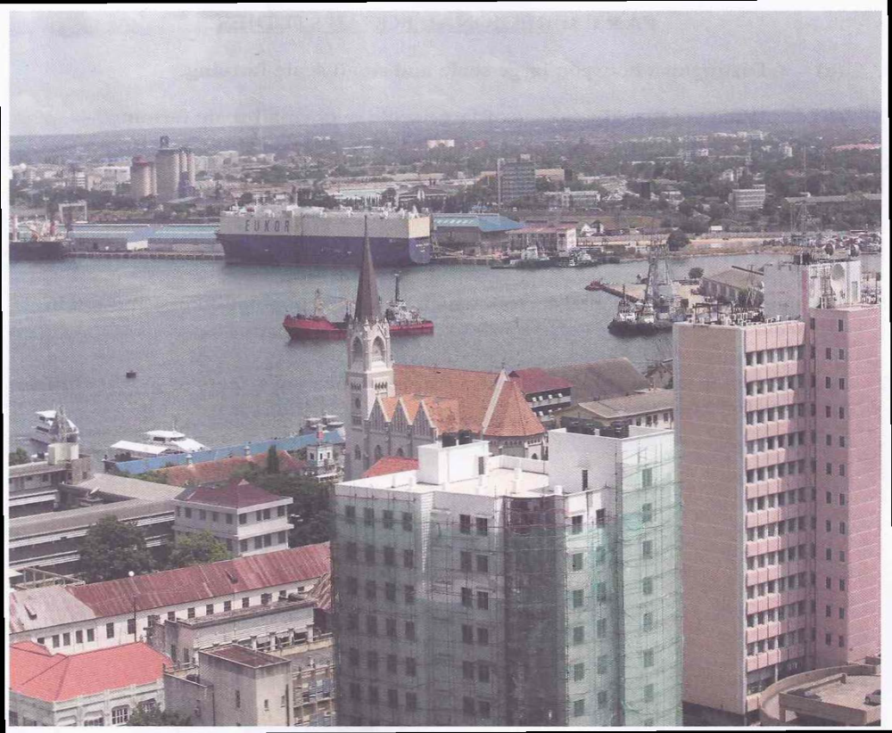
  - Suggest the type of the photograph by giving two reasons.
  - Suggest any four economic activities that might be taking place in the area shown on the photograph.
  - Comment on the nature of the settlement pattern as it is portrayed on the photograph.

SECTION B (30 marks)
Answer two questions from this section
- The government only can improve agricultural sector in Tanzania. Discus. (6 points)

- The current Tanzania government under President John Magufuli shows much effort to improve mining sector. Which benefits will be obtained from this sector? (6 points)

- Explain on the limitations of tourism sector in most East African countries. (6 points)

