PRESIDENT’S OFFICE
REGIONL ADIMINSTRATION AND LOCAL GOVERNMENT
LONGIDO DISTRICT EXAMINATION SYNDICATE
GEOGRAPHY FORM III PRE-REGIONAL EXAMONATION,SEPT 2019.
TIME:3HRS
INSTRUCTIONS
1.This paper consist of section A,B and C
2.Answer all questions in section A and B and two questions in C
3.Map extracted of KIGOMA is provided
4.Cellular phones and calculators are not allowed in the examination room.
5.Write your names (Examination number) on every page of your answer sheet.

SECTION A (15MARKS)
PHYSICAL AND MATHEMATICAL GEOGRAPHY
- For each of the items (i)-(x) choose the correct answer from the given alternatives and write its letter beside the item number.
- Which sequence of the following process is necessary for the formation of rainfall
- Condensation, cooling, and Evaporation
- Evaporation, sedimentation and cooling
- Evaporation, condensation and cooling
- Evaporation, cooling and condensation
- Evaporation, cooling and sedimentation
- Rock exfoliation is the result of
- Chemical weathering
- Physical weathering
- Biological weathering
- None of the above
- Both chemical and biological weathering
- In grid reference the Easting number located at
- Both Easting and West part
- Both north and South part
- At the centre of the map
- A number of longitudes
- In Triangle which have the dot
- What is the compass bearing of WNW
- 270⁰
- 337⁰
- 315⁰
- 327⁰
- 292⁰
- Which of the following statement is true about equatorial region?
- It has small annual range of temperature
- It has four rainfall maxma
- It experience the temperature below 20⁰c
- It has high annual range temperature
- It’s found between 15⁰ and 30⁰ north and south of Equator

- Salinity of the ocean depend on the following except
- Amount of fresh water inters in the ocean
- Distance from the Equator
- Nature of the Evaporation capacity
- High tides and low tides
- The volume of water
- The less rigid semi-molten plastic materials for balancing earth movement is known as;
- Lithosphere
- Isostatic Readjustment
- Asthenosphere
- Barysphere
- Mantle
- Testing of A nuclear, dynamite and mining explosing are greatly associated with;
- Endogenic force
- Artificial force
- Exogenic force
- Explosive force
- The branch of natural or Earth science, which studies the properties and distribution of soil is referred to as;
- Geology
- Climatology
- Neurology
- Pedology
- AStology
- If the time at town X 15⁰E is 12:00 noon. What could be the longitude of town Y if is 8:00am?
- 15⁰W
- 30⁰E
- 30⁰W
- 45⁰W
- 45⁰E
- Match the following items in List A with the Responses in List B by writing the letter of the correct response beside the items number
LIST A
(i) Soil texture
(ii) Soil fertility
(iii) Soil profile
(iv) Cation Exchange
(v) Soil erosion

LIST B
A. Contains granular increase the soil fertility
B. Can be determined in the field by sense of feel, either rough or smoothness
C. It influence metabolic reactions in the soil
D. The status of the soil with respect the amount of elements for plants growth
E. It improve soil compatibility and fertility
F. Vertical arrangement of the soil from the top to underlying rock.
G. Increase soil hardness
H. Chemical soil property
I. The process whereby soil materials are deposited after leaching.
J. Removal of the soil materials from the surface of the land.

LIST A | i | ii | iii | iv | v
SECTION B (55MARKS)
Answer all questions in this section
- What is Earth quake?
(b) Explain briefly five (5) effects of Earthquake.
- Study carefully the following hypothetical data of marks obtained by student in a certain class and then answer the questions that follows.
student | A | B | C | D | E | F | G | H | I | J | K | L | M | N
Marks | 20 | 16 | 16 | 20 | 13 | 22 | 11 | 20 | 24 | 25 | 16 | 16 | 18 | 25
(a) Find the following
(i) Median
(ii) Variance
(iii) Standard deviation
(iv) Mode
(b) Briefly explain the significance of studying statistics in Geography (3 points)
- The chairman of Tingatinga village advised his villagemates to use simple chain survey to get right measurement of their farms show the merits and demerits of simple chain survey.
- Study the map extracted of KIGOMA (sheet 92/3) then answer the question that follows.
- Measure the distance of the roads from grid reference 935630 to grid reference 010636 . The will be in.
- With the vivid from the map, mention the major types of transport shown on the map.
- A part from fishing activities, name other economic activities taking place (3 activities)
- In which hemisphere the map is located. Give evidence for your answer.

- Study the photography given below and then answer the questions that follows;
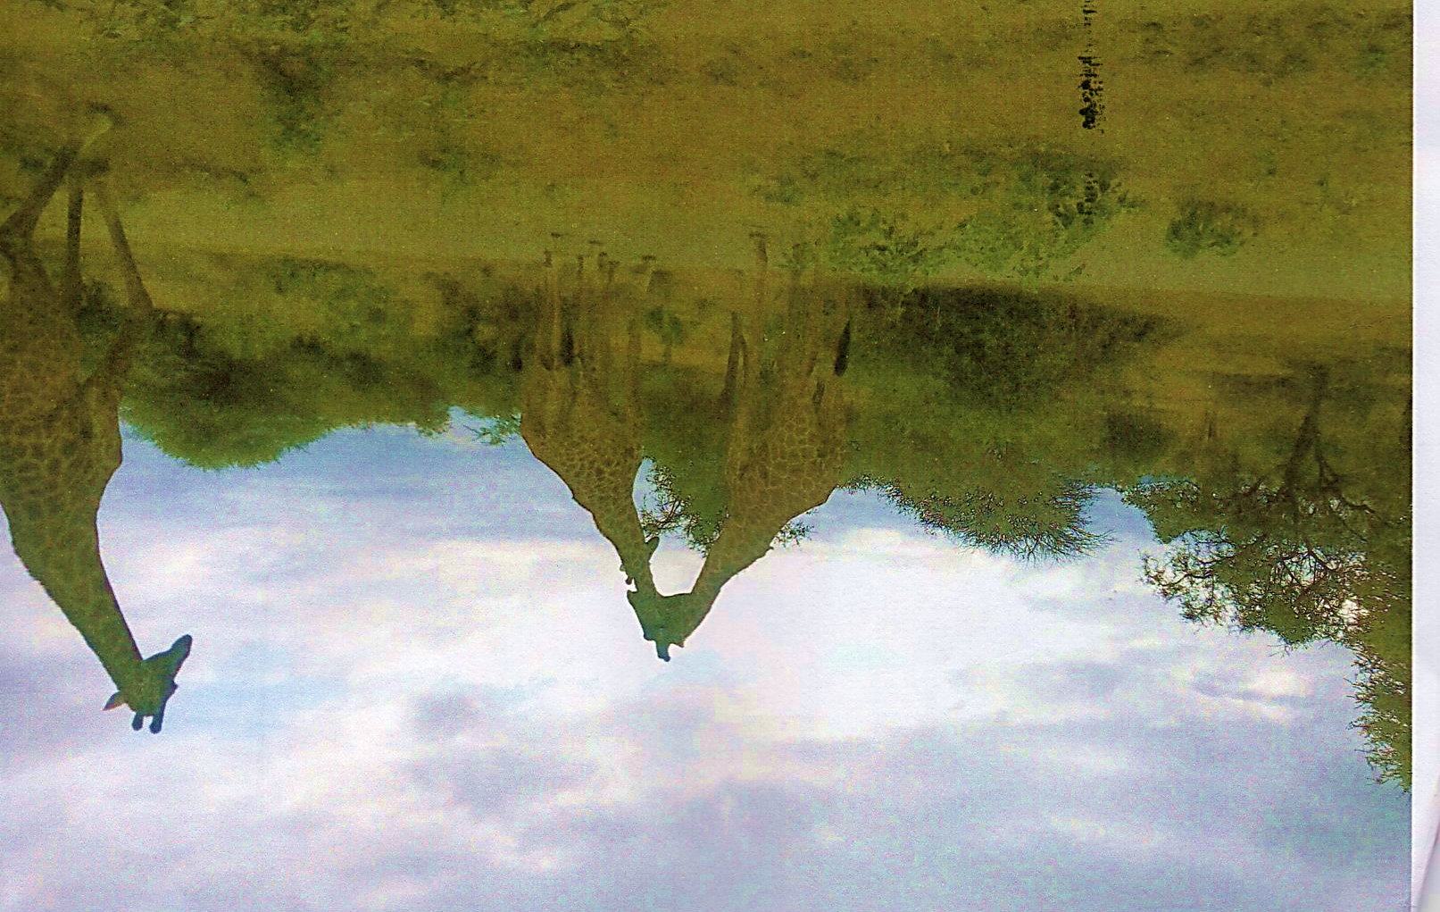
(a) Identify the type of photography
(b) By providing the evidence from the photography describe/suggest the climate of the area.
(c) Give three economic importance of the area
(d) Give four characteristics of the type of photograph in (a) above.

SECTION C (30 MARKS)
Answer two questions from this section
- Does Tanzanian ready to adapt industrial economy? Give seven (7) points to justifying the statement.
- River Transport in Africa is still an existing problem. Discuss by giving six points.
- Explain the problem facing livestock farming in Tanzania.

