PRIME MINISTER’S OFFICE AND LOCAL GOVERNMENT
KARATU DISTRICT COUNCIL
FORM THREE TERMINAL MARKING SCHEME
GEOGRAPHY
013 May 2026

SECTION A (16MARKS)
Qn 1: @ 1mk = 10mks
i | ii | iii | iv | v | vi | vii | viii | ix | x
C | B | B | E | B | C | D | E | A | B

Qn2: @ 1mk = 6mks
i | ii | iii | iv | v | vi
H | E | B | C | A | G

SECTION B (54MARKS)
Qn3:
- Mass wasting
This is the downward movement of weathered materials on a slope under the influence of gravity. (1 mark)

- Types of rapid mass wasting
Mudflows; Is a rapid movement of saturated soil containing gravels and boulders down a slope.
Earthflows; Is a flow of relatively less saturated unconsolidated rock materials down a steep slope.
Landslides; This is the rapid movement of a large mass of debris, rocks or earth down a hill or mountain side.
Rockslide; Is a sliding movement of a slab or rock down a steep slope.
Rockfall; Is a free fall of rock masses from the top to the foot of a cliff.
Avalanche; Is a sudden sliding or falling of a large mass of snow, ice and loose rock materials down a mountain side. (2mk @ = 6mks)

- The nature of the materials and the extent of saturation.
The angle of slope
Climate
The influence of vegetation
Human activities
Earthquakes and volcanic eruptions. (1mk @ = 2mks)
Qn4:
- 1:100,000
Map : Ground
1cm : 100,000cm

But 1km = 100,000cm
1km = 100,000cm
? =100,000cm
1km × 100,000cm = 1km
100,000cm
One centimeter on the map represents one kilometer on the actual ground. ( 2mks)

- Grid reference
Latitudes and longitudes
Bearing and direction 1@ = 3mks)
Place name

- Complete squares = 14
Incomplete squares = 16
Area = Complete squares + incomplete squares
2
A= 14 + 16
2
A = 14 + 8 = 22
A = 22 squares
Scale 1 : 50,000
But 1km = 100,000cm
? = 50,000cm
1km × 50,000cm
100,000cm = 0.5km
Area of 1 square
S × S
2cm × 2cm
2cm × 0.5km × 2cm ×0.5km
1cm 1cm
=1km²
22 squares = 22 × 1km²
=22km² (4mks)

Qn 5:
- Intrusive volcanic features
- Sill – is a rock sheet formed when the magma solidifies horizontally along the bedding plane.
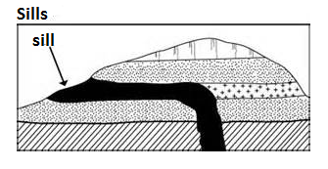
- Dyke- is a rock sheet formed when the magma solidifies vertically across the bedding planes.
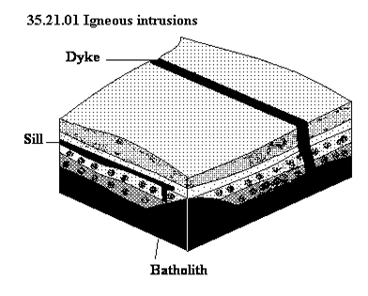
Laccolith is the cone dome shaped mass of rock with flat formed of viscous lava. It looks like a mushroom.
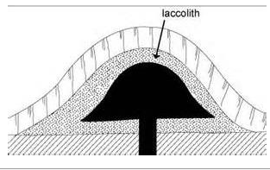

- Lapolith –is a scar shaped mass of rock formed in geo syncline. It forms a saucer – like shape may be due to the increased weight of the deposits
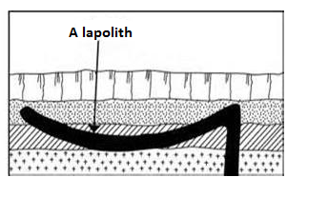

- Phacolith – is a lense shaped strip of igneous rock formed when the magima solidies along the anticline or syncline.


- Batholith is the large mass of solidified rock formed when magma cools plutonically at the great depth at the heart of the mountain ranges.

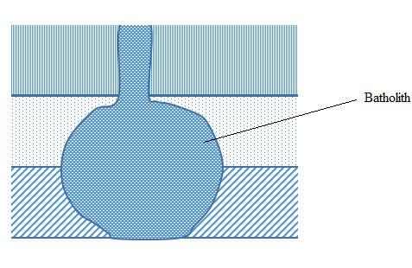1 mark @= 4mks

i. Lava on weathering leads to the formation of very fertile soil which support agriculture.
ii. Volcanicity eruption leads to the formation of mineral deposits like copper deposits
iii. Volcanic eruption provide geothermal power for electric generation
iv. Some hot springs utilized for heating homes in glaciated region
v. Volcanic features attract tourist
vi. Volcanic cones are the source of rivers.
Qn 6
- The difference between weather and climate.
 | WEATHER | CLIMATE
1. The condition of the atmosphere of a |  | The average weather conditions of a
 | place at a particular time over a short | region which have been observed over a
 | period of time | long time
2. | Weather varies from one place to another | Climate remains uniform over a large
 | within a region | region
3. | Weather changes abruptly within a short | Climate change is slow, gradual and
 | period | occurs over many years
4. | There are weather instruments for | Climate elements are not measured but
 | measuring most of the elements of | calculated from the weather
 | weather | measurements
5. | It is obtained through observing weather | It is obtained by using recorded weather
 | instruments and recording them daily, | data over a long period of time
 | weekly or monthly
1mk@ = 4mks
- Factors that affect temperature of a place
- Latitude or distance from the equator; Temperature of a place depends on the amount of sunshine reaching the area, Places near the equator are hotter compared to places far from the equator.
- Altitude; The higher you go the cooler it becomes therefore Karatu is on a higher altitude than Dar es Salaam.
- Cloud cover
- Ocean currents
- Distance from the sea
- Prevailing winds @ 1mk = 3mks
- Data
Karatu;
Altitude = 950m
Temperature =24ºc
kibo
Altitude = 5894m
Temperatures = ?
Difference in altitude = 5894 – 950 = 4944m
Difference in temperature
100m = 0.6ºc
4944m = ?
4944m × 0.6ºc
100m = 29.66ºc
Since kibo is on a higher altitude we subtract from karatu’s temp
24ºc -29.66ºc = -5.66ºc
Therefore the temperature of kibo will be -5.66ºc. 2mks

Qn7
  - Renewable energy is energy which once used can be replaced naturally example solar, hydroelectricity while Nonrenewable energy is the energy that once used cannot be replaced e.g. coal, petroleum, firewood @2mks = 4mks.
  - Sources of renewable energy.
Biogas energy; Is a mixture of gases produced by decomposition of gases produced by decomposition of organic matter such as manure, plant materials, sewage or food waste.
Wind energy; Energy that is generated from wind. Wind turbines are used to generate electricity.
Solar energy; energy generated from the sun using collector panels.
Geothermal energy; Is heat energy generated and stored in the earth. Force from hot water from hot rocks drives turbines to generate electricity.
Hydro electric power; It is created by the force of flowing water from mountains or high cliff. The running water turns the turbines to generate electricity. @1mk = 5mks

Qn8
- Factors for soil formation
  - Climate
  - Relief/ topograghy
  - Living organisms
  - Parent materials
  - Time @1mk =3mks
- Physical properties of soil
  - Soil porosity
  - Soil colour
  - Soil texture
  - Soil density
  - Soil Structure @1mk = 3mks
- Causes of soil erosion
  - Deforestation
  - Overgrazing
  - Shifting cultivation
  - Monocropping @1mk = 3mks

SECTION C (30mks)

Qn9 Land survey is the art, science and technology of measuring and recording distances, angles, directions and elevations in order to position features on the earth surface.
Objectives of survey include; 1.5mks
(i)To determine horizontal distance between points on the earth surface.
(ii)To determine vertical distance or height between the points on the earth’s surface
(iii) To determine the area of the piece of land or plot
(iv)To determine the direction of various features on the earth’s surface
(v) To determine the location of physical and non-physical features on the earth’s @2.5mks
Conclusion: Any relevant 1mk

Qn 10: Define transport……..1.5mks
Solutions to challenges facing transport sector
  - Government should provide financial resources e.g loans
  - To come up with energy efficient means of transport in order to minimize costs
  - To improve Transport safety and security in order to reduce accidents.
  - To carry out environmental impact assessment so as to develop sustainable transport systems.
  - Human and institutional capacity building (Trained labour force to get good drivers)
  - To improve national policies to meet domestic investment needs in transport sector.
  - To improve transport information systems e.g electronic tickets
  - To build and improve transport infrastructure. @2mks
Conclusion: Any relevant @ 1.5

Qn 11: Define mining……………. 1.5mks
Contributions of mining sector to the economy of Tanzania.
  - Government revenue
  - Employment opportunities
  - Provide raw materials for industries
  - Increase gross national product of the country
  - Stimulate development of social services
  - Stimulate the development of infrastructures such as roads @2mks
Conclusion: Any relevant. 1.5mks

