PRESIDENT`S OFFICE
REGIONAL ADMINISTRATION AND LOCAL GOVERNMENT
LONGIDO DISTRICT
FORM THREE MID-TERM EXAMINATION, MARCH, 2024
GEOGRAPHY
MARKING SCHEME
1.
i | ii | iii | iv | v | vi | vii | viii | Ix | x
B | B | A | B | B | B | C | D | A | D
1mark@=10marks
2
i | ii | iii | iv | v | Vi
A | H | C | E | F | B
1mark@=06 marks

SECTION B (54 MARKS)
3. (A) area of whole map (3marks)

Full square = 16
Area =?

Full Square + half square/2

16 + 00
16+00
TS =16Squares.

From the map scale.

1cm = ½ km
2cm = X
1cm x X = 2cm x ½ km
1CmX/1cm = 1CmKm/1cm

X = 1km
Area of square = side x side
1km x 1 km
1km²

Area of 1 square = 1km²
16 Square = X

1 square x X = 1Km² x 16 squares.

1 square/1 square = 5 Squareskm²/1 square

X = 16KM²

Area of the feature is 16Km²

B) i) Water transport (2 marks)
^{ii) Land transport}
C) (i) linear scale (02marks)
^{(ii) Representative scale}
D) To change the scale. (03 marks)
1km = 100,000Cm
X = 50,000 Cm

1km x 50,000 cm = X x 100,000CM
100,000 CM 100,000CM

IKM X ½ = X
X = ½ KM
1CM = ½ KM

One centimeter of a map represents a half kilometer on the ground.

E) 1km = 100,000Cm
X = 50,000 Cm

1km x 50,000 cm = X x 100,000CM
100,000 CM 100,000CM

IKM X ½ = X
X = ½ KM
1CM = ½ KM

1cm=0.5km
9cm=?

9cmx 0.5= 1cmx

4.5kmcm/1cm= 1cmx/1cm =4.5km

Distance of railway from 09031to 11038 = 4.5km
4. a) weather station (1mark)
b) Weather forecasting (1mark)
c) Annual rainfall = Sum of total rainfall
A.R = 50+25+75+45+00+15+25+30+00+24+125+115
A.R = 529 mm
Annual rainfall = 529mm (2 marks)
d) Average annual temperature=sum of total rainfall
Number of months
A.A.T = 12+20+21+17+19+18+15=16+18+19+11
A.A.T = 208=
12
A.A.T =17.3$℃$
Annual average temperature = 17.3$℃$ (2 marks)
e) Thermometer and rain gauge (2 marks)
f) Annual range temperature = maximum temp- minimum temperature
A.R.T =22-11=11
A.R.T =11$℃$ (1mark)
5. Volcanic features (relevant diagram)
- Sill
- Dyke
- Laccolith
- Lopolith
- Phacolith
(2marks each any five points)

6. (A) Mass wasting (1mark)
(B) Factors affecting mass wasting
- angle of slope
- climate
- the influence of vegetation (2 marks each any four )
- human activities
- Nature of materials and extent of saturation
- Earthquakes and volcanic eruptions

7. Effects of earthquakes
- Faulting and production of joints
- Landslides lead to land degradation
- Destruction of infrastructure
- Death of people
- occurrences of Tsunami (1Marks@ Any five points)
- Destruction of houses
- Lead to fire outbreak
8. A). Rock cycle (relevant diagram) (2 marks)
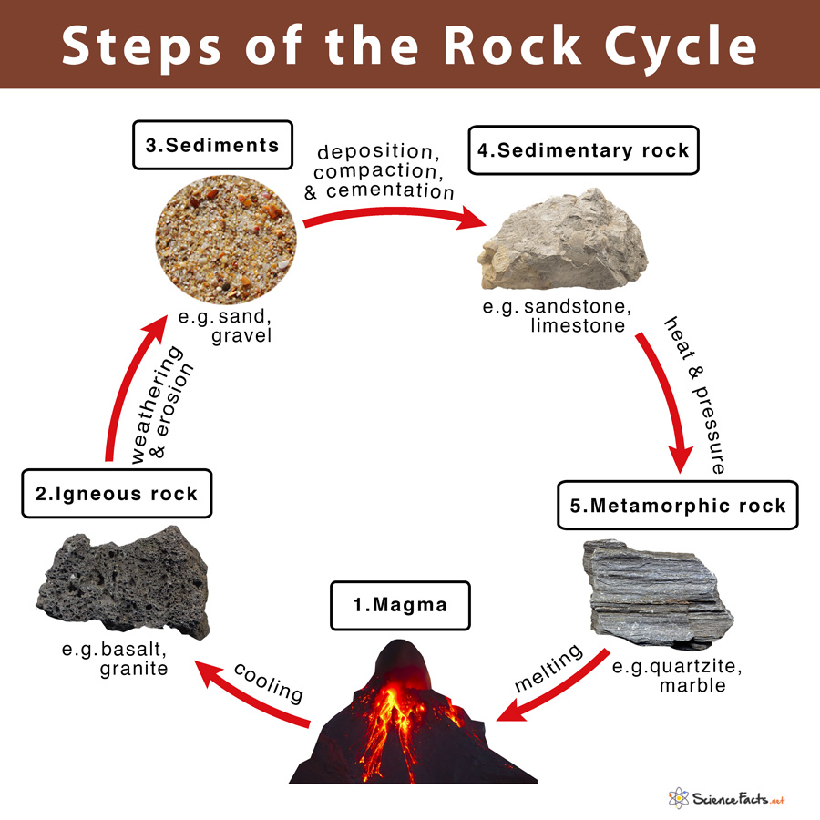

B) Internal structure of the earth.
- The crust is outermost and thinnest zone of all zones of the internal structure of the earth, consist of sima and sial.
- The mantle is made up of very dense igneous rocks of iron silicon and oxygen (3marks)
- The core is innermost part of the earth it consist of nickel and iron ,the core is under great heat and pressure

- Results/ effects of earth rotation.
- Gain or loss of a day when crossing the International Date Line
- Deflection of winds and ocean currents
- The daily rising and falling of tides (0.5@ any four points=02)
- Day and night
- Differences in time between places located at different longitudes

SECTION C (30 marks)
- Introduction (2marks)
Relief. Is the variations in the elevation of the ground or height above the plain.
Relief features (main body)
- Mountains
- Plateaus.
- Valley. (6@2mark= 12 marks)
- Basins.
- Hills.
- Ocean.
- Island
- Conclusion (1mark)

- Introduction.
Manufacturing industry is industry which involves processing and changing the materials order to make new product of great value to man. (2marks)
Factors for location of manufacturing industries
- Availability of raw materials
- Availability of capital
- Availability of power supply
- Availability of land
- Availability of skilled and unskilled labor(2marks@ any six points)
- Good transport and communication
- Government support
- Conclusion (1mark)

- Economic importance of rocks
Introduction (2marks)
Rocks is an aggregate of minerals in a solid state.
- Formations of soil
- We get minerals and metal
- Used for fuel such as coal
- Storing underground water (2marks @ any six points)
- Limestone used for manufacturing of cement
- Salt extraction take place in rocks
- Manufacturing of chemical such gypsum
- Define the landscape
- Conclusion (1mark)

