THE UNITED REPUBLIC OF TANZANIA
THE PRESIDENT’S OFFICE
REGIONAL ADMINISTRATION AND LOCAL GOVERNMENT
NAMANGA FORM THREE PRE-MIDTERM EXAMINATION


GEOGRAPHY
MARKING SCHEME AUGUST 2024

SECTION: A (16 MARKS)
- choosing the correct answer 10 MARKS
D | A | D | C | B | C | B | A | C | A

- Matching the items 06MARKS
COLUMN A
COLUMN B | F | E | D | C | B | A

SECTION: B (54 MARKS)
- Student should study climatic data given then to answer the questions given. 09 MARKS
- Calculate the mean annual temperature for the station =02 MARKS
$$Annual mean Temperature=\frac{total temperature}{12month}$$

$$Temperature=\frac{313.9}{12month}=26.15 C$$

- Calculate the annual range of temperature =01 MARKS
$$Annual Range Temperature=H.Temperature-L.Temperature$$
$$Annual Range Temperature=27.2-25=2.2 C$$

- Calculate the total rainfall for the station =02 MARKS
$$Total Rainfall=Sum of all rainfall in a year$$
$$Total Rainfall=2416MM$$
- What are the three economic activities can be conducted in the station =02 MARKS
- AGRICULTURE because the area receives enough rainfall in a year.
- FISHING because the place has many waters bodies
- LUMBERING since the place is covered by thick forest.
- Give two reasons for suggesting the type of climate of the station. =02 MARKS
- EQUATORIAL CLIMATE because, has lo annual temperature range which is 2.2C also the area receives heavy rainfall in a year which is 2416MM

- Student should explain the internal structure of the earth with the aid of diagram 09 MARKS
- Inner Zone includes: -
- Crust
- Mantle
- Core
- THE CRUST (LITHOSPHERE).
- Is the outermost layer of the earth which form the part of the earth on which we live. It sometimes known as lithosphere.it consist of two layers namely, SIAL and SIMA.
- SIAL is the upper layer of the earth crust which is made up by silica and aluminums. The sial form the continents.
- SIMA is the layer below sial which consist of silica and magnesium. The sima underlies continental blocks and form the ocean floor.
- A thin envelope of air mass, which is known as ATMOSPHERE surround the earth’s crust.
- It has a layer called CONRAD DISCONTINUITY which separate sial and sima.

- THE MANTLE (MESOSPHERE).
- The mantle is the second layer of the earth, it is also called mesosphere. The mantle lies between the crust and core. It is made up of very dense igneous rocks of iron and manganese silicates.
- It is separated from the crust by the layer called MOHOROVIC DISCONTINUITY.
- Mantle is divided into Upper mantle (Asthenosphere /molten layer) and Lower mantle.

- THE CORE (BARYSPHERE)
- The core is the innermost part of the earth. It is also called barysphere. The core comprises of two main parts, the inner and the outer core.
- The inner part composes iron and nickel while the outer part consists of uranium, rhodium and thrombium.
- It is believed that the core is in a molten state because it is subjected to great heat and pressure.
- It is separated from mantle by a layer called GUTENBERG DISCONTINUITY.
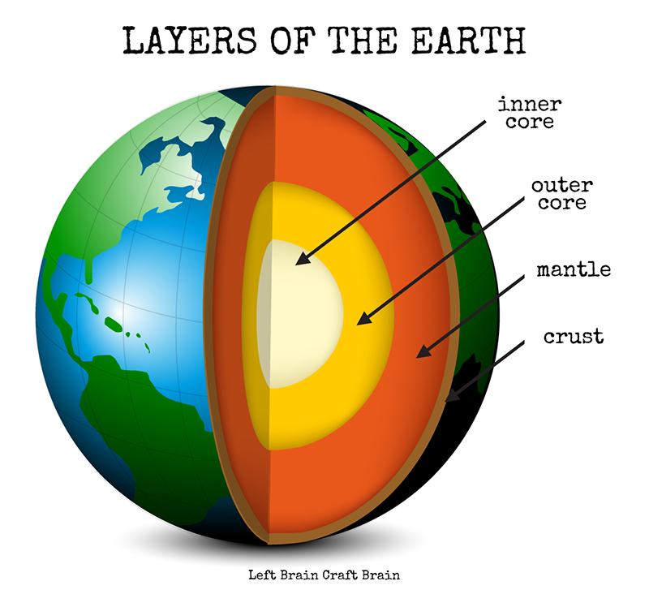

- Student should explain the terminologies given 09 MARKS @3
a) Asthenosphere Is the semi –molten fluid material which can move easiy, hence carry the Lithospheric plates and it is responsible for balancing of the earth material through Isotactic.The asthenosphere is between 100-200Km below upper mantle.
b) Diastrophismis the type of internal forces which involves physical displacement ot the solid part of the earth surface, sometimes diastrophism is called Earth movement. Examples of diastrophism is Faulting. Folding and Earthquakes.
c) Hade It is the inclination of the fault plane that is vertical or the angle between a fault plane and the vertical, measured perpendicular to the strike of the fault.

- Student should explain any five volcanicity features 09 MARKS
Intoduction =1.5 MARKS
Features =1.5MARKS ( Diagram 0.5, features and explanation 1)
Volcanicity features are also called Etrusive Vulcanicity features.
  - ASH AND CINDER CONE (Scoria cone)Is the cone shaped like structure formed when the rock fragment (Ashes) are accumulated or solidifies along the event and its slope is concave Example Busoka and Butala S.W Uganda.
  - COMPOSITE CONE /STRATA VOLCANOThese are formed of alternate layer of cinder and ash on one side while on the other side there is accumulation of lava which are being solidifies Example Nyilanyonga and Kilimanjaro.
  - VOLCANIC PLUGIs a rigid cylidrically plug formed when a very viscous lava solidifies immediately at the mouth of the vent.
  - EXPLOSION CRATERI t is a hole formed which have a shape like funnel found on top of volcano due to violent eruption of magma. Example of lake Turkana (Kenya).
  - CALDERAIs a large rounded depression (crater) formed when the upper part of the volcano is either bomberd of in the volcanic cone. Example Ngorongoro crater.
  - SHIELD VOLCANO /BASALT DOMEIs an extensive cone with gently sloping side formed when basic (basalt) lava is poured on the surface and spread to occupy a large area.
  - COMULO DOME /ACIDIC LAVA CONE It is a dome shaped volcano with steep sides formed when the acidic solidifies around the event. Example Uyole in Mbeya.

- Student should answer the map question as follows-. 09 MARKS
- The bearing is 280⁰ and direction is South West. =02 MARKS
- Three economic activities taking place in the area. =03 MARKS
- Fishing due to presence of Lake Tanganyika.
- Transportation due to precent of waterbodies, road and railway.
- Trade due to presence of infrastructure which attract trade and town center.
- Actual ground distance will be 6KM times 3 times = 18KM =02 MARKS
- Type of North is GRID NORTH due to present of gridline Northing =02 MARKS

- Student should study the photography given then answer the question as follows: -. 09 MARKS
- SEDENTARY LIVESTOCK FARMING or (ZERO GRAZING.) =02 MARKS
- Pros (merits, advantages) of Zero grazing. =02 MARKS
i. The animals are healthy.
ii. Yield is high since; the method uses more advanced technology than nomadic technology.
iii. High disease control and food supply.
vi. Easy for pastoralists to get assistance e.g., education
vii. Environment conservation.
viii. Manure can be used in the garden and other crops farms.
ix. Farmer can get balanced diets and carbohydrate.
x. Farmers can engage in different activities example Fishing, trading etc.
xi. Easy to count animals in the country.
- Chaga and pare of Kilimanjaro, Meru of Arusha and Bena of Njombe=02 MARKS
- Large scale farming, because animal are health and the use of modern sheds. =01 MARKS
- Reasons to why farmer practice that type of agriculture=02 MARKS
- Increase in the level of education.
- Advancement in technology.
- Increase number of populations.
- Government encourage farmer to settle in one place.
- Pastoralist want to engage in other activities e.g., fishing, trade etc.
- Farmer want to get high yields

SECTION:C (30 MARKS)

- Introduction -02 MARKS
Meaning of water sources
- Main body -02 x 6 =12MARKS
Student should explain how the distance to water sources from the household affects the girl children
- The girl wastes a lot of time looking for water
- Girls cannot participate in studying effectively
- Health problems e.g., Tiredness
- Girl can be attacked by dangerous animals e.g., Lion
- Girl cannot learn other importance responsibilities
- Sexual harassment e.g., rape
- Conclusion -01 MARKS
Any relevant
TOTAL MARKS=15%

- Introduction -02 MARKS
Meaning of Tourism
- Main body -02 x 6 =12MARKS
Student should explain how the tourism sector has the bright future.
- Good governent support: The government has shown a greater interest in promoting this industry Through the following ways: -
- The ministry of Natural Resources and Tourism has been so much active in promoting this economic sector. The departments into chemistry have their own policies.
- There are promotion offices in different countries for advertising tourism in Tanzania. For example promotion offices are in Germany (Frankfurt), Sweden (Stockholm), North America, New York and England (London). There has been promotions campaigns going like the one launched at the 36th ) International Tourism exchange (ITB) in Berlin, March 2001 to make other nations know that Tanzania is among the attractive destination in the world.
- It created the tourist industry new promotion logo that is Tanzania the land of Kilimanjaro and Zanzibar and about 50 tour operators, hoteliers, lodge keepers and the tourist Board presented the nation as an ideal holiday destination offering wide range of possibilities for the discerning visitors from abroad.
- Then Tanzania's minister for Natural Resources and tourism said “even though beach tourism and safari will continue to be the backbone of Tanzania tourism industry, we are trying to develop more niche products and special interest in tourism”. “This is part of Tanzania's ongoing efforts to develop an economy friendly and environmentally sustainable development of tourism which will preserve the country tourism resources and enhance the wellbeing of the host population”.
- There is a wide variety of tourist attraction (honey pots) this ranges from game reserves, national parks, coastal beaches historical sites coral reefs cultural aspects like language and dressings and the carving, spectacular features like the Kilimanjaro mountain lake Tanganyika.
- New areas are being established: These include into the southern circuit lake region and coastal areas as well as in the islands of mafia and Zanzibar.
- The east African cooperation will act as a dynamo in the promotion of tourism like many other east African countries. The cooperation will intensify security measure will enhance visitors mobility in the region and advertisement of tourism sector visa procurement procedures will be implied.
- The government stability: that has made the country maintain some degree of peace will continue attracting the visitors into the country with conflicts like the Democratic Republic of Congo, Rwanda and Burundi, Tanzania is struggling to maintain security so as it can become a safer destination.
- The government is trying to use information Technology in the tourism industry: so that the activities should keep on running more effectively and monitoring the tourist activities in the country.
- Tanzania has established international relationship with other countries in the world: Apart from attracting more tourists especially from Germany, the country is seeking more German investment in further developing of tourism infrastructure. Germany has been supporting management and conservation of some other national parks within the frame work of German Development and investment company (DEG) is actively involved in Tanzania hotel and tourism sector and help to build up several hotels, lodges and tourist facilities.
- The government of Tanzania under the president SAMIA SULUHU, put much emphasis on improving infrastructure in the country: These will facilitate the movement of tourists in the country. This including improvement of old roads and constructions of new roads as well as construction of new standard gauge railway which run from Dar-es-salam to Dodoma via to morogoro.
- Conclusion -01 MARKS
Any relevant

TOTAL MARKS=15%

- Introduction -02 MARKS
Meaning of mining
- Main body -02 x 6 =12MARKS
Student should explain the challenge that can be caused by mining sector.
- Can cause land degradation (destroy nature of landscape)
- Deforestation due to clearing of vegetation
- Global warming and Greenhouse effect.
- Disappearance of some species (loss of biodiversity)
- Accelerate the spread of malaria. It creates natural habitats for dangerous insects: The pits which are flooded with water act as mosquito breeding places and hence accelerate the spread of malaria
- It accelerates soil erosion
- Environmental pollution
- Water pollution
- Noise pollution
- Air pollution
- Soil pollution
- Change of soil texture and structure

- Conclusion -01 MARKS
Any relevant

TOTAL MARKS=15%

