THE UNITED REPUBLIC OF TANZANIA
THE PRESIDENT’S OFFICE
REGIONAL ADMINISTRATION AND LOCAL GOVERNMENT

NAMANGA FORM THREE PRE-MIDTERM EXAMINATION

GEOGRAPHY
Time: 3 Hours August 2024

Instructions
- This paper consists of three sections A, B and C.
- Answer ALL questions in section A and B and ONLY two questions from section C.
- Map extract is provided.
- Credit will be given for the use of relevant sketch maps, examples and diagrams.
- Write your examination name to each page.

SECTION “A” (16 MARKS)
- For each of the following item (i-x), choose the most correct answer from among the given alternatives and write its letter besides the item number in the booklet provided.
- The following are form of organically formed sedimentary rock;

- Argillaceous, arenaceous and rudaceous
- Argillaceous, siliceous and calcareous
- Siliceous, argillaceous and calcareous
- Carbonaceous, siliceous and calcareous
- Carbonaceous, calcareous and arenaceous

- Linda climbed up mountain Kilimanjaro last year. She saw very heavy forests along the way few feet before the peak. Identify the type of climate in the area

- Equatorial region
- Tropical region
- Tundra and polar regions
- Monsoon region
- Mediterranean region

- The transition zone between outer mantle and inner mantle is known as………….

- Conrad discontinuity
- Lehman discontinuity
- Mohorovicic discontinuity
- Repeti discontinuity
- Gutenberg discontinuity

- Paleozoic these are rock formed between: -

- 30-600 million years ago
- 1-20 million years ago
- 220-600 million years ago
- 60-220 million years ago
- 40-300 million years ago

- ……………….is the type ocean Tide that rise very high and fall very low which occur during new moon days and full moon day.

- Neap tides
- Spring tides
- Shallow waves tides
- Deep waves tides
- Crest waves tide

- The season of the year after winter and before summer in which vegetation begins to appear is known as…….

- Fall season
- Autumn season
- Spring season
- Winter season
- Hot season

- A striker from Azam sports club, Fei toto won a prize for the best goal of the year at CAF awards held in Mali. He scored the goal against the Bamako team in Mali (24°S, 39°E) at 4:10Pm. What will be the time his home town in Dar es salaam (34°N, 6°W)?

- 7:10 am
- 1:10 Pm
- 6:22am
- 1:58 pm
- 1:10 am

- The process of changing one types of into another types of rock is called………………...

- Metamorphism
- Sedimentation
- Melting
- Weathering
- Lithification.

- During dry seasons, most plants shade their leaves as a way to reduce the amount of water released, the correct term for this process is

- Evaporation
- Precipitation
- Transpiration
- Condensation
- Infiltration

- The temperature of Mombasa at mean sea level is 20º C. What will be the temperature of Tanga at 2000 meters above mean sea level?

- O8ºC
- -08ºC
- 28ºC
- -28ºC
- 12⁰C

- Match the phrases in “LIST A” with the responses in “LIST B” by writing the letter of the correct response besides the item number.
COLUMN A | COLUMN B
- Conrad discontinuity  - Mohorovic discontinuity  - Guttenberg discontinuity  - Repetti discontinuity  - Lehmen discontinuity  - Asthenosphere | - Semi-molten flid material.  - Layer between inner core and outer core.  - Layer between upper mantle and lower mantle.  - Layer between mantle and core  - Layer between crust and mantle.  - Layer between sial and sima  - Layer between crust and core  - Layer between sial and inner core.

SECTION “B” (54 MARKS)
Answer all the questions in this section and write short answer. Each question carries 09 marks.
- Study carefully data below and then answer the questions that follows.
Month | J | F | M | A | M | J | J | A | S | O | N | D
Temp ºc | 25.5 | 25.5 | 26.1 | 26.7 | 27.2 | 26.7 | 25 | 26.1 | 26.7 | 26.7 | 25.6 | 26.1
Rainfall (mm) | 246 | 180 | 185 | 198 | 165 | 178 | 170 | 198 | 175 | 201 | 256 | 264
- Calculate the mean annual temperature for the station
- Calculate the annual range of temperature
- Calculate the total rainfall for the station
- What are the three economic activities can be conducted in the station
- Give two reasons for suggesting the type of climate of the station.

- The earth consists of inner zone and outer zones. With the aid of diagrams describe the internal structure of the earth.

- Define the following terminologies: -
- Asthenosphere.
- Diastrophism.
- Hade

- There are some forces that operate within and outside the earth surface, which are endogenic forces and exogenic forces. With clearly diagram and examples describe any five volcanicity features.

- Study the map given then answer the questions that follows: -
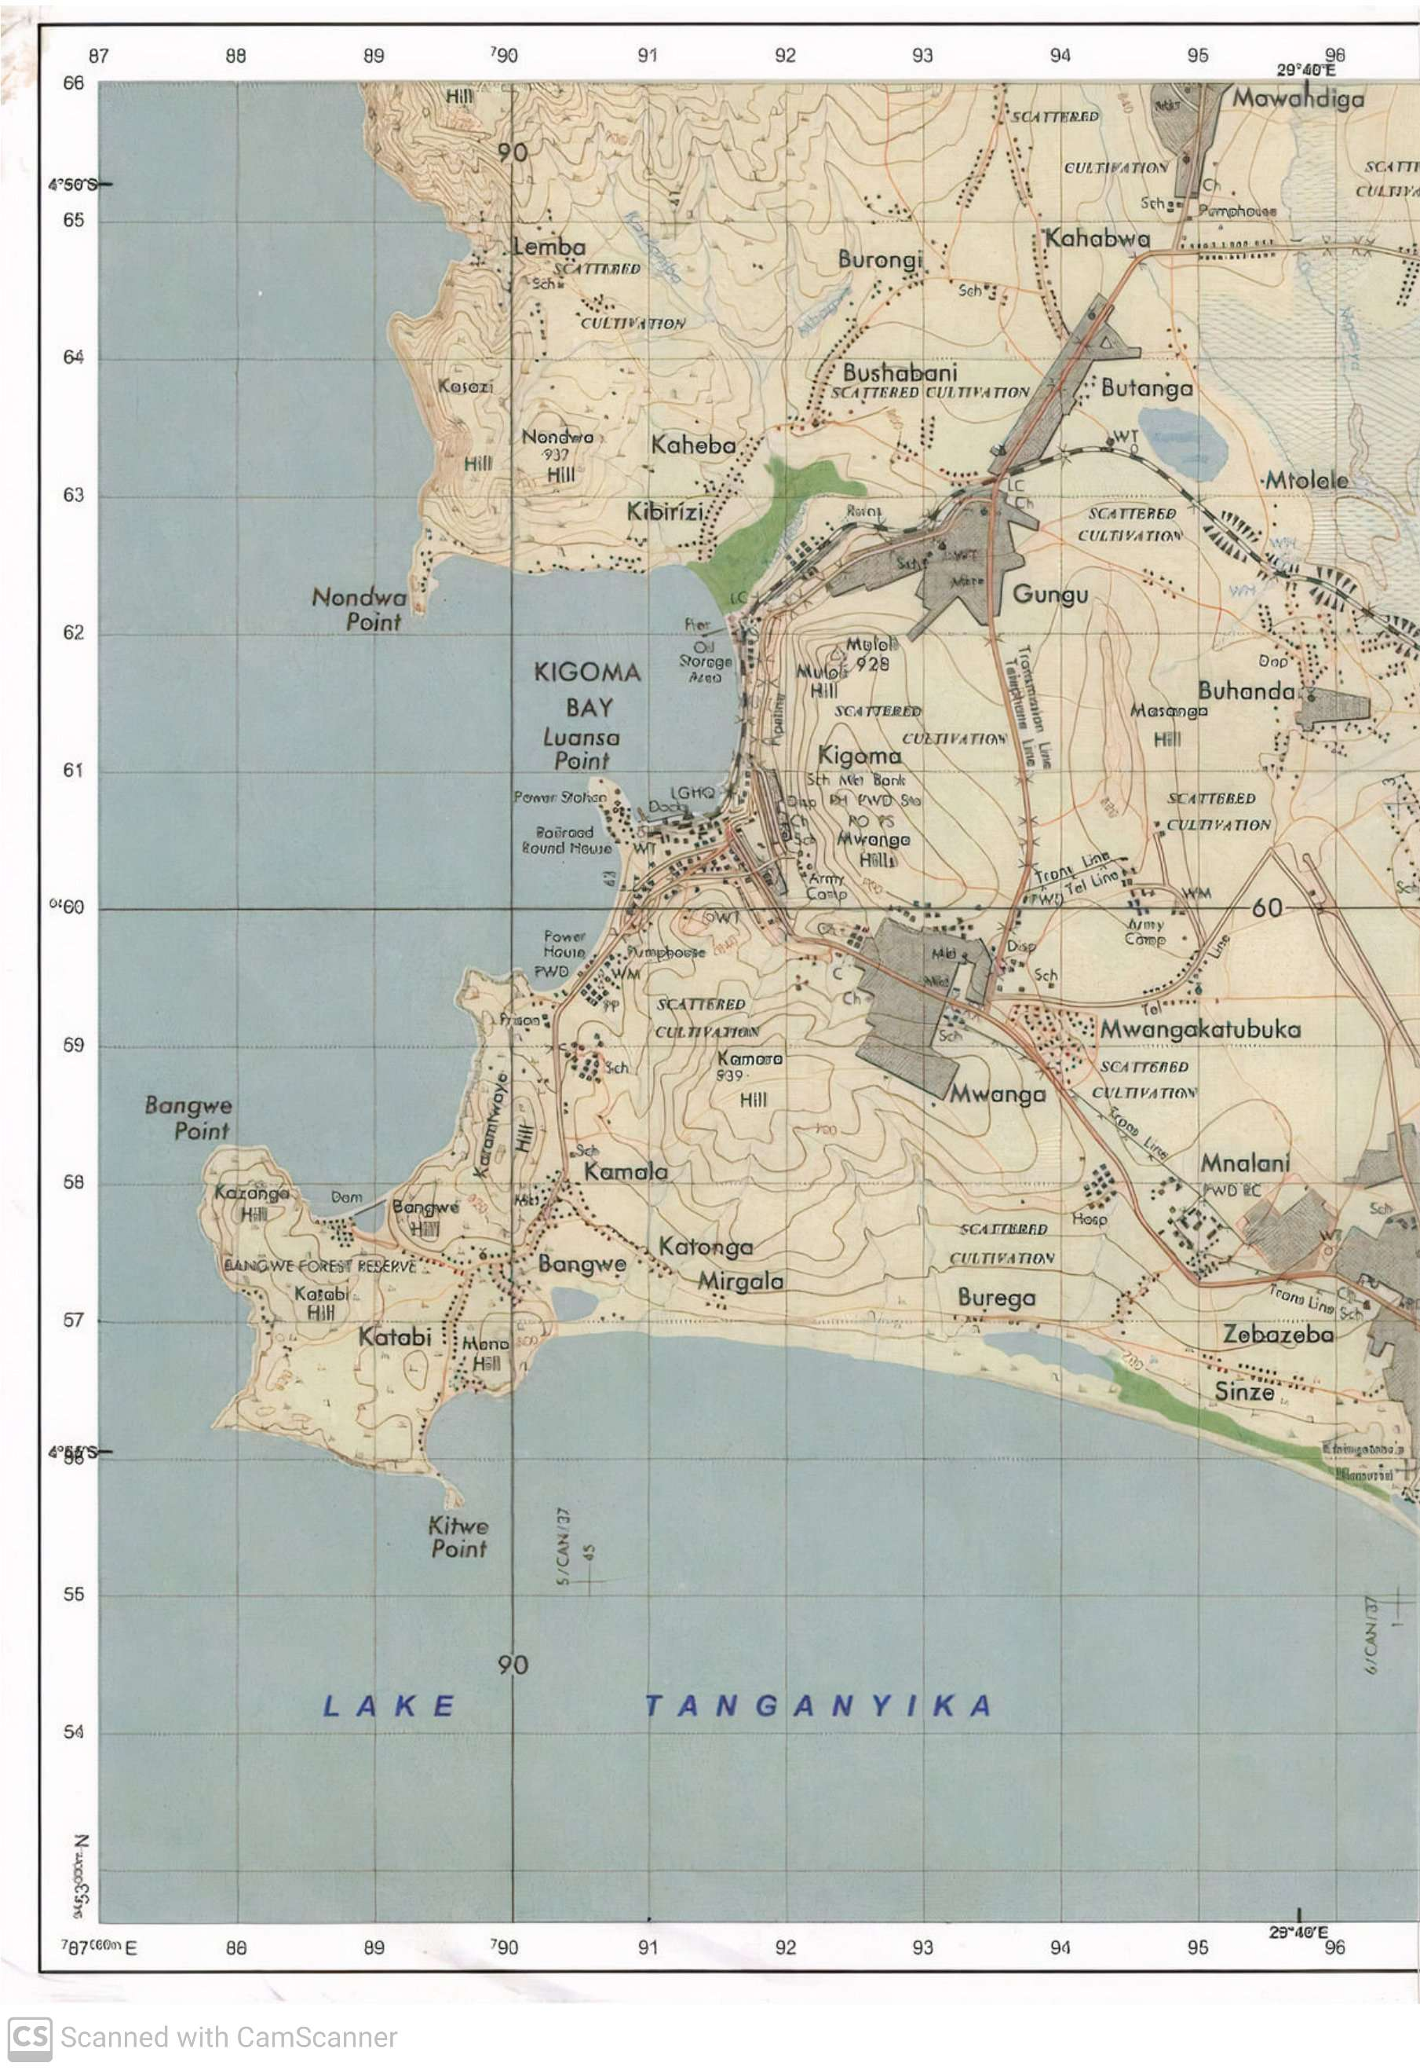
  - Find bearing and direction of grid reference 910540 from grid reference 940570
  - Giving evidences from the map, suggest three economic activities taking place in the area.
  - If the boat sail from grid reference 880550 to grid reference 960550.What will be the actual ground distance, if the boat sail three times.
  - Comment on the type on North used on the map.

- By using the knowledge of agriculture topic in form two, study the following photography given then answer the question that follows
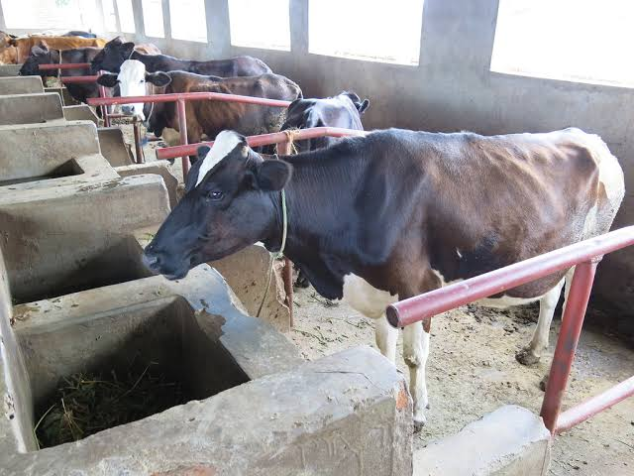

- With clear reason, specify the type farming.
- Mention four pros of the specific types of farming mention in (a) above.
- Mention three regions in Tanzania that might practice that kind of agriculture.
- State the scale of agriculture (with two reasons).
- State two reasons to why farmer practice that type of agriculture.

SECTION “C” (30 MARKS)
Answer ONLY two (2) questions from this section.
- Explain how distance to water source from household affects the girl child.

- Tanzania tourism sector has the bright future. Discuss this statement by giving six (6) points.

- Mining plays a great role in improving the economy of Tanzanian peoples. With examples, elaborate five challenges that can be caused by mining sector.

