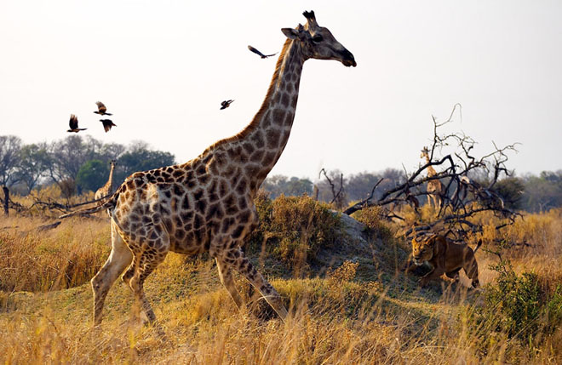

7
PRESIDENTIAL OFFICE
REGIONAL ADMINISTRATION AND LOCAL GOVERNMENT
NAMANGA SECONDARY SCHOOL EXAMINATION SYNDICATE
FORM THREE GEOGRAPHY TERMINAL EXAMINATION –MAY 2017
GEOGRAPHY
23RD MAY 2017 TIME: 3:00 HRS

INSTRUCTIONS:
- This paper consist of Section A, B, C and D.
- Answer ALL questions in Section A, B, and TWO (2) questions from section D.
- Map extract of KASAMWA sheet no.32/4 is provided.
- Credit will be given for the use of relevant sketch maps and diagrams.
- Calculators and Cellular phones are NOT allowed in the examination room.
- Show your work clearly in ALL sections.
- Write your name on every page of your answer sheet(s).

This paper consist of 7 printed pages
SECTION A (25 MARKS)
Answer all questions in this section
PHYSICAL AND MATHMATICAL GEOGRAPHY
- For each of the following item (i) – (x) choose the correct answer from the given alternatives and write its letter the item number in the answer sheet provided
- The line draw through place with similar amount of sunshine is called;
- Isotherms C. Isonephs
- Isosunshine D. Isohels
- Liverpool team scored a goal at 5:00 pm in England (15° W). At what time the goal was scored in Dar-es-salaam (45°E).
- 1:00 pm C. 9:45 pm
- 7:00 pm 9:00 pm
- The large part of Southern Hemisphere is covered by,
- Land mass C. Water mass
- Volcanoes D. Ice
- The part of the Earth which is made up of very high density materials comprising of Nickel and Iron (NIFE) is term as:
- Sima C. Barysphere
- Mesosphere D. Sial
- The temperature of Arusha in Tanzania 1300m above the sea level is 25°c. What will be the temperature at Mtwara where the altitude is 300 m?
- 19°C C. 19°F
- 31°C D. 31°F

1
SECTION D: (20 MARKS)

Answer only two (2) questions from the following:

- Discuss factors for little development in manufacturing industries in East Africa.
- Explain six factors that hinder development of river transport of river transportation in Africa.
- Explain seven values of photographs in daily life.
- Describe six contributions of cash crops production to the economy of any country.

6
SECTION C (28 MARKS)
Answer all questions in this section
MAP READING AND PHOTOGRAPH INTERPRETATION
- Study the map extract of Kasamwa (sheet 32/4) then answer the questions that follow.
- Identify two ways that have been used to show relief on a map.
- Draw a relief section to connect Nyabubele Hill at 383834 and Bungwe Hill at 430825
- Identify the length of the all-weather road in km from grid reference 315844 to 443940.
- Find the bearing of Chibulongo Hill at 367917 to school at Nyamahuna 349818.
- Study the photograph given on page 7 and answer the following questions:
- Name the type of photograph
- Give three characteristics of the type of photograph in (a) above.
- Explain four possible factors which may cause the loss of biodiversity in the photograph.
- Give two economic importance of the area.
- In three points, describe the importance of vegetation shown in the area.

5

- Which of the following by origin and composition is not a form of igneous Rock
- Sill C. Gypsum
- Dyke D. Lava plain
- Autumn, winter, spring and Summer are the results of,
- Monsoon C. Revolution
- Lunar eclipse D, Rotation

- The Large cone with alternative Layers of fragments is called
- Strata volcano C. Overthrust fault
- Crater D. Magma
- The process that causes the wrinkling of the earth’s surface rocks is:
- Cirque C. Compression forces
- Vulcanism D. Tensional forces
- The highland or upland usually up to 500m from the mean sea level is;
- Ridge C. Hill
- Col D. Gorges

2

- Match the items in List A with responses in List B by writing the letter of the correct responses beside the item number.
LIST A | LIST B
- /  - Radial drainage pattern  - Used in map making  - Hypabyssal  - The mantle | - Ground photograph.  - Low oblique photograph  - Formed inside but near the surface  - Formed deep down in the crust  - Mesosphere  - Hydrosphere  - Types of volcanism  - High oblique photograph  - Pattern whose stream flow inwards toward the central point.  - Pattern whose tributaries diverge outward from centre  - Small gap between two mountain or hill.  - The large and wide gap between two hill or mountain.  - Barysphere

- By using aid of diagrams show features Associated with intrusive Vulcanic features. (Not less than six (6).

3

SECTION B (27 MARKS)
DEFINITIONS AND SHORT NOTES
- Define the following Geographical terms
- Mohorovic discontunity
- Atmosphere
- Folding
- Volcanism
- Diastrophism

- Distinguish between the following
- Thermal and dynamic metamorphism.
- Differentiate between Hot spring and Geysers’.
- Differentiate between active volcano and dormant volcano.
- What is the different between map and photograph
- Differentiate between magma and lava.

- Study the diagram below carefully then label features A - F

