THE PRESIDENTS OFFICE
REGIONAL ADMINISTRATION AND LOCAL GOVERNMENT
NAMANGA SECONDARY SCHOOL
FORM THREE GEOGRAPHY MID TERM EXAMINATION
TIME :3HRS
INSTRUCTIONS
- This paper consists of section A and B
- Answer all questions in both sections
- For each of the following items (i-x) choose the correct answer from among the given alternatives and write its letter in the provided box.
- Which of the following layers of the earths interior is made up of Sima and said
- Biosphere
- Hydrosphere
- Asthenosphere
- Lisosphere
- Barysphere
- Senegal national team scored a goal at 2:00 pm in Senegal (150˚W).At what time at Burundi (30˚E) the goal was scored?
- 10:00pm
- 10:00am
- 4:00am
- 12:00am
- 2:00am
- The intensity of an earthquake is measured by
- Epicenter
- Mercalli scale
- Seismograph
- Richer scale
- Focus
- -------------are good examples of fold mountains in Africa
- Uluguru and oldonyolengai
- Jos and karoo
- Atlas and cape rangers
- Elgon and Kilimanjaro
- Udzungwa and Kilimanjaro
- Which of the following instruments is used to measure pressure?
- Wet and dry bulb thermometer
- Rain gauge
- Anemometer
- Aneroid Barometer
- Hydrometer
- What is the compass bearing of WNW?
- 270˚
- 337˚
- 327˚
- 292˚
- 315˚
- The sun is overhead at tropic of capricon every year on
- 12st June
- 22nd December
- 21st march
- 23 rd September
- 03rd January
- Mountains can be classified on the basis of
- Their importance
- Their formation
- Their surrounding
- Their height
- Their composition
- Which one of the following is not a outcome of the ration of the eath on its own axis
- If the location of a point on a map is given by grid reference 365490,then
- 365 are degrees
- 365 are longitudes
- 490 are northings
- 490 are Eastings
- 365 Northings
No | i | ii | iii | iv | v | vi | vii | viii | viii | ix | x
Answer

- Match the items in list A with the responses in List B by writing the letter of the correct response beside the item number.
LIST A | LIST B
i/the earths zone which is made up of nickel and iron.  ii/a wall like feature formed when a mass of magma cuts across the bedding plane  iii/the upper most layer of the earth  iv/a sheet of magma which lies along the bedding plane  v/magma which reaches the eaths surface and solidifies to form extrusive features | - Crust  - Lava  - Magma  - Mode  - Dyke  - Sill  - Core  - Volcano  - Batholiths

QN, NO | (I) | (II) | (III) | (IV) | (V)
ANSWER

- (a)What is an earthquake?
(b) briefly explain five effects of earthquakes
(c) describe four ways of reducing the risk of earth quakes

- With well labeled diagrams,explain five(5)intrusive volcanic features

SECTION B.
- Study the photograph provided below and then answer the questions that follows.

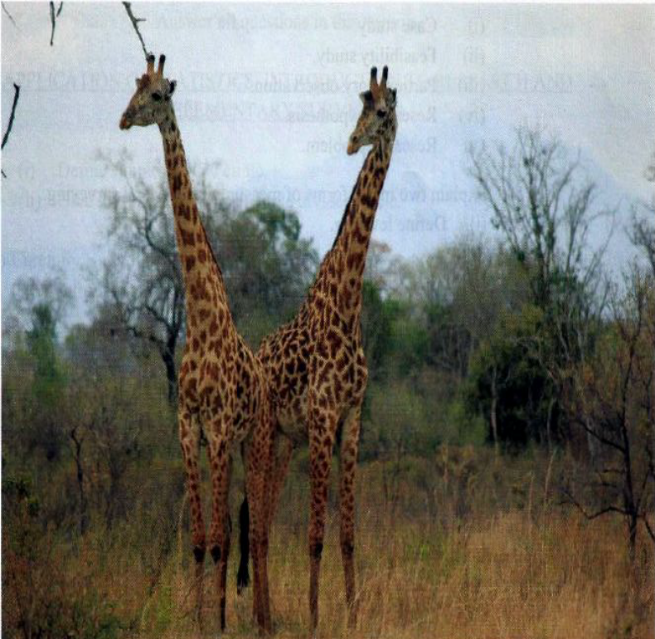

- Name the type of photograph
- Give three characteristics of the type of photograph in (a) above
- Explain four possible factors which may cause the loss of biodiversity in the photograph
- Give two economic importance of vegetation shown in area
- List down six (6) differences between photographs and maps.

