PRIME MINISTER OFFICE
REGIONAL ADMINISTRATION AND LOCAL GOVERNMENT
NAMANGA SECONDARY SCHOOL
FORM THREE MID-TERM EXAMINATION, MARCH 2026
GEOGRAPHY
TIME: 3HRS
SECTION A
Answer all questions in this section
1.For each of the items (i)-(x) choose answer from among the given alternatives and write its letter in the answer booklet(s) provide
(I) Rocks rich in silica and aluminum form a layer of the earth’s crust called….
A. Sima
B. Sial
C. Mantle
D. Core
(ii) The envelope of air surrounding the earth’s surface is called…….
- Lithosphere
- Atmosphere
- Biosphere
- Hydrosphere
(iii)Continents and their respective mountains are formed on the ……
- Sial
- Mantle
- Mohorovic
- Magma
(iv) The core is rich in ……………….
- Silica and sima
- Iron and nickel
- Aluminum and oxygen
- Silica and magnesium
(v) Igneous rocks are…………….
(A) Crystalline
(B) Not very hard
(C) Formed in layers
(D) Metamorphic
(VI) The outer of the internal structure of the earth is called ….
- The mantle
- The crust
- The hydrosphere
- The atmosphere
(vii) Earthquakes may be caused by the following except…..
- Tensional forces
- Lateral movement
- Soil erosion
- Vertical movement
(viii) The following are extrusive volcanic features except…
- Ash and cinder cones
- Composite cone
- Volcanic plug
- Dyke
(ix) ………… is the process where a rock changes from one type of rock to another
- Rock cycle
- Sedimentary rock
- Metamorphic rock
- Igneous rock
(x) Which of the following is precautions to be taken prior to earthquake incident
(A) Listen to media for latest emergence information
(B) Houses should be constructed using light materials
(C) Stay away from building and trees eclectic pole
(d) people should stay away from high risk areas

2. Match descriptions of the higher point of the correct type of the continent in list B By writing the letter of the correct response in the answer sheet provided

LIST A | LIST B
- Atlas and Drakensberg  - Baringo and naivasha  - Mpoli and kulod  - Oldonyo lengai  - Senkeke hill  - Sinai and Vosges | A.fold mountains  B. block mountains  D. dormant volcano  C.Extinct volcano  E.Active volcano  F. Residual mountains  G. fossils mountains  H. Rift valley

SECTION B (54Marks)
Answer all questions in section
3. Study carefully sketch map drawing and answer the following question.
a] Calculate the area of whole sketch map drawing using the square method. Give your answers in km29( given 1 square= 2cm).
b] Describe types of transport found in the sketch map drawing.
c] Explain two ways used to represent scale of the sketch map.
d] Change the scale presented into statement scale.
e] Measure the distance of railways from 090031 to 11

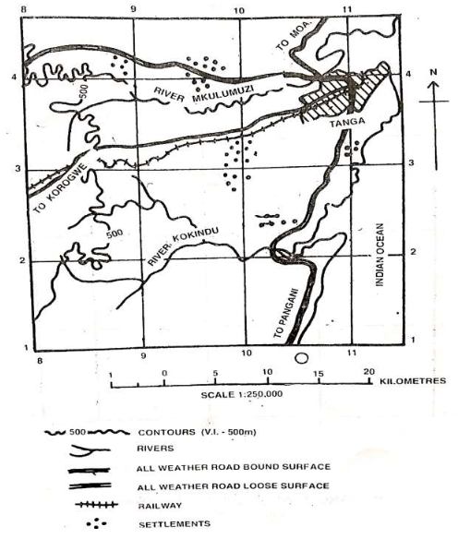
4. Study carefully the following climatic data and then answer the questions that follow

months | J | F | M | A | M | J | J | A | S | O | N | D
Temperature($℃$ | 12 | 20 | 21 | 17 | 22 | 19 | 18 | 15 | 16 | 18 | 19 | 11
Rainfall(mm) | 50 | 25 | 75 | 45 | 00 | 15 | 25 | 30 | OO | 24 | 125 | 115
a) Name the area where data is normally recorded.
b) State the process by which the data is pre - determined for its future occurrence
c) Calculate the annual rain fall.
d) Find the average annual temperature.
e) Give the instruments used to record each of the elements of weather presented in the data above
(F) Find annual range temperature

5. with aid of diagram explain explain intrusive features of vulcanicity (5points)
6. Form three students visit Madeline scene they surprised on movement of rock materials down a slope.By using a knowledge, you have in form three.
i. Identify the process takes place in Madeline scene.
ii. Suggest four factors that affect the nature and speed for that process
7. Great East Africa rift valley is the among of the area experience high record of earth quake. Briefly explain the effects of earthquake (five points)
8. (a) with the aid of diagram define rock cycle
(b) explain of internal structure of the earth
(c) Outline four results of the planet earth when is spinning on its axis

SECTION C
Answer two questions from this section
9. .All the continents of the world are associated with different relief features. Justify this Statement by providing six points
10. Explain six factors influencing the location and development of manufacturing industries
11. The aggregates of minerals in solid state may be useless in some societies like the Hadzabe of central Tanzania. As a form three student explain in short the economic importance of these aggregates. Use six points

