THE PRESIDENT’S OFFICE
REGIONAL ADMINISTRATION AND LOCAL GOVERNMENT
NAMANGA SECONDARY SCHOOL
FORM THREE SERIES ONE EXAMINATION
GEOGRAPHY
Time: 2 HRS FEB-2025

INSTRUCTIONS
- This paper consist of sections A, B, and C and a total of ten questions
- Section A carries 15 Marks, Section B carries 70 marks and Section C carries 15 Marks
- Answer all questions in all section
- Credit will be given for use of relevant sketch maps and diagrams
- Except for diagram which will be drawn with pencil, all writing must in blue or black ink
5. Write your examination name or number on each page.

SECTION A (15 Marks)
Answer all questions from this section
- For each of the following items (i)–(x) choose the correct answer from the given alternatives and write its letter in the box provided.
  - One of the following statements is not correct about Geography:
    - Geography deals with the earth surface only
    - Geography deals with the environment
    - It helps to understand the environment
    - It is the study of human being and his or her environment

  - The position of which the earth is furthest from the sun is known as:
    - Equinox C. Perihelion
    - Autumn D. Aphelion

  - The following is the proper arrangement of the last four planets of the solar system
according to their position from the sun
    - Jupiter, Saturn, Uranus and Neptune
    - Mercury, Venus, Mars and Earth
    - Mercury, Venus, Earth and Saturn
    - Mercury, Venus, Earth and Jupiter

  - All below are forms of farming except
    - Arable farming
    - Intensive farming
    - Extensive farming
    - Expensive farming

  - What is the temperature of Newala at 0 meter above sea level? If the temperature of Mbinga is 23°C situated at 1500 meters above sea level?
    - 0.8°C B. 17°C C. 0.6°C D. 32°C

  - Wood, nuclear energy, natural gas and coal are________ A. .Resources
    - Non-renewable resources
    - Natural resources
    - Renewable resources vii) At Algeria 45°W is 8:00 am, what will be the time at Songwe 15°E?
    - 9:30am C. 9:00pm
    - 10:30pm D. 10:00am

viii) Good examples of existing volcanic mountains are:
    - Kilimanjaro and Uluguru mountains
    - Oldoinyo Lengai and Mufumbiro mountains
    - Oldoinyo Lengai and Uluguru mountains
    - Oldoinyo Lengai and Kilimanjaro mountains

ix) The imaginary lines drawn on a map horizontally from West to East.
    - Longitude
    - Latitude
    - Greenwich
    - Equator

x) Which of the following gives the proof that the earth is spherical in shape?
    - Circumnavigation of the earth, solar eclipse and lunar eclipse
    - Great circles, day and night and the curved horizon
    - Day and night, lunar eclipse and season
    - Ships visibility, lunar and aerial photograph

- Match the item in LIST A with response in LIST B by writing the letter of the correct response below the number of corresponding item in the table provided.
LIST A | LIST B
i) Rearing of livestock for production of milk ii) Grazing livestock in the natural pasture  iii) Keeping large number of livestock by moving from one place to another in search of water and pasture iv) Seasonal movement of herdsmen between lowland and highlands in search of water and pasture  v) Rearing of livestock in an extensive area for commercial purpose | - Nomadism  - Ranching  - Diary  - Sedentary livestock keeping  - Transhumance  - Beef farming  - Pastoralism

SECTION B (70 Marks)
Answer all questions from this section 3.
Study the diagram below and answer questions that follows
a) i)Name the diagram above _____________________________ ii) Name letters labeled
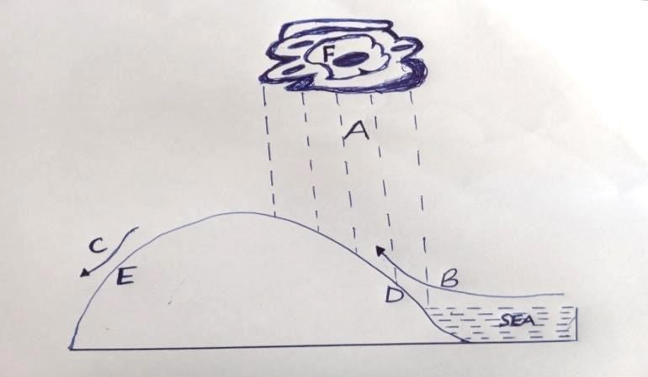

iii) List down three importance of letter named A in a(ii) above? (3 Marks)
- With example describe the following terms
  - Block mountain
  - Volcanic mountain
  - Residual mountain
  - Fold mountain

- Forest is among the natural resources Tanzania has been naturally gifted.
  - Describe types of forests found in Tanzania.
  - Outline any six values of forest resources to Tanzanian community

- In a practical session of geography, a teacher gave different maps to students, and you were given a map showing rivers, a lake, ponds and other man made features for your personal studies
a) Name the type of map the teacher gave you. __________________________________
b) Name four possible ways of locating a position of features you will observe

  - Suggest three instruments in which a distance of river can be measured on the map

- Form one students were very happy to watch a video program showing earth’s surface which was irregular. Difference in altitudes and slopes gave rise to different features; and, human activities were also observed in the video program.
a) Outline five possible features observed by students

  - By giving examples, mention three major types of water bodies observed

  - Name four types of large elevated parts of the earth’s surface that rise from greater heights the students observed in a video program

- a) Name the following latitudes:
i) 0° _______________________________________________________________ ii) 23½°N __________________________________________________________ iii) 23½ °S____________________________________________________________ iv) 66½ °N___________________________________________________________
v) 66½ °S____________________________________________________________
  - What is International Date Line? Why is it zigzag? Give two reasons
- a)Outline five characteristics of small scale agriculture

b) Describe any five benefit people get by conducting agricultural activities

SECTION C (15 Marks)
Answer all questions from this section
- Explain five contributions of the mining industry to the economy of Tanzania

