REGIONAL ADMINISTRATION AND LOCAL GOVERNMENT

NAMANGA SECONDARY SCHOOL
MID TERM EXAMINATIONS March 2023
GEOGRAPHY
Time 03:00 Hours March 2023

Instructions
- This paper consists of Sections A, B and C with total of 11 questions
- Answer All questions from sections A and B and any Two(2) questions from section C
- All writings should be in Black/blue ink and drawings should be in a pencil
- Write your name on every page of your Answer sheet

SECTION A (16 Marks)
Answer All questions from this section

1. For each of the following items (i-x) choose the most correct answer from among the given alternative
and write its letter in your Answer sheet

- Some minerals like Calcium sulphate in rocks can absorb water and swell causing internal stress and fracturing of that rock. This process can be described as
- Hydration (B) Hydrolysis (C) Oxidation (D) Carbonation

- In certain place at Lukwika the effects like environmental pollution, land dereliction, loss of biodiversity and destruction of soil texture and structure were observed, these are the evidence of which activity has taken place on the area/
- Mining activities (B) Tourism activities
(C) Manufacturing industry activities (D) lumbering activities

- When you wake up in the morning you see the sun rising from the east the moving till evening to set to the West, This is because
- The sun rises from the East and sets to the west
- The earth rotates on its axis from east to the west
- The earth revolve around the sun from West to the East
- The earth rotates on its axis from West to the East

- Suppose you were invited to narrate the speech about forest conservation in Michiga village, which of the following method you will not suggest?
- Destocking of animals (B) Deforestation
(C) afforestation (D) Encourage good farming method

- Most of the people in urban areas engage in various activities like trading, manufacturing industry, transport and tourism. Which group of types of human activities can these activities be grouped?
- Primary and tertiary activities (B) Secondary and tertiary activities
(C) primary and secondary activities (D) tertiary and quaternary activities

- Morogoro at height of 800m above the sea level has a temperature of 270C while Iringa at 1800m experience a temperature of 210C. what factor has influenced the difference in temperature between Morogoro and Iringa?
- Prevailing wind (B) Latitude (C) Distance from the sea/ocean (D) Altitude

- Which of the following earth’s crust processes caused the formation of Mount Kilimanjaro?
- Outflow and spread of lava (B) Wrinkling of the earth’s crust
(C) Faulting of the earth’s crust (D) Sinking of the earth’s crust (E) Prolonged denudation

- Bibi Jane believed that the earth is flat because she used to see the flatland. So Jane ask you to tell Bibi Jane that the earth is a sphere. Which of the following evidence is Not correct?
- Sunrise and sunset (B) Solar eclipse
(C) Circumnavigation of the earth (D) Aerial photographs of the earth

- One day Fagio went to the forest to chop firewood, along the road he wondered to see the electric poles tilted when he reached in the forest he wondered more to see the trees bended down to the direction of the slope. This is the sign that_______________ has taken place
- Soil creep (B) Mudflow (C) Landslide (D) Solifluction

- Some rocks like clay soil tend to expand after absorbing water and contract when they become dry leading to the formation of cracks hence break down easily into small fragments.
This process of mechanical weathering is known as
- Exfoliation (B) Alternate wetting and drying (C) Frost action (D) Pressure release

2. Match the items in List A with their corresponding response in List B by writing the letter of the correct response below the corresponding item in your answer sheet

LIST A | LIST B
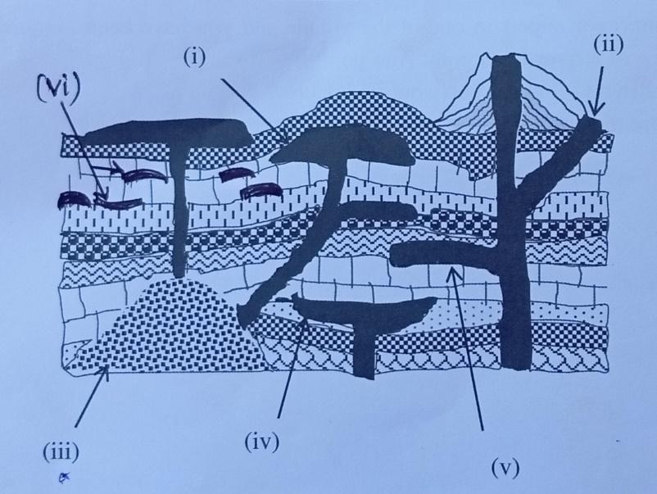 | (A) A large body of igneous rocks formed at  the base of the mountain  (B) lens shaped strip of igneous rock formed  when magma solidifies along the  anticline or the base of syncline  (C) Dome shaped intrusive feature formed  when the pressure of viscous magma  forces the overlying rocks to bend up  (D) Large saucer like intrusive feature lying  concordant to the rock strata to form a  shallow basin  (E) A sheet of igneous rocks formed when  magma solidifies along the bedding plane  (F) A wall of igneous rocks formed when  magma solidifies across the bedding plane  (G) Are the result of folding of the earth’s  crust due to the compressional forces

SECTION B (54 marks)
Answer All questions
4. Carefully study the Climatic data given for the Kwetu station then answer the questions that follow
Month | J | F | M | A | M | J | J | A | S | O | N | D
Temp(⁰c) | 26 | 26 | 25 | 25 | 24 | 24 | 25 | 26 | 26 | 27 | 28 | 27
Rainfall(mm) | 120 | 152 | 133 | 115 | 94 | 66 | 41 | 25 | 14 | 122 | 154 | 186

- Calculate the annual Range temperature
- Determine the total rainfall per year
- What is the annual Mean temperature?
- Suggest the type of Climate Kwetu station is experiencing
- Outline two evidence to support your answer in (d) above

5. By using a well labelled diagram describe the Internal structure of the earth

6. Msimbe village is blessed with different types of rocks, the largest part of the village is dominated
with the rocks which were formed by the accumulation and lithification of weathered materials from
different parts of other villages
(a) Identify the type of rocks dominated the village
(b) Explain four(4) characteristics of that type of the rocks you identified
(c) Mention four(4) importance of the type of ricks dominated Msimbe village

7. In the year 2017 Kagera region experienced the shaking/vibration of the earth’s crust due to sudden
displacement of rocks. That shaking was produced from the point of Origin, in Bukoba town around
the Bus terminal is where the maximum destructions of that shaking took place.
- What is the best term that can describe the above scenario?
- What is the name of the point of origin where the shaking was produced?
- What is the name of point in Bukoba town around Bus terminal where maximum destructions took place?
- Outline three(3) causes which may lead to that shaking of the earth’s crust
- Explain three(3) effects which may be brought by that shaking of the earth’s crust took place

8. With the aid of diagram illustrate the internal structure of the earth
SECTION C ( 30 Marks)
Answer any Two (2) questions

9. Ngongingo has enough financial capital in his bank account. He wants to establish a cashewnuts
processing industry in Masasi town. Apart from capital analyse six factors he should take into
consideration before locating the industry in Masasi town
10 Outline the importance of rock

11. Zanzibar used to receive a good number of tourists per year. Explain as to what extent Zanzibar can
negatively be affected by presence of these tourists? (use six(6) points)

