THE UNITED REPUBLIC OF TANZANIA
MISANMISANMISANMISANMISANMISANMISANMISANMISANMISANMISANMISANMISANMISANMISANMISANMISANMISANMISAN MISANMISANMISANMISANMISANMISANMISANMISANMISANMISANMISANMISANMISANMISANMISANMISANMISANMISANMISAN MISANMISANMISANMISANMISANMISANMISANMISANMISANMISANMISANMISANMISANMISANMISANMISANMISANMISANMISAN MISANMISANMISANMISANMISANMISANMISANMISANMISANMISANMISANMISANMISANMISANMISANMISANMISANMISANMISAN MISANMISANMISANMISANMISANMISANMISANMISANMISANMISANMISANMISANMISANMISANMISANMISANMISANMISANMISAN MISANMISANMISANMISANMISANMISANMISANMISANMISANMISANMISANMISANMISANMISANMISANMISANMISANMISANMISAN MISANMISANMISANMISANMISANMISANMISANMISANMISANMISANMISANMISANMISANMISANMISANMISANMISANMISANMISAN MISANMISANMISANMISANMISANMISANMISANMISANMISANMISANMISANMISANMISANMISANMISANMISANMISANMISANMISAN MISANMISANMISANMISANMISANMISANMISANMISANMISANMISANMISANMISANMISANMISANMISANMISANMISANMISANMISAN MISANMISANMISANMISANMISANMISANMISANMISANMISANMISANMISANMISANMISANMISANMISANMISANMISANMISANMISAN MISANMISANMISANMISANMISANMISANMISANMISANMISANMISANMISANMISANMISANMISANMISANMISANMISANMISANMISAN MISANMISANMISANMISANMISANMISANMISANMISANMISANMISANMISANMISANMISANMISANMISANMISANMISANMISANMISAN MISANMISANMISANMISANMISANMISANMISANMISANMISANMISANMISANMISANMISANMISANMISANMISANMISANMISANMISAN MISANMISANMISANMISANMISANMISANMISANMISANMISANMISANMISANMISANMISANMISANMISANMISANMISANMISANMISAN MISANMISANMISANMISANMISANMISANMISANMISANMISANMISANMISANMISANMISANMISANMISANMISANMISANMISANMISAN MISANMISANMISANMISANMISANMISANMISANMISANMISANMISANMISANMISANMISANMISANMISANMISANMISANMISANMISAN MISANMISANMISANMISANMISANMISANMISANMISANMISANMISANMISANMISANMISANMISANMISANMISANMISANMISANMISAN MISANMISANMISANMISANMISANMISANMISANMISANMISANMISANMISANMISANMISANMISANMISANMISANMISANMISANMISAN MISANMISANMISANMISANMISANMISANMISANMISANMISANMISANMISANMISANMISANMISANMISANMISANMISANMISANMISAN MISANMISANMISANMISANMISANMISANMISANMISANMISANMISANMISANMISANMISANMISANMISANMISANMISANMISANMISAN
PRESIDENT’S OFFICE - REGIONAL ADMINISTRATION AND LOCAL GOVERNMENT
SIMIYU REGION
MISAN ACADEMIC DEVELOPMENT PROGRAM
FORM THREE JOINT ROUTE TO ANNUAL EXAMINATIONS, OCTOBER – 2019
013 GEOGRAPHY
Time: 3 Hours. Tuesday, 15th October 2019 p.m.
____________________________________________________________________________________________________

Instructions
- This paper consists section A, B and C.
- Answer ALL questions from each section.
- Unwanted materials are highly prohibited in examination room.
- Map of Arusha sheet 55/3 is provided.
- All writings should be done in black or blue pen except for the diagrams which must be in pencil.
SECTION A: (15 Marks)
PHYSICAL AND MATHEMATICAL GEOGRAPHY.
- Choose the right answer and write its letter on your answer sheet.
- The composition of the earth’s interior made up of ___________
- Core, inner and mantle (b) Crust, mantle and Core
(c) Crust, mantle and structure (d) zone, structure and mantle ( )

- The inner core is said to be __________ due to high pressure at the Centre.
- Solid (b) liquid
(c) Molten (d) gaseous ( )

- ___________ is an elongated trough with steep sided produced by faulting due to tensional forces or compressional forces.
(a) Fold mountain (b) Joints
(c) Block mountains (d) Rift valley ( )

- The types of erosion happen when rill erosion become more concentrated producing deep troughs into land called __________
(a) Gully erosion (b) sheet erosion
(c) Rill erosion (d) fluvial erosion ( )

- Which of the following is associated with magnitude of an earthquake?
(a) Seismography (b) Focus
(c) Richter scale (d) Epicenter ( )

- The following are the features produced at the youth stage of the river except______
(a) V- shaped valleys (b) Pot holes
(c) Waterfalls (d) Meanders ( )

- A channel diverging from the main river and flowing into the sea or a lake, a separate mouth is called___________
(a) Tributary (b) Stream
(c) Distributary (d) Water shade ( )

- Mountains can be classified on the basis of _______
(a) Their importance (b) Their height
(c) Their formation (d) Their composition. ( )

- The type of river erosion that takes place on the river bed is referred to _____
(a) Pot hole (b) Lateral erosion
(c) Headward erosion (d) Vertical erosion ( )

- The following are features produced by intrusive except
(a) Dyke (b) sill
(c) Crater (d) Lapolith ( )

- Match the question statement from List A and its answer from List B write its letter on your answer sheet.

COLUMN A | COLUMN B
- A low laying area of land formed at a river mouth.  - ___ is a tributary in a lower course of the river that have been forced to flow alongside the main stream for long distance before joining it  - Depression contain water in the desert  - A stream that lost headwaters and has been reduced in volume to become small in valley  - An old meander which cut off as material deposited by the river to leave water apart from the main stream | A: Oasis  B: River capture  C: Ozone layer  D: Ox-bow lake  E: Delta  F: Flood plain  G: Differed tributary (Yazoo stream)  H: Misfit  I: River – bank  J: Water logging

SECTION B: (55 Marks)
Short answers

- What is chain surveying?
- Describe equipments used in chain surveying (five equipments)
- Mention five (05) sources of errors in chain surveying.
- Differentiate between primary data and secondary data

- (a) What is leveling in surveying?
(b) Identify three instruments used in leveling surveying
(c) Give four (4) significant of leveling surveying in daily life.

- The followings data are Meatu District cotton productions in tonnes from 2001 – 2008.

Year | Cotton Production
2001 | 22000
2002 | 23000
2003 | 28000
2004 | 28000
2005 | 24000
2006 | 32000
2007 | 29000
2008 | 30000

- Give out (3) another method which can be used to construct graph
- Construct a divergence bar graph.
- State the merits and demerits of divergence bar – graph

- Carefully study the map extract of Arusha sheet 55/3 provided then answer the questions that follow.
- Describe the relief of the mapped area
- With evidence, mention three means of transport shown in a map
- Change the scale of the map into a statement scale
- Measure the length of the road from grid reference 160234 to grid reference in kilometers 370279
- With evidence from the map identify three social services which are found in the mapped area.

7. Study the photograph provided below and then answer the question that follows.
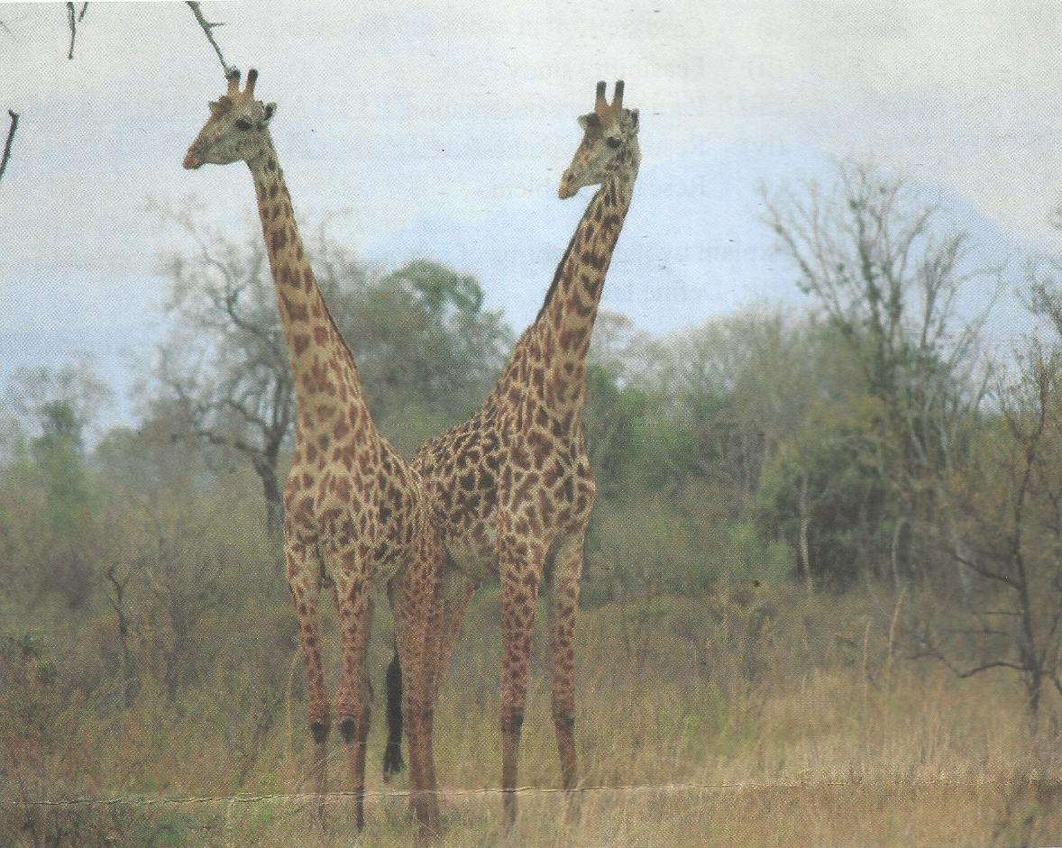

- Name the type of photograph
- Give three characteristics of the type of photograph above
- Give two economic importance of the area
- Suggest the climatic condition of the area.
- Describe the importance of the vegetation shown in the area (three points)

SECTION C: (30 Marks)
REGIONAL FOCAL STUDIES
Answer any two questions

- Explain five (5) the challenges facing the development of agriculture sector in Tanzania.

- Assess five (5) the economic contributions of mining sector in Tanzania.

- Explain five (5) ways which can be used to promote textile industries in Tanzania

_THE_END_
*********** Wishing You All The Best In Your Regional Annual Exams– 2019 ***********

