PRIME MINISTER’S OFFICE
REGIONAL ADMINISTRATION AND LOCAL GOVERNMENT

ARUSHA REGION


FORM ONE TERMINAL EXAMINATION

CODE: 0
62

BOOK KEEPING

TIME: 2:
0
0
HRS

3
rd

JUNE
, 2026

INSTRUCTIONS:

➢

This paper consists of sections A, B and C

➢

Answer ALL questions

SECTION A (15 MARKS)

1.

For each of the following items(i)
-
(
x) choose the correct answe
r from the given alternative and
write it's letter the box provided

(
i
)

Which of the following is not a source document

A.

Remittance advice notes

B.

Payment voucher

C.

Bank pays in slip

D.

Debit note

(
ii
)

Which one plays the role of a ledger account and book of original entry?

A.

Sales journal

B.

Purchases journal

C.

General journal

D.

Cash book

(
iii)Mangi commenced business worth Tshs 3900000 in cash. What is the double entry for
recording this transaction

A.

Dr.
Cash account and Cr. Mangi account

B.

Dr.Capital Account and Cr.cash account

C.

Dr.Cash account and Cr. Capital account

D.

Dr Mangi account and Cr.Cash account

(
iv)Which of the following is not correct

A.

Assets
-

Liabilities =Capital

B.

Liabilities + Assets =Ca
pital

C.

Assets
-

Capital = Liabilities

D.

Liabilities + Capital = Assets

(v)..................it records page of reference in the books of accounts
- invoice number C. folio
- particular D. Account

Page 1 of 4
(vi)Requires accountants to record all income earned by the business even if is not yet been actually received
A. Realization concept C. monetary measurement
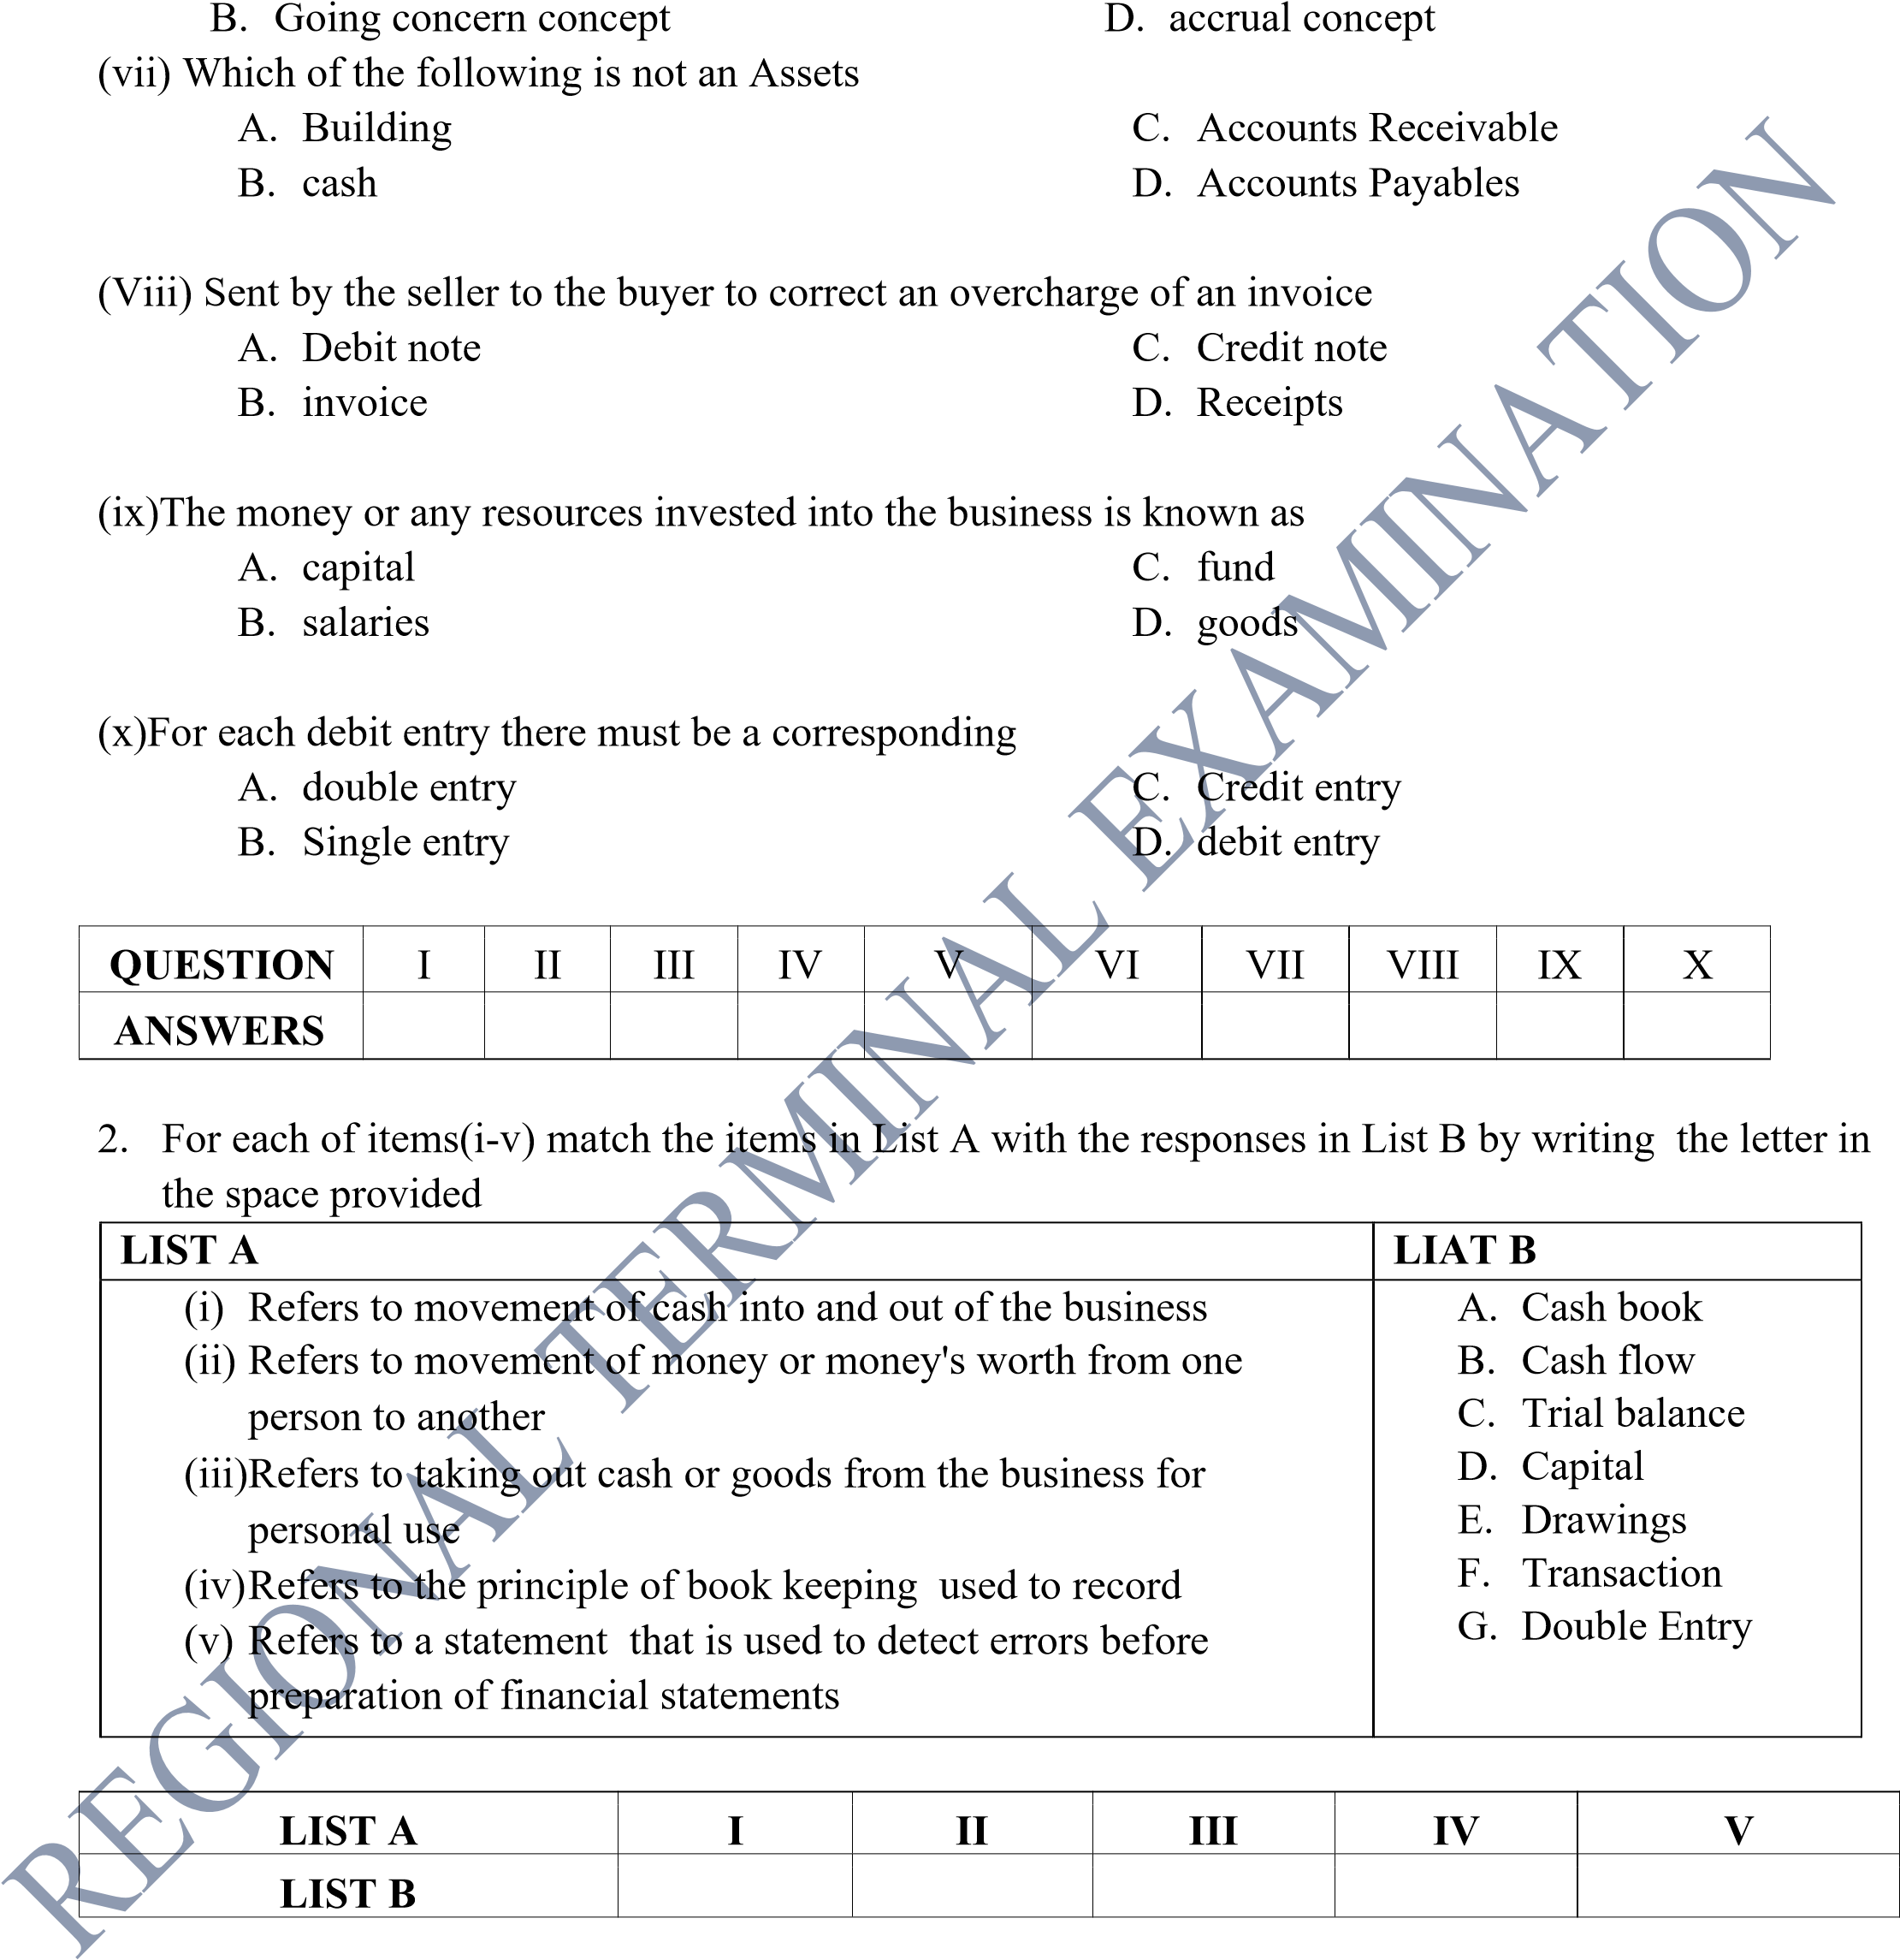

Page 2 of 4

SECTION B (40 marks)
- Arrange the following stages in the Accounting cycle in chronological order by writing its letter in the space provided
  - Posting transaction to the ledger
  - Preparation of financial statements
  - Extracting the Trial balance
  - Recording transactions in the books of prime Entry
  - Analysing and interpreting the financial statements
  - Identifying transaction using source documents
  - Making adjusting entries and correction of errors
  - Extracting the adjusted Trial balance
I II III IV V VI VII VIII

- Book keeping knowledge supports operationalization of other displines.As a Form one student explain how Book keeping relate to :
i) Business studies ii. Agriculture
5.Rachel and Albert were arguing on the primary and basic objectives of recording and keeping accurate financial informations of daily Business transaction in a business . As a expert in business help them by giving five points
6. Complete the gap in the following table
ASSETS. LIABILITIES. CAPITAL

(a). …………………. 720000 4280000 1200000. (b)………………………. 500000
6720000 1720000 ( c )………………….
(d)………………………. 2520000 1680000
1000000 100000 (e)…………………..

SECTION C (45 MARKS)
7. Robert had the following properties and claims for the business on the month of February 2026
Business buildings...................350000
Accounts Payables.....................84000
Furniture....................................100000
Accounts Receivables.............30000
Balance at bank.........................90000 Cash balance...........................20000
Motor van.................................400000
Loan from Bank.......................220000
Computer..................................180000
Motorcycle ...............................150000
Page 3 of 4
Required: Prepare General Journal showing the calculation of Capital for the business

8. From the following transactions indicate the account to be debited or credited and show the effect of Assets, Liabilities, capital ,Revenue or Expenses
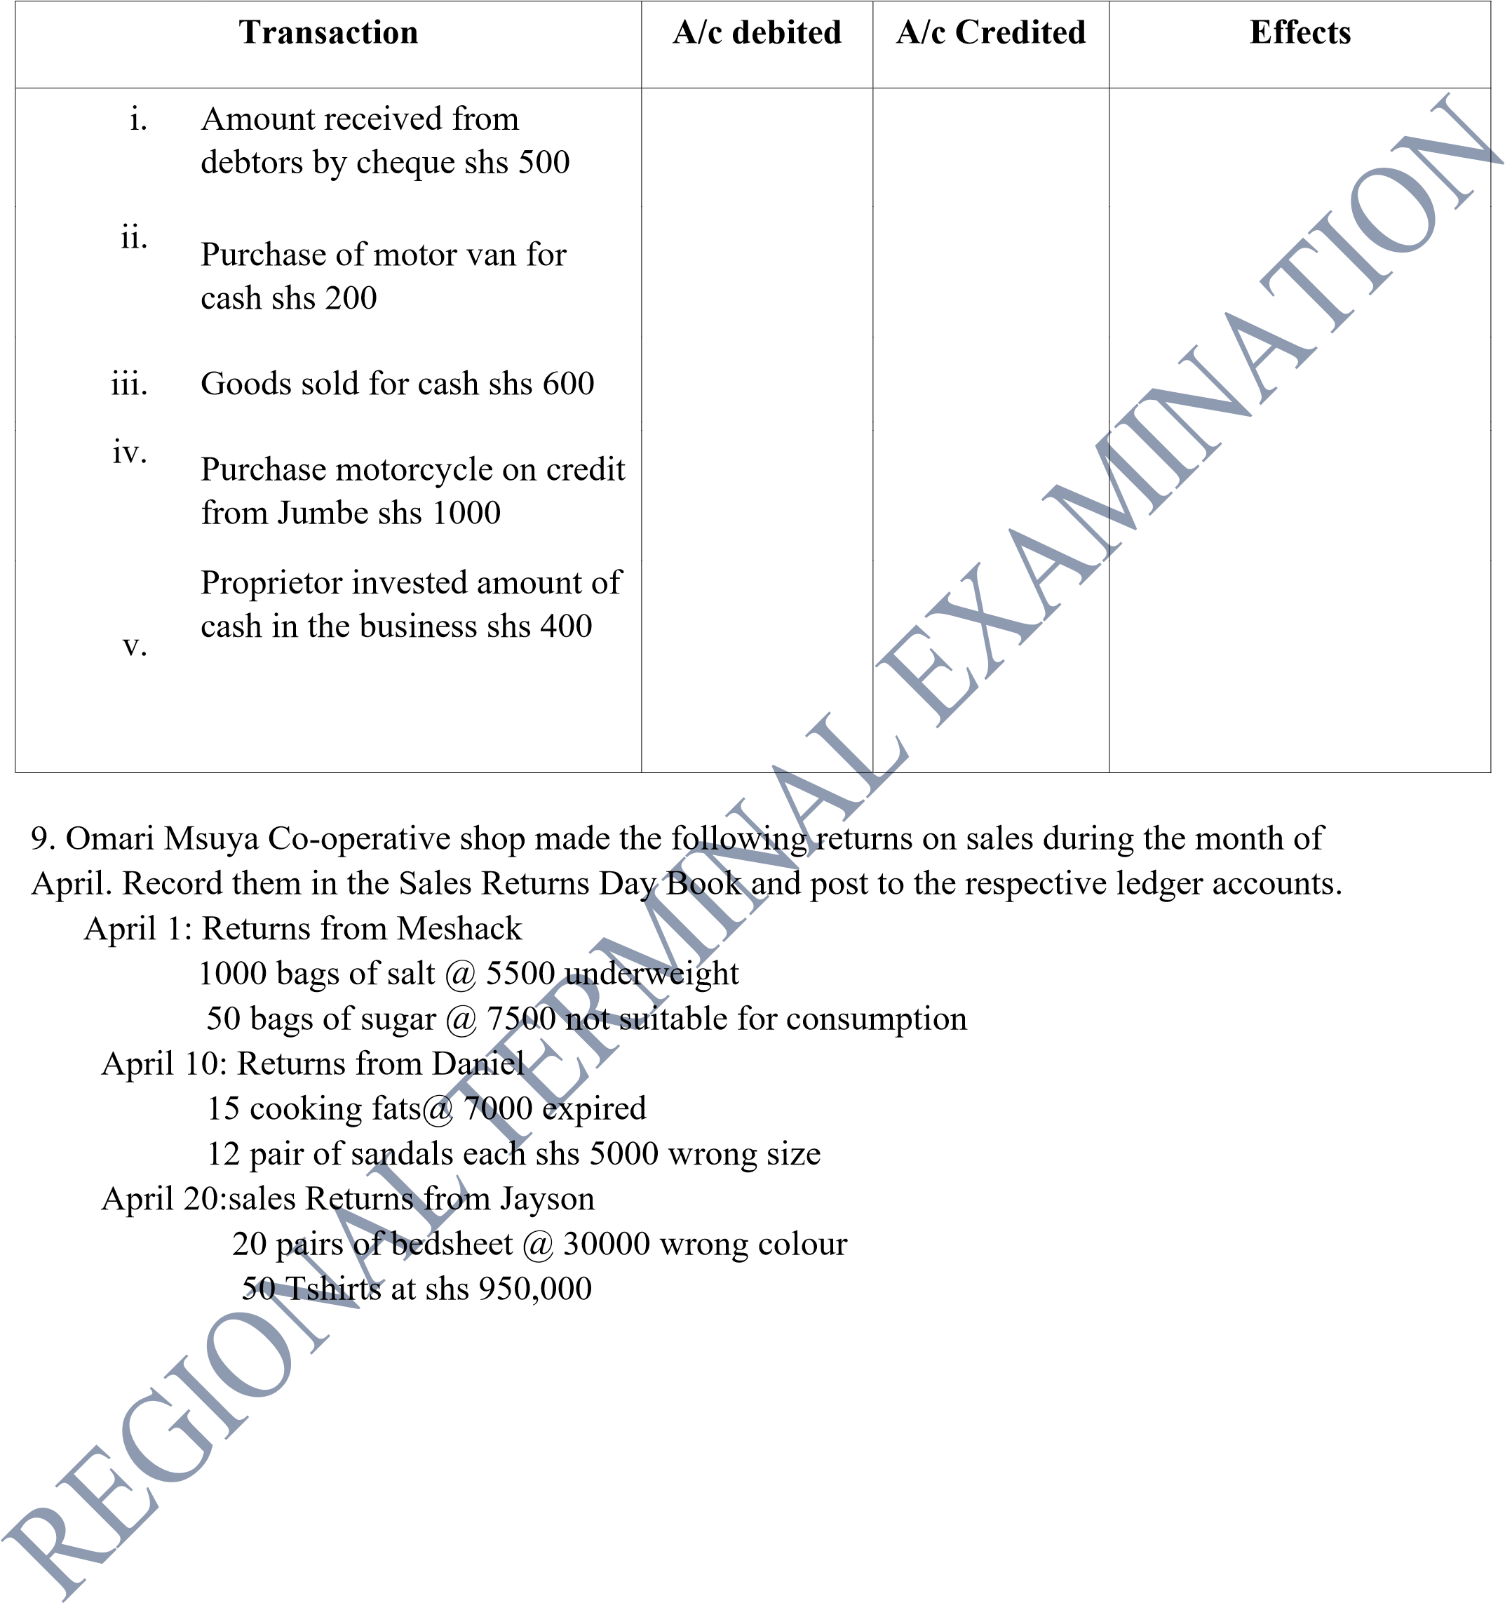
Page 4 of 4

