

THE PRESIDENT’S OFFICE
REGIONAL ADMINISTRATION AND LOCAL GOVERNMENT
LONGIDO DISTRICT

FORM ONE ANNUAL EXAMINATION
062 BOOK KEEPING
MARKING SCHEME NOVEMBER 2025

SECTION A (15 MARKS)
QUESTION 1
(10tick@1mark=10marks)
E | B | E | D | C | A | C | C | B | D

QUESTION 2
(5 marks, 1 @)
LIST A
LIST B | E | C | A | B | D

SECTION B (40 MARKS)
QUESTION 3
Accounting guideline or assumptions.
- MONETARY UNIT CONCEPT/ MONEY MEASUEREMNT CONCEPT:
According to this concept, a business transaction will always be recorded and can be expressed in terms of money. most countries would require that financial statements are presented in their local currency, example Tanzanian Shillings (TZS).
- BUSINESS ENTITY CONCEPT:
According to this concept, the owner or proprietor of a business is always separated and distinct from the business or enterprise.
- MATCHING CONCEPT:
This concept implies that revenues should be matched against expenses/costs in order to determine the profit or loss for the particular accounting period.
- REALIZATION CONCEPT/REVENUE RECOGNITION CONCEPT:
According to this concept revenue is recognized when a sale is made or an accountant only recognizes a profit when the goods are sold or services are rendered
- PERIODICITY CONCEPT/ TIME PERIOD CONCEPT:
This concept state that the financial activities of a business should be divided into specific and meaningful time periods for reporting purposes.
- DUAL ASPECT CONCEPT/DUALITY CONCEPT:
This basic concept in accounts which states that every transaction must be recorded twice
- GOING CONCERN CONCEPT/CONTINUITY ASUMPTION:
According to this concept, it is assumed that the business will continue to operate for the foreseeable future.
- HISTORICAL COST CONCEPT/COST CONCEPT:
This concepts state that, assets should be recorded and reported at their original cost when acquired by an enterprise.
- CONSISTENCY PRINCIPLE:
It states that an entity should not change its accounting methods frequent from one period to another.
- FULL DISCLOSURE PRINCIPLE:
Suggests that, every financial statement should fully disclose all relevant information for all interested parties like investors, lenders, creditors and shareholders to see.
- ACCRUAL CONCEPT:
This concept state that revenue is recognized when they are earned, and expenses are recognized when they are incurred. Regardless of when cash is received or paid.
- PRUDENCE CONCEPT/CONSERVATISM PRINCIPLE
This concept states that an entity must not overestimate its revenues, assets and profits besides this it must not underestimate its liabilities, losses and expenses.
(5points@2marks=10marks)

QUESTION 4
S/N | SOURCE DOCUMENT | USES
 | Receipts/cheque | Record cash transactions
 | Invoice | To record goods sold on credit/ credit sales
 | Debit note | To record goods returned back to supplier
 | Credit note | To record goods returned in business by customers
 | Invoice | To record goods bought on credit
(10tick@1mark=10marks)
QUESTION 5
CHIMWAGA’S JOURNAL PROPER FOR JULY 2021
Name of account | DEBIT | CREDIT
Business buildings | 350,000
Furniture | 100,000
Motorcycle | 150,000
Computer | 180,000
Van | 400,000
Debtors | 30,000
Bank balance | 90,000
Cash balance | 20,000
Loan from finca |  | 220,000
Account payable |  | 84,000
Capital |  | 1,016,000
 | 1,320,000 | 1,320,000
(13tick@0.76mark=10marks)

QUESTION 6
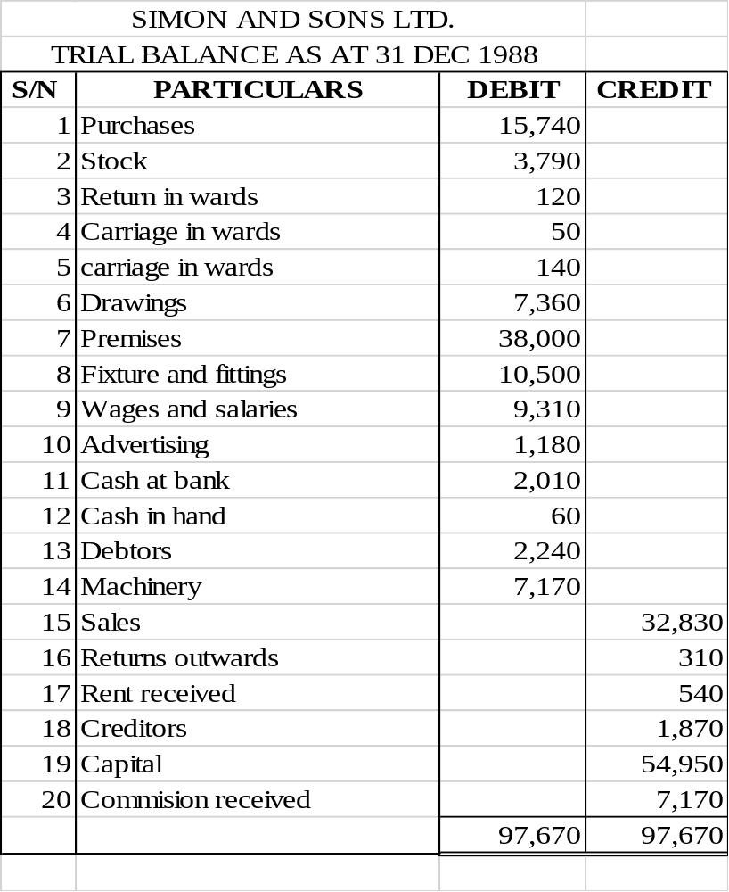
(20tick@0.5mark=10marks)
SECTION C (45 MARKS)
QUESTION 7
PRINCE’S SALES DAY BOOK
DATE | PARTICULARS | INVOICE NUMBER | INVOICE DETAILS | INVOICE TOTALS
2021  APRIL 1ST  APRIL 5TH  APRIL 12TH  APRIL 15TH  APRIL 22ND  APRIL 30TH | JUNIOR  10 dozen of Vitenge at 8,000 @  25 dozen of khanga at 10,000@  MERCY  100 pairs of shoes at 2,000 @  200 pairs of boots at 3,000 @  BARAKA  100 dozens of exercise at 3000 @  200 reams of papers 1500 @  NEEMA  Credit sales at 5,000  STAR BOOK STORE  200 dictionaries at 2,500 @  800 fiction book at 500 @  Transfer to the credit side of sales account | SL1  SL2  SL3  SL4  SL5  GL | 80,000  250,000  200,000  600,000  300,000  300,000  5,000  500,000  400,000 | 330,000  800,000  600,000  5,000  900,000  2,635,000

GENERAL LEDGER
 | PARTICULARS | F | AMOUNT | DATE | PARTICULARS | F | AMOUNT
 |  |  |  | 2021  30TH APRIL | SUNDRY DEBTORS |  | 2,635,000
DR. SALES ACCOUNT CR

QUESTION 8
INCOME STATEMENT AS AT 31ST DECEMBER 2012
DETAILS | TSHS | TSHS | TSHS
Sales |  | 328,300
Less sales return |  | (1200)
Net sales |  |  | 327,100
Less: cost of goods sold
Opening stock |  | 37,900
Add: purchases | 157,000
Add: carriage inwards | 5000
 | 157,900
Less: return outward | (3100)
Net purchases |  | 154,800
Cost of goods available of sale |  | 192,700
Less: closing stock |  | (30,300)
Less: goods sold |  |  | (162,400)
Gross profit |  |  | 164,700
Add: income: Rent received |  |  | 54,00
 |  |  | 170,100
Less: Expenses
Carriage outwards |  | 1400
Wages and salaries |  | 93,100
Advertising |  | 11800
Total expenses |  |  | (106,300)
Net profit |  |  | 63,800

STATEMENT OF FINANCIAL POSITION
DETAILS | TSHS | TSHS | TSHS
FIXED ASSET
Premises | 380,000
Fixture and fitting | 105,000
Total fixed asset |  |  | 485,000
CURRENT ASSETS
Stock |  | 22,400
Debtor |  | 30,300
Cash at bank |  | 20,100
Cash at hand |  | 600
Total current asset |  | 73,400
Less: CURRENT LIABILITIES
Creditors |  | (18,700)
Working capital |  |  | 54,700
Capital employed |  |  | 539,700
FINANCED BY

Capital | 549,500
Add: net profit | 63,800
 | 613,300
Less: drawings | (73,600)
Capital employed |  |  | 539,700

QUESTION 9
Dr Cash Account (1) Cr
Date | Details | Folio | Amount | Date | Details | Folio | Amount
1/4/2021 | Capital | 2 | 200000 | 3/4/2021 | Rent | 7 | 6000
18/4/2021 | Sales | 5 | 6000 | 4/4/2021 | Purchases | 3 | 8000
 |  |  |  | 6/4/2021 | Postage | 8 | 1000
 |  |  |  | 8/4/2021 | Drawings | 9 | 5000
 |  |  |  | 17/4/2021 | Salaries | 12 | 9600
 |  |  |  | 19/4/2021 | Advertising | 13 | 7000
 |  |  |  | 22/4/2021 | Purchases | 3 | 18000
 |  |  |  | 24/4/2021 | Furniture | 14 | 10000
 |  |  |  | 27/4/2021 | Machinery | 15 | 60000
 |  |  |  | 28/4/2021 | Wages | 16 | 16000
 |  |  |  | 30/4/2021 | Balance | c/d | 57400
 |  |  | 206000 |  |  |  | 206000
1/5/2021 | Balance | b/d | 57400

LEGDERS:
Date | Details | Folio | Amount | Date | Details | Folio | Amount
 |  |  |  | 1-4-2021 | Cash acc |  | 200,000
Dr Capital Account Cr

Date | Details | Folio | Amount | Date | Details | Folio | Amount
 |  |  |  | 18-4-2021 | Cash acc |  | 6000
Dr Sales Account Cr

Date | Details | Folio | Amount | Date | Details | Folio | Amount
3/4/2021 | Cash acc |  | 6,000
Dr Rent Account Cr

Date | Details | Folio | Amount | Date | Details | Folio | Amount
4/4/2021 | Cash acc |  | 8,000
22/4/2021 | Cash acc |  | 18,000
Dr Purchases Account Cr

Date | Details | Folio | Amount | Date | Details | Folio | Amount
6/4/2021 | Cash acc |  | 1,000
Dr Postage Account Cr

Date | Details | Folio | Amount | Date | Details | Folio | Amount
8/4/2021 | Cash acc |  | 5,000
Dr Drawing Account Cr

Date | Details | Folio | Amount | Date | Details | Folio | Amount
17/4/2021 | Cash acc |  | 9,600
Dr Salaries Account Cr

Date | Details | Folio | Amount | Date | Details | Folio | Amount
19/4/2021 | Cash aa |  | 7,000
Dr Advertising Account Cr

Date | Details | Folio | Amount | Date | Details | Folio | Amount
24/4/2021 | Cash aa |  | 10,000
Dr Furniture Account Cr

Date | Details | Folio | Amount | Date | Details | Folio | Amount
27/4/2021 | Cash acc |  | 60,000
Dr Machinery Account Cr

Date | Details | Folio | Amount | Date | Details | Folio | Amount
28/4/2021 | Cash acc |  | 16,000
Dr Wages Account Cr

