OFISI YA WAZIRI MKUU
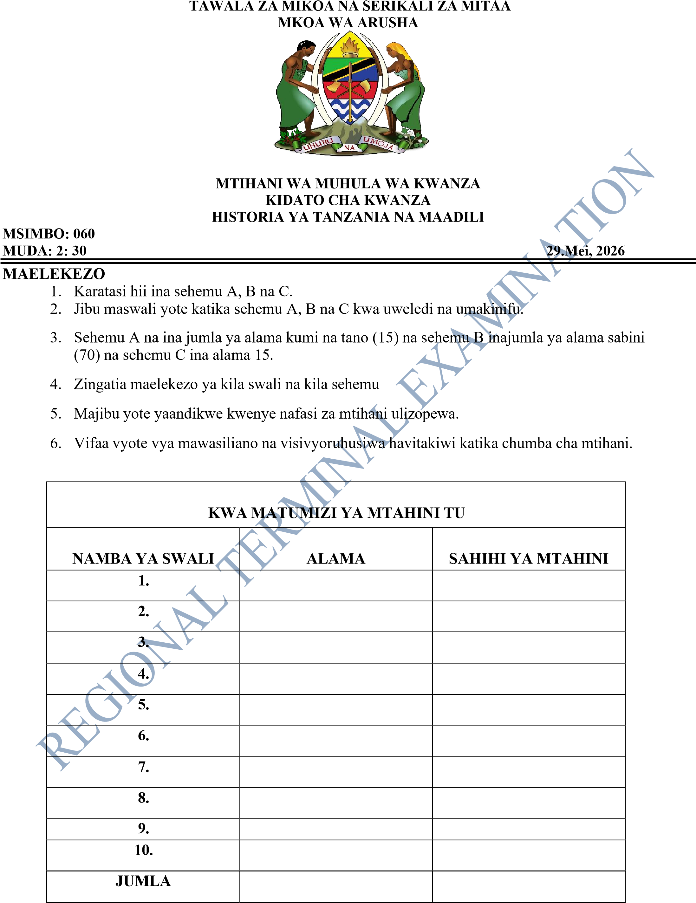
Ukurasa wa 1 kati ya 6

SEHEMU A (Alama 15)
Jibu maswali yote katika sehemu hii

1. Chagua herufi ya jibu sahihi katika kipengele (i) mpaka cha (x) kisha andika herufi ya jibu sahihi katika sehemu ya karatasi ya mtihani uliyopewa
(i) Somo la Historia ya Tanzania na Maadili linajumuisha dhana kuu ngapi?
- Moja
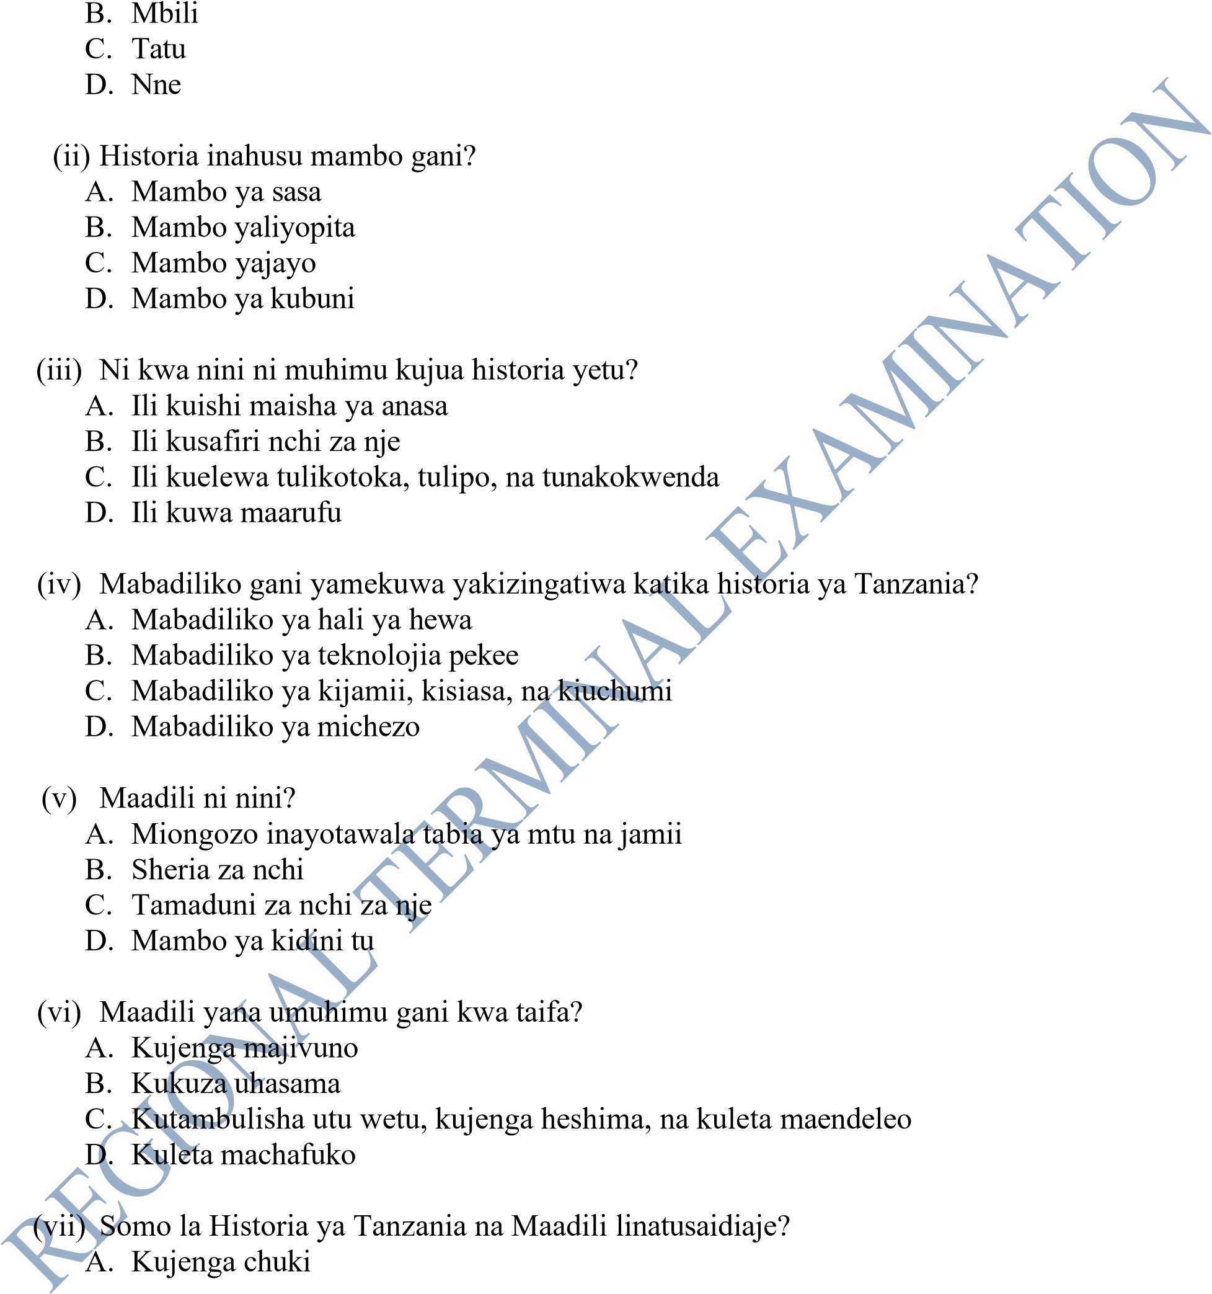
- Kuelewa mila, desturi, na maadili ya jamii za Tanzania
- Kuiga tamaduni za kigeni
- Kuacha mila zetu
- Ni nini umuhimu wa somo la Historia ya Tanzania na Maadili?
  - Kujifunza lugha za kigeni
  - Kujenga moyo wa kuipenda, kuilinda, na kuiheshimu nchi yetu
  - Kusafiri duniani
  - Kuwa na mali nyingi
Ukurasa wa 2 kati ya 6

- Somo la Historia ya Tanzania na Maadili linahusiana na masomo gani mengine? A. Jiografia, Hisabati, Kiswahili, Kiingereza, Chakula na Lishe, Sanaa na Michezo,
  - Muziki, na Kilimo
  - Fizikia na Kemia pekee
  - Biashara na Ujasiriamali pekee
  - Ufundi na Teknolojia pekee

- Ni kwa nini maadili ni muhimu katika jamii?
  - Huleta fujo
  - Huleta ubaguzi
  - Huleta amani, upendo, na maelewano
  - Huleta vita

i ii Iii iv v vi vii viii ix x

- Oanisha SAFU A kwa kutoa jibu sahihi kutoka katika SAFU B kisha andika herufi ya jibu sahihi katika visanduku chini yake.
SAFU A SAFU B
    - Histori A. Miongozo inayotawala tabia ya mtu na jamii a B. Mkusanyiko wa watu wenye uhusiano wa damu na asili moja
    - Maadil C. Mambo au matukio yaliyopita yenye athari kubwa i kiuchumi, kisiasa na kiutamaduni
(iii)Jamii D. Kitendo cha mtu binafsi, familia, kundi kubwa au jamii nzima
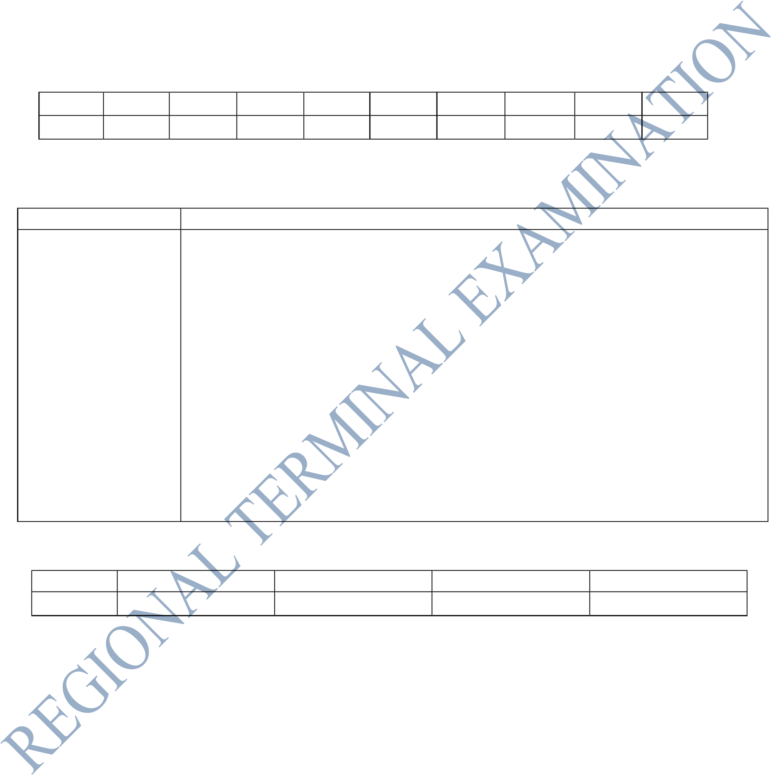
(iv) Ukoo kuondoka sehemu moja ya makazi na kwenda sehemu nyingine (v) Kabila E. Kundi la watu wanaozungumza lugha moja na huwa na mila na desturi za aina moja
F. Mkusanyiko wa watu kwa ujumla wake

I ii iii iv v

Jibu maswali yote katika sehemu hii
- Eleza ni kwa jinsi gani uhamiaji umechangia katika mabadiliko ya kijamii na kiuchumi katika jamii za Kitanzania?
  - ................................................................................................................................................. (ii) .................................................................................................................................................
(iii).................................................................................................................................................
(iv) ................................................................................................................................................. (v) .................................................................................................................................................
- Tanzania ina takribani makabila mia moja na ishirini na kila kabila lina utamaduni wake wa asili pamoja na mila na desturi zake . Taja makabila manne makuu yanayopatikana Tanzania, na utaje asili ya kila kabila.
  - ................................................................................................................................................. (ii) ................................................................................................................................................. (iii).................................................................................................................................................
(iv) .................................................................................................................................................

- Watanzania wengi katika jamii ya leo tumetokana na Wabantu kwani lugha nyingi za makabila nchini Tanzania hufanana matamshi pia hata maana. Eleza kwa kutoa mifano mitano (05) shughuli za kiuchumi na kijamii za jamii za Kibantu.
  - ................................................................................................................................................. (ii) .................................................................................................................................................
(iii).................................................................................................................................................
(iv) ................................................................................................................................................. (v) .................................................................................................................................................

- Kwa kutoa mifano thabiti eleza uhusiano kati ya somo la Historia ya Tanzania na Maadili na
masomo mengine kama vile (i) Jiografia
..........................................................................................................................................
.......................................................................................................................................... ..........................................................................................................................................
(ii) Hisabati
........................................................................................................................................... ........................................................................................................................................... ...........................................................................................................................................
- Taja baadhi ya mambo yanayozingatiwa katika Historia ya Tanzania.
  - ........................................................................................................................................................ (ii) ........................................................................................................................................................
(iii)........................................................................................................................................................
(iv) ........................................................................................................................................................ (v) .......................................................................................................................................................
- Jamii huusisha watu wa sehemu tofauti tofauti kwakulijua hilo, wewe ukiwa kama mwanafunzi wa kidato cha kwanza fafanua dhana ya jamii na vipengele vyake.
(i) ................................................................................................................................................... (ii) ...................................................................................................................................................
(iii)...................................................................................................................................................
(iv) ................................................................................................................................................... (v) ...................................................................................................................................................

- (a) Nini maana ya maadili
............................................................................................................................................................ ............................................................................................................................................................
............................................................................................................................................................
(b) Toa faida (04) nne za maadili katika taifa la Tanzania
(i) ................................................................................................................................................ (ii) ................................................................................................................................................
(iii)................................................................................................................................................
(iv) ................................................................................................................................................

SEHEMU C (Alama 15)
Jibu swali namba 10
- Shule ya Sekondari ‘’KATWE’’ kulikua na mgongano baina ya wanafunzi wa kidato cha kwanza ‘’A’’ wakidai kwamba somo la historia ya Tanzania na maadili halina faida kwao huku kidato cha kwanza ‘’B’’ hawajui somo linahusu nini kabisa. Wewe ukiwa kama mtaalamu wa historia na maswala ya utamaduni wasaidie wanafunzi wa kidato cha kwanza ‘’A’’ na ‘’B’’ katika shule ya ‘’KATWE’’ kujua umuhimu wa somo hilo.
............................................................................................................................................... ............................................................................................................................................... ............................................................................................................................................... ............................................................................................................................................... ...............................................................................................................................................
...............................................................................................................................................
...............................................................................................................................................
............................................................................................................................................... ............................................................................................................................................... ............................................................................................................................................... ............................................................................................................................................... ............................................................................................................................................... ............................................................................................................................................... ...............................................................................................................................................
...............................................................................................................................................
...............................................................................................................................................
............................................................................................................................................... ............................................................................................................................................... ............................................................................................................................................... ............................................................................................................................................... ............................................................................................................................................... ............................................................................................................................................... ...............................................................................................................................................
............................................................................................................................................... ............................................................................................................................................... ............................................................................................................................................... ............................................................................................................................................... ............................................................................................................................................... ............................................................................................................................................... ............................................................................................................................................... ............................................................................................................................................... ...............................................................................................................................................
............................................................................................................................................... ............................................................................................................................................... ............................................................................................................................................... ............................................................................................................................................... ............................................................................................................................................... ............................................................................................................................................... ...............................................................................................................................................
...............................................................................................................................................
...............................................................................................................................................
............................................................................................................................................... ............................................................................................................................................... ............................................................................................................................................... ............................................................................................................................................... ............................................................................................................................................... ............................................................................................................................................... ...............................................................................................................................................
...............................................................................................................................................
...............................................................................................................................................
............................................................................................................................................... ............................................................................................................................................... ............................................................................................................................................... ............................................................................................................................................... ............................................................................................................................................... ............................................................................................................................................... ...............................................................................................................................................
...............................................................................................................................................
...............................................................................................................................................
............................................................................................................................................... ............................................................................................................................................... ............................................................................................................................................... ............................................................................................................................................... ............................................................................................................................................... ............................................................................................................................................... ...............................................................................................................................................
............................................................................................................................................... ............................................................................................................................................... ............................................................................................................................................... ............................................................................................................................................... ............................................................................................................................................... ...............................................................................................................................................

