PRIME MINISTER’S OFFICE
REGIONAL ADMINISTRATION AND LOCAL GOVERNMENT
ARUSHA REGION


FORM ONE TERMINAL EXAMINATION

CODE: 031

PHYSICS

TIME: 2: 30 HRS

26
th

May, 2026

INSTRUCTIONS

1.

This paper consists of sections A, B and B with a total of the (10) questions.

2.

Answer all questions in each section.

3.

All answers must be written in the spaces
provided

4.

All writing must be in blu
e or black in except drawings which must be in pencil.

5.

Write your name at the top of each page

6.

Where necessary the following constants may be used

(
i
)

Acceleration due to gravity
, g= 10 m/s or 10N/kg

(
ii
)

Density of water 1000Kg/m³ or 1g/cm³

(
iii
)

Π = 3.14

Page 1 of 9

SECTION A:(15MARKS)
Answer all question from this section

1. For each of the items (i-x) choose the correct answer among the given alternatives and write its answer in the box provided
(i) How does physics help us in understanding the natural world and the universe?
- Physics is not related to the study of natural world and universe
particles to celestial bodies

C.

Physics only deals with artificial and human made systems

D.

Physics is not e
ssential for understanding the natural world and the universe

(
ii
)

Both density and relative density
are physical quantities; How do they differ?

A.

Density is the basic quantity while relative density is a derived quantity

B.

Density has unit but relative density h
as no units

C.

Density has no unit while relative density has unit

D.

D
ensity
is derived quantity while relative density is a basic quantity

(
iii
)

During measurement of the length by using a metre rule,
one

can get a wrong answer due to
wrong position of the eye
, an
error associated with this situation is called,

A.

Parallax

error

B.

Eye error

C.

Zero error

D.

metre rule error

(
iv
)

The mass of an object is increased if its

A.

S
tate is changed

B.

S
urface is increased

C.

V
olume

is reduced

D.

A
mount of matter is
increased

(
v
)
A person
measures the length, width, height and mass of a rectangular metal block. Which
of these measurements must be used in order to calculate the density of the metal?

A.

Mass and volume

B.

Height and mass only

C.

Length, width and height only

D.

Length, width, height and
mass

(
vi
)

The ball in the figure 1 below have the same size which one will hit the ground first

if they
are dropped at the same time and the same height?

- Physics help us to understand the behavior of matter and energy from subatomic

Wooden ball Plastic ball Metal ball
Page 2 of 9

  - Metal first, then wood followed by plastic ball
  - Wood first, then plastic followed by metal ball
  - They will hit the ground at the same time D. They will; hit the ground at different interval for the same acceleration due to gravity.

(vii) The same body is immersed in liquid A then in liquid B. The extent which the body sinks in liquid B is less than in liquid A. What conclusion can be drawn from such an
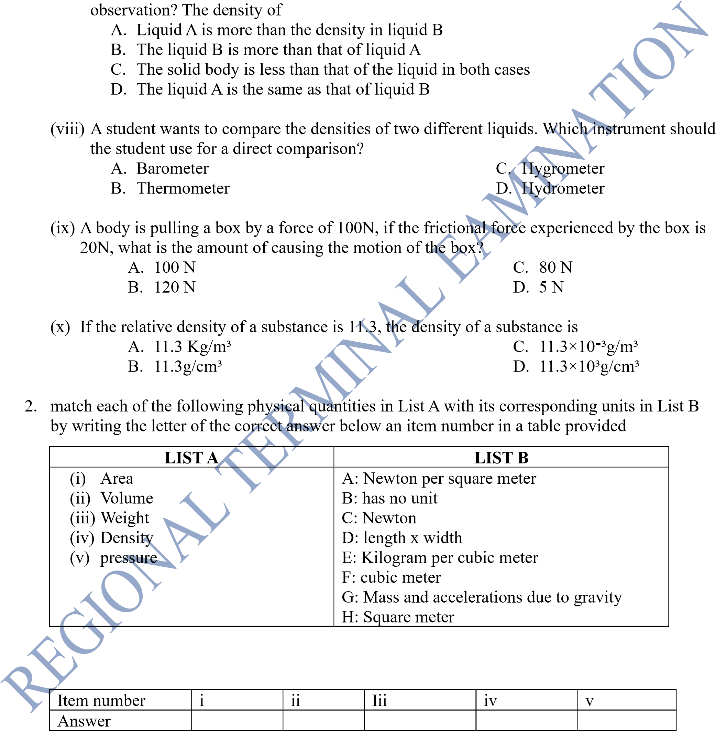 ANSWERS

Page 3 of 9

SECTION B: (70 Marks)
Answer all questions
- (a) In the process of measuring the diameter of a ball bearing by using a micrometer screw gauge with a least count of 0.01mm, the sleeve shows that it has 1.6cm, and the thimble indicate 46 divisions. What is the actual diameter of the ball bearing?

(
b)
(
i) what are the significant of the two parties in measurement?

(
a
)

…………………………………………………………………………………………
………………………………………………………………………………………….

(
b
)

………………………………………………………………………………………….

(
ii)
W
ith the aid of diagrams
write down the procedures which must be followed during
measurement of volume of irregular objects by using measuring cylinder

(iv) Why a triple beam balance is so named?
………………………………………………………………………………………………
…………………………………………………………………………………….…………

- (a)( i) the force of friction between the surface of a floor and the surface of a box in contact with the floor is 200N. John wishes to move the box on the floor with the constant velocity. How much force has to be applied on the box?

(
ii)

I
f a box has a mass of 100kg. calculate the coefficient of the friction force.

(
b) Why car dashboards are fixed with air bags?

……………………………………………………………………………………………………
……………………………………………………………………………………………………

5.

(
a
)

(
i ) Explain how
each of the following quantities differ from each other

(
a
)

Density and relative density

…………………………………………………………………………………………
…………………………………………………………………………………………
…………………………………………………………………………………………
…………………………………………………………………………………………
…………………………………………………………………………………………

(
b
)
Mass and Weight

…………………………………………………………………………………………
…………………………………………………
………………………………………
…………………………………………………………………………………………
…………………………………………………………………………………………
…………………………………………………………………………………………

(
ii) The density of water is 1000kg
/
m
3
. What does this imply?

………………………………………………………………………………………………
………………………………………………………………………………………………
………………………………………………………………………………………………

(b)In our daily life the application of physics is very important particularly in density; Mention five
(5) application of density
  - …………………………………………………………………………………………………
…………………………………………………………………………………………………
  - …………………………………………………………………………………………………
…………………………………………………………………………………………………
(iii)…………………………………………………………………………………………………
…………………………………………………………………………………………………
  - …………………………………………………………………………………………………
…………………………………………………………………………………………………
  - ………………………………………………………………………………………………… ………………………………………………………………………………………………….
6. (a)( i) energy can neither be created nor destroyed but transformed from one form to another form of energy, what is the name given to a device used to convert one form of energy to another form?
(ii) what are the energy changes when two cars are colliding head to on each other?
……………………………………………………………………………………………
……………………………………………………………………………………………
……………………………………………………………………………………………
……………………………………………………………………………………………
……………………………………………………………………………………………
…………………………………………………………………………………………… …………………………………………………………………………………………….

(b) Draw a diagram showing a simple pendulum swing freely from point A to point C through point B and show the energy changes in each point.

7. (a) A sample of milk diluted with water has a density of 1040 Kg/m³. If a pure milk has a density of 1080 Kg/m³. Find the percentage of water by volume in the diluted milk.
……………………………………………………………………………………………………
……………………………………………………………………………………………………
……………………………………………………………………………………………………
……………………………………………………………………………………………………
…………………………………………………………………………………………………… ……………………………………………………………………………………………………
……………………………………………………………………………………
(b)(i) A student place a hollow plastic ball and solid plastic ball of the same size into water. The hollow ball floats and the solid ball sinks. Explains the difference in their behavior using the Archimedes’ Principle and the concept of density.
……………………………………………………………………………………………………
……………………………………………………………………………………………………
……………………………………………………………………………………………………
……………………………………………………………………………………………………

(ii) State the Archimedes’ Principle
……………………………………………………………………………………………………
…………………………………………………………………………………………………… ……………………………………………………………………………………….
8. (a) During experiment in laboratory or measurement in a school laboratory, someone may obtain an answer which is somehow deviate from the current answer due to errors. Mention four (4) reasons for arise of errors;
- ……………………………………………………………………………………………
- ……………………………………………………………………………………………
(iii)……………………………………………………………………………………………
(iv) ……………………………………………………………………………………………
(b) Rectangular block measures length 4.00cm, width 2.5cm and height 1.009cm.
- Name the instrument used to measure the sides of the rectangular block

- Calculate the volume of the rectangular block

(iii)If the mass of the rectangular block is 300g, find the relative density of the block.

- (a) Laboratory is a special room or building designed specifically for carrying scientific experiments, therefore a laboratory must have good features for scientific experiments, mention five (5) features of a good laboratory.
  - ……………………………………………………………………………………………
  - ……………………………………………………………………………………………
(iii)…………………………………………………………………………………………… (iv) ..………………………………………………………………………………………….
(v) ……………………………………………………………………………………………
(b)(i) What is the difference between first Aid and first Aid kit
…………………………………………………………………………………………………
…………………………………………………………………………………………………
…………………………………………………………………………………………………
(ii)Mention four importance of first Aid
………………………………………………………………………………………………… ………………………………………………………………………………………………… …………………………………………………………………………………………………
…………………………………………………………………………………………………

SECTION C (15 Marks)
- (a) During experiment of determine the relative density of ethanal in the laboratory, John has got the following data during the observation
Mass of empty bottle =40g
Mass of empty bottle plus mass of a sand =90g
Mass of a sand plus mass of an ethanal is 120g
If the bottle used has a capacity of 600.0cm3. find the following
  - Mass of ethanal in kg
  - density of a bottle used
  - relative density of an ethanal
  - which is denser between sand and ethanal? Why?

…………………………………………………………………………………………………
…………………………………………………………………………………………………
…………………………………………………………………………………………………
…………………………………………………………………………………………………
…………………………………………………………………………………………………
………………………………………………………………………………………………… ………………………………………………………………………………………………… …………………………………………………………………………………………………
…………………………………………………………………………………………………
…………………………………………………………………………………………………
…………………………………………………………………………………………………
…………………………………………………………………………………………………
…………………………………………………………………………………………………
(b) A ship is sailing in sea enters a wide and deep river. The density of sea water is 1100kg/m³.
Determine a comparison of volume of object when wit is in sea water to when it is in river water.

