THE UNITED REPUBLIC OF TANZANIA
THE PRESIDENT’S OFFICE
REGIONAL ADMINISTRATION AND LOCAL GOVERNMENT

NAMANGA FORM ONE PRE-MIDTERM EXAMINATION

031 PHYSICS
MARKING SCHEME AUGUST 2024

SECTION A (15 Marks)

(i) | (ii) | (iii) | (iv) | (v) | (vi) | (vii) | (viii) | (ix) | (x)
A | A | C | D | C | D | D | D | A | A
01@ = 10 marks

01@ = 05 marks
List A: | (i) | (ii) | (iii) | (iv) | (v)
List B: | D | A | E | C | F

SECTION B (70 Marks)
01 mark
- (a) Derived unit: units of measurement derived from the seven SI basic units.
Examples: Square mtre (m²), Cubic metres (cm³), metres per second (m/s)
0½@ = 01½ marks
(b) Importance of forming hypothesis before doing an experiment:
A prediction about what could happen in an experiment, based on prior knowledge.
01½ marks

(c)
Importance of learning physics in our daily lives

(i)Physics develops fundamental knowledge for future technological advances that will continue to drive the economic engine of the world.
(ii) Physics enhances our understanding of other disciplines such as agriculture, environmental sciences, …

(iii)Physics is an interesting intellectual that inspire young people and expand the frontier of our knowledge about nature…

(iv) Physics helps him to help others; medicine without physics technology would not be so useful. It is also important in acquiring well-paying careers.
01½ @ = 06 marks

- (a) First aid is an immediate care given to an injured person before she/he is taken to a nearby hospital for further medical treatment while first aid kit is a small box containing items that are used to give help to a sick or injured person and Usually labeled as “FIRST AID” and stored in a safe and easily accessible place (2 marks)
(b)
ITEMS | FUNCTION
- A pair of scissors | To cut adhesive tapes, bandages  and gauze
- 2. Rolls of adhesive tape | To hold firmly into wounds,  bandages, gauze and cotton wool.
- 3. Bandages and cotton wool | To clean and cover wounds.
- 4.Sterilized new razor blade | Used in treating fresh or old wounds
Any four 02 mark@ = total 08 mark

- (a) Mass is the quantity of matter in an object while weight is the force of gravity on the object.
02 marks
(b) Juma stands on the scale and it reads 54 kg.
- Solution:
Data: mass 54 kg
01 mark
Mass of Juma is 54 Kg

- Weight = mass × gravitational force
54 Kg × 10N/Kg
02 marks
∴Weight = 540N

(c) Data: force of gravity on that planet is 2 N/Kg
01 marks
Mass of Juma is 54 Kg
01 marks
Weight = M × g
01 marks
Weight = 54 Kg × 2 N/Kg
01 marks
Weight = 108 N
01 marks
∴ His mass will be 54 Kg and his weight will be 108 N.

- (a) Application of Archimedes’ principle
Archimedes principle is employed in determination of relative density of solids heavier or lighter than water.
1 mark
(b) Solution:
Volume of cylindrical solid = a × h
0½ mark
$0.0004 m^{2}$ × $0.30 m$ = 0.00012 m³
Mass of cylindrical solid = volume × density
0½ mark
= 0.00012 m³ × 15000 Kgm⁻³
0½ mark
= 0.18 Kg
0½ mark
- Weight of solid = m × g = 0.18 Kg × 10 N/Kg
0½ mark
Weight = 1.8 N
0½ mark
- Volume of displaced water = volume of the cylindrical solid
= 0.00012 m³
Mass of water displaced = Volume of water × density of water
0½ mark
= 0.00012 m³ × 1000 Kg/m⁻³
= 0.12 Kg
0½ mark
0½ mark
Upthrust = mg = 0.12 Kg × 10 N/Kg
0½ mark
∴ Upthrust = 1.2 N
- Apparent weight of the cylinder in water and alcohol.
= 1.7 N – 1.2 N
0½ mark
= 0.6 N
Apparent weight of the cylinder in water = 0.6 N
01 marks
Upthrust due to alcohol = volume × density × g
= 0.00012 m³ × 780 Kg/m⁻³ × 10 ms⁻²
01 mark
= 0.936 N
0½ marks
∴ Upthrust due to alcohol 0.936 N
- (a) The addition of soap solution reduces the surface tension of water. This reduces the strength of skin that was preventing the pin from sinking, and therefore the pin sinks.
02 mark

(b) Solutin:
- Force constant.
Data: Extension (e) = 10 cm = 0.1 m
0½ mark
Force = 0.5 N

Formula:
Force cintant (K) = $\frac{Force }{extension }$ = $\frac{F}{e}$
01 mark
K = $\frac{F}{e}$ = $\frac{0.5N }{0.1}$ = 5 N/m
01 mark
02 marks
∴ The force constant = 5 N/m

- Solution
01 mark
From Hook’s law, Force α e; e =20 cm = 0.2 m
F = 5 N/m × 0.2 m
01 mark
F = 1 N
01 mark
0½ mark
∴ The required force is 1N.

- (a)
0½ mark
- E-mail
0½ mark
- Shor text message (SMS)
0½ mark
- Fax
0½ mark
- Write a letter

(b)
- You should not carry out an experiment if there is no teacher or technician in the laboratory.
01½ mark
- Wash your hands using soap and clean water, put on gloves, wash the cut using salt water and a clean cloth, and finally cover the cuts with adhesives bandages or plaster.
01½ mark
01½ mark
- Burn waste papers away from buildings
01½ mark
- Avoid tasting, eating or drinking anything in the laboratory
- Avoid handling apparatus or chemicals in the laboratory unless you are asked to do so by the teacher. Also, experiments should be carried out in the laboratory
01½ mark
Neatness 0½ mark

- (a) Density is the mass per unit volume of substance and it unit is kg/$m^{3} org/{cm}^{3}$ (2 marks)
(b) An error is the difference between the measured value and the true value. It can be caused by various factors such as limitations of the measuring instrument, environmental conditions, and human errors. Mistakes, on the other hand, are errors caused by the person performing the measurement. (3 marks)
- Data given
$m_{0}=19g$
$m_{1}=45g$
$density of liquid X=$0.81g/${cm}^{3}$
$m_{2}= ?$
$from;$
$RD=\frac{M_{2}-M_{0}}{M_{1}-M_{0}}$ …………………………………………………………… 01 marks
$0.81=\frac{M_{2}-19g}{45-19}$ …………………………………………………………… 01 marks
$m_{2}-19g=0.81×26$
$m_{2}-19=21.06$ …………………………………………………………. 01 marks
$m_{2}=40.06g$
Therefore, mass of bottle full of water = 40.06g …………………………….. 02 mark

SECTION C (15 Marks)

(a)
Items | Accuracy(mm)
- metre rule | 1
- Vernier calliper | 0.1
- Micrometer screw gauge | 0.01
01 mark@ = total 03 mark
(b) Consider the following steps:-
- Use beam balance measure the mass of stone as M
- Fill the overflow can with water up to the level of the spout
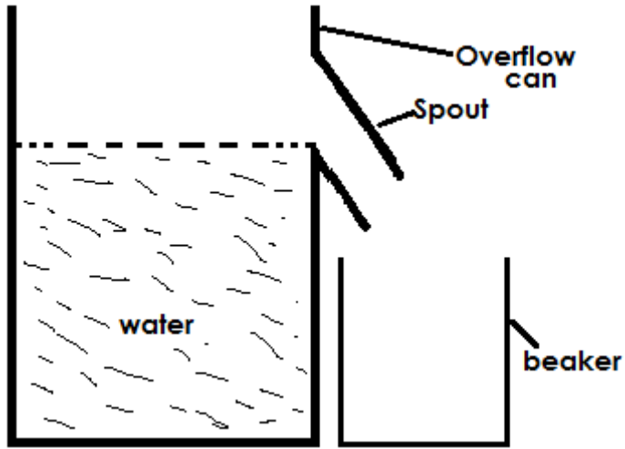

- Tie the irregular solid (stone) with a string
- Gently drop the irregular solid into water using a string
- The irregular solid (stone) will displace some water which will be collected in the beaker

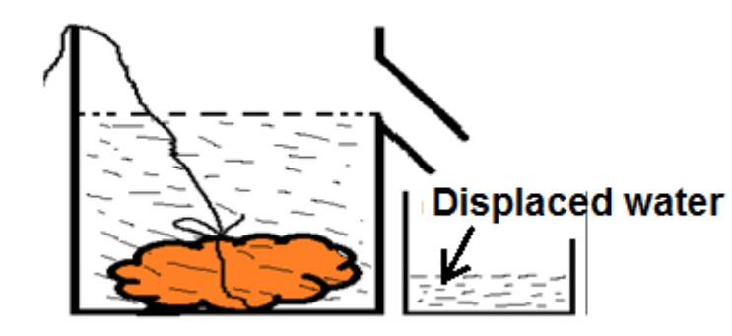

- Transfer the displaced water into a graduated cylinder
- Measure the volume of water, which is the volume of irregular solid as V
- Determine the density of stone = $\frac{mass of stone}{volume of stone}$
Conclusion
Density of stone = $\frac{M}{V}$
08-mark total
(c) main scale = 10.6cm
Vernier scale = 0.04cm
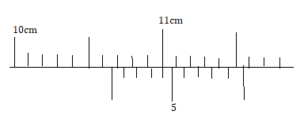(4 marks)

