THE UNITED REPUBLIC OF TANZANIA
PRESIDENT’S OFFICE,
REGIONAL ADMINISTRATION AND LOCAL GOVERNMENT
NAMANGA SECONDARY SCHOOL
FORM ONE TERMINAL EXAMINATION
PHYSICS
MARKING SCHEME 2024
INSTRUCTIONS

C | B | C | A | A | B | D | D | A | B
01 mark@ = 10 mark

F | G | C | A | B
01 marks @ = 05 mark
- (a)
- It enables us to answer many questions concerned with physical properties of matter
- It enables different people to acquire skills that required in different professions. For example, engineering, teaching and architecture
- It enables us to design and manufacture different items. Eg Generators etc
- It enables us to enjoy since we study practically ( Physics is fun )
01 marks @ =04 marks

- Mass (kg)
- Length (m)
- Time (second) 02 marks@ = 06 marks
- (a)
- Before use, the faces of anvil and spindle should be wiped clean to remove any dirt particles, which would cause false readings.
- zero reading must always be checked and recorded and if necessary a (+) or (–) correction applied to the final answer 02.5 marks@ = 05 marks

- No mobile phones
- Stop engine
- Petroleum spirit highly flammable
- Only approved containers may be filled with petrol
- Do not eat or drink near pump
- No smoking (05 marks)

- (a) Archimedes principle state “when the body is totally or partially immersed in liquid it experiences an upthrust which equal to the weight of the fluid displaced”. 03 marks

(b) Data given
Volume of container (V) = 400${cm}^{3}$
Mass of container (m) = 48g
Density of steel ($ρ_{2})=$ $8000kg/m^{3}$
From
Density of water = $\frac{mass of container+mass of steel}{volume of container+volume of steel}$ since density of water =1$g/cm^{3}$
Mass of container + mass of steel = volume of container + volume of steel 01 marks
48 +$m_{s}=400+V_{s}$ , but m = $ρV$ …………………………………………. 01 marks
48 + 8$V_{s}$ = $400+V_{s}$
Collect like term
$8V_{s}$ $-V_{s}$ = 400 – 48 …………………………………………………….. 01 marks
$7V_{s}=352$
$V_{s}$ = 50.29$cm^{3}$ …………………………………………………………….. 01 marks
$then$
Mass of steel = density of steel$×volume of steel=50.29×8=402.29g$ 01 marks
Therefore, the mass of the steel = 402.29g ………………………………..... 02 marks

- (a) It is better to measure from 1cm mark of the metre rule or measuring tape and then subtract 1 cm from the final reading. This is because of the wears and tears of zero edge of the scale. 04 marks

    - Data given
Main scale reading =0.5mm
Least count (LC) of micrometer screw gauge = 0.01mm
Circular scale reading (CSR) = 27divisions
Then
The reading = MSC + $CSR×LC$ …………………………………… 01 marks
The reading = 0.5mm + $27×0.01mm$ …………………………….. 01 marks
The reading = 0.5mm + 0.27mm …………………………… 01 marks
The reading = 0.77mm …………………………………… 01 marks
Also
The correct reading
Reading = 0.77mm + 0.05mm = 0.82mm ……………………… 01 marks
Therefore, the correct diameter of the wire is 0.82mm. ………….. 01 marks
- (a) Procedure
- Measure the weight of a pendulum bob in airas $W_{1}$
- Measure the weight of pendulum bob when immersed in water as $W_{2}$
- Measure the weight of pendulum bob in turpentine as $W_{3}$
- Determine the upthrust turpentine = $W_{1}-W_{3}$
- Determine the upthrust of water = $W_{1}-W_{2}$
- Relative density of turpentine = $\frac{upthrust of turpentine}{upthrust of water}$
RD = $\frac{W_{1}-W_{3}}{W_{1}-W_{2}}$ total 05 marks
- Data given
Mass of crown = 330g
Volume of crown = 60cm³
Density of gold = 1.5g/cm³
Density of iron = 7.5g/cm³
Mass of iron = ?
Volume of gold = ?
From
Mass of crown = mass of gold + mass of iron
330g = $m_{g}+m_{i}$ but mass = density $×volume$
$ρ_{g}V_{g}+ρ_{i}V_{I}=330$
$1.5V_{g}+7.5V_{i}=330$ ------------------------------------------- (i) 01 marks
Volume of crown = volume of gold +volume of iron
$V_{g}+V_{i}=60$ …………………………………………… (ii) 01 marks
$solve simultaneously equation \left(i\right)and \left(ii\right) above$
$V_{g}=60-V_{i}$ ……………………………………………….. (iii) 01 marks
$substitute eqn \left(iii\right)into \left(i\right)above$
${1.5 (60-V}_{1 })+{7.5V}_{i}=330$
$90-1.5V_{i}+7.5V_{i}=330$
$90+{6V}_{i}=330$
$6V_{i}=330-90=240$
$V_{i}=40$ …………………………………………………… (iv) 01 marks
$substitute eqn \left(iv\right)into \left(iii\right)above$
$V_{g}=60-V_{i}$
$V_{g}=60-40=20$ cm³
$mass of iron=40×7.5=300g$
Therefore, mass of iron =300g and volume of gold =$20$ cm³ 01 marks

- (a) Astronauts merely feel weightless in International space station because there is no external contact force pushing or pulling upon their body. They are in a state of free fall. The normal force does not comes into play giving the feeling of being weightless. 04 marks
- Data given
Weight of rockert at the earth = 10000N
Weight of rocket on other planet = 300N
Acceleration due to gravity on the earth = 10N/kg
From
Mass of the rocket at the earth = mass of the rocket to the other planet …. 01 marks
But weight = m$×g$ which implies that m = $\frac{W}{g}$ ……………….. 01 marks
$\frac{w_{e}}{g_{e}}= \frac{W_{P}}{g_{p}}$ ……………………………………………………………… 01 marks

$\frac{10000}{10}= \frac{300}{g}$ ………………………………………………………… 01 marks
$g= \frac{10×300}{10000} =0.3N/kg$ …………………………………………… 01 marks
Therefore, acceleration due to gravity of other planet = 0.3N/kg .. 01 marks

- (a) Ship floating on the water because of the large volume which displaced a lot of the fluid and make the overall density of ship to be less than the water while the 500 hundred coin is denser than water. 04 marks
- Data given
Main scale, m.s = 7.0mm = 0.7cm , ……………………………………… 02 marks
Thimble scale, v.s = 33 x 0.001 = 0.033cm ……………………………… 02 marks
Therefore, correct 𝑟𝑒𝑎𝑑𝑖𝑛𝑔 = 0.7 + 0.033 = 0.733 𝑐𝑚 ……………………………. 02 marks
- (a) Consider the following steps:-
- Use beam balance measure the mass of stone as M
- Fill the overflow can with water up to the level of the spout
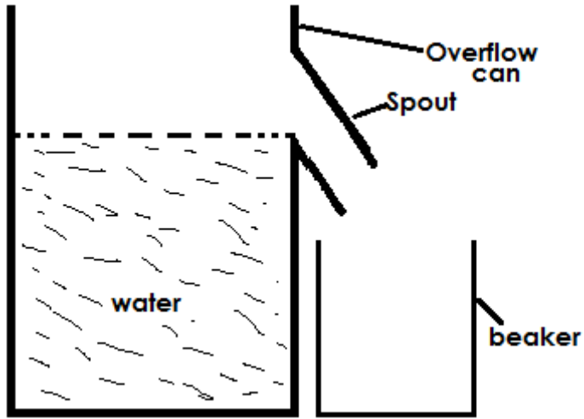

- Tie the irregular solid (stone) with a string
- Gently drop the irregular solid into water using a string
- The irregular solid (stone) will displace some water which will be collected in the beaker

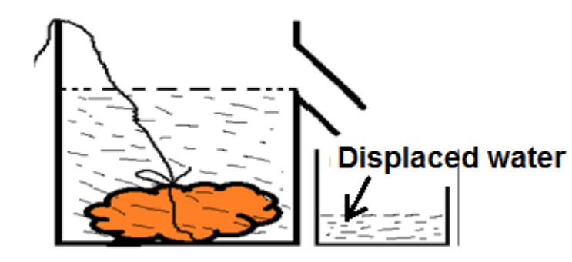

- Transfer the displaced water into a graduated cylinder
- Measure the volume of water, which is the volume of irregular solid as V
- Determine the density of stone = $\frac{mass of stone}{volume of stone}$
Conclusion
Density of stone = $\frac{M}{V}$ total 05 marks

- Relative density of the liquid
Data given
Mass of empty bottle = 25g
Mass of fully water = 80g
Mass when filled with other liquid= 55g
From
RD = $\frac{m_{2}-m_{1}}{m_{3}-m_{1}}$ ……………………………………………………………… 01 marks
RD = $\frac{55-25}{80-25}$ ……………………………………………………………… 01 marks
RD = 0.54
Therefore, relative density = 0.54 ……………………………………….. 01 marks
- Density of the liquid
Density = RD $×density of water=0.54×1g/{cm}^{3}$ ………….. 01 marks
Density of the liquid = 0.54$1g/{cm}^{3}$ ……………………………… 01 marks

- Diagram of hydrometer
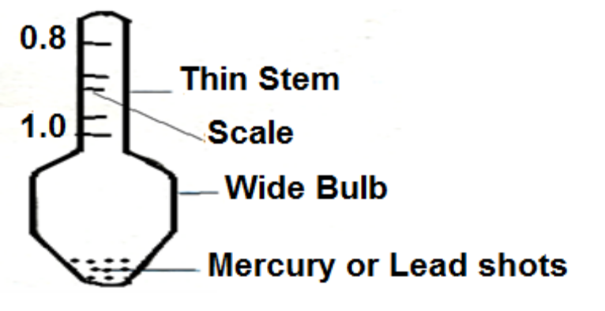 05 marks

