
TANZANIA HEADS OF SECONDARY SCHOOLS ASSOCIATION (TAHOSSA)
SIMIYU REGION
MEATU DISTRICT COUNCIL
FORM ONE DISTRICT JOINT TERMINAL EXAMS, MAY - 2019

031 PHYSICS – MARKING SCHEME ____________________________________________________________________________________________________

- (1 MARK @ TOTAL = 10 MARKS)
A | B | D | A | C | D | A | C | C | C

- (1 MARK @ TOTAL = 10 MARKS)
K | L | J | I | H | G | E | C | B | A

- (2 MARKS @)
- MATTER
- VOLTMETER
- THEORY
- SPRING BALANCE
- ENERGY

- (a) (i). Quantity of matter in an object SI Unity Kilogram (kg) (2:30 marks)
(ii). Beam balance (2:30 marks)
(b). Differences between mass and weight
Mass | Weight
- Quality of matter in an object | - Force of gravity acting on an object
- Fundamental physical quantity | - Derived physical quantity
- SI Unit is Kilogram (kg) | - SI Unit is Newton
- Measured by beam balance | - Measurement by spring balance

- (a). (i). Amount of space occupied by a substance. (1 mark)
- - Measuring Cylinder
- beaker (1 mark @)
- Volumetric flask

(b). Given
Volume of metal block (V₂) = 25cm³
Volume of water raised (V₃) = 65cm³
Initial volume of liquid (V₁) = ?
V₂ =V₃ – V₁
25cm³ = 65cm³ – V₁
V₁ = 65cm³ – 25cm³
= 40cm³
Initial volume of liquid = 40cm³ (6 marks)

- (a). (i). mass of Unit Volume (2 marks)
(ii). Ratio of Density of substance to the density of water. (2 marks)
(b). Given
Volume of copper metal = 5.1cm³
Mass of copper metal = 41.6g
Density of copper metal =?
Relative density of copper metal =?
Density of copper metal = Mass of copper metal (1 mark)
Volume of copper metal
= 41.6g
5.1cm³ (1 mark)
Therefore density of copper metal = 8.16/cm³ (1mark)

Relative density of copper metal = Density of copper metal
Density of water (1 mark)
= 8.16g/cm³ = 8.16 (1 mark)
1g/cm³
Relative density of copper metal = 8.16 (1 mark)

- (a). Because we use the basic ideas of physics in trying to understand the universe, it’s components their motion and how things intercut with each other.
(b). (i). Lead a variety of careers and profession.
(ii). Develop a logical and numerate mind
(iii). Core for communication Advances
(iv). Knowledge of physics is applied in very day activities to make work easier.
- (a) (i). Immediate assistance or care give to sick or injured person before getting
professional medical help (1mark)
(ii). Small box contain items that are used in firs aid. (1 mark)

(b). (i). Preserve life
Reduce pain and suffering
Prevent infection
Promote recovery by bringing hope and encouragement to the victim. (1 mark @)
(ii). Cotton wool
Razor blade
Pain killer
Assorted bandage

- (a). (i).. kilogram (kg)
(ii). Kilogram per meter tube (kg/m³) or gram per centimeter tube (g/cm³)
(iii). Tube meter (m³) (1 mark @)

(b). Given.
Measure of rectangular work = 8cm x 5cm x 2cm (1st)
Mass of rectangular block = 880g
Measure of rectangular block = 6 cm x 4cm x 2cm (2nd)
Volume of rectangular block (1st) = 8cm x 5cm x 2cm = 80cm³ (1 nark)

Density = mass = 880g (1 mark) = 11g/cm3 (1 mark)
Volume 80cm³
Volume of rectangular block (2nd)= 6cmxx4cmx1cm =24cm³ (1 mark)
Density = Mass 11g/cm³ = Mass (1 mark)
Volume 24cm³
Mass = 11g/cm³ x 24cm³ = 264g (1 mark)
Therefore Mass of a block is 264g. (1 mark)

- (a). (i) Laboratory Special room that has been designed and equipped for carrying out
experiment. (2 marks)
(ii)
- Well ventilated and its doors showed open outwards.
- Floors showed not be polished to avoid slippery.
- Fire extinguishers should be fitted in an accessible position.
- First aid kit should be in very laboratory. (1 mark @)
(b)
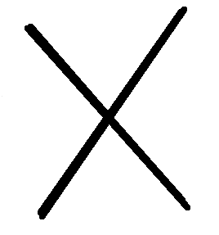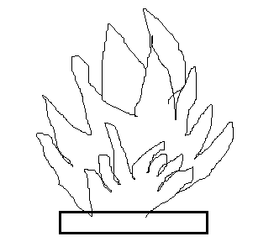
Harmful
Flammable

********************* All the Best *******************

