THE UNITED REPUBLIC OF TANZANIA
THE PRESIDENT’S OFFICE
REGIONAL ADMINISTRATION AND LOCAL GOVERNMENT

NAMANGA FORM THREE PRE-MIDTERM EXAMINATION

INFORMATION AND COMPUTER STUDIES
MARKING SCHEME AUGUST 2024

SECTION A (16 MARKS)

E | C | B | D | B | A | C | E | D | A

LIST A | 1 | 2 | 3 | 4 | 5 | 6
LIST B | H | A | E | G | D | C

SECTION B (54 MARKS)
- (a) ANY two(2) causes 01 mark Total = 02marks
- Virus
- Outdated application
- Outdated system software
- Sharing of CD, DVD and flash disks
(b) explanations of any two above causes 01 mark @ Total = 2 marks
(c) two (2) advices 2.5 marks @ Total = 05 marks
- install antivirus
- regularly Update installed system and application software.

- (a) web server is a super computer that runs special serving (website) and software required by client. Or related definition (o2 mark)
(b) Client – server diagram (05 marks)
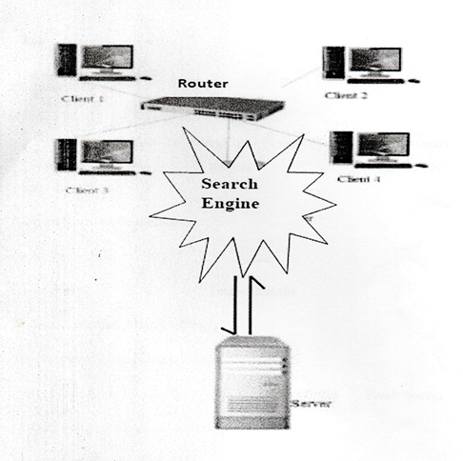
(c) Convert digital video computer signals into analogy telephone signals and viceversa.
- allow the computer to communicate over telephone line. (02 marks)

- (a) 01 mark @ Toal = 03 marks
Normal layout view: this displays page in normal view with the slide on the right and a list of thumbnails to the left. This view allows you to edit individual slides and also rearrange them (01mark)
Slide Sorter View: this displays all the slides as a matrix, this view only allows you to rearrange the slides but not edit the contents of each slide. (01 mark)
Slide show view: Slide Show View takes up the full computer screen, like an actual slide show presentation. In this full – screen view, the presentation is shown the way it will be seen by the audience. You cannot edit anything in this view. (01 mark)
(b) 01 mark @ any five explained (5) points Total = 05 marks
- purposes of presentation (topics)
Audience
Occasion
Relevance
Attractive contents
Interactive ( audible and visual)
(c) ANY two(2) points 0.5 mark@ total = 01 mark
Time management
Cover large area
Use many media elements
Motivate audience

- (a)
- Network topology is Peer – to – Peer (p2p)/ Mesh (01 mark @ Total = 01 mark @
- Explained any two points 01 mark @ Total = 02 marks
- Simple to configure
- Low cost ( needs little hardware)
- Faster data transfer
(b) 01 mark @ total = 02 marks
- Wireless communication technology
- Bluetooth communication technology
- Wireless Fidelity (Wi-Fi)
(c) explained consideration ( any two) 02marks@ Total = 4 marks
- Distance coverage (device to device)
- Communication Technologies
- Cost effectiveness
- Bandwidth (file size)
- Power supply

- (a) Microsoft Office Excel application 01 mark
(b) File name: SOLD ITEMS 01 mark
(c) font face : Verdana 0.5 mark
(d) font size : 12 0.5 mark
(e) Merge cells + bold 01mark
(f) =SUMIF(E4:E8,”<40000”) 02 marks
(g) 1.5 marks @ Total = 03marks
Relative cell referencing – in this, a cell reference changes relative to the position of the formula. E.g. By using the formula in 7(f) =SUMIF(E4:E8,”<40000”) entered in E10. Column letter and Row number change as you reference formula.
Absolute cell referencing- when a formula is copied to other cells, the cell references remain unchanged. A dollar sign is placed before the column letter and the row number by either typing it or pressing =SUMIF($E$4:$E$8,”<40000”) entered in E10.

- (a)
- Website is collection of related HTML pages rendered and interpreted by web browser.
While webpage is hypertext document markup with HTML codes 02 mark
- Internet and Intranet 02 marks
(b) HTML CODES 05 marks
<HTML doctype html!>
<HTML>
<BODY>
<h1> Congratulation for opting computer studies</h1>
My favourable subjects are:
<OL TYPE =”A”>
<LI>Physics </LI>
<LI>Mathematics and </LI>
<LI>Computer studies </LI>
</OL>
My details:
<UL>
<LI>Age: 14 Years Old</LI>
<LI>Telephone :0768548635 </LI>
<LI>Address: P.O. BOX 2023 </LI>
</UL>
<FORM>
<INPUT TYPE = “SUBMIT” VALUE = “Send”>
</FORM>
</BODY>
</HTML>

SECTION A (30 MARKS)
ONLY two question each 15 marks

- Introduction (02 marks)
- Explained point (03 marks) any four (04 points) = 12marks
- Conclusion = 01 marks

- Introduction (02 marks)
- Explained point (03 marks) any four (04 points)=12 marks
- Conclusion = 01 mark

- Introduction ( 02 marks)
- Explained point ( 03 marks) any (04 points) = 12 marks
- Conclusion = 01 marks

