THE UNITED REPUBLIC OF TANZANIA
THE PRESIDENT’S OFFICE
REGIONAL ADMINISTRATION AND LOCAL GOVERNMENT

NAMANGA FORM THREE PRE-MIDTERM EXAMINATION

INFORMATION AND COMPUTER STUDIES
Time: 3 Hours August 2024
Instructions
- This paper consists of sections A, B and C with total of twelve (11) questions.
- Answer all questions in sections A and B and two (2) questions from section C.
- Sections A carries sixteen (16) marks, section B fifty four (54) marks and section C carries thirty (30) marks.
- Cellular phones and unauthorized materials are not allowed in the examination room.
- Write your Examination Number on every page of your answer booklet(s).

SECTION A (16 Marks)
Answer all questions in this section.
- For each of the items (i)-(x), choose the correct answer from the given alternatives and write its letter beside the number in the answer booklet provided.
- Development which marked in the second generation of computers
A. Microprocessor B. Vacuum Tubes C. Registers D. Intelligence
E. Transistors

- Which of the following is the correct meaning of the term workbook as used in Microsoft office excels?
- Collection of more than one sheet
- Collection of cells
- Collection of more than one worksheet
- Collection of more than one spreadsheet
- Collection of more than one row and column

- Najua typed URL www.necta.go.tz on a web browser when searching form four results, immediately he interacted with first page displayed on his computer. What this webpage is called
- HTML page B. Homepage C. Bookmark page D. Link page
E. Webpage

- The following are auxiliary memory for electronic devices except
- Memory Card B. Flash disk C. Read only Memory D. Random Access memory
E. SSD

- Relational Database Management System is application software used to organize, store, manage and analyze data in good system. Which presentation of data this system applies?
- Stores data in distributed systems
- Stores data in tables that contains rows and column
- Stores data in the form of parent-children relationship nodes
- Stored in a virtual environment
- Stores data at a centralized database system

- Communication media are channels provides the pathways, which the messages can travel from source to destination. Which are two types of those media used in distributing information in the society?
- Mechanical media and Physical media
- TV and Radio
- Notice board and magazine
- Social media and News media
- Images and sound
- In Microsoft office word the command 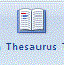 during creating document is used for
- Full screen reading document.
- Print layout a document.
- Suggesting other words with similar meaning to the word you have selected.
- Checking the spelling and grammars of the text in the document.
- Switching the pages between portrait and landscape layouts.

- Which of the following is necessary for running application software?
- Utility software B. Graphical user interface C. Network card software
D. Command line interface E. System software

- The Headmaster Seypalm Secondary school needs to move packets of data from her local area network to TAMISEMI Headquarter office. Which device among the following will you advise her to buy in order to configure network?
- Hub B. Switch C. Bridge D. Router E. Fax machine.

- Interactive multimedia which designed and combined together sound, video and animations elements is called
- Hypermedia B. Mixed media C. Hyperlink D. Hypertext E. Visual media

- Study the computer internal hardware parts labeled (1-6) and match them in List A with their corresponding functions in List B by writing the letter of the correct response beside the item in number in the answer booklet provided. (6 MARKS)
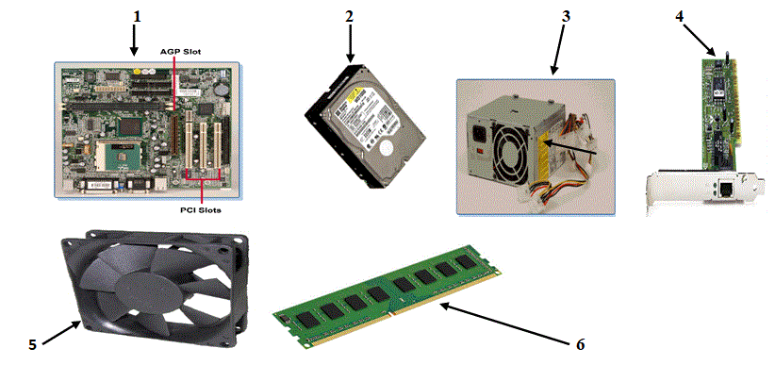

List A | List B
- Hardware 1  - Hardware 2  - Hardware 3  - Hardware 4  - Hardware 5  - Hardware 6 | - Provides storage capacity for future use  - Displays graphical images.  - Where the OS, application programs, and data in current use are kept before quickly reached by the processor.  - Prevents the computer components from overheating by maintaining airflow in the case.  - Provides the needed voltage to power the various electronic circuits.  - Connect all peripheral devices to the computer system.  - Connect a local computer to a group of other computers so they can share data and resources in a networked environment.  - Everything else in the system plugs into it.  - Produce sound in the computer system.

SECTION B (54 Marks)
Answer all questions in this section.
- Mandonga has computer which helps jobs at his office and communicate with remote people, One day the computer started to behave work slowly, starkly and unfortunately lost all data and he do not have more knowledge about computer repair and maintenance. As a computer studies student helps him by answering the following questions.
- What are probably two causes of this situation? (2 marks)
- Briefly explain the two causes identified above. (2 marks)
- How can you advice Mandonga to avoid loss of data again? Give two points. (5 marks)

- (a) What is web server as used in information and communication technology? (2 marks)
(b) Draw a well labeled diagram of the client-webserver architecture model and explain its components. (5 marks)
(c) Why Modem is very important in World Wide Web (WWW) based communication. (2 marks)

- Microsoft PowerPoint has three main views: normal view, slide sorter view and slide show view for creating, and designing presentation.
- Briefly explain how three views work. (3 marks)
- Explain five conditions to consider when preparing a good presentation to audience.
(5 marks)
- Which are two benefits of using Microsoft PowerPoint in our daily life? (1 mark)

- Study carefully figure 2 and then answer the questions that follow:
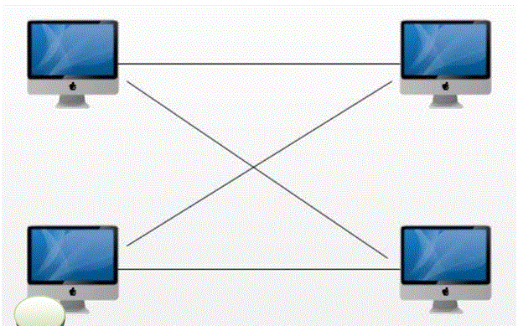
- What is the type of the network topology presented in figure 2? Explain two advantages of using this type of a network. (3 marks)
- Which other two communication technologies can be used to connect devices in this network identified in 6 (a) above? (2 marks)
- What are factors to consider when designing and creating this topology? Explain two reasons.
(4 marks)
- Mazoea sold shop items and kept information for further more record and analysis. Study carefully screenshot and then answer the questions that follow:
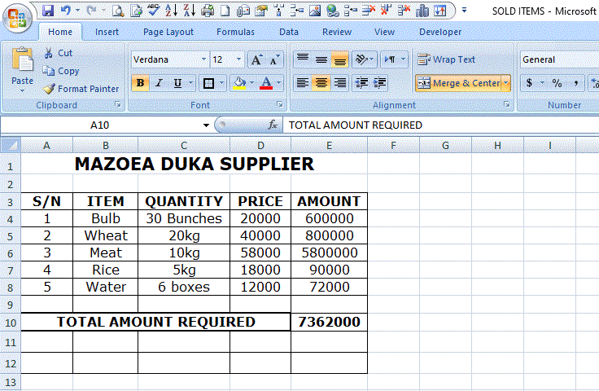
- What is application software Mazoea used to create the document? (1 marks)
- What is the file name of document? (1 marks)
- What type of font face applied in the created document above? (0.5 marks)
- Identify font size of the texts. (0.5 marks)
- Write the formatting tool used in cells contains word “TOTAL AMOUNT REQUIRED” and “MAZOEA DUKA SUPPLIER”. (1 marks)
- Write the functional formula may be used to get the total amount required only for price at most 40,000. (3 marks)
- Mazoea does not know two ways of cells referencing. By using formula you have written in 7(f) above describe to help Mazoea. (3 marks)

- (a) Differentiate the following terms.
- Website and webpage (2 marks)
- Internet and intranet (2 marks)
(b) Write basic HTML structure code of displaying the interface below. (5 marks)
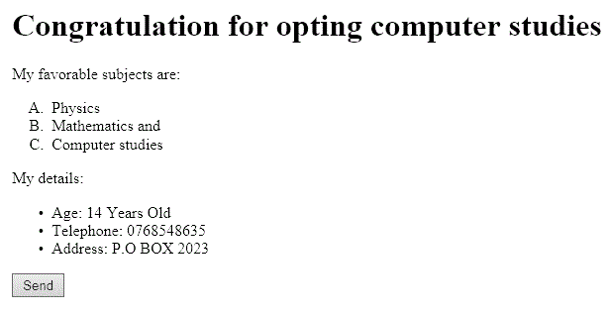
SECTION C (30 Marks)
Answer only two (2) questions in this section.
- Many Institutions use electronic publications to advertise daily business activities and increase production. Give four (4) advantages of application software used by Institutions.

- “Electronic database is powerful tool of processing data now days in computerized technologies”. Defend your answer by using only four (4) points.

- In a school debate, the motion state that “Computer without system software is like empty box”. Suppose you are invited to urge the motion, with four (4) strong points discuss.

