PRIME MINISTER’S OFFICE
REGIONAL ADMINISTRATION AND LOCAL GOVERNMENT ARUSHA REGION

FORM THREE TERMINAL EXAMINATION
CODE:036 INFORMATION AND COMPUTER STUDIES
TIME: 3: 00 HRS 03rd June, 2026 INSTRUCTIONS
- This paper consists of sections A, B, and C with a total of eleven (11) questions.
- Answer all questions in sections A and B, and two (2) questions from section C.
- Section A carries sixteen (16) marks, section B fifty-four (54) marks and section C carries thirty
(30) Marks.
- Communication devices and any other unauthorized materials are not allowed in the examination room.
- Write your Examination Name on every page of your answer sheet booklet(s).

SECTION A (16 MARKS)
Answer all questions from this section.
- For each item (i) – (x), choose the most correct answer from the given alternatives and write its corresponding letter beside the item number in the answer booklet provided.
(i) Charles Babbage is referred to as the father of computing. He designed two computing machines namely:
A. Napier's bones and Abacus C. Difference engine and B. Weaving loom and Slide rule Analytical engine
D. Abacus and Slide rule
(ii) One of the following describes why it is important to update antivirus software regularly: A. To ensure that software identifies old viruses
        - To protect your computer from all known viruses
        - To protect your computer from unwanted bulk messages
        - To prevent the spread of malicious programs on the Internet

(iii) Hardware for a computer system is similar to:
        - The instructions that are given to a clerical system
        - The equipment in clerical system
        - The input data that is used in a clerical system
        - The output that is generated from clerical system E. The file cabinet in the clerical system

(iv) When a computer is turned on, it undergoes the following process in sequence:
A. Post, Booting, Read Bios C. Post, Read Bios, Booting B. Read Bios, Post, Booting D. Booting, Post, Read Bios

(v) Grouping two or more adjacent cells into one large cell is referred to as:
        - Merging cells C. Joining of the cells
        - Grouping cells D. Combining cells

Page 1 of 5

(vi) Another name for temporary storage is:
        - Secondary storage D. Magnetic tape storage
        - Auxiliary storage E. Main storage
        - Floppy diskette storage

(vii) Output from a printer is normally called:
        - Printer copy D. An electronic copy
        - A soft copy E. A hard copy
        - A photocopy

(viii) Transmission of data of all kinds (text, graphics, sound and video) over a variety of different communication channels such as public telephone, private cables, microwave and satellites is called:
        - Telecommunication C. Information and Communication
        - Communication D. Teleconference

(ix) The speed of a central processing unit (CPU) is measured in:
        - Horse power
        - Bytes
        - Bits per second (BPS)
        - Megahertz (MHZ), Gigahertz (GHZ) and Kilohertz

(x) RAM is a volatile memory. The term volatile means:
        - Data in RAM is not permanent and can be changed
        - Data in RAM is permanent and cannot be changed
        - RAM can multifunction easily and is very expensive
        - RAM contains programs for starting the computer

- Match the items in List A with their corresponding descriptions in List B by writing the letter of the correct response beside the item number.
LIST A LIST B
  - Tags for emphasizing the header of the table in a webpage. A. <img src="">
  - Tags for creating a list of bullets in a webpage. B. <h1> </h1>
  - Tags for creating a link in a webpage. C. <body> </body>
  - Tags for highlighting the main title of the webpage. D. <th> </th>
  - Tags for inserting a picture in a webpage. E. <b> </b>
  - Tags for enclosing the elements for visibility to webpage visitors. F. <ul> </ul>
            - <hr> </hr>
            - <ol> </ol>
            - <a href=" "> </a>

SECTION B (54 Marks)
Answer all questions in this section.
- (a) Why is it advised to close windows and doors in a computer laboratory? Give four reasons.
(6 marks)
  - Why is it prohibited to use liquid fire extinguisher in the computer laboratory? Give two reasons. (3 marks)
Page 2 of 5

- The Ministry of Health uses television and radio broadcasting to disseminate information about pandemic diseases and the measures to be taken by society.
(a) Which type of information dissemination method is used by the Ministry of Health? (1 mark) (b) Why does the Ministry use such means of disseminating information? Give four reasons.
(6 marks)
(c) What two challenges would the Ministry face by using such a method of disseminating information? (2 marks)

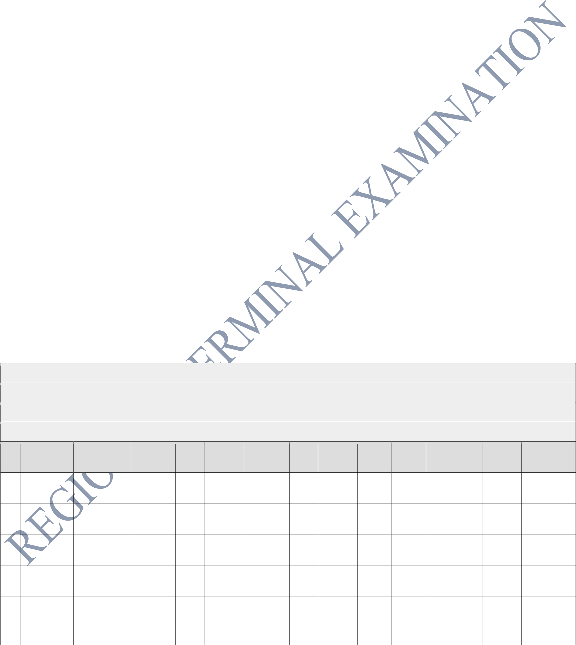
- (a) You have been assigned by the coordinator of the Open University of Tanzania to propose the type of computer network that connects its branches all over the country. What type of network would you suggest? (1 mark)
  - A school in Kimbiji has four classrooms, each with ten computers, all connected to one central device. The network administrator is deciding whether to install a router or a switch as the central device.
    - Distinguish between a router and a switch by comparing how each device handles data within a network.
    - Which device would you recommend for connecting the four classrooms to each other within the school? Give one reason for your choice.
(iii)The school later wants students to access the internet. Explain why the device you chose in (ii) alone would not be sufficient, and identify what additional device would be needed.
(5 marks)
  - "Deploying Fiber Optical cable for computer network in recent technology is inevitable". Justify this statement by giving three reasons. (3 marks)

- The ICS Teacher at Kampaga Secondary School assigned you to prepare the following worksheet which shows the second term results of Form Four students. Study it carefully and answer the questions that follow:

THE UNITED REPUBLIC OF TANZANIA

KAMPAGA SECONDARY SCHOOL
FORM IV RESULTS SECOND TERM
S Surname Given Maths Bio Phys Chemi ICT Kisw Eng Total Average Grade Position
N Names
- Biguttu Mohamed 90 89 78 70 85 75 80 567 81 A 1
Hassan
- Mwakipe Peter John 34 56 45 48 60 52 56 351 50 C 3 sile
- Byarugab Andrea 20 25 30 34 24 56 48 237 34 D 4 a Josephat
- Mwijuma Hussein 15 23 18 30 25 20 22 153 22 F 5
Sheikh
- Mrisko Jackso 78 65 90 58 64 72 88 515 74 B 2
John
10

  - Which function would you use to calculate the Average of the student marks which are integers?
    - marks)
  - Suggest the function used to assign the grades for each student.
Hint: (If average stands from 75 - 100 = A, 65 - 74 = B, 45 – 64 = C, 30 – 44 = D and 0 – 29 = F).
    - marks)
  - Which function would you use to rank the candidates' positions? (The rank should be based on candidates' Average). (2 marks)
  - Which steps would you follow to remove row 10 from the worksheet? (3 marks)

- Read the following scenario carefully and answer all questions that follow.
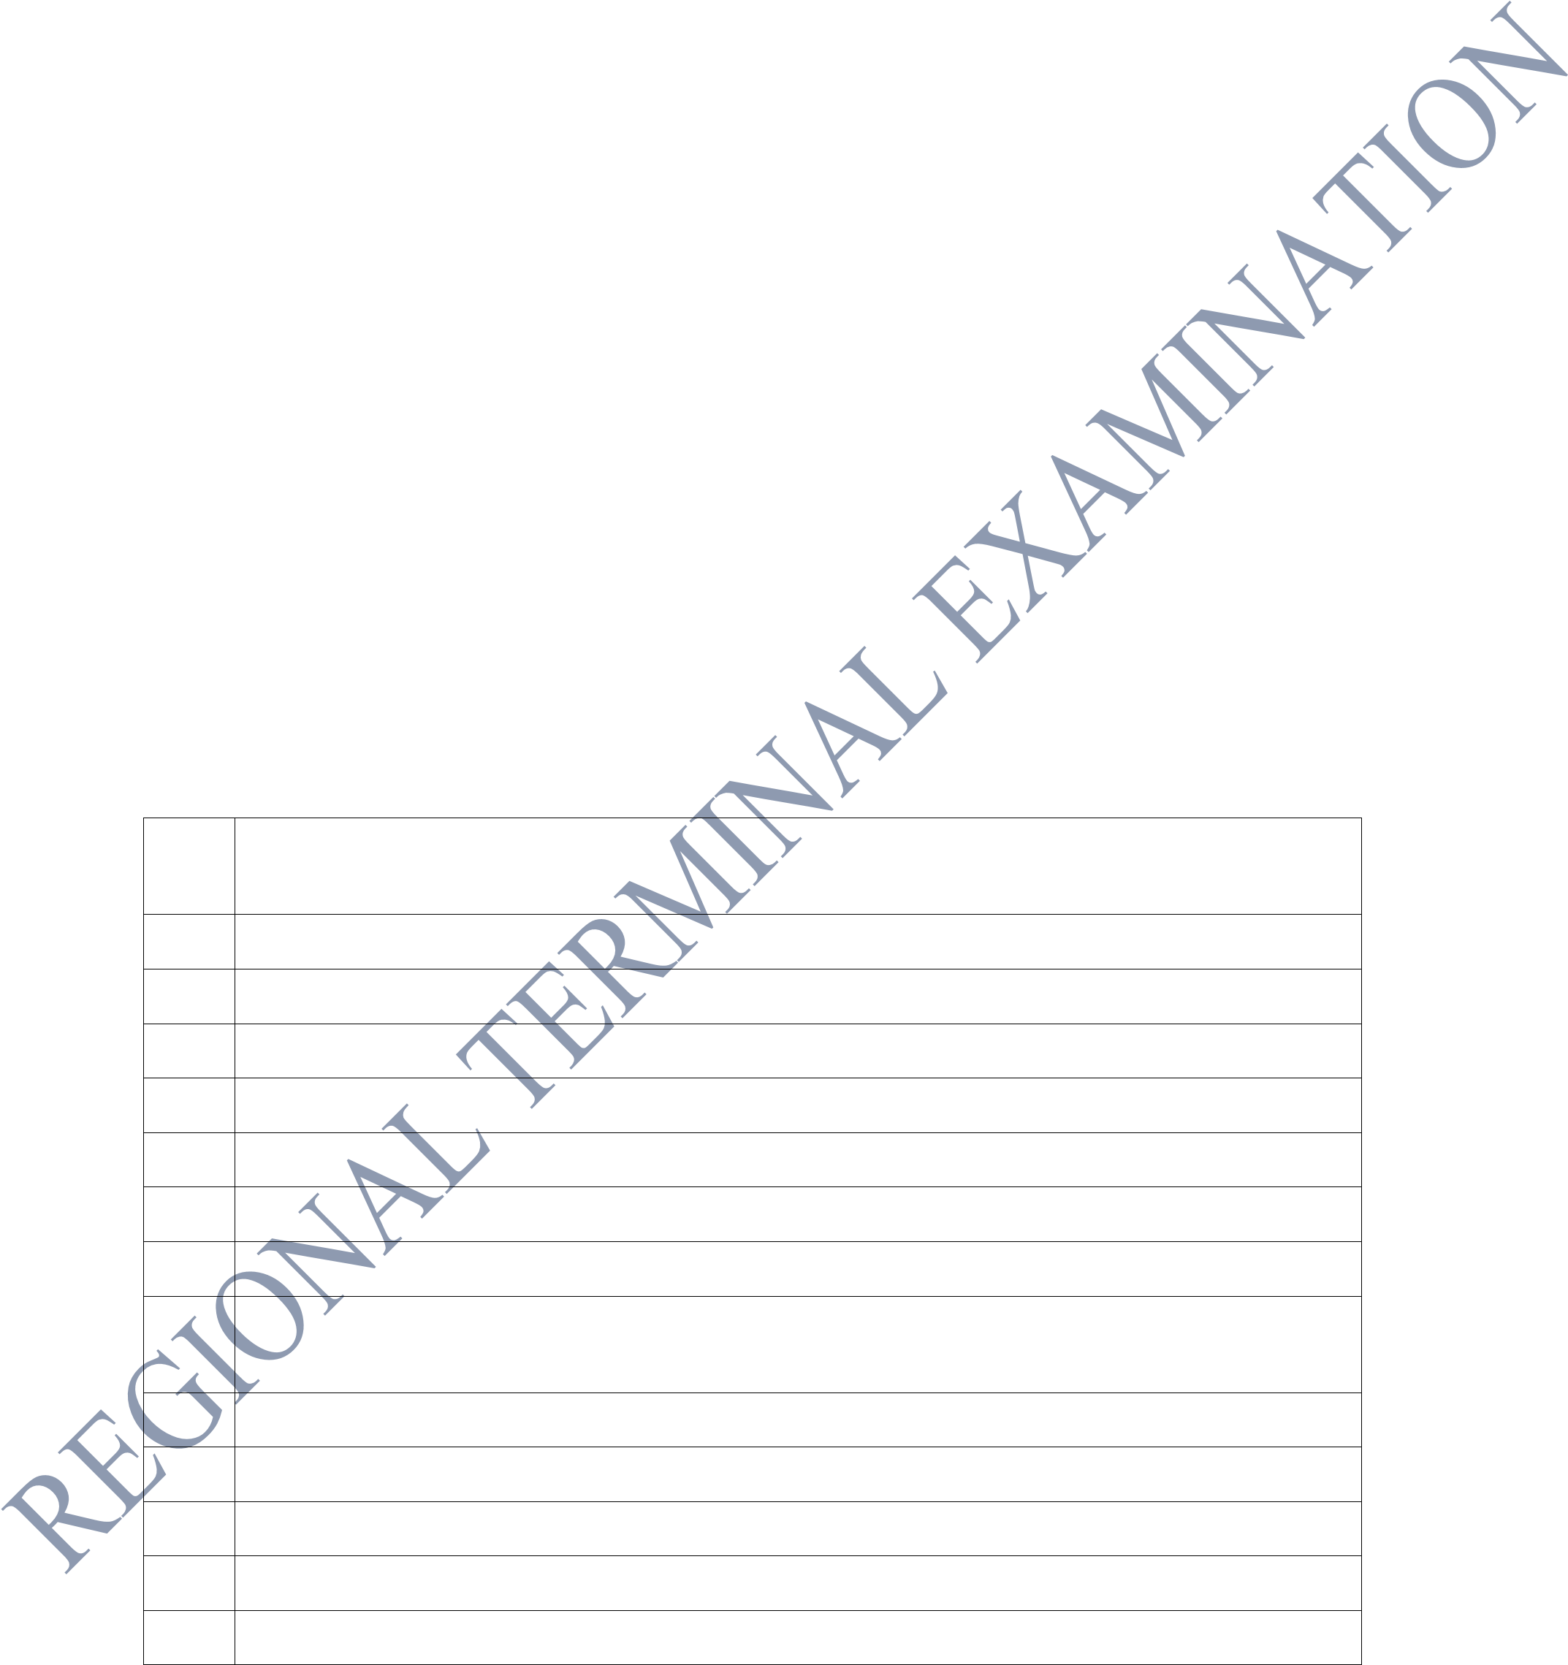
Amina, a Form Three student at Ngotio Secondary School, received an email from an unknown sender claiming to be her bank. The email asked her to click a link and enter her account details. Her classmate Juma secretly accessed another student's social media account and posted offensive content. Meanwhile, a local business discovered that a competitor had copied their software without permission.
  - Identify the specific ICT-related crime committed against Amina and explain how such crimes are carried out. 2 marks
  - Classify the crimes committed by Juma and the business competitor into their correct ICT crime categories. Justify your classification for each. 4 marks
  - Propose three measures that the school administration at Ngotio Secondary School should put in place to protect students from ICT-related crimes. 3 marks

- Study carefully the following HTML codes and answer the questions that follow:

    - <!DOCTYPE HTML PUBLIC "-//W3C// DTD HTML 4.0 Transitional// EN">
    - <html>
    - <body bgcolor="white">
    - <br><br>
    - <h2 align="center">Please! Fill Your Information Correctly</h2>
    - <form>
    - <table align="center">
    - <tr>
    - <td>Name:</td><td><input type="text" placeholder="Enter FullName" name=""></td>
    - </tr>
    - <tr><td colspan=2><b>Data for Information</b></td></tr>
    - </table>
    - <img src= "Crane.jpg" Align = "right">
    - </form></body></html>

- Which line has the tag used for inserting a picture? (1 mark)
- What is the function of the HTML tags presented by lines 6, 8 and 11? (3 marks)
- What will happen if the tag presented by line 3 is deleted? (1 mark)
- If lines 11 and 13 were deleted from the given codes, what will be the output? (4 marks)

SECTION C (30 Marks)
Answer only TWO questions from this section.

9. ESC Ltd is a company which uses the face-to-face way of selling its devices. The company marketing officer decided to adapt electronic commerce to widen their business. However, he/she had limited knowledge of this approach. Explain to him/her:
- Three benefits the company will gain by adapting the new system.

10.

In the banking industry, many banks have introduced computerized systems to improve the
efficiency and convenience of banking services. As a student studying computer s
tudies, describe
four computerized banking services available today in the banking industry.

(15
marks
)

11.

A school computer laboratory has been experiencing frequent hardware failures and slow
performance. As a computer technician, describe four measures yo
u would take to protect the
computers from damage.

(15
marks
)

- Three limitations the company will face by adapting the new system. (15 marks)

