THE UNITED REPUBLIC OF TANZANIA
PRESIDENT’S OFFICE
REGIONAL ADMINISTRATION AND LOCAL GOVERNMENT

LONGIDO AND NAMANGA SECONDARY SCHOOLS

FORM THREE TERMINAL EXAMINATION
INFORMATION AND COMPUTER STUDIES
MARKING SCHEME 2024
SECTION A

e | e | a | c | a or d | b | c | d | a | e

F | D | E | A | B

SECTION B
- (a) computer network - Refers to the connection of more than one computer in the network for data sharing.
(b) demerits of installing LAN at an institution.
- Very expensive during its installation.
- File server may fail easily.
- Cable may break faster.
- It requires more administrative time.
- Virus can spread easily
(c) Bus network Topology
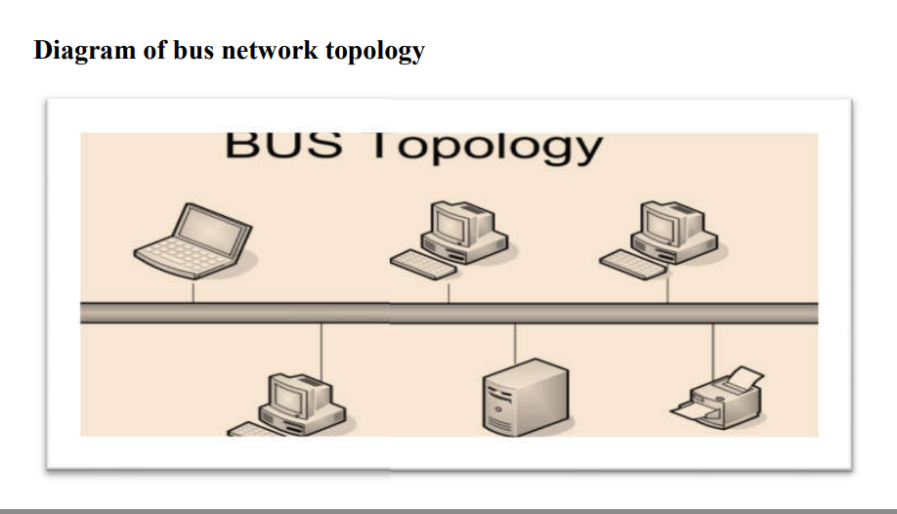
Advantages of bus topology
- It is easy to install.
- It is does need central devices such as hub, switch.
- It is less expensive.
- It is easy to expand.

- (a) Computer handling - Computer handling: Is the process of caring the computer and its accessories so that it can perform its work properly. Sometimes it is called Computer maintenance
(b)factors may lead to data loss to computer
- Software corruption.
- corrupted by virus.
- Program installation conflicts.
- Deleting a file by accident,
- Damage of directory structures that cause entire folders to disappear.
- Breaking of computer.
(c) Factors to consider when buying a computer
- The amount of memory(RAM)
- User review for Longevity
- Whether the PC is for Personal or Business Use
- The processor speed
- Storage capacity
- Hard drive type

- (a) Internet: Is a wide world connection of computers which enables sharing of resources like files and folders, pictures and music, teaching materials like notes/tutorials. Or Internet: Is a hug number of computers that are connected to each other throughout the world
Intranet is a computer network for sharing information, easier communication, collaboration tools, operational systems and other computing services within an organization.
(b) Yes,
- Watching movie
- Playing games
- E commerce
- Charting through email, watsap, facebook
(c) meaning of parts of URL address, http://www.ttcl.com
- http - is a set of rules of transferring web page files based on common websites
- www - means the file requested is in wide world web connection.
- ttcl – sub domain
- .com- top level domain

- (a)
- Cell address - Is a name of a particular cell that represented by alphanumerical values such as H1, G16, A1, C4, B2, and D3
- Cell range –is a group of cells.
(b) application of spread sheet in daily life
- Keeping students assessment records.
- To analyze students examination results.
- Research.
- School budgeting and calendar. Accounting, budgeting, sales forecasting, financial analysis, and scientific fields
(c)
- =IF(C2<100,50,100)
- =B2*C2
- =D2+C2
- =IF(E2>3500,”High”,”Reasonable”)
- – count of item- =SUM(B2:b9)
-Average of tax - =AVERAGE(D2:D9)
-Min ITEM PRICE - =MIN(C2:C9)
Max ITEM PRECE - =MAX(C2:C9)

- Free space of hard disk in Megabyte(s)
Size of computer is 2GB RAM with 60 files
Size of each file is 22MB
Size of 60 files = 60 X22MB
=1320MB
1GB = 1024MB
2GB= ?MB
2GB = 1024MB X 2G
1GB
=2048MB
FREE SPACE OF HARDISK = 2048MB – 1320MB
= 728MB
- Space occupied by 60 files of a hard disk in Gigabyte(s)
=1320MB X1GB = 1.29GB
1024MB
(b) (i) why RAM is characterized as Volatile memory
- Store data temporarily
(ii) RAM used to store temporary when computer is in use.
- (a) long form of the following
- VGA – Video Graphics Arrays
- HTML – Hypertext Mark Up Language
- ICS – Information and Computer Studies
- CPU – Central Processing Unit
- UPS – Uninterrupted Power Supply
(b) utility software - This is the software that enables user to safe manage computer files.
(c) functions of utility software
- Display the error message.
- Detect malicious files.
- Protect computer from being harmed.
- Recover damaged files of the system.

- (a) <body> and </body> because are tags designed to display the content of the webpage
(b) the output of the html codes is as follows;
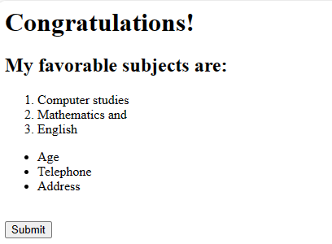

SECTION C
- Types of computer based on size
- Microcomputer.
- Minicomputer.
- Main Frame computer.
- Super computer

- Roles of ICT in Education
- Help in develop of E-learning: is learning utilizing electronic technologies to access educational curriculum outside of a traditional classroom. This kind of learning can be delivered through internet that is Web based Training (WBT), Computer Based Training (CBT), CD-ROM, DVD etc.
- Used to record and keep students marks: Usually students marks are recorded in the computer so as to make reference, producing academic reports, analyzing student’s performance and such like that.
- Search of materials: Students and their teachers can use knowledge of ICT to find different materials on the internet.
- Staffs and Students registration: Through the use ICT all staffs and students are registered electronically in the computer databases. This is the most importance and reliable way of keeping data for more security.
- Sharing materials and knowledge: Different teachers and students throughout the world can take the advantage of ICT to share their materials and knowledge with other fellows so as to enrich their understanding.
- As computer aided instruction (CAI): Sometime it is referred as a computer assisted instruction that refers to the use of computer to learn, drill and practice particular educational principles. For example when learning a new concept of foreign language such as Japanese, the leaner is presented with the explanation of the concept. The computer then presents questions from which the learner is to select the correct answer.
- As computer aided learning (CAL): Is another educational technique where by computer aided learning presents educational materialsthe way a teacher does in the classroom

