THE UNITED REPUBLIC OF TANZANIA
THE PRESIDENT’S OFFICE
REGIONAL ADMINISTRATION AND LOCAL GOVERNMENT
LONGIDO DISTRICT
ANNUAL JOINT EXAMINATION

FORM THREE
036 INFORMATION AND COMPUTER STUDIES
Time: 3 Hours November 2024

Instructions
- This paper consists of sections A, B and C with a total of twelve (12) questions.
- Answer all questions in sections A, B and two (2) questions in section C.
- Section A carries fifteen (16) marks, section B seventy (54) marks and section C carries fifteen (30) marks.
- Cellular phones and any unauthorized materials are not allowed in the examination room.
- Write your Examination Number and Full Name on every page of your answer sheet(s).
- All answers should be written with black or blue ink in the space provided.

SECTION A (16 Marks)
Answer all in questions in this section.
- For each of the items (i) - (x), choose the correct answer from the given alternatives and write its letter beside the item number in the answer sheet provided.
- Which of the following best describes the concept of data entropy in information theory?
A The measure of the randomness or unpredictability of data
B The process of compressing data to reduces its size
C The mathematical formula for calculating the information content of data
D The principle that data should be organized in a hierarchical structure for efficient retrieval
E The process of providing a way to quantify the amount of surprise for an event measured in bits

- A person who uses the computer skills to gain access of information illegally is known as
A Theft B Programmer C Hacker D administrator E Analyst

- Why modern ways of disseminating information are preferred than traditional ways?
A They are expensive B They need skill C They are Complex
D They are fast E They are not selective
- Which of the following element is responsible for making the text bold in HTML?
A <pre> B <a> C <b> D <br> E <p>

- What is the blank space outside the printing area on a page?
A Clipart B Margins C Header
D Footer E Ruler
- A term in computer terminology is a change in technology a computer is/was being used.
A Development B Version C Advancement
D Growth E Generation

- Which of the following is not a cybercrime?
A Denial of Service B Man in the Middle C Malware
D Advanced Encryption Standard E Eaves dropping

- The following spreadsheet was prepared to show the results of the students who did one different tasks. In cells E5 an error occurred. What might be the reason? 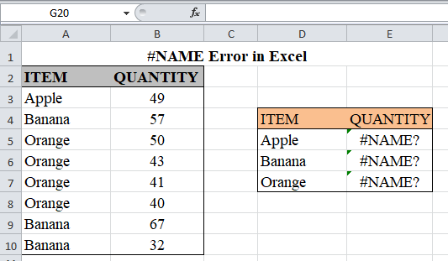

A There is invalid cell referencing in the formula used
B The column is not wide enough to accommodate the value
C The formula uses incorrect argument or operator
D The reference to a value is not available to a formula
E The formula references an invalid intersection of cells

- User communicates with a computer with the help of which devices?
A Input device B Output device C Software device
D Both A and B E Central processing unit

- Form Two students were editing and modifying documents and appears very attractive characters through word processors in Computer laboratory. Which describe the above Form Two students work?
A Viewing B coloring C Formatting
D Layout E Styling
- Match the following functions of each component in List A to their corresponding network device names in List B by writing the letter of the correct option beside the item number in the answer sheet provided.
List A | List B
- A hardware device that connects at least two networks and forwards communication traffic between them.  - A hardware device used to connect one network device to other network devices.  - A hardware device that filters and forwards network traffic.  - A hardware device that enables a computer to connect to a network.  - A hardware device used to connect multiple network devices together.  - A hardware device that connects a computer to a broadband network. | - Network Switch  - Network Modem  - Network Interface Card  - Network Hub  - Network Router  - Network repeater  - Network cable

SECTION B (54 Marks)
Answer all in questions in this section.
- (a) What is an internet Services Provider
(b) A new company SEYPALM NEWS intends to go into the business of word processing. Advice the company on three computer-hardware system specifications features to consider as a measure of enhancing performance.
(c) You are provided with serial cable, USB cable, and parallel cable. Which of the cables provided can be used to.
- Transmit data in a short distances
- Transit data in a long distance
- Support variety of peripheral devices

- (a) Give the importance of backing up data.
- Briefly describe, the following terms as used with disk management
- Formatting
- Compression
- Partitioning
- Fragmentation

- (a) Explain the following e-mail address parts nyalulubogirls@gmail.com.
(b) i) Define the term Search engine
ii) Give two examples of Search engines

(c) Differentiate between the following terms.
i) Downloading and Uploading
ii) Internet and network
iii) User Log in and sign up

- (a) One of the functions of an Operating System is job scheduling. Explain what is meant by job scheduling.
(b) List and explain three types of user interfaces.
(c) Describe the following categories of software
- Firmware
- Proprietary software

- (a) Define the term computer virus
(b) Give any four sources of a computer virus
(c) Explain any four control measures against viruses
- Study the spreadsheet below and answer the questions that follow.
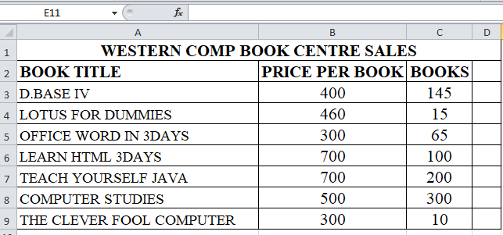
- Write down the formula that can be used to find the price of the most costly book.
- Write down the formula that can be used to determine the total sales for the book titled COMPUTER STUDIES
- Write down the formula that can be used to determine the average of price of the books.
- Write down formula in cell D6 that can be used to find the new price per book. If went up by percentage written if cell C4 and the formula has to be entered only in cell D3 then copied to other cells.
- Write down the output total sales in D7 if B6 is 10%.

- (a)Write the long form to each of the following acronyms as used in ICS (04 marks)
- BIOS
- URL
- WWW
- HDMI
(b) Write the HTML codes that will display the following webpage interface on a browser
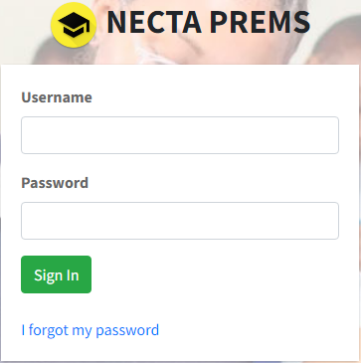.
HINT:
- Use the NECTA picture which named logo1.jpeg.
- Use “I forgot my password” to add link with file named forgotfile access user account.

SECTION C (30 Marks)
Answer two (2) questions in this section.
- Despite the ICT advancements and contributions to socio-economic development, there are threats brought about by its use. Such threats trigger the need for security mechanisms. What are the four common security measures practiced to protect information.

- When computers and other electronic devices are integrated in teaching and learning process, studying becomes more engaging for students. How do Information and Computer Studies relate to other subjects such Physics, Chemistry and Biology? Give four points.

- Elaborate any four advantages of using electronic spreadsheets as compared to traditional worksheets.

