REGIONAL ADIMINISTRATION AND LOCAL GOVERNMENT
LONGIDO DISTRICT COUNCIL
FORM THREE MID TERM ASSESSMENT- MARCH 2024
036 INFORMATION AND COMPUTER STUDIES
Time: 3 Hours
Instructions
1. This paper consists of sections A, B and C with a total of ten (11) questions.
2. Answer all questions in section A and B and only one question in section C
4. Write your answers in the provided booklet
5. All answers must be written in black or blue ink.
6. Cellular phones and any unauthorized materials are not allowed in the assessment room.
7. Write your Assessment Number at the top right corner of every page
SECTION A (15 Marks)
Answer All Questions in this Section
- For each of the following items, (i-x), choose the most correct answer among the alternatives provided and write its letter beside the item number in your answer booklet
- ………….. is a computer memory that store data for immediate/current use in a CPU?
A. ROM. B. RAM
C. Processor D. CD-ROM
- What is the smallest unit of computer data among the following?
A. Kilobyte B. Byte
C. Bit D. Megabyte
- When we watch TV is when we can get …………….
A. Data. B. Information
C. Information dissemination D. Communication
- CPU can perform calculations. Which part of CPU is responsible for such function
A. Registers B. Processor
C. CU D. ALU
- The following error may occur in spread sheet if the column is not wide enough to display all the characters in a cell.
A. ###### B. # Div./0!
C. #Name? D. #REF!
- The common item on the desktop that used to keep deleted files is known as:
- Recycle bin B. My document
C. My computer D. My network place
- A special Computer that stores a network’s programs and data is called:
A. Client B. Supercomputer
C. Server D. Router
- A small blinking bar is a point which indicates a place where the text/object is to be typed in word processor. What is the name of that bar?
A. Tool bar B. Insertion point
B. Status bar D. Task bar
- A command that normally used to save a word document for the first time is known as
A. Save B. Save in
C. Save as D. Save all
- Is a network device that connects and passes signals between two network segments that use the same communication protocol?
A. Bridge B. Switch
C. Hub D. Repeater

- Match the following items in List A with the corresponding responses in List B by writing the letter of the correct response below the corresponding item number in the table provided

LIST A | LIST B
- Columns  - Active Cell  - A Cell Reference  - Workbook  - Cell range | - They run from left to right across the window and their position is designated by numbers.  - Shows group of cells by using colon sign.  - Runs from top to bottom of window and their headings represented by letters  - Is a spread sheet container of sheets?  - Is a single page or sheet in a spreadsheet program such as Excel?  - A space where data can be written in spread sheet.  - Is the intersection between row and column?  - Normally displayed in Name box.

SECTION B
Answer all questions in this section
- Word processing is not complete without Printing.
- Define the term Printing
- The headmistress of CHEGERE secondary wanted to print an office document by using hers Desktop Computer connected to HP Laser jet printer, once she tried to print a printer failed to give output print. As a Computer expert suggest and describe shortly two possible causes for a problem.
- Explain two types of Printer

- Every Website have URL for its visibility online
- What is the meaning of URL?
- Write the names of the following parts of URL
http:// www.cardealersTZ.com
1 2 3 4
- Define the term Internet service provider (ISP)
- Write four examples of internet service providers (ISP) companies found in Tanzania.

- Networks can be configured and designed in various ways and layouts.
(a) Describe three physical network layouts.
(b) Write short notes on the two types of network based on area coverage.

- Virus is a malicious program that affects executable files in the computer, once a computer affected by virus it can display some features.
- Write down four signs shown by a computer that has affected by virus
- Suggest four great ways for spreading computer virus
- One among the ways used to prevent computer against virus is to use Anti-virus. Write any two Anti-virus programs

- Power management is the process of dealing with power disturbances over a computer.
- Write short notes on the following power disturbances over the computer
- Surge
- Sags
- Outage
- Outline two computer power management devices you know.
- Write two effects of voltage fluctuations to electrical appliances

- Use the spreadsheet below to answer the following questions
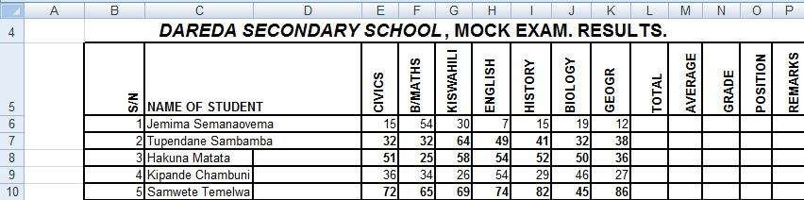
- Write a spreadsheet Formula using cell L6 to calculate Total of the first row
- What is the value of H10?

- Write a spreadsheet Formula in cell M8 to calculate Average of Hakuna Matata
- State the location of the cell containing the value 72
- Give the Names of the following lines in Ms. Excel program.
- Vertical lines
- Horizontal lines
- It is very important to make data backup because in case of hard drive failure you will still having your data.
- What is Data backup
- Write down three importance of data backup
- In order for a user to back up his or her data, he or she needs to have special device. List five computer devices used for data backup.

SECTION C
Answer only one (1) question
- Technology came to solve many problems in our societies. Write an essay on five (5) advantages of E-commerce in the society based in Tanzania
- With vivid example explain the role of ICT in the following sectors: agriculture, medicine, entertainment, engineering and education

