THE UNITED REPUBLIC OF TANZANIA
PRESIDENT’S OFFICE
REGIONAL ADMINISTRATION AND LOCAL GOVERNMENT
MATALE SECONDARY SCHOOLS
INFORMATION AND COMPUTER STUDIES
FORM THREE TERMINAL EXAMINATION
Time: 3 Hours 2024
Instructions
- This paper consists of sections A, B and C.
- Answer all questions in sections A, B and C.
- Cellular phones are not allowed in the examination room.
- Write your Examination Number one very page of your answer booklet(s).

SECTIONA (15% Marks)
Answer all questions in section
1. For each of the following items (i)-(x), choose the correct answer among the given alternatives and write its letter beside the item number in your answer booklet provided.
(i) What is type of computers are client computers (most of the time) in a client-server system?
- Mainframe (c) mini-computer (e)microcomputer
- PDA (d) supercomputer
(ii) an example of numeric data is
- Employee address (c) Examination score (e) bank balance
- 078951A (d) 15yrs ( e) Examination Number
(iii) First page of immediately when interact with Website
- Homepage (c) Index (b) HTML (d) Bookmark (e) webpage
(iv) Mr Najua IT was editing document and modify and appear very attractive characters. Which describe the above Mr Najua IT work?
- Size (b) Colour (c) formatting (d) layout (e) point
(v) Which of the following is necessary for running application software?
(a) System software (b) Utility program (c) Graphical user interface (d) Operating system
(e) Network card

(vi) Computer’s information which is represented by spoke phrases or sentences is termed as
- paragraph (b) Output (c) video (d) input (e) music
(vii) Which of the following is not used in the storage phase of a computer-based information system?
- Magnetic disk (b) Hard disk (c) MS Word (d) ROM (e) Floppy
(viii)Development which marked in the second generation of computers
- Microprocessor (c) Vacuum tubes (e) Registers
- Intelligence (d)Transistors
(ix) Which of the following is the correct meaning of the term workbook as used in the spreadsheet?
- Collection of worksheets (c) collection of spreadsheets (e) collections of cells
- Collection of sheets (d) collection of rows and columns
(x) A software which make components system software except
(a) Utility programs (c) antivirus software (e) application software
(b) Operating system (d) drivers programs
- Match the following meaning in List A to corresponding terminologies in List B by writing letter of the correct option beside the item number in your answer booklet.
LISTA | LIST B
- Consists of buttons of commands (icons) that provide shortcuts to command available in the menu bar.  - Is the communication channel between the user and application?  - This is the work area where you create document.  - Indicates the tasks which are currently running on its right  - Provides the user with a group of commands. | - Title bar
 | - Menu bar
 | - Zoom bar
 | - Status bar
 | - Document window
 | - Toolbar
 | - Scroll bar

SECTION B (70% Marks)
Answer all questions in this section
- (a) What is computer Network?
(b) Describe four demerits of installing LAN Area Network (LAN) at an institution.
(c) With diagram, briefly describe bus networks topology and give two advantages of designing this type of topology.
- (a) What do you understand about Computer handling?
(b) Briefly, Explain any five (5) factors which may lead data loss to computer.
(c) Suppose your Father requests you to tell him which is very important things should consider when buying computer. Give him four (4) considerations so as can buy for your studies use.
- (a) Differentiate between internet and intranet as used in network.
(b) Fifth (5^{TH)} generation people run their businesses and entertainments in internet. If the answer is Yes or No state four (4) points.
(c)Study the following URL address, http://www.ttcl.com of Tanzania telephone line website.
What does the following parts of URL meaning in address above?
- http……………………………………………………………………………..
- www……………………………………………………………………………
- ttcl………………………………………………………………………………
- .com……………………………………………………………………………
- (a) Explain the following
- Cell address
- Cell range
(b) Describe four application of spreadsheet in daily life.
(c) Study the given screenshot carefully then answer questions that follow:
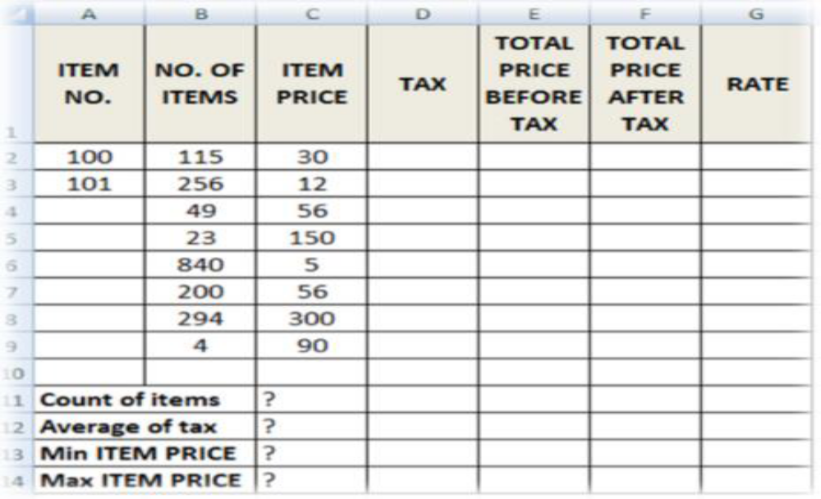
Write formula or function that can be used if any to calculate:

- Tax (if item price is less than 100, tax is 50 and otherwise it should be 100).
- Total price before tax.
- Total price after tax.
- Rate (if total price after tax greater 3500 then the rate is “High”, otherwise it is Reasonable.
- Count of Items, Average of Taxes, Min Item PRICE and Max Item PRICE.
- (a) Mr. Abode has a computer with 2GB RAM contains 60 files and each file with size of 22 MB that occupied by running application software. Calculate
- Free space of hard disk in Megabyte(s).
- Space occupied by 60 files of a hard disk in Gigabyte(s).
(b) (i) Why RAM is characterized as volatile memory?
(ii) List one use of RAM in the computer.

- (a)Write the long form of the following abbreviations as used in ICS
- VGA
- HTML
- ICS
- CPU
- UPS
(c) Give the meaning of utility software
(d) Describe five functions of utility software
- (a) State the reason why the content of the web page need to be written between the <body> and </body> tags.
(b) Show the output of the following HTML codes when run with any browser.
<HTML>
<BODY>
<H1> Congratulations! </H1>
<H2>My favorable subjects are: </H2>
<OL>
<LI> Computer studies</LI>
<LI> Mathematics and</LI>
<LI> English </LI>
</OL>
<UL>
<LI>Age</LI>
<LI> Telephone</LI>
<LI> Address</LI>
</UL><br>
<FORM>
<INPUT TYPE=”SUBMIT” VALUE=”Submit”>
</FORM>
</BODY>
</HTML>

SECTION C (15% Marks)
Answer only one (1) questions in this section
- Describe the types of computer based on the size of computer.

- The advance of science and technology make education to apply ICT in teaching and learning, explain the roles of ICT in education.

