NAMANGA SECONDARY SCHOOL
FORM THREE MID TERM EXAMINATION
INFORMATION AND COMPUTER STUDIES
AUG, 2025
TIME: 3HRS
INSTRUCTIONS
- This exam consists of ELEVEN (11) questions in total
- Answer all questions from SECTION A, SECTION B, and only two questions from SECTION C
- Your work should be neat, and all answers with explanations should be written in blue pen and listings and mentions in black pen.
- Give examples where necessary.
SECTION A – 16 Marks
Answer all questions in this section
- Choose the letter of the most correct answer and write it in the provided box. (10 marks, 1 @)
- Which of these elements encloses all the other elements and tags in HTML?
- <BODY>………….... </BODY>
- <HTML>…………... </HTML>
- <HEAD> ………...... </HEAD>
- <END> ……………...</END>
- <TITLE> …………... </TITLE>
- Which of the following is the attribute of the BODY Element?
- Color
- Background
- Font face
- Bottom margin
- Up margin
- Which of these elements is used to highlight the text in the web page?
        - <sup> ………... </sup>
        - <strike>……. </strike>
        - <sub> ……... </sub>
        - <strong> ………. </strong>
        - <italic> …………... </italic>
- Trackballs, pointing sticks, and touch pads are found mainly on ________ computers and perform the same functions as a mouse.
- Super
- Mainframe
- Desktop
- Laptop
- Touchpad
- _________ use laser beams and reflected light to translate drawings, photos and even text into digital form.
- Projectors
- Stylus pen
- Printers
- Scanners
- Plotters
- It decides where to send data; after it is processed it sends the data onwards for output.
- CPU
- ALU
- CU
- GPU
- VDU
- The efficiency of a processor can be increased by doing the following with the exceptions of the following:
- Increasing its speed
- Using the external Hard Drive (HDD)
- Help it to communicate with main memory by using cache memory
- Using parallel processing
- A &D
- In order to reduce the breakdown and malfuction of your computer system you must:
- Not drink around the computer
- Not eat around the computer
- Use a UPS
- Not placing of magnets around the computer
- All of the above.
- Σ function is used to perform the following _______
- Multiplication
- Auto sum
- Division
- C and B
- A and C
- Which of the following allows you to read, compose, send and access e-mail from a server?
- Mail Server
- Mail Outlook
- Mail receiver
- Mail client
- Mail transfer

2. Match the functions of Microsoft Office Word icons in List A with their corresponding icons on the screenshot in List B by writing the letter of the correct answer beside the item number.
List A
- The icon is used to check for spelling and grammar mistakes
- The icon which is used to view and print word document files
- The icon which is used to save a word document file
- The icon which is used to remove text in w word document.
H
- The icon which is used to add styles on a text in word document.
G
List B
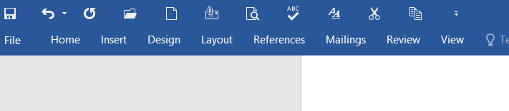
B
C
A
D
E
F

SECTION B – 54 Marks
Short Answer Questions.
Answer all questions from this section
- I) Use the concepts of computer networks and communications to answer the following question.
a) What is a computer network, and why is it important? (01 Marks)
- Explain the difference between LAN and WAN. (02 Marks)
- What is the purpose of an IP address? (01 Marks)
- Define bandwidth in the context of network communication. (01 Marks)
- What is a router, and how does it function in a network? (01 Marks)
II) Differentiate between the following words as they are used in Word processing: (1 Marks, @)
- Cut and Copy
- Formatting and Editing
- Backspace key and Delete key

- (a) From the following URL stracture study it and answer questions that follows:-
HTTPS:// COINT.UDSM.AC.TZ
- Identify the protocol used. (1 Marks)
- From the URL name the subdomain. (1 Marks)
- From the URL name the main domain name. (1 Marks)
- State the country code top level domain used (ccTLD). (1 Marks)
- Explain the role of your answer in roman (iii) and explain why its important. (2 Marks)
(b) With examples explain all requirement used in publishing a webpages. (3 Marks)

- The school management has decided to shift from manual computation of examination results. You have been asked to assist the school to manipulate students’ marks to provide a report and the below was your arrangements. Use the arrangements to answer questions that follows;
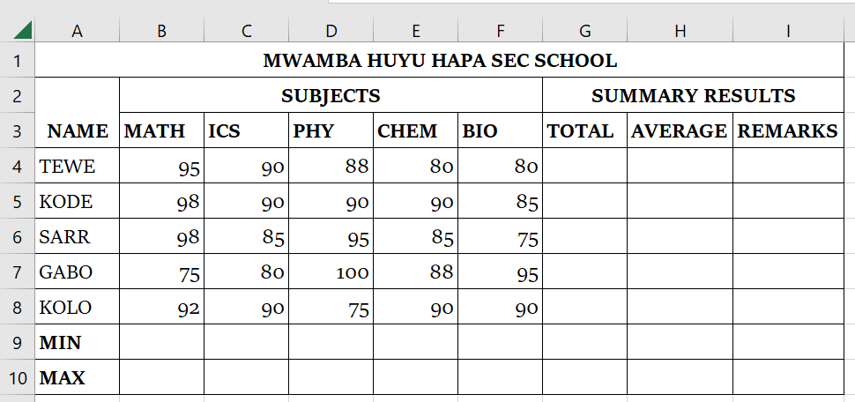
- Use the concept of cell referencing and write the function that will be used to find the total marks obtained by each student. (1 Mark)
- Write down the formatting features applied on the cell address B9 and cell I3. (2 Mark)
- Use the concept of cell referencing write the function that will be used to find the average marks obtained by each student. (1 Mark)
- Write the function that will be used to calculate minimum and maximum marks for ICS. (1 Mark)
- If the average marks obtained by the student is more than 90, the remarks should be “Distinction”; otherwise, the remarks should be “Excellent”. (2 Marks)
- You need to restrict the range of students marks for all subjects to be from 0 and 100 in order to prevent any other value out of this range. State the steps that you are going to use. Note: The students marks are only whole numbers. (2 Marks)

- Use the concepts of web development, HTML tags and webpage structure to create a HTML webpage with the following functionalities.
  - Set the title of the web page as “inspirational Quotes” for the webpage(0.5 Mark)
  - Set the background color as “pink” (1 Mark)
  - Add the first three most important multilevel headings with the following texts respectively.
    - Education inspirational Quotes(1 Mark)
    - Sports inspirational Quotes(1 Mark)
    - Music inspirational Quotes(1 Mark)
  - Inside each heading add paragraphs with the following texts respectively.
    - “Education is the passport to the future, for tomorrow belongs to those who prepare for it today.” — Malcolm X (1.5 Mark)
    - “I’d rather regret the risks that didn’t work out than the chances I didn’t take at all.” — Simone Biles (1.5 Mark)
    - “Music gives a soul to the universe, wings to the mind, flight to the imagination, and life to everything.” – Plato (1.5 Mark)
- (a). Explain the following terms as used in ICS:-
- Modems (1 Mark)
- Network hubs (1 Mark)
- Switches (1 Mark)
- Bridges(1 Mark)
- Routers (1 Mark)
(b). Why is the use of DBMS recommended? Explain three same of its major advantages (4 Marks)
- (a). For example in window 10, creating password is very important depending on computer operating system. So using an example given outline steps or procedures used in creating password in that operating system. (5 Marks).
(b). Mention only basic principle of information security.

SECTION C – 30 Marks
Essay Format Questions
Answer only two questions from this section.

- Suppose you were given an opportunity to speak to your fellow students on the motion which state that “internet causes more harm to student than benefits”. Explain five points that you would use to support this motion. (15 Marks)
- A computer consists of hardware and software that work together to perform various tasks. Other people tried to compare humans and the computers, but there are slightly differences between them and these differences can be identified depending on the characteristics between these two machines. With vivid points, Explain characteristics of computers. (15 Marks)
- You are a cybersecurity expert and you were invited at the school of St. Jude to spread awareness about the danger associated with being connected to the internet. In your narration you stated that, the commonly encountered cybercrimes or ICT related criminal activities includes but not limited to; computer virus, phishing, Denial of Service (DoS) and Hacking. With the use of essay explain how would you have carried out the presentation with the use of above crimes. (15 Marks)

