NAMANGA SECONDARY SCHOOL

FORM THREE MID- TERM EXAMINATION

INFORMATION AND COMPUTER STUDIES
TIME: 3hrs

Instructions
- This paper consists of sections A, B and C .
- Answer all questions in sections A, B and one question in section C.
- Calculators, cellular phones and any unauthorized materials are not allowed in the examination room.

SECTION A (15 MARKS)
Answer all question in this section.
- For each of the following items(i) – (x), choose the correct answer from among the given alternative and write its letter in the box provided.
- Which of following is the correct order of the units of computer memory in terms of size in descending order?
- Byte>Kilobyte>Bit>Gigabyte>Megabyte
- Bit>Byte>Kilobyte>Megabyte>Gigabyte
- Gigabyte>Megabyte>Kilobyte>Byte>Bit
- Byte>Bit>Kilobyte>Megabyte>Gigabyte
- Megabyte>Gigabyte>Kilobyte>Byte>Bit

- A computer network media that supports large volume of data transfer is called
- Two wire open line cable
- Fibre optic cable
- Twisted pair cable
- Network Interface card
- Coaxial cable

iii. Which of the following can be used to avoid data loss due to disk damage or failure in a computer?

    - Using password
    - Creating separate accounts
    - Creating backup
    - Installing licensed antivirus

- Word processing, spreadsheet and photo editing programs are examples of

    - System software
    - Operating system
    - User-interface software
    - Application software

- Which of the following software is useful in editing a legal document?

A.Spreadsheet
C. Word processor

- The WWW is accessed using a
- Browser
- Gopher

- Which one among the following is not malicious code?
A.virus C. Trojan horse
B.worm D. hacker

B.Operating system
D.Editor

- Search tool
- OS software

- Which of the following formula adds cells A1 through A5 in MS –excel

A.=SUM(A1+A5)
B. =SUM(A1:A5)

C. =ADD (A1:A5)
D. TOTAL (A1:A5)

- Which of the following network topologies always use a Hub in communication?
- Ring B. bus C. star D.Hybrid
- HTTP refers to:
- Hyper Text Transfer Protocol
- Hyper Text Transfer Procedure
- Home Text Translating Process
- None of the above

- match the following terms in List A with their corresponding meaning in List B by writing the letter of the correct below the item number in the table provided.
List A | List B
- Downloading  - Uploading  - Search Engine  - Browser  - URL | - Bing  - WWW  - Sending data or information to internet  - Storage of data in the computer  - Allow users to access and view web pages on internet  - Internet service provider  - Retrieving web document from server to client computer  - It specify the location or address of the resources on  internet.

SECTION B (70 MARKS)
Answer all question in this section.
- Arrangements the following in terms of Computer generation (5 marks)
- The computer used Transistors replaced
- Used in intelligent robot
- The computer used vacuum tubes for circuit and magnetic drums for memory1
- Integrated circuit
- Used in VLSI technology
- Mr. Michael was typing a letter using his computer, suddenly a computer screen started displaying unusual messages, unknown programs appeared, operating system started running slowly and a computer started switching off and on unexpectedly. All these activities occurred without his permission.
- Suggest the possible cause of that problem
- What program you think could be run in a computer to solve such a problem?
- Outline four examples of the program named in 4 (b) (iii) above
- In this Corona era many Multi-national companies often use video conferencing such as Zoom cloud meeting rather than face to face meetings. Explain two advantages and two disadvantages of using this system of conferencing
- Read the following snapshot and answer the following question
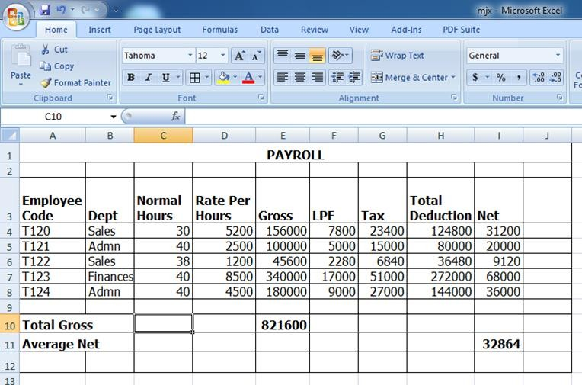
  - Give the name of the program used to create the snapshot above...………………………………….
  - Write the font face and font size used to type the details in given snapshot
  - Give the reference name of the active cell……………………………………………………………
  - What format was done for the cells in row 3?....................................................................................
V) Write the function required to calculate the total gross

- A) What is cybercrime ?
B) Distinguish between :
i) Hacking and phishing
ii) software piracy and eaves dropping
- Briefly explain the role of ICT in creating awareness on :
  - Gender
  - Drug trafficking
  - Family life
  - HIV/ AIDS
- a)What is the function of point of sale (POS) terminal is used in supermarket
b) Is e-banking different from m-banking ? if Yes, how, if No, how

SECTION C 15 marks)
Answer one (1) Question from this section

- Why schools include the use of ICT in teaching and learning process? Explain by giving four reasons.

- With examples explain the role of ICT in the following sectors:

- Medicine c) employment

- Entertainment d) cultural interaction

