PRESIDENT OFFICE
REGIONAL ADMINISTRATION AND LOCAL GOVERNMENT
NAMANGA SECONDARY SCHOOL
FORM THREE MID-TERM EXAMS
INFORMATION AND COMPUTER STUDIES

TIME: 3 Hours AUGUST ,2024

Instructions
- This paper consists of Section A, B and C with a total of twelve (11) questions.
- Answer all questions in section A, B and two questions in section C in answer sheet provided.
- Calculator, cellular phones and any unauthorized materials are not allowed in the examination room

SECTION A (16 Marks)

Answer all question in this section

For each of the items (i)-(x) choose the correct answer from among the given alternatives and write its letter beside the item number in the space provided
  - How can you classify the lap top and desktop computer?
    - portable computers B supercomputer C microcomputer
D minicomputer
  - The problem of eye strain which is caused by spending a lot of time on using computers can be minimized by
    - taking regular break and using antiglare screen
    - using adjustable monitor stands and keyboards
    - adopting a healthy sitting style
    - using adjustable chairs and footrests
  - Which program would you use in preparing application letter
    - Microsoft excel B Microsoft word
C Microsoft power point D Microsoft access
Cell A4, A7, C4, C5 and C7 contain values 4,4,9,2 and 3 respectively. Then in cell D78 a formula, =C5*(A4+A7) – (C4/C7) is entered. What will be the value of cell D78?
          - 10
          - 12
          - 11 D. 13

  - Communication channel between the user and application program that provides information such as current page, current page, current section, total number of pages, total number of words, the language used, current line number and current column number. A. Title bar
          - Menu bar
          - Document window
          - Status bar
  - Which tag would you use to emphasize the heading of the article in the webpage?
    - <head> </head> B <title> </title>
C <hr> </hr> D <th></th>
  - What is alternative name of utility program?
    - Operating program B Application program C Software program D Interface program
  - memory in terms of size in descending order?
    - Byte>Kilobyte>Bit>Gigabyte>Megabyte
    - Bit>Byte>Kilobyte>Megabyte>Gigabyte
    - Gigabyte>Megabyte>Kilobyte>Byte>Bit
    - Byte>Bit>Kilobyte>Megabyte>Gigabyte
    - Megabyte>Gigabyte>Kilobyte>Byte>Bit
  - A computer network media that supports large volume of data transfer is called
    - Two wire open line cable
    - Fibre optic cable
    - Twisted pair cable
    - Network Interface card E. Coaxial cable
  - Which device would you use to connect seven computers so that they can share the same bandwidth?
    - Switch B Router C Hub D Modem
  - Which keyboard keys are referred to as special purpose keys in a personal computer?
    - F1, F2, F3 up to F12 B A to Z, Tabs, Caps lock and 0-9
C Arrow keys, Tab and Home key D SHIFT, Ctrl, Alt and ESC

- Match the following descriptions of the filed properties in LIST A to their corresponding names in LIST B by writing the letter of the correct answer beside the item number in the table provided
List A | List B
- Downloading  - Uploading  - Search Engine  - Browser  - URL  - Web page | - Bing  - WWW  - Sending data or information to internet  - Storage of data in the computer  - Allow users to access and view web pages on internet  - Internet service provider  - Retrieving web document from server to client computer  - It specify the location or address of the resources on  internet.  - Is Part of a website that contains specific information  - Is computer language Used to create website

SECTION B (54 Marks)

Answer all question in this section

a)Arrangements the following in terms of Computer generation (5 marks)
- The computer used Transistors replaced
- Used in intelligent robot
- The computer used vacuum tubes for circuity and magnetic drums for memory1
- Integrated circuit
- Used in VLSI technology
b)Asume that you are a web developer. How can you let someone understand the following terminologies. A.Web page b. Home page. C. Website d. Web server.
4. a) As an expert in Web development, briefly explain three (03) Properties of Quality Web page design.
b) How can you differentiate between Tag and Atribute.
5. a)what are other function of point of sale (POS) terminal a part from being used to calculate the total amount of money the customers are supposed to pay after buying goods?
b)Explain how transparency reform increase detection of corruption
6. a)explain the following commonly encountered cybercrime activities;
a) identity theft b) phishing c) fraud d) software piracy
b) mention 5 tips to create strong password in order to protect information system from cybercrimes
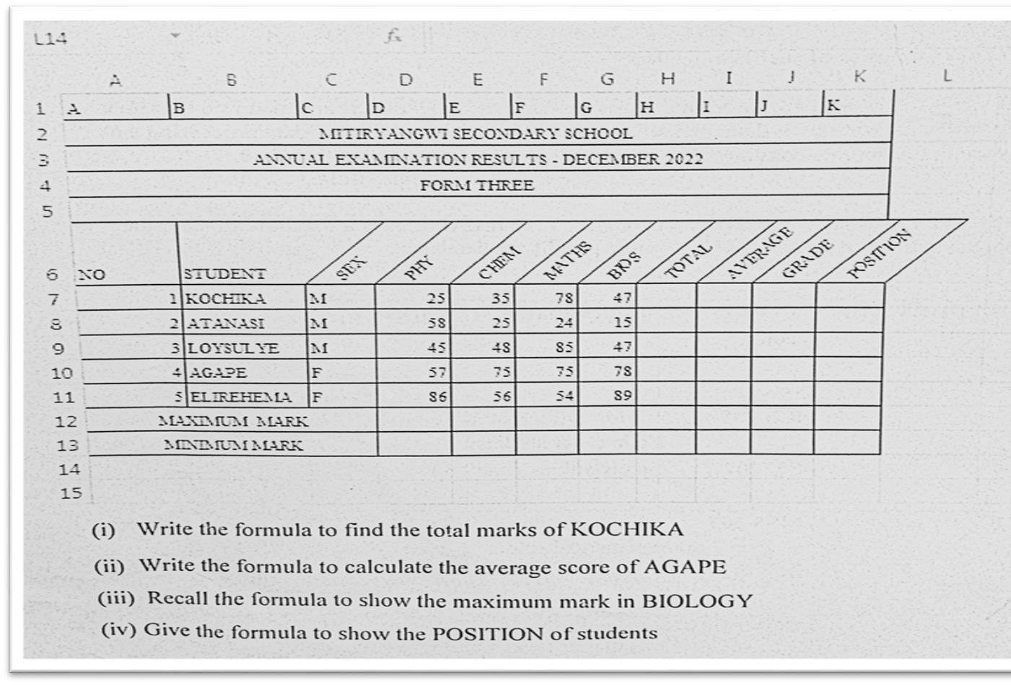
- Study the worksheet below and answer the question that follows.
  - In Qn 8(a) shows data entered in a cell. What are the types of cell data types?
Outline four (04) basic cell data types.
  - What type of software used in Qn 8 (a) ?

- a) Prepare a html document(Tags) that display the followings instructions;
- Heading of the page “MY CLASS”, Use heading (h1);
- Five names of you classmate by ordered list;
- Five subjects names you like.The type list should be circle and
- Decscription list defining any five information and computer studies terms of your interest
b) Briefly describe how one can access the website.
SECTION C (30 Marks)
Answer two (2) questions from this section.
- During the development of computer, different scientists contributed much to make sure that computers are portable. Hence we reached to a point of recognizing Charles Babbage as a father of computer. With this context write an ESSAY based on history of computer, explain computer evolution, explain why Charles Babbage is a father of computer and hence discuss the five generations of computer based on time and used technology.
- In this Corona era many multi-national companies often use video conferencing such as Zoom cloud meeting rather than face to face meetings. Explain two advantages and two disadvantages of using this system of conferencing
- Explain the role of ict in the followingsectors;
- Education
- Agriculture
- Business
- Data management
- Medicine

